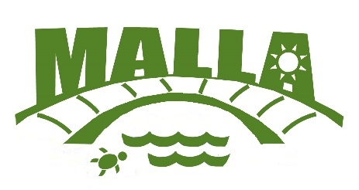
Malcolm & Ardoch Lakes and Landowners’ Assn
Annual General Meeting
June 4, 2022
8:00 am
5364 Ardoch Rd (Whittaker’s Cove)

AGENDA
Time Description Speaker
8:00 – 9:00 Breakfast, Pre-Registration, Membership Renewals & Kathy Smith
50/50 Ticket Sales

9:00 – 9:10 Attendance, Confirmation of a Quorum, Welcome including Brenda Martin
Recognitions, Call to Order

9:10 – 9:15 Approval of Saturday, June 8, 2019 AGM minutes Kathy Smith
9:15 – 9:45 Residential Break-ins /Burglaries 2021/22 OPP Report Marty McConnell
9:45 – 10:00 Fire Safety Eric Korhonen
10:00 – 10:15 Break & 50/50 Draw
10:15 – 10:30 Mayor’s Update Ron Higgins
10:30 – 10:45 Councillor’s Update Gerry Martin
10:45 – 10:50 Approval for 2021/22 Executive Reports Brenda Martin
10:50 – 11:00 a) Financial Audit 2021/22 Allan Jamieson
b) Proposed 2022-2023 Budget Allan Jamieson
11:00 – 11:30 Executive Elections Brenda Martin
- Call for nominations for President
- Call for nominations for Ardoch Lake Vice President
- Call for nominations for Malcolm Lake Vice President
- Call for nominations for Secretary
- Call for nominations for Treasurer
- Voting for new Executive
11:30 – 11:45 Stewardship, Fishing and Social Committee Reports Committee Chairpersons
11:45 – 12:00 New Business/Open Floor – Q&A All
12:00 2022/2023 AGM – Proposed for Saturday, June 10, 2023 Brenda Martin

Adjournment & Farewell Message Brenda Martin

