|  |
| --- |
| MALLA AGM Reports |
| Making Life Better at our Lakes |

|  |
| --- |
| 2020-2021 |

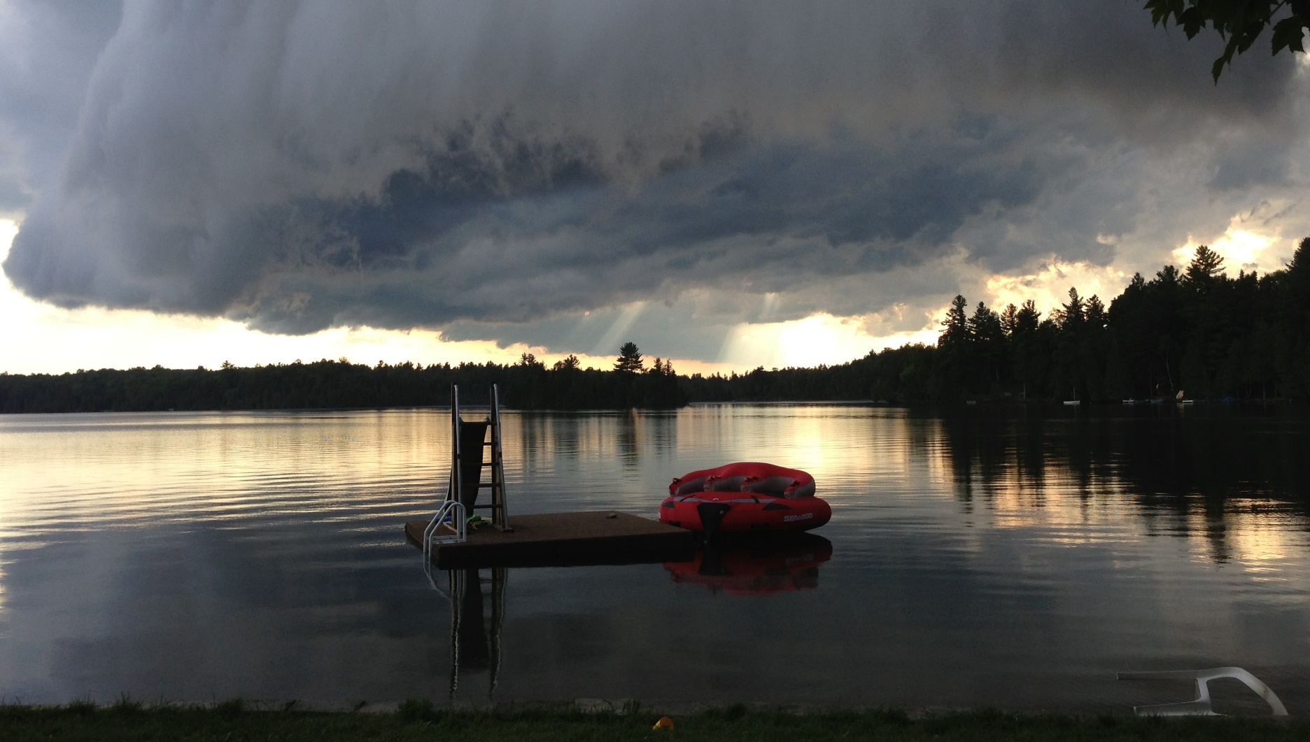

|  |
| --- |
| 2020-2021 |
| Malcolm Lake Vice-President Report 2021  By Brenda Martin, MALLA VP Malcolm Lake  As outlined in the Spring 2021 Newsletter, there were many adaptations needed for fall and winter. We were fortunate to have one social event- the Corn Roast. Being optimistic, the Executive predicted that we would be able to have our annual Winter Social, but the spread of Covid-19 continued and all activities were cancelled.  In the role of Vice President, I continued to participate in the Zoom meetings for the North Frontenac Lake Associations Alliance where we discussed common issues and how to address them. The two main ones are the expansion/improvement of broadband for rural areas and the importance of septic system inspections to protect the water quality of our lakes. There were many learning opportunities offered through Environmental groups such as Nature Conservancy Canada, Watershed Canada and Mississippi Valley Conservation Authority. Since we were on “stay-at-home order” it worked out well to have these interesting sessions.  Hopefully, the membership will remain stable or grow for the coming year. Usually, I do a door-to-door visit the long weekend in May to invite cottagers to join our organization. With a second trip on the July 1st weekend, most people have been contacted. This year that won’t happen, so please take the initiative to renew your membership. Even if social activities are restricted, you can still support the lake preservation projects.  For the past 10 years, I have been on the Executive and enjoyed making a contribution to our Lake Association. Due to health issues, I am unable to continue in the present roles and hope that other property owners will take a turn. Since I am a permanent resident, I am in a position to help with short-term tasks- whether it is Social, Fishing or Stewardship or prepare newsletters. Please consider being the Vice President (Malcolm Lake) or President or Stewardship Chair. I thank the membership for the support I received during my leadership and look forward to supporting the new Executive members. Ardoch Lake Vice- President Report 2021 This last year has been a less active one for the cottage association. With the on-going pandemic, travel was restricted and large gatherings prohibited. On Ardoch Lake, we had two cottages exchange ownership and two other lots have cottages now. The proposed development on the south side of the lake is up for sale presently.  There is a patch of Phragmites on one section of shoreline that we are going to work on this summer to help eradicate it. Brenda Martin has been working hard to obtain funding for this work. The Eurasian Water Millfoil continues to grow along the shallow areas of the lake. There was less collective work done controlling it last year, due to pandemic restrictions, but cottagers have been continually trying to keep it contained along their shores. Three cottagers have used burlap to cover their patches and others are hand picking/cutting it out. This will continue this summer.  The Lake Partner Program, out of Dorset Environmental Services Centre, has been put on hold right now. Sample kits are still awaiting to be used and sent back to Dorset when we get the green light to go ahead again.  Brenda and I represented MALLA at the North Frontenac Lakes Alliance Association meetings by teleconference. There has been ongoing work to encourage council to accept regular mandatory septic inspections.  ou can easily change the formatting of selected text in the document text by choosing a look for the selected text from the Quick Styles gallery on the Home tab. You can also format text directly by using the other controls on the Home tab. Most controls offer a choice of using the look from the current theme or using a format that you specify directly.  To change the overall look of your document, choose new Theme elements on the Page Layout tab. To change the looks available in the Quick Style gallery, use the Change Current Quick Style Set command. Both the Themes gallery and the Quick Styles gallery provide reset commands so that you can always restore the look of your document to the original contained in your current template. Heading 3 On the Insert tab, the galleries include items that are designed to coordinate with the overall look of your document. You can use these galleries to insert tables, headers, footers, lists, cover pages, and other document building blocks. When you create pictures, charts, or diagrams, they also coordinate with your current document look.  You can easily change the formatting of selected text in the document text by choosing a look for the selected text from the Quick Styles gallery on the Home tab. You can also format text directly by using the other controls on the Home tab. Most controls offer a choice of using the look from the current theme or using a format that you specify directly.  To change the overall look of your document, choose new Theme elements on the Page Layout tab. To change the looks available in the Quick Style gallery, use the Change Current Quick Style Set command. Both the Themes gallery and the Quick Styles gallery provide reset commands so that you can always restore the look of your document to the original contained in your current template. |
| Ardoch Lake Vice-President Report 2021  By Ruth Cooper, MALLA VP Ardoch Lake  This last year has been a less active one for the cottage association. With the on-going pandemic, travel was restricted and large gatherings prohibited. On Ardoch Lake, we had two cottages exchange ownership and two other lots have cottages now. The proposed development on the south side of the lake is up for sale presently.  There is a patch of Phragmites on one section of shoreline that we are going to work on this summer to help eradicate it. Brenda Martin has been working hard to obtain funding for this work. The Eurasian Water Millfoil continues to grow along the shallow areas of the lake. There was less collective work done controlling it last year, due to pandemic restrictions, but cottagers have been continually trying to keep it contained along their shores. Three cottagers have used burlap to cover their patches and others are hand picking/cutting it out. This will continue this summer.  The Lake Partner Program, out of Dorset Environmental Services Centre, has been put on hold right now. Sample kits are still awaiting to be used and sent back to Dorset when we get the green light to go ahead again.  Brenda and I represented MALLA at the North Frontenac Lakes Alliance Association meetings by teleconference. There has been ongoing work to encourage council to accept regular mandatory septic inspections.  MALLA STEWARDSHIP COMMITTEE REPORT 2021  By Brenda Martin, MALLA Stewardship Committee Chair  As I indicated in the newsletter much of the Stewardship educational aspects came from Zoom meetings with Environmental organizations. Keeping the waterfront property owners abreast of new programs, opportunities and issues is related to our Lake Plan implementation and monitoring.  2020 was year-three of the Eurasian Water Milfoil pilot project on our lakes. Much of the planning, research, activities and reports for the pilot were summarized in an 82- page document entitled, Eurasian Watermilfoil Management Plan (2018-2020). (The document is attached to this report and to be posted on the MALLA website). All members of MALLA are encouraged to read the document, perhaps in small doses for those less keen in scientific matters.  Our research in the early stages of the pilot project, determined that the most effective, feasible and affordable strategy to use was an integrated multi-year management approach. Strategies included: education, plant monitoring and mapping with the drone technology, hand-harvesting where appropriate, burlap (jute) placement, partner with the team organized by Professor Jesse Vermaire (EWM specialist at Carleton University) and to investigate aquaponic production of milfoil weevils with Teacher, Wade Leonard.  Results of this field study will provide some of the first empirical evidence for the effectiveness of large-scale biodegradable barriers in controlling the highly invasive aquatic plant *M. spicatum*. Furthermore, this study also examined what impact, if any, these benthic barriers are having on other important components of aquatic habitat, including light and temperature, nutrient concentrations, algal biomass, zooplankton abundance, and benthic invertebrates. These data will help lake users and managers across much of Canada better develop management plans for this invasive species and where appropriate take management actions to ensure healthy and functional lake ecosystems. It is hopeful that levels of government will direct funds to support intervention strategies.  In 2021, LSC has two summer projects aimed at protecting our lakes from invasive species. In the spring newsletter, it was announced that $1000 of funding will come from Federation of Ontario Cottagers’ Association and the Invasive Species Program for Ontario Region for the “Green Shovels Collaborative”. Matching MALLA dollars and/or in-kind funds will be needed to tackle the four predominant sites where phragmites is spreading.  The second project is IsampleON (invasive Species Awareness Monitoring program and Lake Education, Ontario) which will monitor and help prevent invasive species in our lakes. The program launched by FOCA and the ISC will help us monitor for invasive mussels and spiny water flea. It requires volunteers to sample 3 locations in Malcolm Lake on the same day. Also, 3 sites on Ardoch Lake to be sampled. Justin and Aven Whitton serve on the LSC and have graciously volunteered to conduct this study. Training is supplied through an online video in early June; followed by a Q&A webinar in June. Samples are mailed to ISC for analysis. Hopefully, our lakes do not have the nutrients that produce mussels or spiny water fleas.  A person holding a rock  Description automatically generated with medium confidence A close-up of a shrimp  Description automatically generated with medium confidence A picture containing tied  Description automatically generated  Zebra mussels Spiny water fleas Spiny water fleas  Since the development of The Lake Plan in 2015, the Stewardship Committee has worked consistently to implement and monitor strategies to protect the two lakes. We have appreciated the membership’s co-operation and support whenever we have reached out for volunteers, funding or to be stewards for your own lakeshore. Many property owners have participated in education sessions, prevention strategies, Weed Watchers, Loon Watchers, Walleye bed rehabilitation and shoreline rehabilitation programs. When we offered the Love-Your-Lake Program, not just MALLA members, but almost 100% of property owners participated. This is a testament to the owners who value their lake property and a desire to keep it protected for future generations.  The Stewardship Committee has taken a leadership role on your behalf. In turn, we hope that you have become a good steward through our education and implementation efforts. Hopefully, you can look forward to many years of enjoyment of your “little piece of heaven on the lake”.  MALLA TREASURER’S REPORT 2021  By Allan Jamieson, MALLA Treasurer  As of April 30, 2021:  The MALLA bank account is broken down into 2 sections, the General Account and the Fishing Committee Account.  The opening balance for the account as of May 1, 2020 was $5,373.68. The closing balance for the account as of April 30, 2021 was $5,713.05.  The following is a report of the income, expenses for both sections as of April 30, 2021.  General Account:  The opening balance in this section of the Account as of May 1, 2020 was $1,690.75. We received fees from 60 members this year, an increase from 55 last year. This includes 9 new members. The total fees collected were $1,825.00.  Additional income of $555.00 was received from various sources, for a total income of $2,380.00. The total income balance for the General Account section of the opening balance plus the additional income was $4,070.75  The expenses for this period were $2,040.63; this left a closing balance as of April 30, 2021 in the General Account section of $2,030.12.  Fishing Committee Account:  There was no income or expenses for this Account section for the past year.  The opening and closing balance for the Fishing Committee Account section was $3,682.93.  Combined Total:  The total closing balance as of April 30, 2021 for the 2 sections (the General Account and the Fishing Committee Account) of the MALLA Account was $5,713.05  MALLA SECRETARY REPORT 2021  By Kathy Smith, MALLA Secretary  I initially volunteered for this position to record the minutes for the Annual AGM and Executive Meetings and maintain the membership database ONLY.  I then decided to coordinate septic tank cleaning and furnace maintenance/repair to facilitate group savings for the MALLA membership. I do not want to commit to coordinating septic tank cleaning, etc. for 2021 since that is not a recognized role for a new elected Secretary.  I have also expanded my duties over the past year/s to include Municipal notices regarding Covid restrictions, lost property, death notices, etc.  Executive positions are overdue for election due to Covid restrictions last year.  I want to reiterate that the Secretary position requirements are to record the minutes for the Annual AGM and Executive Meetings and maintain the membership database ONLY. DO NOT be discouraged from volunteering for this position.  However, until elections, I am only an email away…do not hesitate to contact me via [malasecretary@gmail.com](mailto:malasecretary@gmail.com) ; [ksmipicadilly@gmail.com](mailto:ksmipicadilly@gmail.com) or, call 613-479-5583. |