Lake Association Name: Malcolm Ardoch Lakes Landowners’ Association
Main Contact’s Name: Brenda Martin
Contact Email: dbmartin@xplornet.ca
Daytime Phone: (613) 479-2837
Pilot Project Goals: Phragmites control, management and eradication
Preplanning Steps:
- Attempts to dig with shovels failed
- Measurements of the infested areas were taken
- Information package prepared re: identification, control techniques, disposal techniques
- Request for permission to transport to Township waste site
- Dates for work sessions were set
- Supplies were purchased- raspberry cane cutters, garbage bags, tarps, stakes
- Booking of a tractor to have available on site
- Booking of a dump trailer and truck for haulage
- Memo to membership for volunteers
- Prices and sizes checked from tarp supply companies; orders placed

Site #1(B): Removal from Land with tractor along shoreline July 7 and 14th , 2021
Three volunteers worked at this site with the tractor assistance.
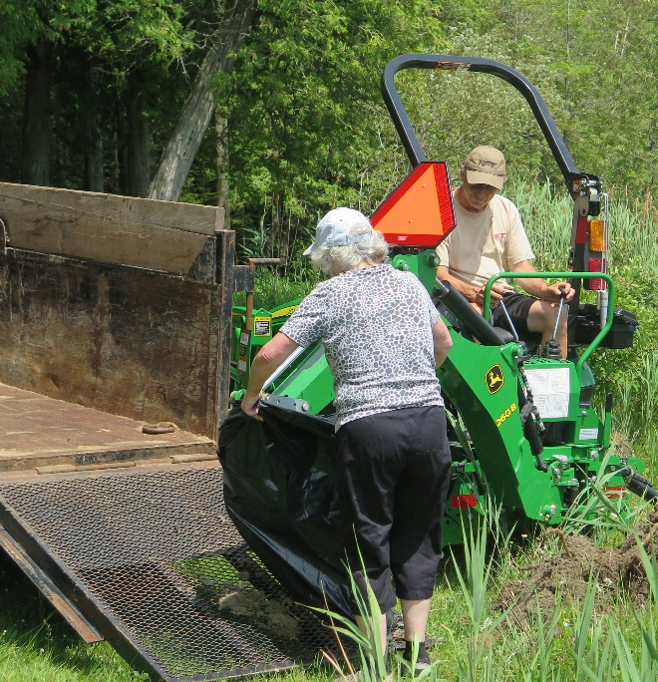

Removal from Water at Shoreline and water’s edge (July 15,2021 Work Session)
Ten volunteers worked at this site for 2 hours using raspberry cane cutters to remove the phragmites in the water. Plants were placed in large industrial garbage bags and taken to the waste site. Special permission was granted by the Township to place these black bags at the waste site where they would be covered with soil later.

Photo of worksite 1 (B) BEFORE
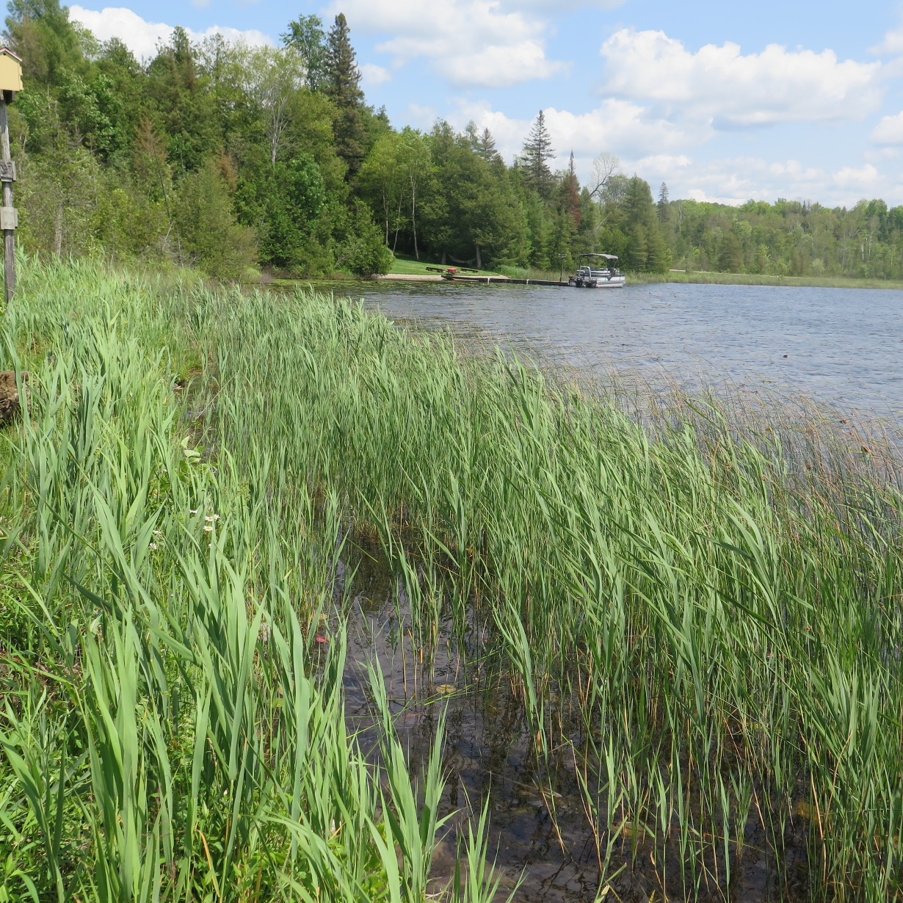

DURING THE WORK SESSION

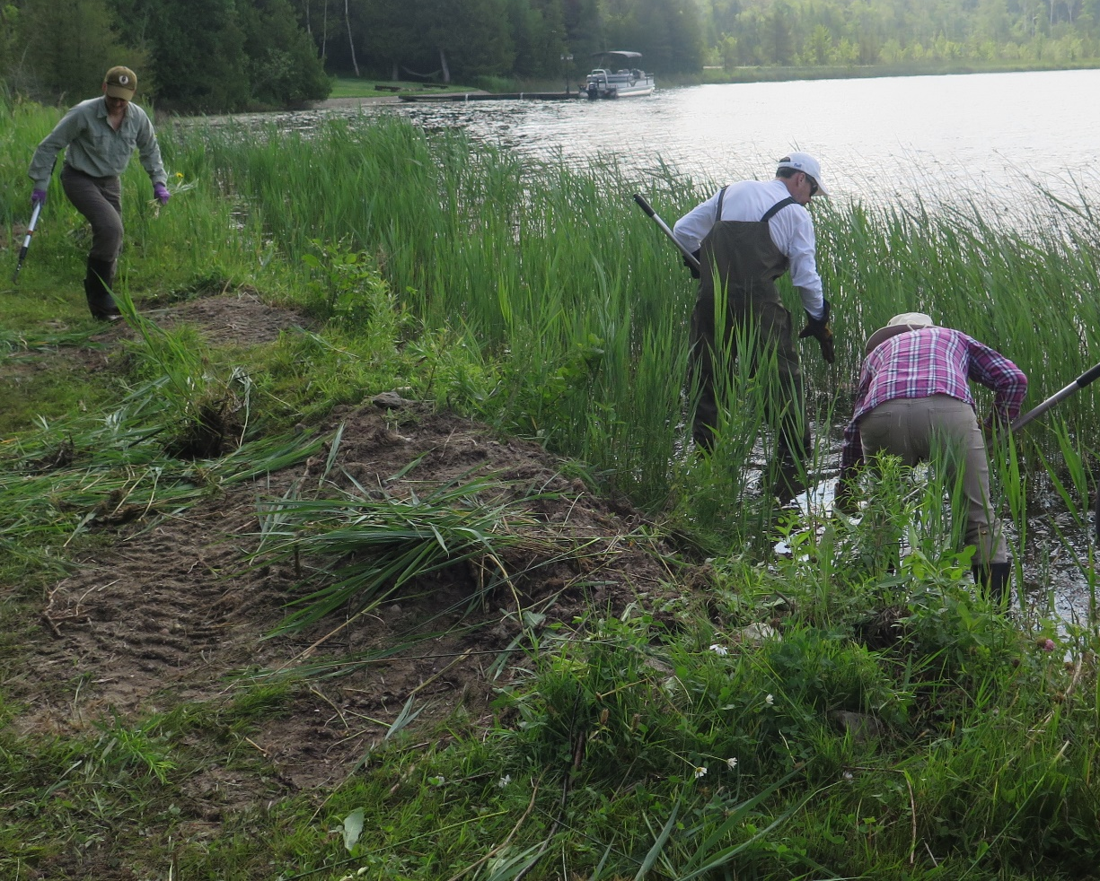
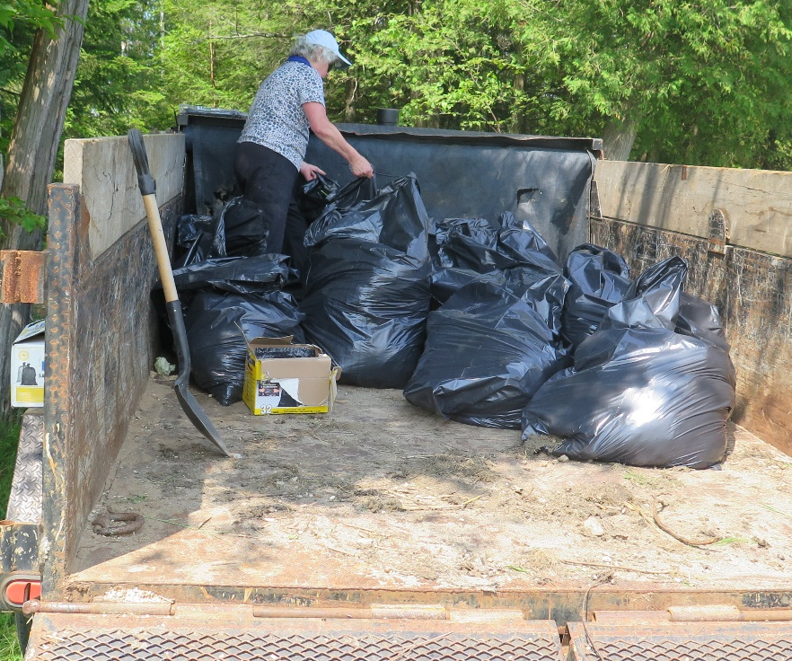
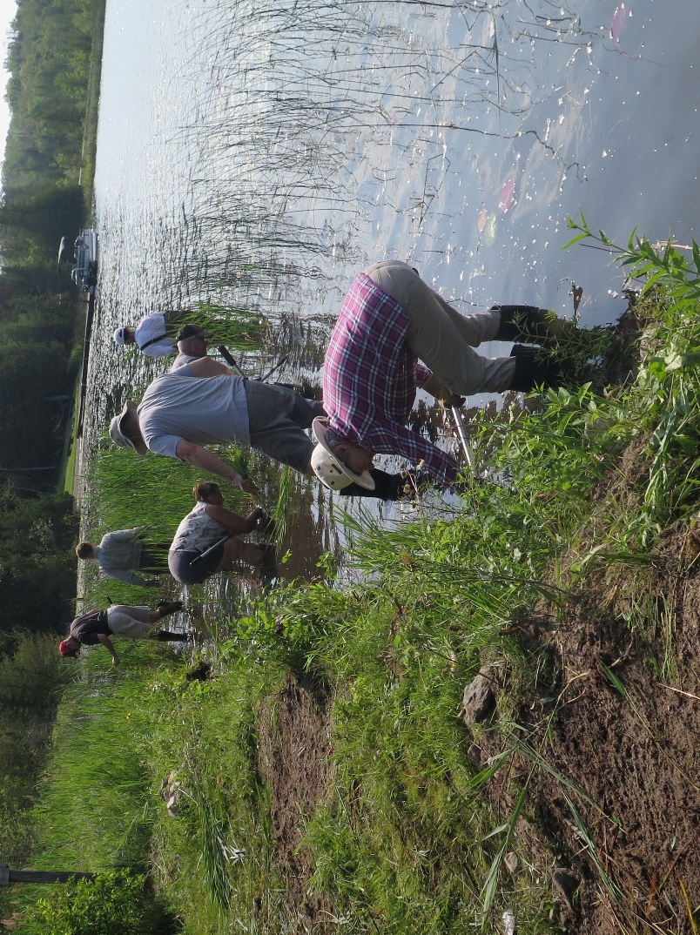
PHOTO OF WORKSITE 1 (B) AFTER REMOVAL
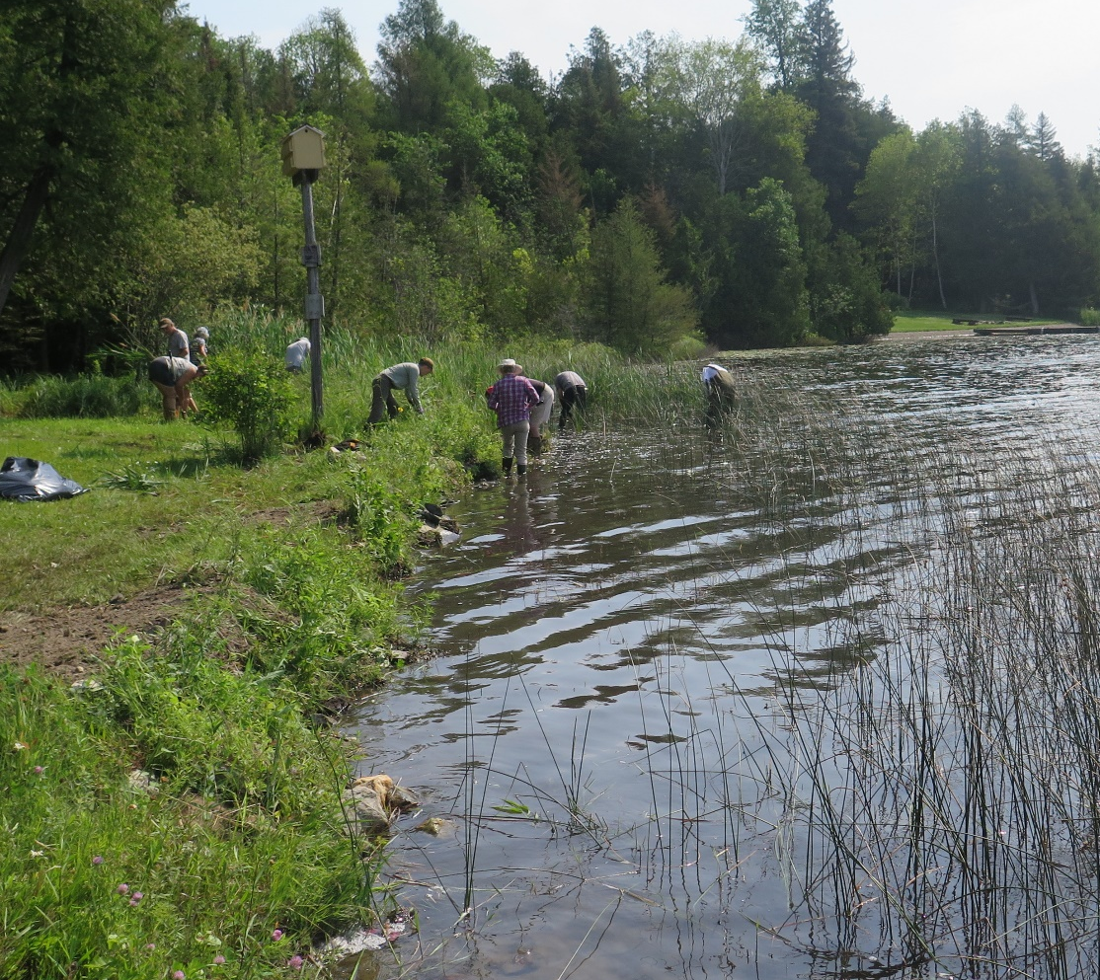
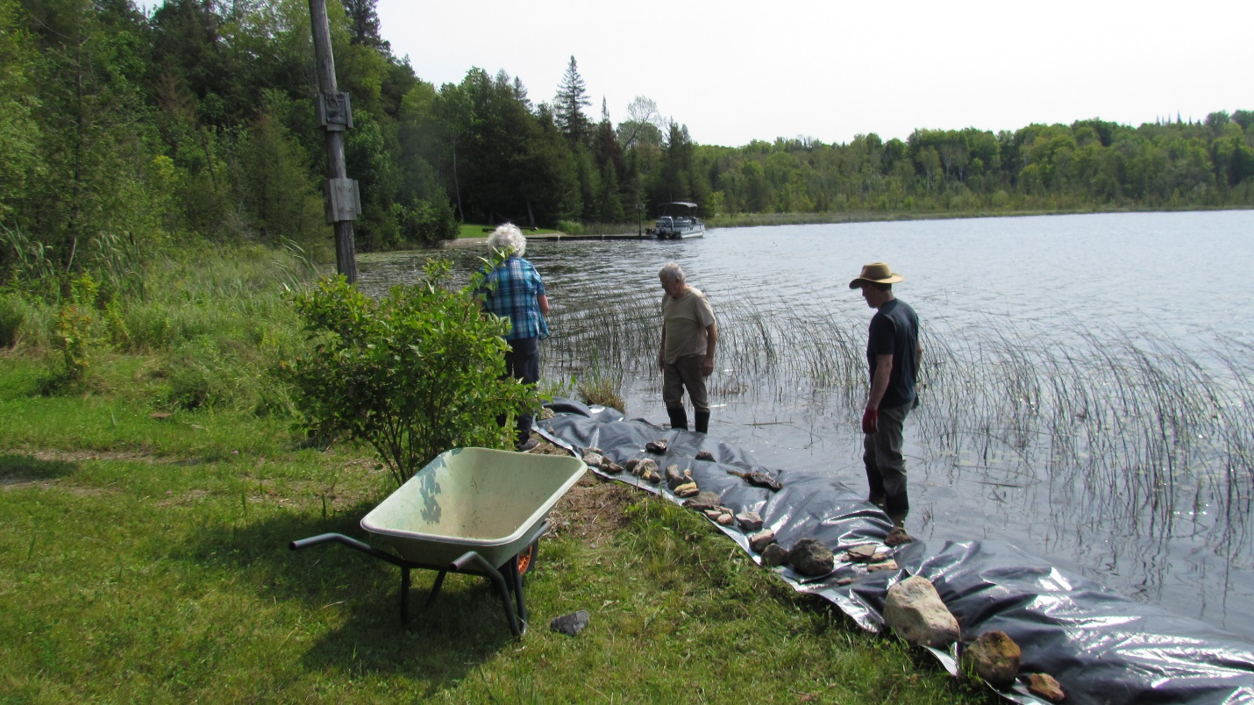
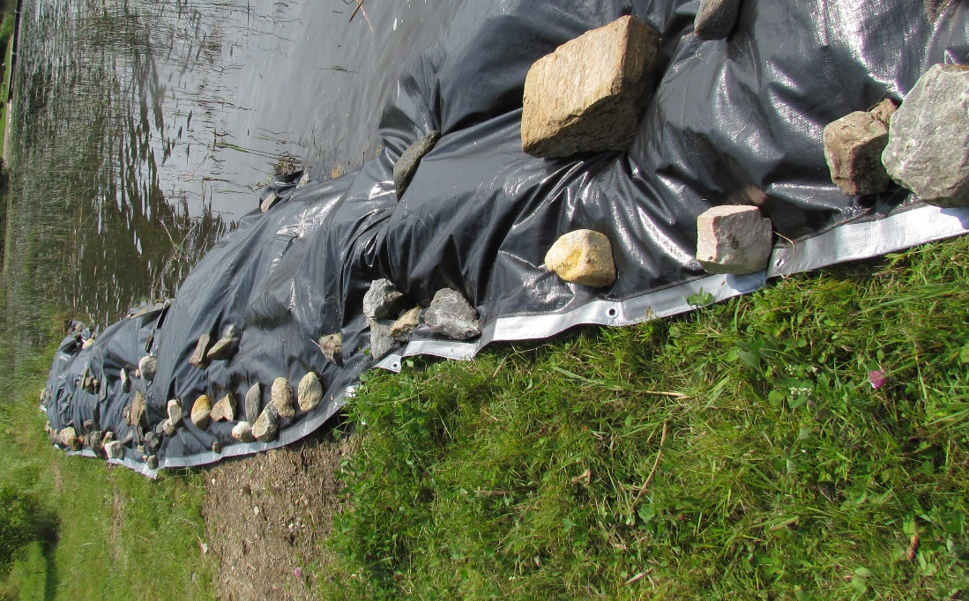
For the next step, the area along the shore was tarped. With the raspberry cane cutters, owners felt that they could continue to remove any plants that appeared in the water area along this shoreline without tarping in the water.
Tarps (12 ml industrial) were purchased from U-line and secured with rocks on top and tent pegs in the grommets.

Once Site 1(A) below was cleared owners will keep the area cut with a mower. Therefore, a tarp was not applied until we see if there will be success with the mower.

WORKSITE 1(A): Removal of Phragmites from Land
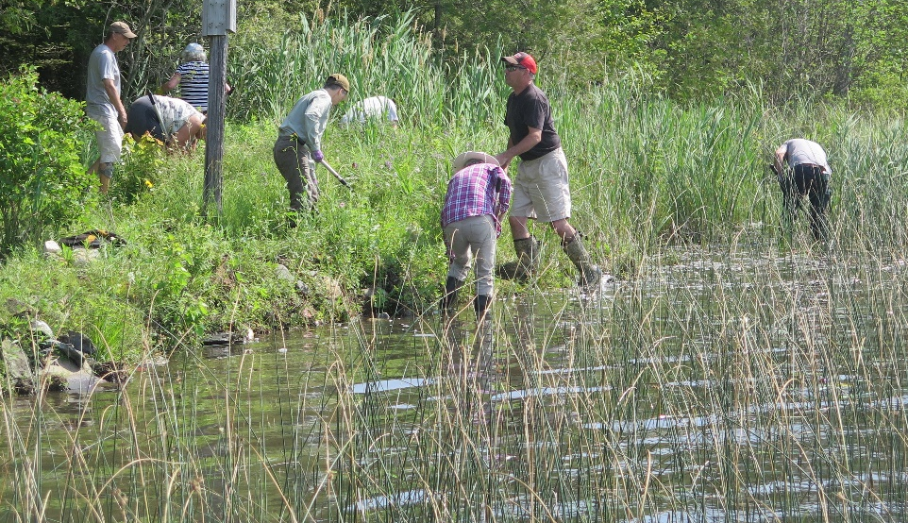
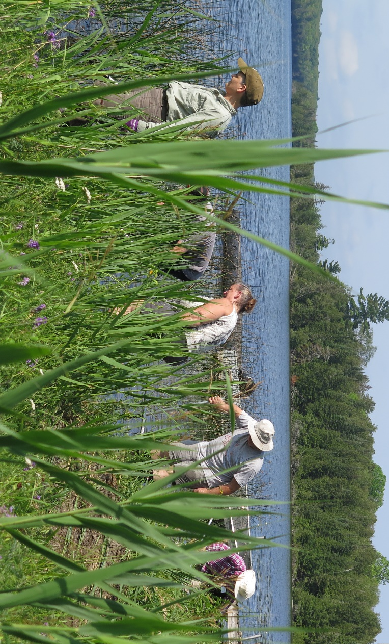
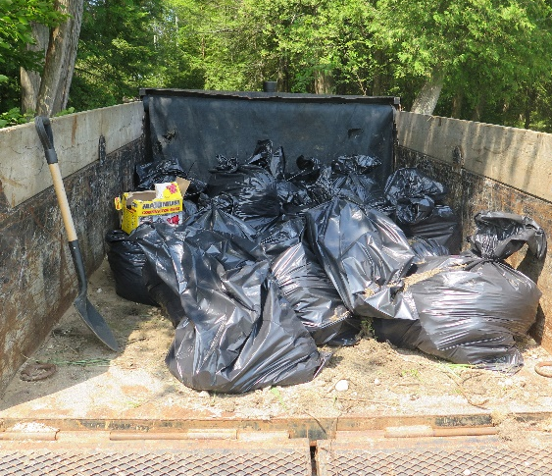
WORKSITE 2: REMOVAL FROM LAND
The site was located along Ardoch Road near the dry hydrant on the shoreline of Malcolm Lake across from the boat launch. The trailer stayed in the previous location and the garbage bags were loaded directly into a truck, then transported back to the trailer. From this site there were phragmites’ roots that measured 18 feet long. Unfortunately, most of the photos did not save on the phone.
BEFORE
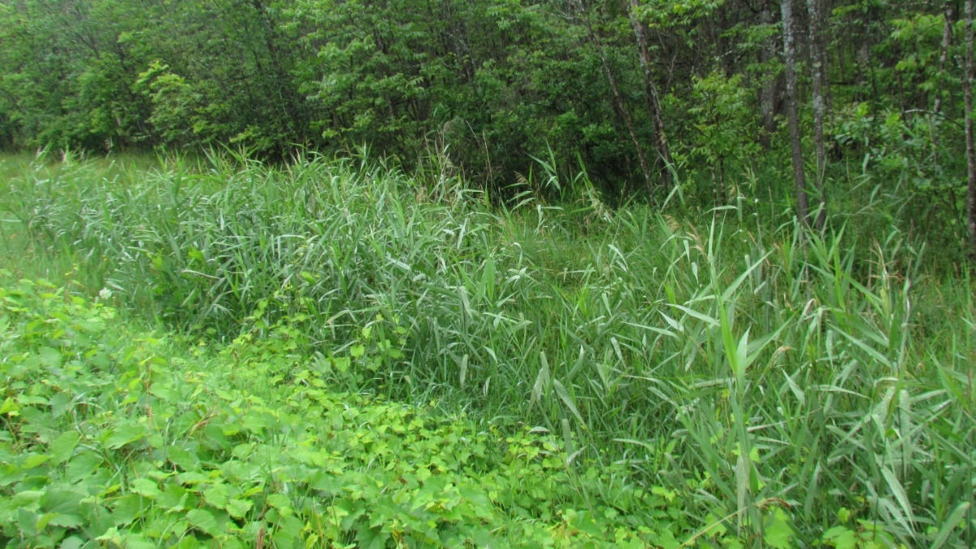

DURING
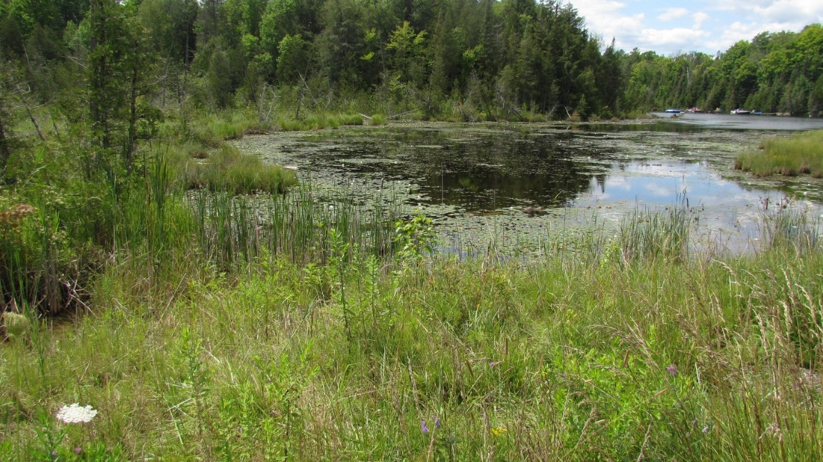
AFTER -ALONG THE ROAD
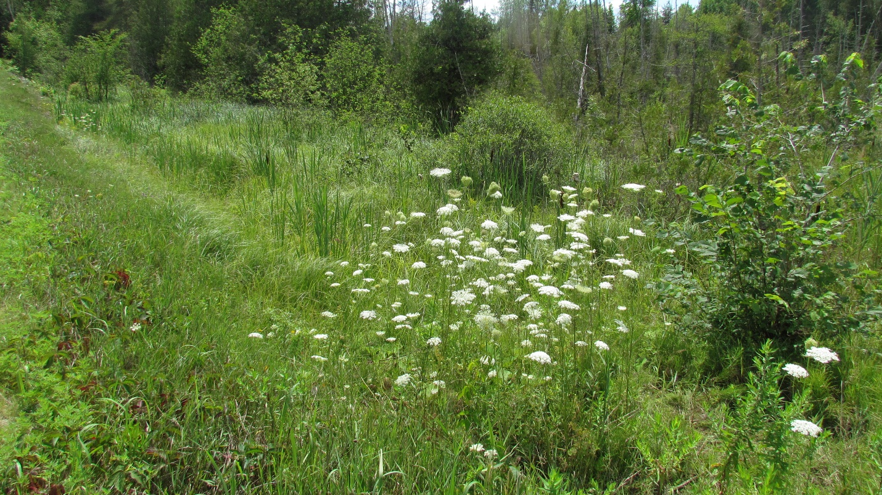

AFTER -AT THE SHORELINE
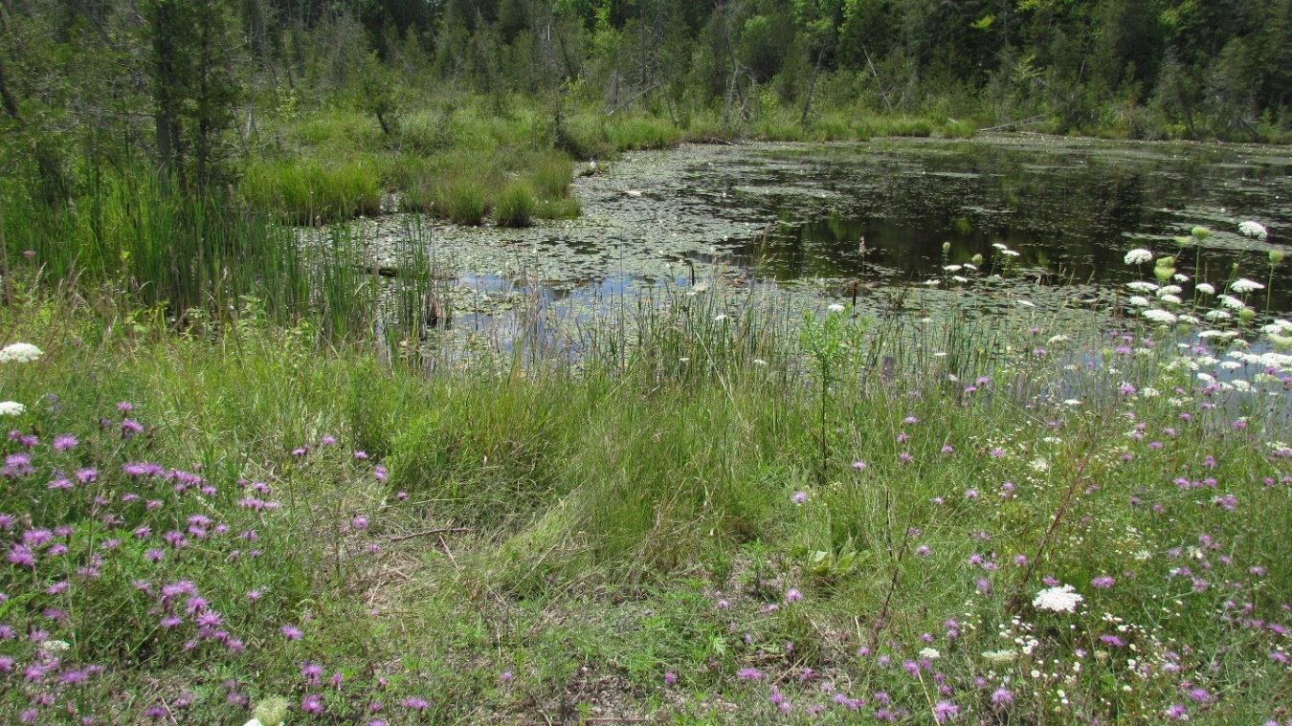

WORKSITE 3: REMOVAL FROM LAND USING A TRACTOR
BEFORE AND DURING
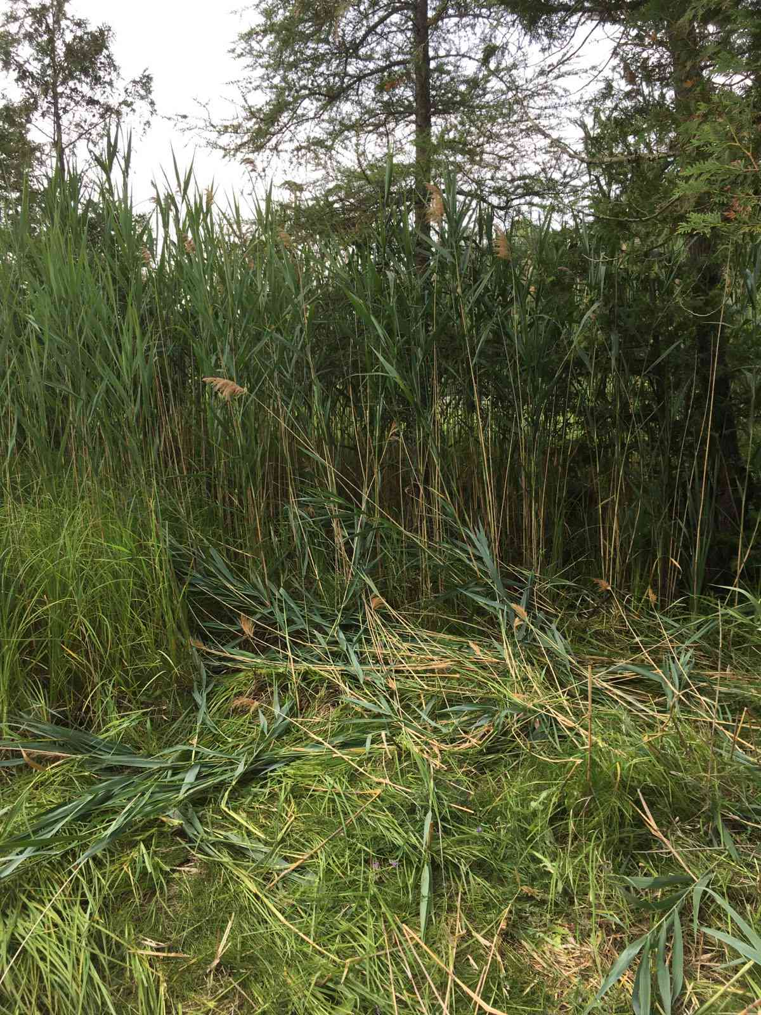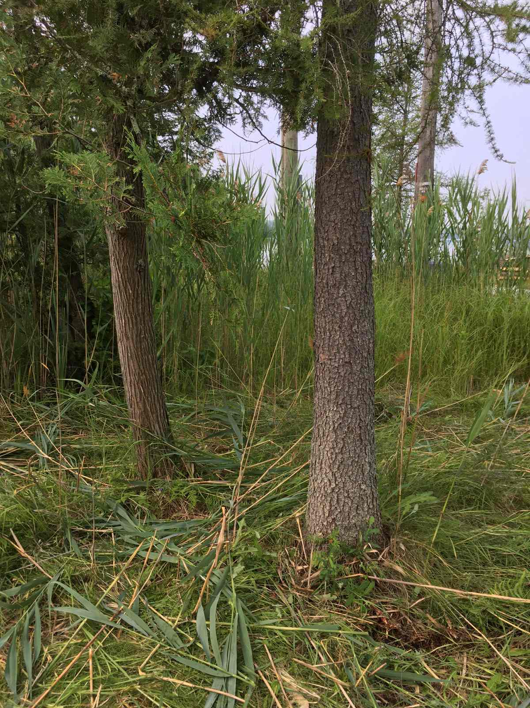

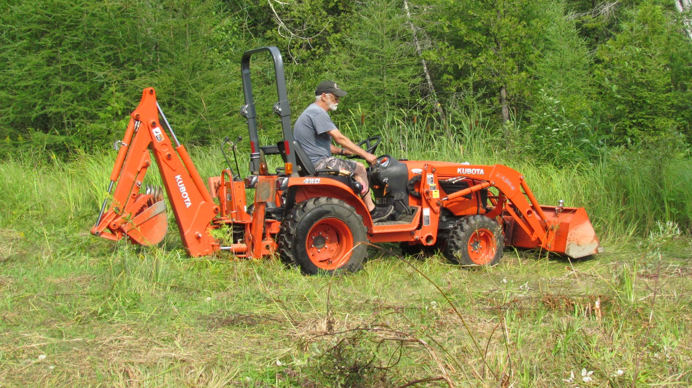
AFTER
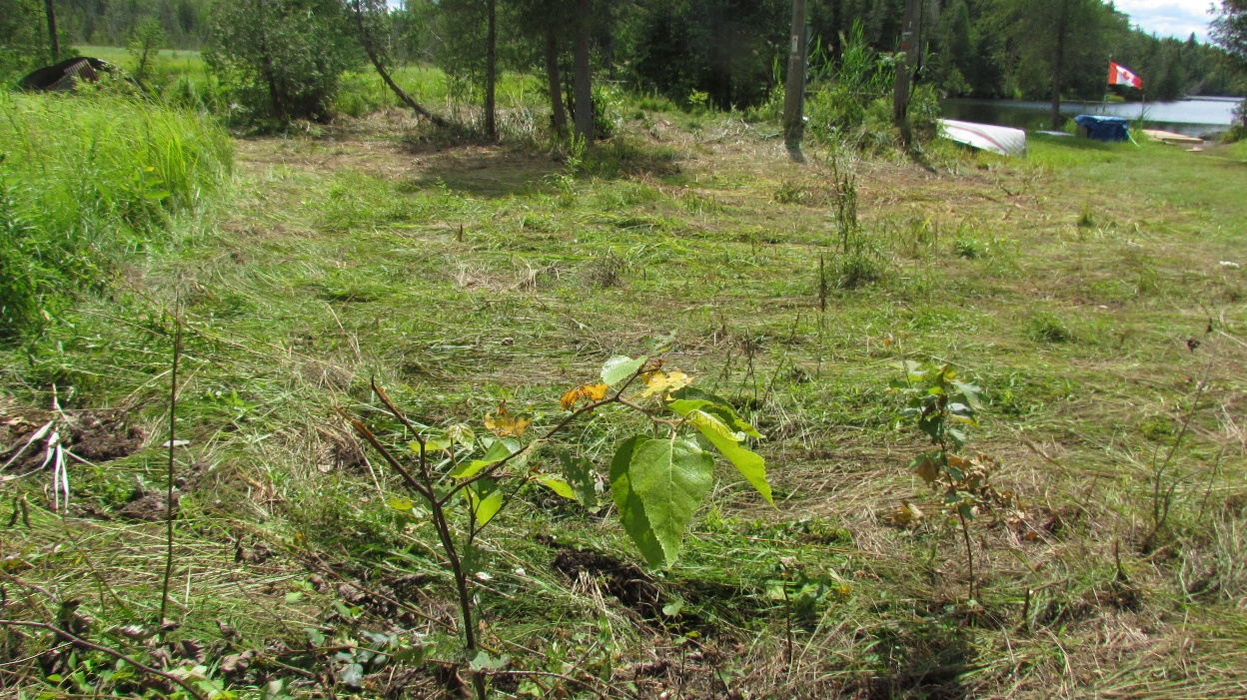

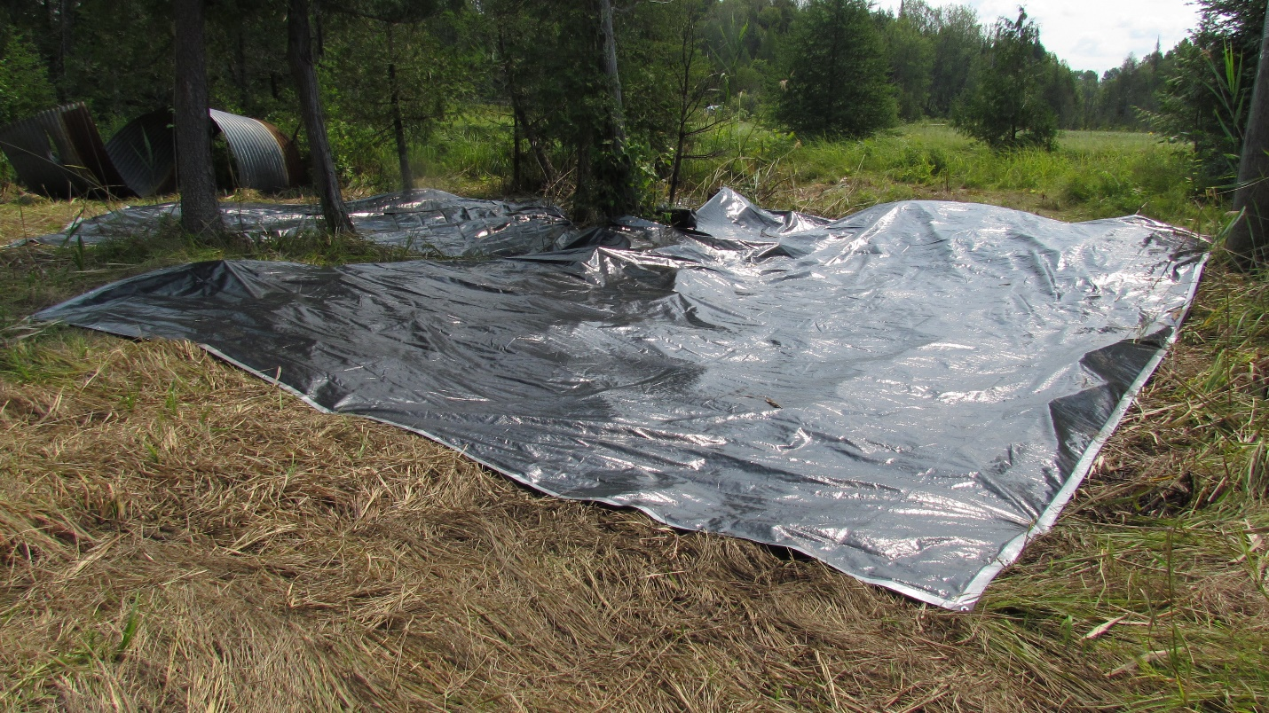

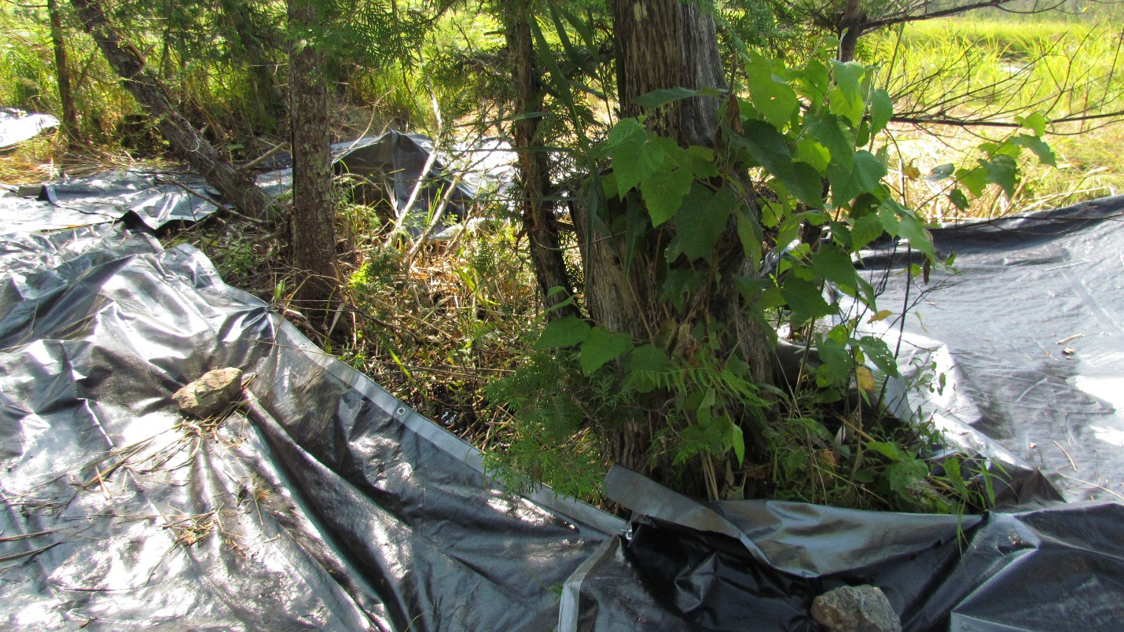
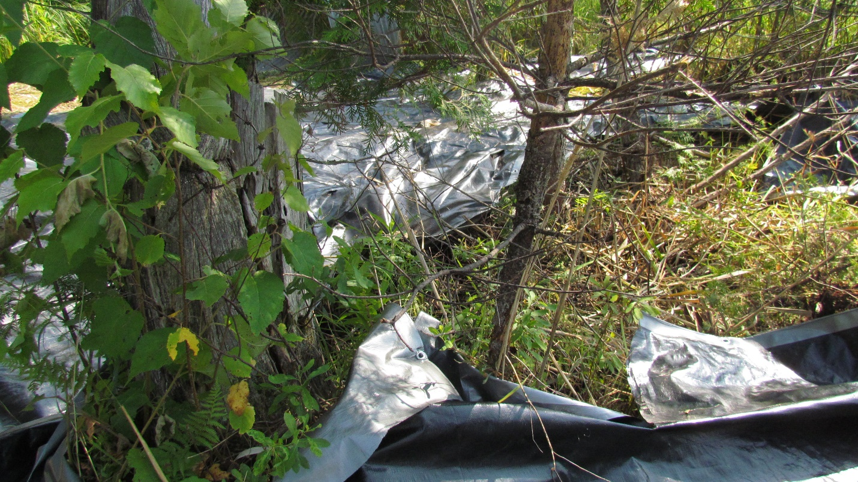

VOLUNTEERS FOR PHRAGMITES PROJECT (July 15,2021)
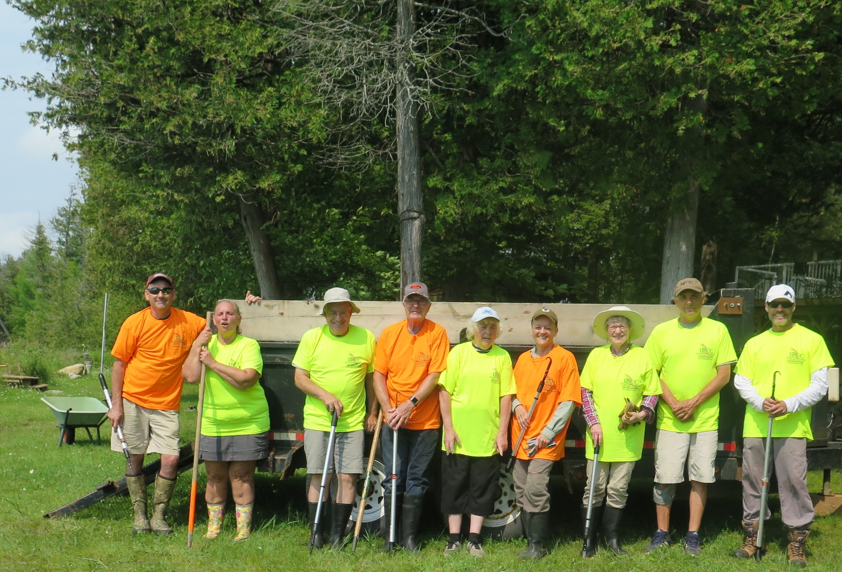
Bob Beauchamp, Kathy Smith, Allan Jamieson, Glen Fowler, Brenda Martin, Brenda Hay, Ruth Cooper, Dave Smith, Geof Green, Photo taker- Pat Jamieson

SITE#4 ARDOCH LAKE
This was the most challenging of all sites! The site could not be reached by boat. The one-lane into the location was a restriction for a truck with a dump trailer. The original plan included tarping but it was obvious that there would be no flat surface to tarp. We recruited two half ton trucks and thirteen enthusiastic volunteers for Sunday August 8th starting at 9 a.m..
The invasive phragmites had greatly spread from the original report. It was deep in a dense wooded area within a swamp. Although everyone had rubbers, only those with hip waders could address the phragmites that headed to the shoreline. One team removed patches along the road that spanned about 80’ long and 15’ into the woods. Another team working in the dense woods covered an area 80’ long and 20’ further into the woods; these two teams met to ensure that the entire area had been cut/pulled. A third team working in the swamp area, far from the main road could only be seen by their colourful shirts. A relay system was used to get the cut stalks out to the roadside. The industrial contractor size bags were heavy coming from the deep woods as the stalks were much larger and often live. There was a heavy rainstorm about 11:30 a.m. and a message was sent to those in the deep section to start back to the road. On two previous days we had heavy thunderstorms and the co-ordinator did not want people stranded. By the time all gathered at the road, the rain had stopped. The group bagged the rest of the stalks.
There was a patch estimated to be 10’X10” left to address. Four MALLA members from the immediate area volunteered to finish the last section over the next two weekends. They were equipped with raspberry cane cutters and industrial bags. The two trucks were loaded to the limit with bagged invasive phragmites, and a trip was made to the waste site. It was an exhausting three hours for the volunteers who worked so hard.
BEFORE- IN THE SWAMP AREA
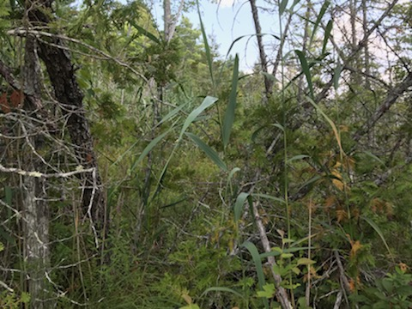
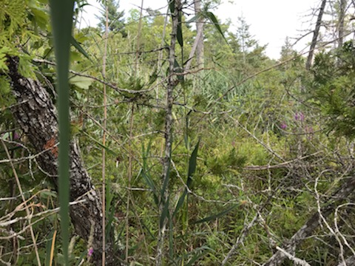
BEFORE- AT THE ROAD
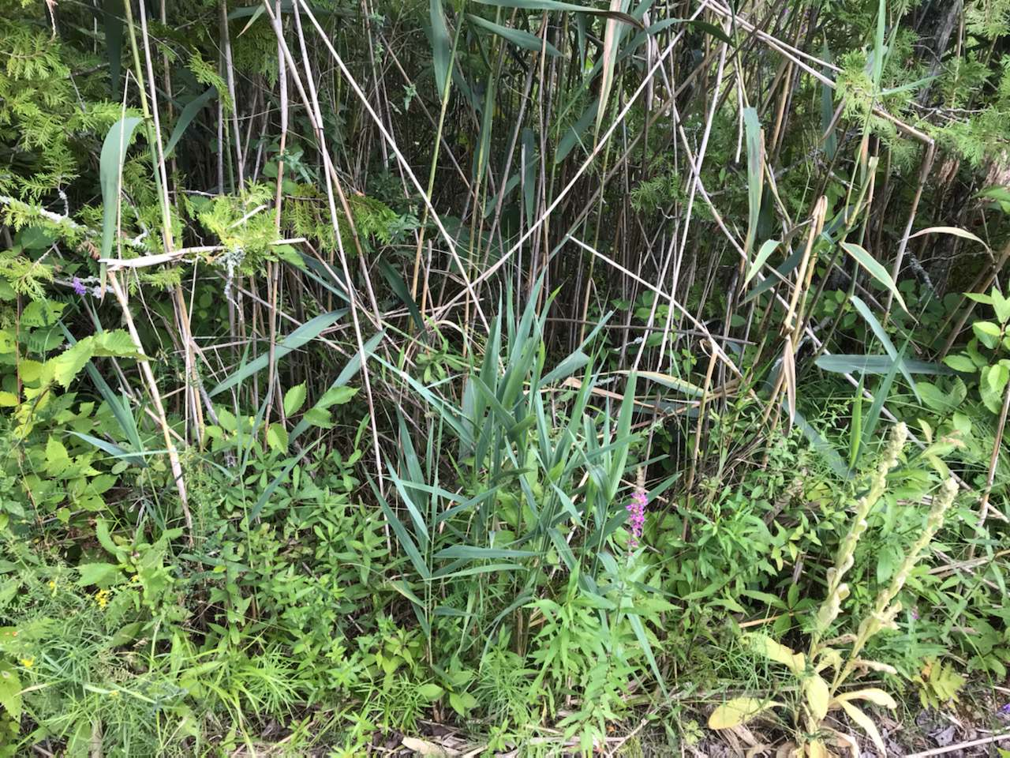
DURING WORK SESSION

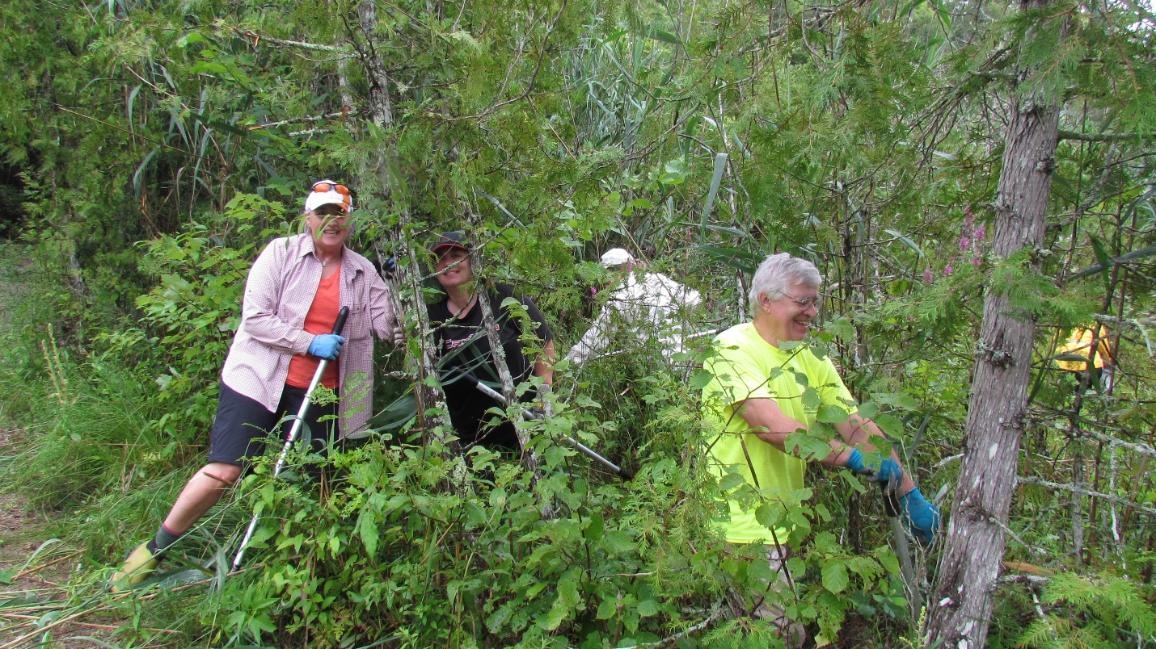
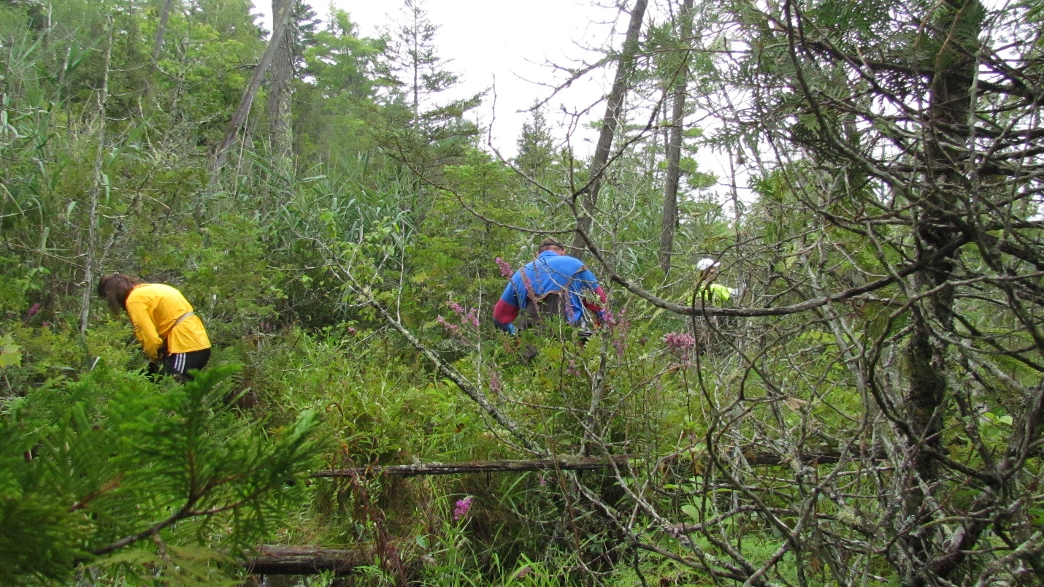

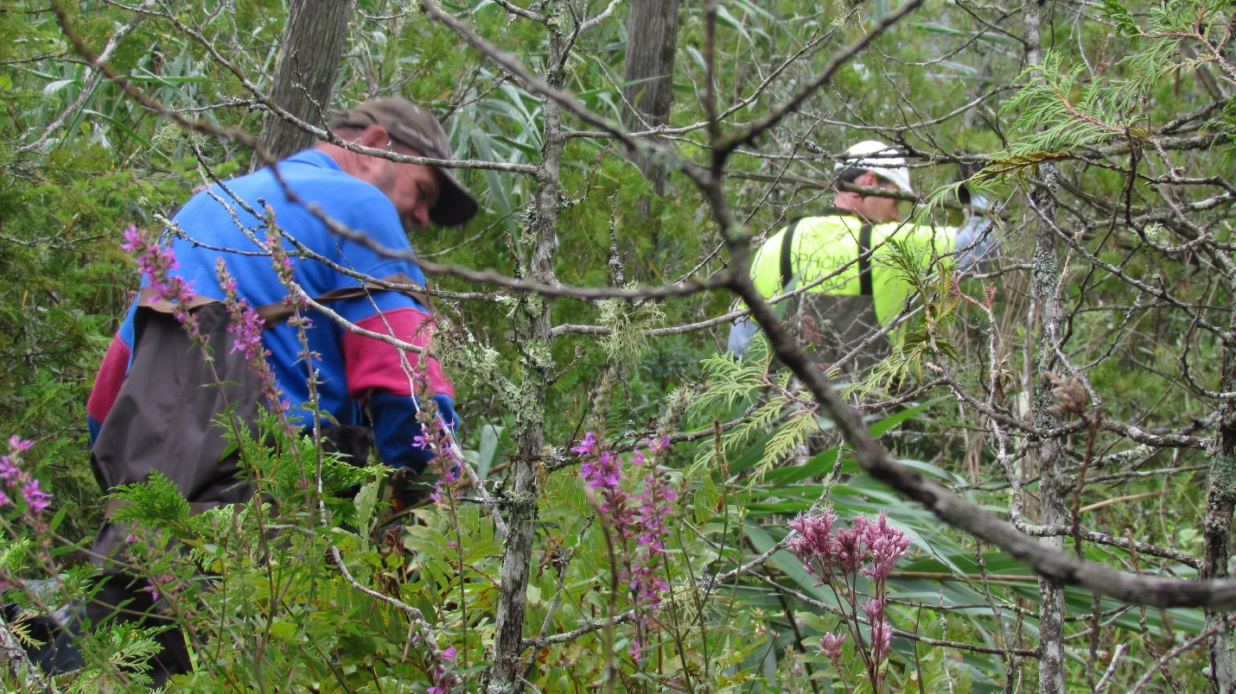
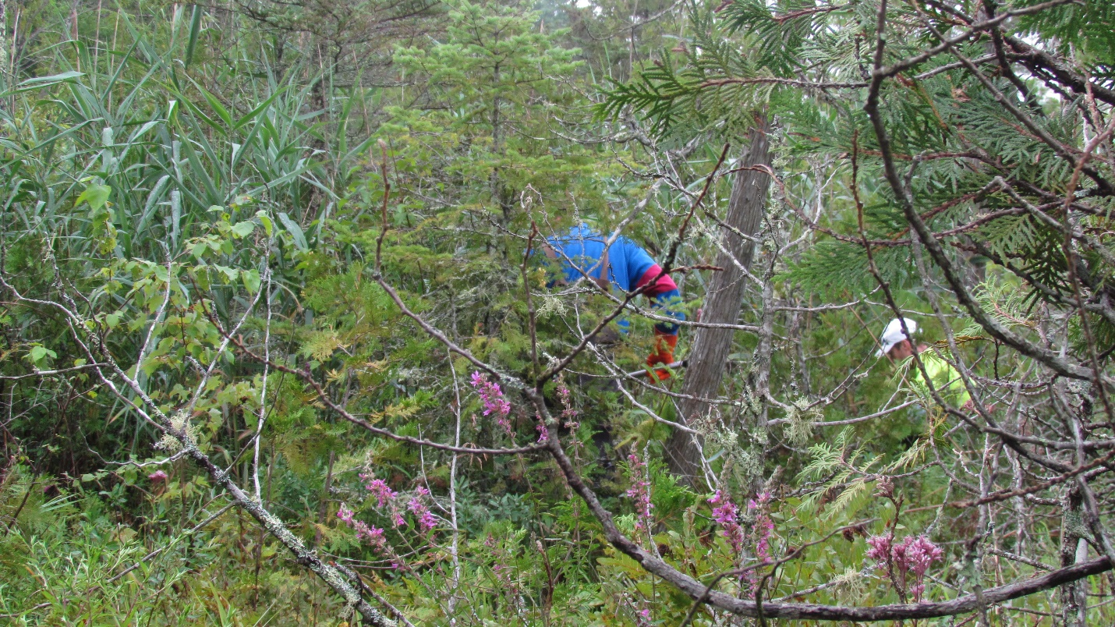
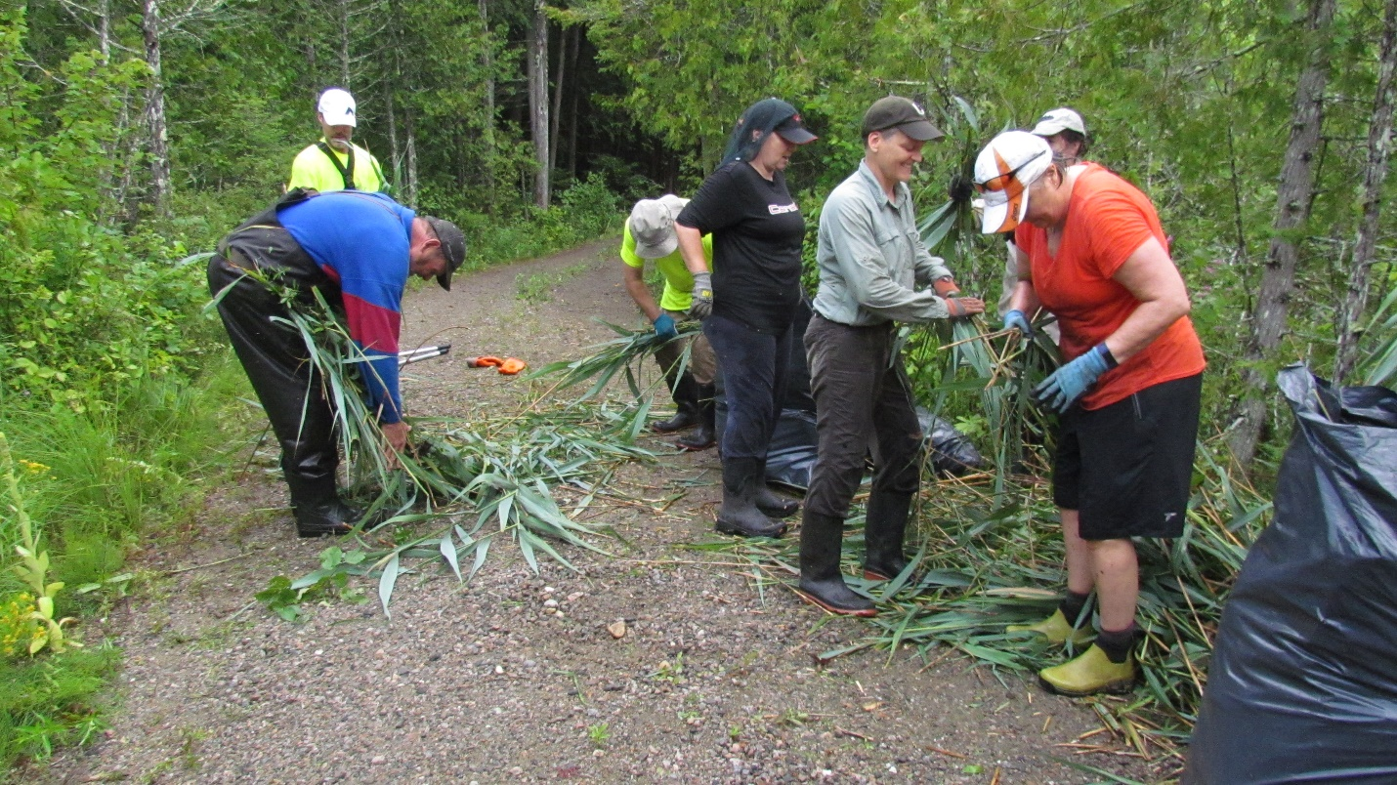
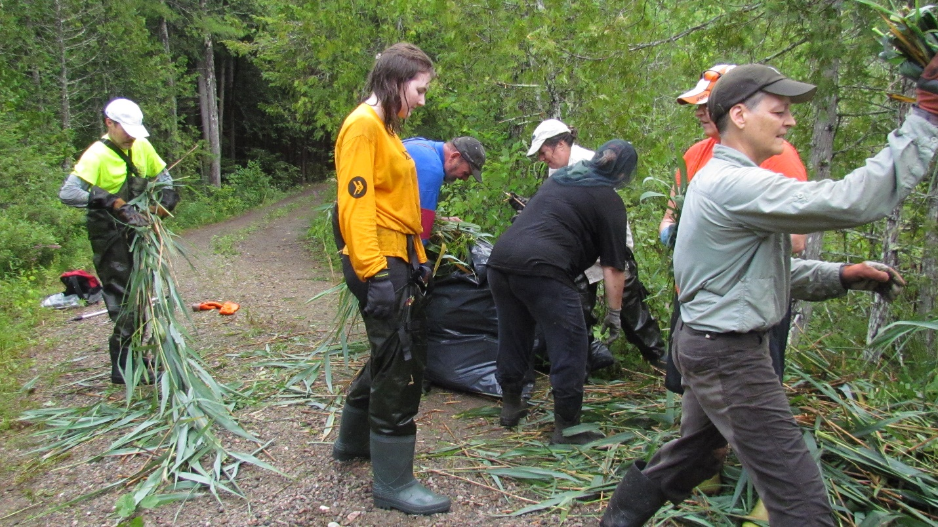

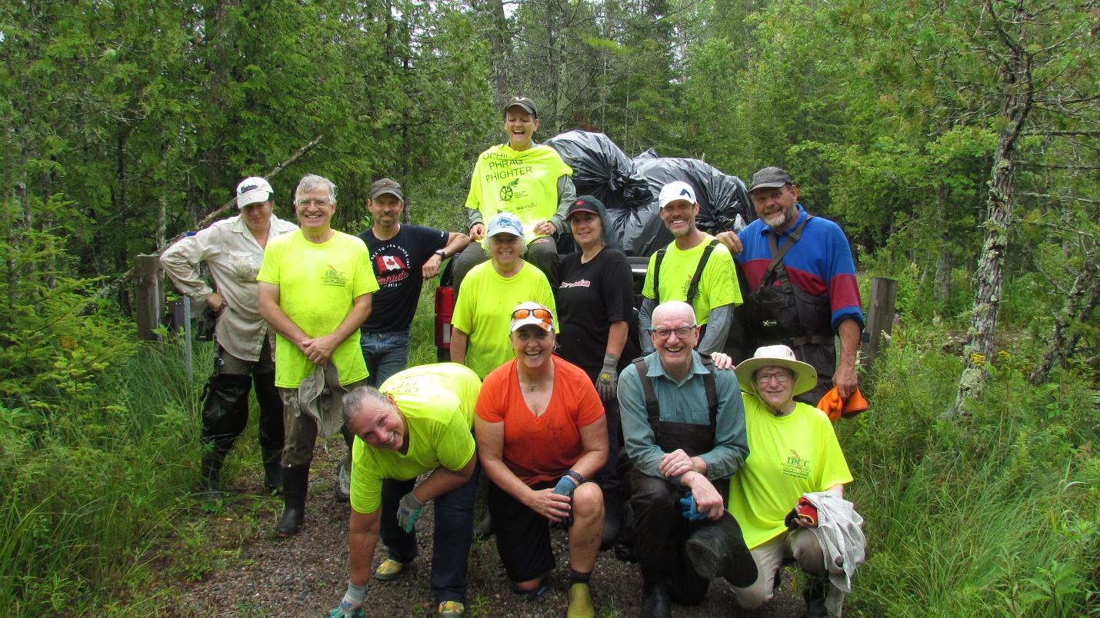
BACK- L to R- Barbara Lindegger, Brian Schonauer, Brenda Hay on the bags in the truck
Middle- Allan Jamieson, Brenda Martin, Lisa Yates-Beauchamp, Geof Green, Rick Duford
Front- Kathy Smith, Cathy Potts, John Cooper, Ruth Cooper Photo taker- Danielle Lindegger
BUDGET BREAKDOWN:
FOCA COVERAGE WITH GRANT FUNDING
Raspberry Cane Cutters $150.00
Tractor #1 (4 hours) $300.00
Tarps (Invoice $862.92-MALLA share) $366.13
Garbage bags $33.87
Tractor #2 (2 hours) $150.00
$1000.00
MALLA FUND CONTRIBUTION
MALLA share of tarp costs $496.79
TOTAL MALLA EXPENSES $496.79

IN-KIND MATERIALS
Industrial bags from Dave S. & Coopers $34.00
Dump trailer (9 hrs) $450.00
Tent pegs (120) $112.77
TOTAL IN-KIND MATERIALS $596.77

IN_KIND LABOUR HOURS
Mileage to get supplies & waste site visits $115.00
Co-ordinator hours (22 hrs) @$20 $440.00
Supervision/planning/recruit volunteers & equipment/report writing
Tractor #1 July 7 and 14th /2021) 2 hrs@$75 $150.00
Volunteer labour 3X (3 hrs@$15) June 22/21 $125.00
Volunteer labour 3X (3 hrs@$15) July 14/21 $125.00
Volunteer labour 10 (3 hrsX$15) July 15/21 $450.00
Volunteer labour 3 (1.5 hrs X$15) August 3,2021 $ 67.50
Volunteer labour 1 (2hrsX$15) August 5,2021 $30.00
Volunteer labour 1 (3 hrsX$15) August 6,2021 $45.00
Volunteer labour 13(3 hrsX$15) August 8, 2021 $585.00
Estimated volunteer hours August 14
4 (4hrsX$15) =$240
Estimated Volunteer hours August 21, 2021
4 (4X$15)= $240.00

As a result of the volunteers working on this project, they identified another patch on Green Forest Way by their property and their neighbours. They will remove the phragmites in this area the week of August 9-14th. They have been given cutters and they have bags.
2(4X$15)=$120.00
TOTAL IN-KIND VOLUNTEER LABOUR HOURS DONATED $2732.50

