Malcolm Ardoch Lakes Landowners’ Association Annual General Meeting – June 13 2026

Clar-Mill Hall 6598 Buckshot Lake Road, Ardoch, ON
Complimentary Breakfast + Membership Table: 8:00 – 9:00 am (optional)
AGM Meeting: 9:00 - 11:15 am

AGENDA

Time | Item | Speaker
09:00 | Call to Order and Welcome Message | Don MacLean  President
09:10 | Land Acknowledgement | Geof Green  VP Ardoch Lake
09:12 | Approval of 2025 minutes | Lisa Beauchamp  A/MALLA Secretary
09:15 | 2025-26 MALLA Expenditure Report, Q&A, Audit and Call for Approval | Allan Jamieson
09:30 | Community Update/Q&A - North Frontenac Ward 2 Counsellor | Roy Huetl
09:45 | Executive Reports Requiring Membership Approval/Q&A  - Proposed 2026-2027 MALLA Budget | Allan Jamieson MALLA Treasurer
10:00 | Stewardship, Fishing and Social Committee Chair Reports | Committee Chairs
10:15 | Review and Approval Update By-Laws | Don MacLean
10:25 | Call for Nominations & Executive Elections 2026  - VP Malcolm, Secretary | Don MacLean
10:45 | MALLA Membership | Steve Keenan & Geof Green
10:55 | New Business, Q&A, Open Discussion | All
11:10 | 50-50 Draw | Allan Jamieson
11:15 | Motion to Adjourn & Provide Next AGM Date (June 5 or 12, 2027) | Don MacLean

Lake Stewardship Report
for MALLA AGM
on June 13, 2026

At a glance:
- Reminder of Goals and Aims
- Actions undertaken in 2025-26
- Plans for 2026-27

Lake Stewardship Goal:
“To protect and improve our lakes for future generations.”
Lake Stewards aim to promote:
- Healthy water quality;
- Biological health and diversity;
- Responsible recreational activity;
- Environmentally sustainable development;
- A friendly approachable attitude towards neighbours and community;
- A healthy fishery; and a peaceful, respectful enjoyment of the lakes.
Source: Lake Stewardship Plan, Executive Summary, 2016
Stewardship Actions Undertaken in 2025-26: (selected only)
Invasive Phragmites:
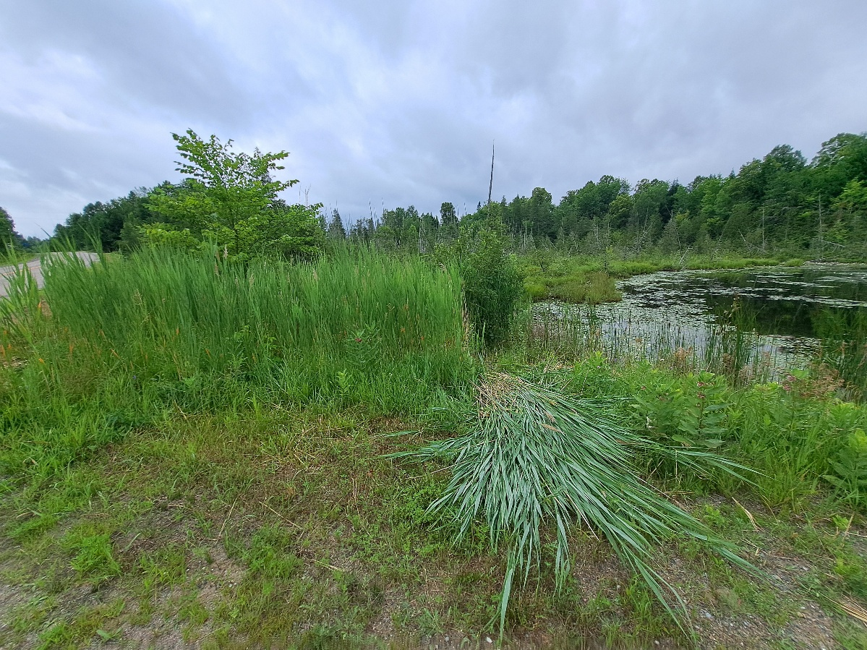
- The four known shoreline and/or wetland patches of phragmites were cut, either directly by the landowners, or with assistance of volunteers. This work resulted in over 30 construction bags filled with cut reeds.
Many thanks to the volunteers, the MALLA landowners, and their friends and family members, for their hard work over the summer of 2025. Together, we are containing Ontario’s current “most dangerous” invasive plant, which severely disrupts wetlands and biodiversity.
- Attended two, half-day workshops as a member of the Mississippi Valley Phragmites Management Area (MVPMA) Working Group:
  - Nov 14, 2025: main focus was on developing a plan to map the patches of Invasive Phragmites across the watershed. MCVA Stewardship Prime was tasked with determining best online mapping tool and an overall plan, including communications. Other topics included: identification and differentiation of types of phragmites; best practices for control and containment in differing environments; new environmental studies; and others.
  - March 17, 2026: main focus was an overview on the chosen mapping app: ArcGIS Survey123. Anyone can download and install the app on their tablets, phones, or PCs. There is a customized version for purposes of mapping the phragmites, link and UPC is being made available to our members. Other topics included mitigation efforts being used by Nature Conservancy of Canada; biological controls starting to be implemented, as explained by Ducks Unlimited Canada; and a deeper dive into newer best practices, such as mechanical cutting and tarping in place.
Some good news from these workshops included new practices for cutting the reeds (mechanical on land); safe disposal of the cut reeds (black tarps and sun ‘baking’, instead of bagging, where practical); and within the next few years, release of biological controls (type of moth) which should weaken the robustness of the reeds, similar to what was done with purple loosestrife. Mapping the colonies, and containment, remain the priorities.

Eurasion Water Milfoil:
- Visual analysis at the locations of former and current EWM colonies, to determine the extent of growth or decline.
- Identification, with assistance of MVCA Biologist Kelly Stiles, of aquatic plant that is replacing EWM in many locations: macro algae Chara. Reasons for this remain unclear; however, various research papers have studied the phenomenon in other (non-local) lakes. Updated drone studies will provide more empirical evidence for presentation to experts.
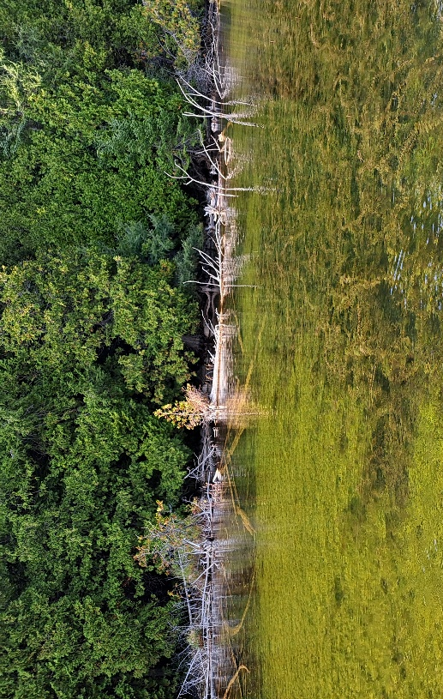
Note the EWM (left) being replaced by Chara (right)
- Review of EWM mitigation using herbicides, including florpyrauxifen-benzyl (ProcellaCOR FX), recently approved for use in Canada (2023) and used by Fairlain Lake at that time. Other lakes/river systems are considering or implementing its use.
- Responded to NFLAA survey regarding status of our lakes’ EWM patches, work done in the past, and other questions. Agreed with NFLAA support of study by Mazinaw Lake into effects of aquatic herbicide use.
- Discussion with Wade Leonard, Granite Ridge Education Centre’s Above and Beyond teacher (GIS program), to confirm interest in and availability to map MALLA lakes in 2026. Recall that Mr. Leonard and his students performed the prior drone mapping studies for MALLA.
- Confirmed MVCA as collaborator in our EWM stewardship work in 2026 (important for grant application, per #10).
- Prepared microgrant application to the Invasive Species Centre to fund the updated aquatic mapping of both lakes, for identification of current EWM colonies, in comparison to last mapping studies, circa 2020-2021. The grant application process was rigorous, and included consideration of many factors.
The grant application status should be available by the MALLA AGM. Stay tuned for updates!
Public Sessions of Interest:
- Attending North Frontenac Township and Alliance meetings with potential impacts to planning and development, which may impact our lakes or our community:
  - Communal Water and Wastewater Services;
  - Ompah Palmerston (Granite Point) Cottage Co-operative – Official Plan Amendment and Zoning Bylaw Amendment;
  - Community Planning Permit System (CPSS) for waterfront building permit applications;
  - Battery Energy Storage System (BESS) proposal for North Frontenac;
  - Annual meeting of North Frontenac Lake Associations Alliance (NFLAA).
Zebra Mussels:
- Observation of live Zebra Mussels in Malcolm Lake (west and north shores), and at the beach at Ardoch Lake. Review of documentation concerning past Zebra Mussel investigations showed that lake water chemistry was not conducive to a large-scale invasion. This should be updated in 2026.
New “No Wake Zone” signage at boat launch:
- Determined that we cannot legally erect signs for speed restriction areas on or near our waterways. Transport Canada has a process wherein we would apply to the Township to submit an application to TC. If approved, the Township would then be responsible for the signs, which must follow a prescribed layout/format. In Ontario, there is already a motorboat speed limit of 10km/h (or 6 mph) within 30m (or 100’) of a shoreline. Action pending: Educate members via e-mail and/or Facebook page.

Plans for 2026-27
Eurasion Water Milfoil:
- Attend workshop on drone imaging and GIS, hosted by Granite Ridge Education Centre’s Wade Leonard and his students.
- Establish project plan for drone imaging of lakes: determine date(s), obtain approvals, notify landowners, ensure access, and ultimately undertake the imaging, interpret the files, and compare to prior years’ images (~2021 and earlier). Follow up with biologist contacts and determine next steps for EWM: new research, remediation techniques, and/or other actions.
- Mandatory reporting to funding agency which provided grant for EWM work: Invasive Species Action Fund.
- Share results and observations with stakeholders and other interested parties.
Invasive Phragmites:
- Promote among membership the mapping of invasive phragmites along the roads of North Frontenac. Provide members with instructions for downloading and using the app.
- Undertake annual cutting and bagging of phragmites in 2026: determine date(s), locations, obtain landowner approvals, solicit volunteers, consider new practices for disposal of cut reeds, and host the work parties.
Zebra Mussels:
- Follow up with investigation into lake chemistry and other conditions that may be changing the ability of ZMs to proliferate in our lakes.
Solicit interest in Lake Stewardship Committee:
- Determine interest among MALLA members in establishing a small group to better manage the stewardship portfolio, and to enable smoother succession planning.

