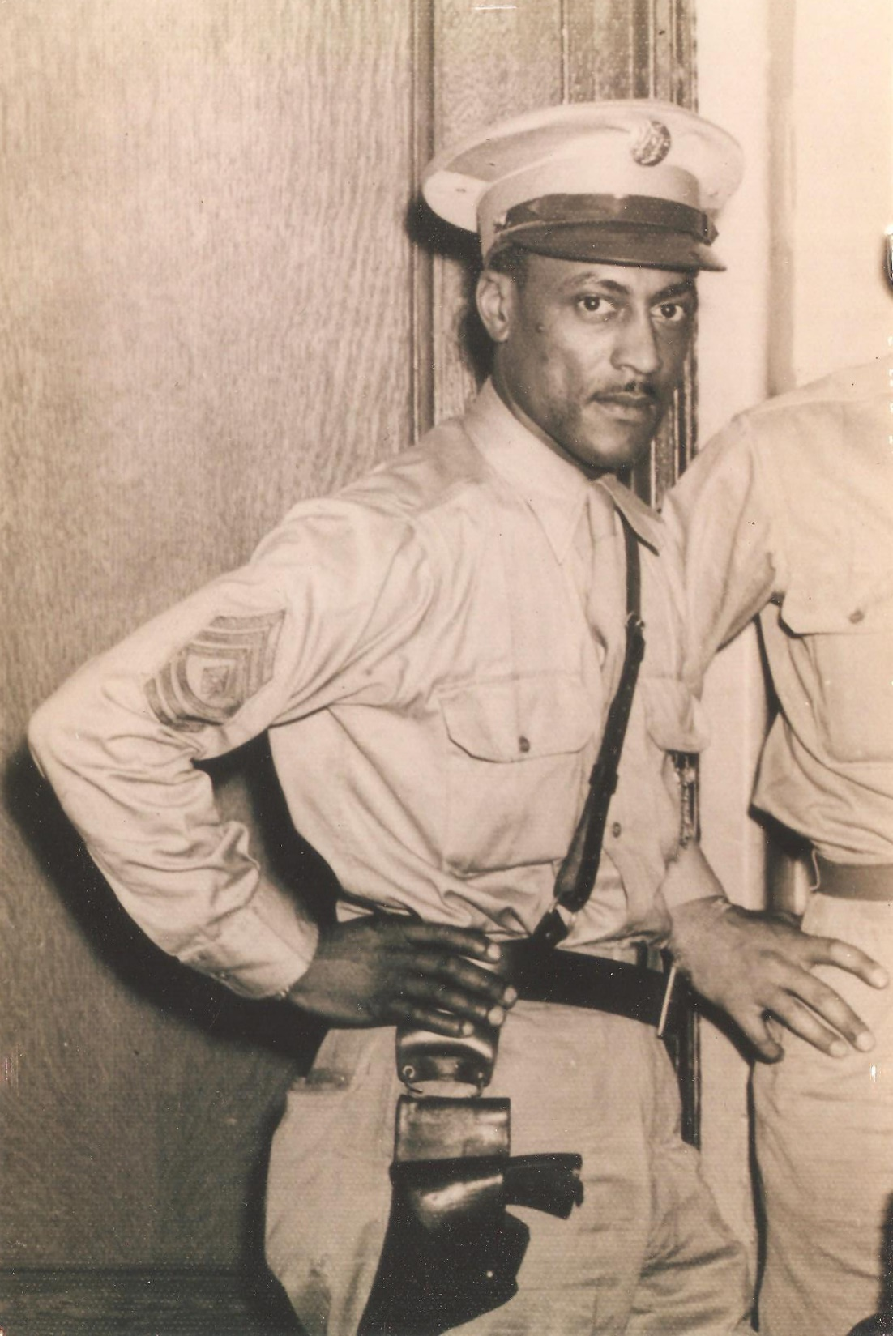

Fernandez “Boots” Jennings Sr.
Fernandez Jennings Sr. or “Boots” as everyone called him was born in 1909 in Corsicana, Texas. He was an athlete in high school participating in both basketball and baseball. In 1929 Boots enlisted in the U.S. Army in the town of Davey Crockett, Texas. His career started in the 25th Infantry division in Fort Huachuca, Arizona. He was in Company “L” Buffalo Soldier. He was a Private 1st Class and then in 1937 he was a Corporal but then went back to a Private according to the 1938 Muster Rolls.
It was around this time that Boots met Bruna Gaillard and courted her for almost 2 years. They got married in 1939 in Lordsburg, New Mexico. The Army would not give Boots permission to marry since it felt that as a Corporal make $42 per month, he could not support a wife. Boots showed the Army a thing or two, not only did he marry Bruna without their permission but stayed married for almost 60 years.
Boots travelled in the military. He went to Maryland, Georgia, Alabama, El Paso, New York, Kansas and Alaska. He was stationed in Alaska during WWII to make sure that the Russians did not cross into U. S. Territory.
Boots and Bruna were blessed with 4 children, Virginia, Fernandez Jr, Ronald and Irving (Chris). All the children attended Grand Ave/Frank Reed School. And all of the boys were in the Military like their father.
In 1951 at Fort Bliss, Texas Boots was discharged as a Master Sargent. He moved the family to Compton, California. He then worked for the U.S. Postal Service and retired in 1971. Boots passed away in October 1997 with his family around. Bruna passed away 2 years later.

