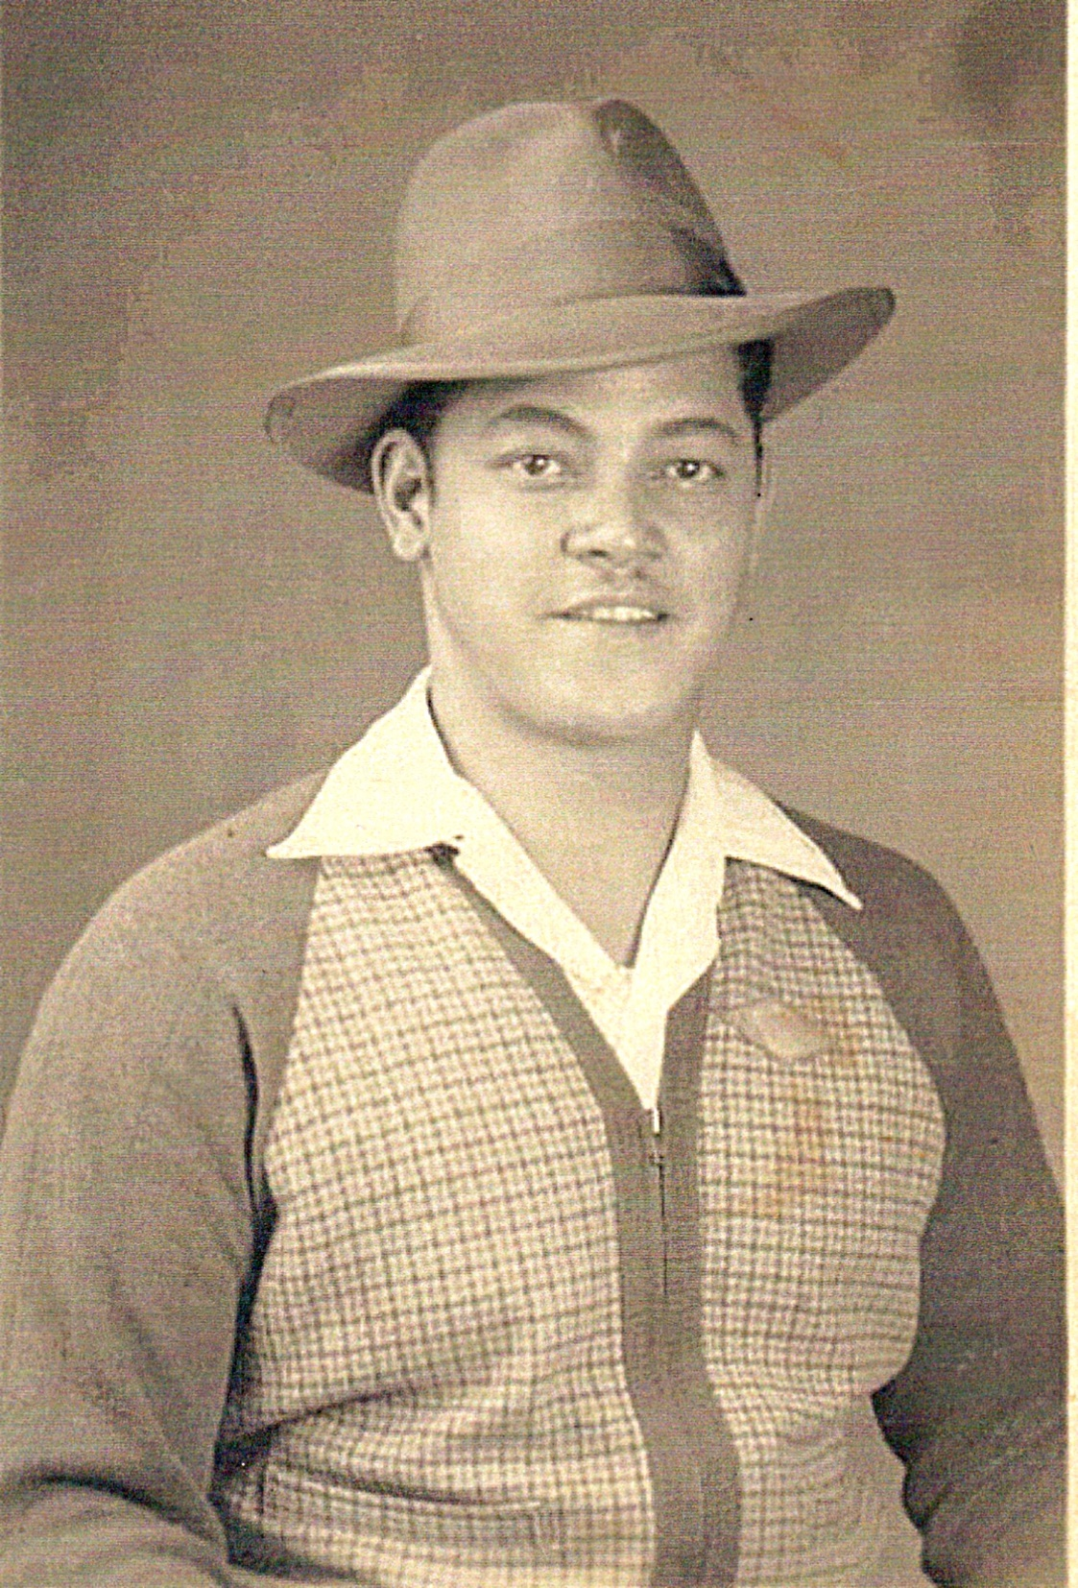

Clifford I. Ray (Roy)

Clifford Ray was born Clifford Irving Roy on Jan. 6, 1910 in Pittsburg, PA. He was probably born in 1914 but his enlistment papers show him born in 1910. Clifford lost his mom when he was either 6 or 10 and lived with his grandmother. He was a spirited young boy and got into trouble a lot. When he was a teenager, he got into some big trouble and his choices were 1) join the Army or 2) go to Jail. He chose the Army. In 1928 he was ordered to the Company E of the 25th Infantry as a Private and was stationed in Nogales Arizona at Fort Huachuca. He thus became a Buffalo Soldier.

Mr. Ray met his wife Connie in Nogales and the two of them had 8 children. Two of their children, two boys died when they were infants. According to the Muster rolls in the 1930’s Clifford remained a Private until about 1935 when he became a Sergeant. In the year 1940 he was discharged from Fort Huachuca and became a civilian. BUT in 1945 after World War II ended Clifford re-enlisted again in Fort McClellan, AL. He was a Master Sargent and he and his family traveled the U.S. and he was stationed in New Jersey. He and the family finally returned to Arizona in the late ‘40’s early 1950’s. But after trying to make the family life in California, Clifford come to the reality that he was not a family man and returned to Arizona.

He lived out his years in Tucson with his common law wife Esther Rivas Jones. He passed away in 1971.

