Daniel Thornton, Jr

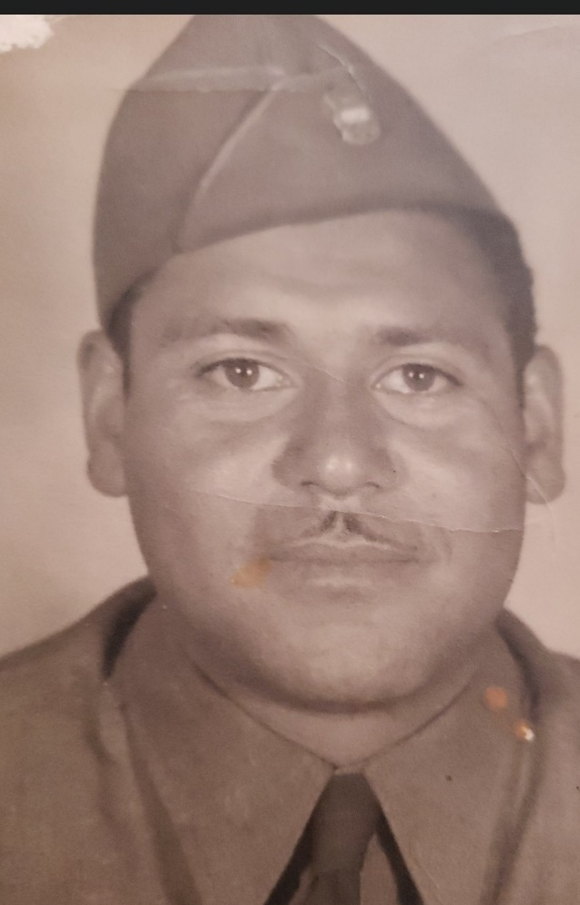

Daniel Thornton, Jr was born February 3, 1920 to Trancito and Daniel Thornton, Sr in Nogales, Arizona.
My Aunt Rosalva Edna Thornton had the following recollections of his early adulthood:
"He [Daniel] loved the cowboy/western life. He was always coming home with a horse. He had a lot of Mexican ranchero friends…he loved Mexico and he just loved that. He helped round the house. He used to rope us [and]…lasso us on the horse.
My brother was everything (Black and Mexican) but he spent most of his time with Mexicans—with poor people.
Mascarena—he was one of his best friends in Mexico.
Pimienta—owned a liquor store and they spent a lot of time together and many others."
He enlisted in the 25th Infantry, Company H. in January, 1940. That unit was stationed at Fort Huachuca. Deployed to the Pacific in WWII, Sergeant Thornton was bayoneted in The Battle of Bougainville. The Bougainville campaign was a series of land and naval battles of the Pacific campaign of World War II between Allied forces and the Empire of Japan, named after the island and was part of Operation Cartwheel, the Allied grand strategy in the South Pacific.
Sergeant Thornton was honorably discharged on January 11, 1945. Daniel married Lucy Arias on January 17, 1945. To this union was born Daniel Thornton, III. He succumbed to his wounds at the Veteran's Administration Hospital in Tucson on September 18. 1945.

Information provided by Alva Stevenson

