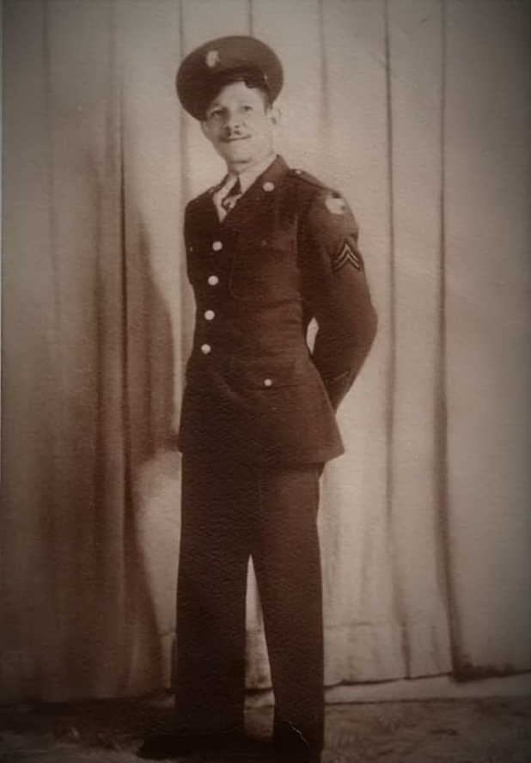

Emerson Smith Mays

Emerson Smith Mays was born in Houston, Harris, Texas in February of 1905.
He was inducted into military service on the 29th of April, 1918 in Petersburg, VA.
His discharge certificate lists him being discharged from the 25th Infantry in 1928.

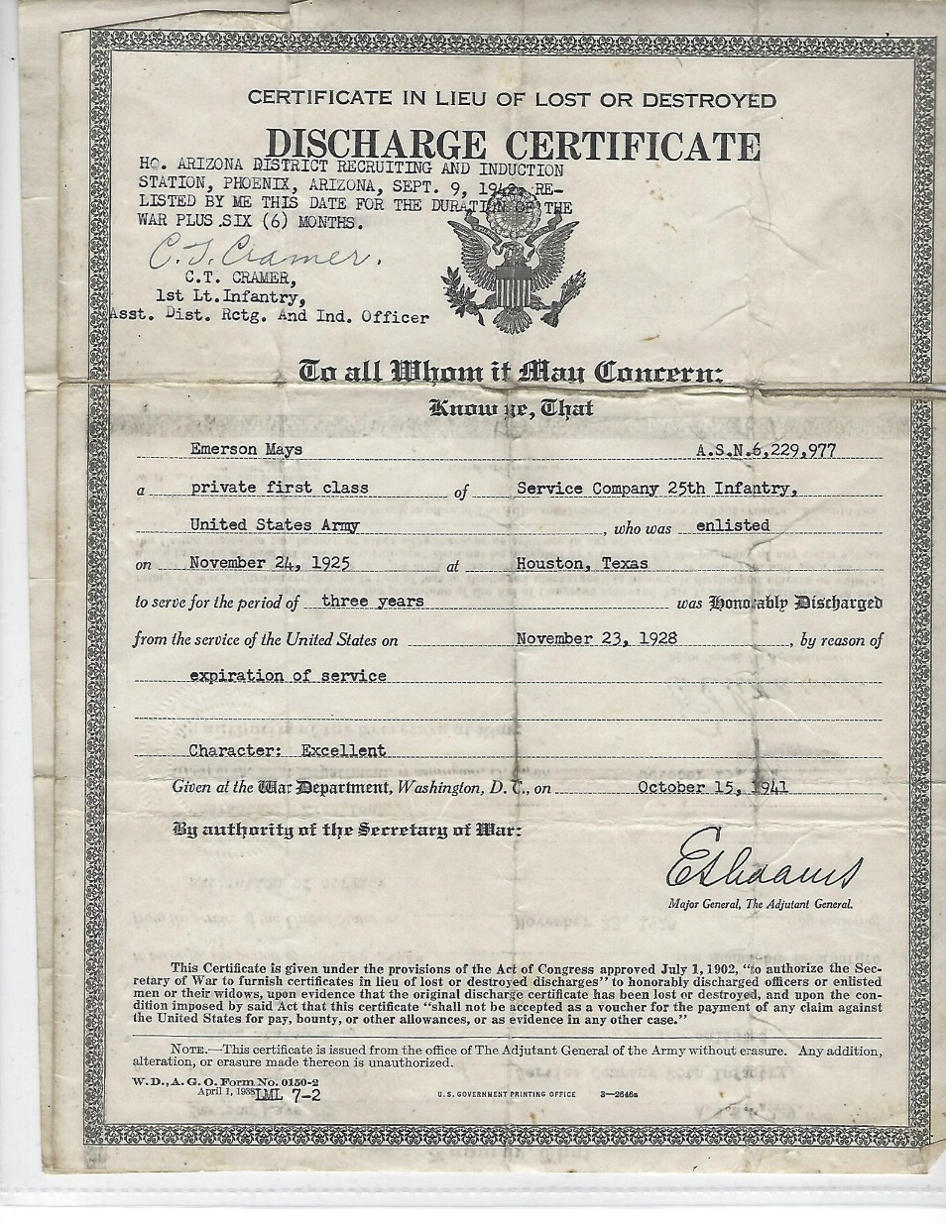

He married Maria Jesus Rivas on January 4th, 1928. They had five children:
Walter Emerson, Lucille Mary, James Miflin, Dolores, and Esther Juana (Juanita).

The young Mays family moved to California soon after Emerson’s retirement, with the children finishing their schooling and pursuing various careers there. The Mays clan returned often to visit family and friends in Nogales.

