Grown Clark

Grown Clark, a World War I veteran and member of Troop H with the 10th Cavalry of the U.S. Army, resided in Georgia prior to his enlistment in May 1914. By the time of his honorable discharge in March of 1919, his military service duties included Border Patrol in Naco and Nogales, Arizona enforcing Neutrality Laws during the time period in which the Battle of Naco took place, the same time period of Mexico’s Revolutionary War. US Troops were in place to ensure there was no spillover of fighting Mexican factions onto US soil.  Grown’s duration of service records[1] also note Troop H of the 10th Cavalry as traversing thousands of miles between Arizona and Chihuahua during March 1916.  This is notable as the timeframe historically is when General Pershing of 9th and 10th Cavalry was in search of Mexican revolutionary leader Pancho Villa.  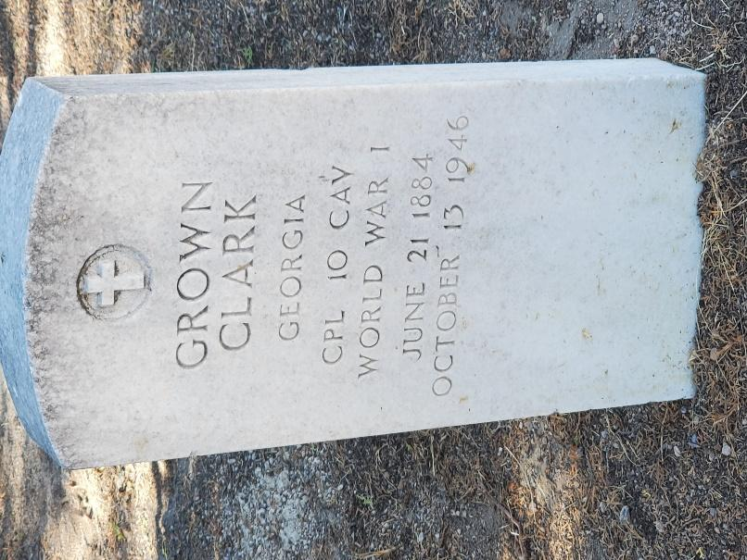

Grown later married a Nogales resident, Cristina Zepeda, who was born in Sinaloa, Mexico. They went on to raise four daughters and four sons in an adobe home on Morley Avenue in Nogales, Arizona that still stands today.

Grown, who retired as a Corporal, passed away October 13, 1946, in Nogales, Sonora, Mexico, and is buried in Nogales (AZ) City Cemetery. He is also honored as part of Nogales, Sonora, Mexico’s veteran’s memorial.

Children of Grown and Cristina Clark

* Tomas, United States Navy, died in World War II when his ship was destroyed in combat.
* Oscar, United States Army
* Angelina, who married Edward A. Simpson (graduate of Nogales High School and retired Army veteran (World War II, Vietnam)
* Berta, who married Jesse Stevenson and raised her family in California
* Arturo, United States Army
* Amelia, who married Raphael Gautier and raised her family in California
* Alejandro, United State Army
* Consuela, who died in infancy

1. Source: U.S., Buffalo Soldiers, Returns from Regular Army Cavalry Regiments, 1866-1916