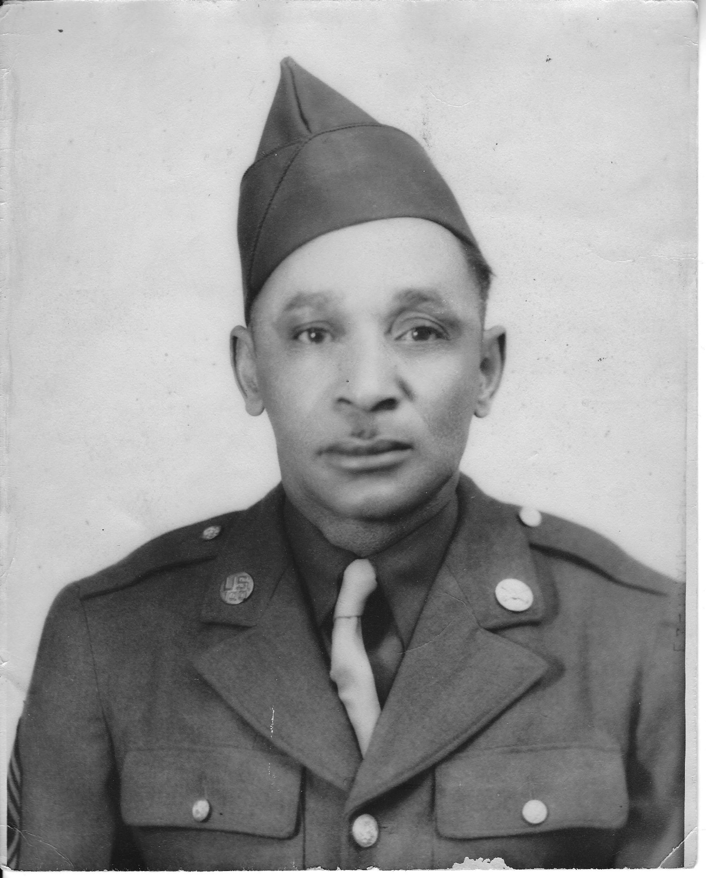

Master Sergeant Levi Biggs, Sr

Levi Biggs, Sr. was born in Louisiana, Missouri on January 25, 1892. He left home at the age of 14, and only knew his father’s name for sure (George Washington Biggs).

1915 Enlisted at Jefferson Barracks, Missouri: assigned to 10th Cavalry; posted to 25th Infantry, WW I.
Served at Schofield Barracks, Honolulu, Hawaii.

1918 25th Infantry Regiment transfer to Nogales to relieve 35th Infantry at U.S. Army Camp Steven D. Little (1910-1936), an army camp headquartered at Ft. Huachuca first established in Nov. 1910 to secure the border during the Mexican Revolution, renamed in Dec 1915 for a private killed in action during the Battle of Ambos Nogales. Ft. Huachuca troop camps at Nogales, Bisbee, and Patagonia. The cavalry and infantry regiments who fought against 1916 raids into the U.S. that year peaked at 12,000. It later undertook regional preparations for WWI, after which it numbered less than 1,000 troops. The post was abandoned May 5, 1933.

1933. 25th Infantry Regiment transferred to Ft. Huachuca to replace the 10th Cavalry as main combat unit. The 25th Infantry during WWII joined the 93rd Infantry Division. The post then had more than 30,000 troops and trained two black infantry divisions: the 92nd and 93rd, which had the largest concentration of black Army officers. The old post became a war installation. The state’s third largest city had a barracks, warehouses, maintenance structures, offices, and two hospitals, one of which was the country’s largest and only black-commanded and staffed Army hospital.

1939-~1940 Camp Davis, near Wilmington NC. 100th Coast Artillery [less than one year]
Ft. Bragg, Camp Gibbons, Wilmington WWII Antiaircraft Training Center AK Cook, Radio Operator, Regimental Supply Sergeant, Pitcher, Regimental Baseball Team, Chief Clerk Hq Btry Gun Bn 234th AAA [Army Antiaircraft Artillery Gun Bn. J.

1942-~43 Ft. Brady, Sault Ste. Marie, MI. Northwest Frontier Fort and Army Training Center. Guard, Sioux Locks connecting Lakes Michigan and Superior.

1944 Hot Springs, AK. and Augusta, GA. Family remained in Nogales.

30 Jun 1945 Honorable Discharge MSgt.

He married Maria Dolores Rivas in September of 1924. Together they raised 5 children. Their four sons all served in the US Air Force and their only daughter worked for Civil Service on Post in Fort Huachuca.

- Major George W. Biggs (authenticated Tuskegee airman)
- Major Levi Biggs, Jr.
- Master Sergeant John Biggs
- Colonel Richard Biggs
- Bertha Biggs Castillo

Master Sergeant Biggs worked at the Nogales Post Office and for a time he co-owned a resale shop with one of his Army buddies. He worked for a time at Kaanta Radio (he had worked on repairing radios in the service). He had also worked on street projects and helped lay sidewalk throughout town.

Biggs passed away in the Spring of 1979 and is buried alongside his wife, Dolores, and his son, George in the Nogales Cemetery in what was the segregated military section.

*dates of military service provided by Dolores Bahti, PhD.

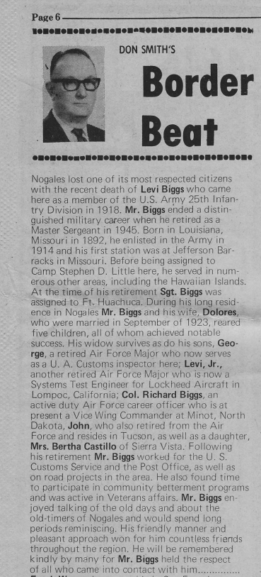

Often Master Sergeant Biggs could be seen sitting at the downtown Park (Karam Park), talking, reminiscing, and sometimes arguing with his fellow soldiers. His grandchildren fondly remember him taking us downtown to spend time at the park.

He was a fixture in Nogales for many years and we are all proud to honor him and his service to our country and to the community of Nogales.




