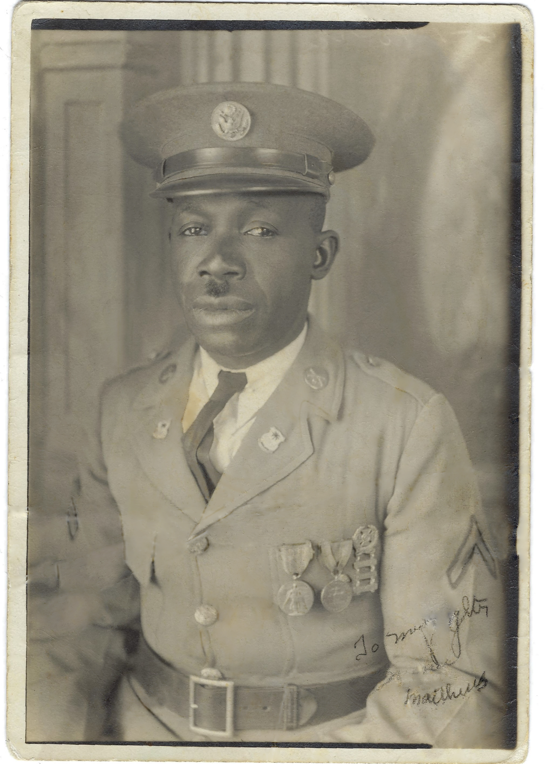

Oscar Mathews, Sr

Oscar Mathews, Sr. was born in 1891 in Forsyth, Georgia.

He came to Nogales, Arizona by way of the U.S. Army. Once he enlisted, he was assigned to the 10th Cavalry…the famous Buffalo Soldiers. The early part of his tour of duty was spent in the Philippines during the Moro Rebellion 1899-1913.

Eventually, his division was transferred to Fort Huachuca to ensure that the Mexican revolution did not spill over into the United States.

In 1928, he was transferred to Camp Steven Little for a brief period. While in Nogales, he met and married Maria de Jesus Rubio. She was born in Mazatlán, Sinaloa Mexico and came to Nogales from her hometown of Guaymas, Sonora Mexico.

Oscar and Maria became the parents of 3 children:
- Oscar Matthews, Jr.
- Laura Ethel
- Elsa Mia (Elsie).
- Step-daughter: Maria Bruna.

All of the Mathews children attended the Grand Ave/Frank Reed School. Oscar Sr. lived with his family in Nogales until his death in 1939. He was buried in Macon, Georgia.

Oscar Mathews, Sr. leaves a legacy of 3 children, one stepdaughter, 17 grandchildren, 4 step-grandchildren, and many great grandchildren, several of which who served in various branches of the United States Military.

