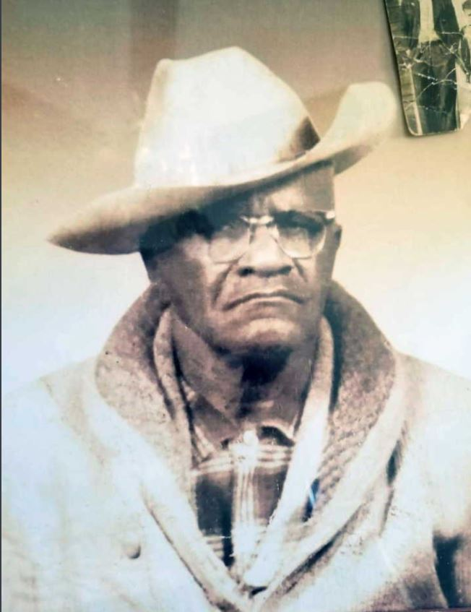
Thomas C Maken

Tom Maken was born in Shreveport, Louisiana in 1889.
Maken was one of the youngest and last of the Buffalo Soldiers, the all African-American U.S. Army cavalry regiments that fought in the Indian Wars in the Southwest. He was also a veteran of World Wars I and II, and was stationed at the former Camp Little in Nogales.
When Maken got out of the Army, he became the first black man to work for U.S. Customs in Arizona. He simultaneously worked for the U.S. Postal Service in Nogales.
He married Juana Villegas in 1934 in Nogales and they had a daughter, Guadalupe, in 1947.
“He was a boxer for many years and loved to be a cowboy,” recalled his grandson Jesus Acosta-Maken. “He used to love to dance and listen to country music and Motown songs.”
(Information and photos submitted by Gracy Mariscal, junior vice-commander at VFW Post 2066.) https://www.nogalesinternational.com/community/veterans-honored-on-eve-of-memorial-day/article_921c08a6-a1fb-11ea-b063-ef2923ed5c2d.html

