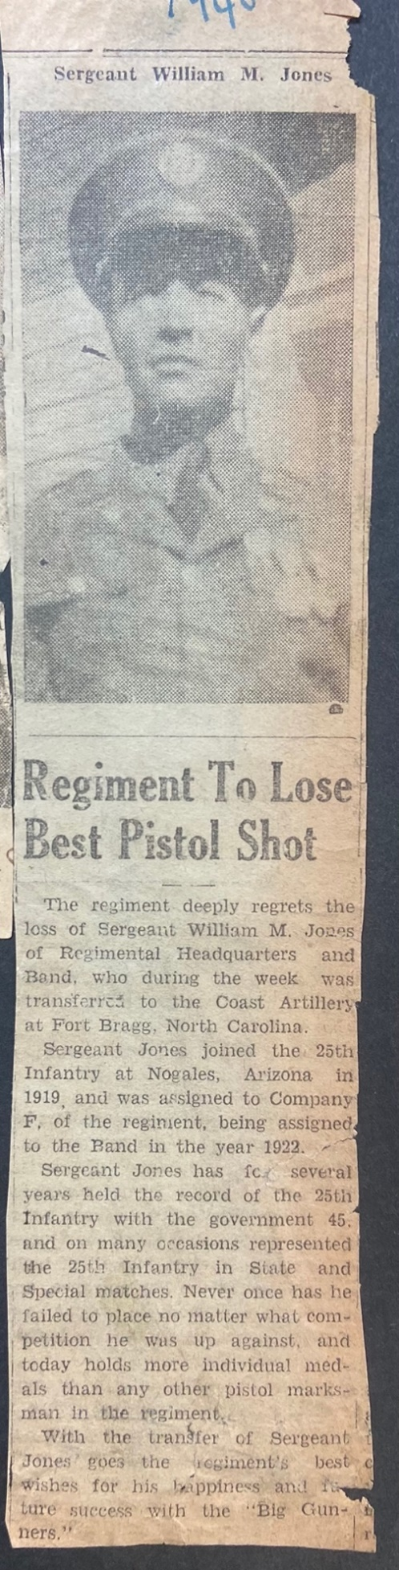
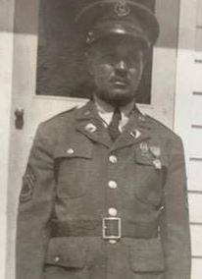
William McKinley Jones

William McKinley Jones was born October 30th, 1897, to Henry Jones and Sarah Proctor in Fairfield, Texas.

William left home a few times but finally left for good and joined the U.S Army in his late teens. The first records we have found are of his enlistment in 1918 at Camp Bowie, Texas although he said he had joined even before then. He was then transferred to Camp Little in Nogales, AZ in 1919. After this he went to Fort Riley for training with the Buffalo Soldiers and returned to Camp Little. Over the next several years he moved from Camp Little to Fort MacArthur in Los Angeles in 1925. In 1929 he was stationed at Camp Jones in Douglas, AZ then finally back to Camp Little in Nogales in 1930.
William Jones met and married the woman that would be with him for the rest of his life Juanita Rubio. By 1935 they moved to Ft. Huachuca and over the course of 8 years, they had 5 children: James M. Jones, William D. Jones, Conrad H. Jones, Judy D. Jones, and Frank E. Jones.

At the start of the war in 1941 he and his young family were sent to Fort Bragg, North Carolina as they were preparing to send the troops overseas for war. His regiment was sent to Liberia to defend against the possible German invasion of Sub-Saharan Africa. As the war went on, they went further north eventually following the troops to Corsica. His regiment was not a combat unit, but instead was a unit that was to build morale for the troops and the people they were protecting. He was the leader of the famous 25th infantry band that played for ambassadors, statesmen and presidents. Before leaving Liberia, they had the honor of playing for the president of Liberia and possibly for FDR on his famous visit to Liberia during the war. It is rumored that they also played for Charles de Gaulle in Corsica during the Liberation of Corsica before returning home from the war.
William returned with his regiment in 1943 and was reunited with his family while stationed in New York and New Jersey. He then went on to do a stint in Ohio before returning to Nogales.

He retired from the military in 1949 and moved his family to Los Angeles and ultimately returned to Nogales for his retirement.

William and Juanita had nine children: James, William, Conrad, Judy, Frank, Sarah, Waymond, Lonnie and Autrey. The two taught their children (some of whom served PROUDLY in the military and fought bravely in Vietnam) about their diverse heritage, through oral and documented history. The Jones children traveled and lived all over the world and married into diverse cultures making the Jones family culturally eclectic. He was a man proud of his heritage, his service to his country, and of his family.

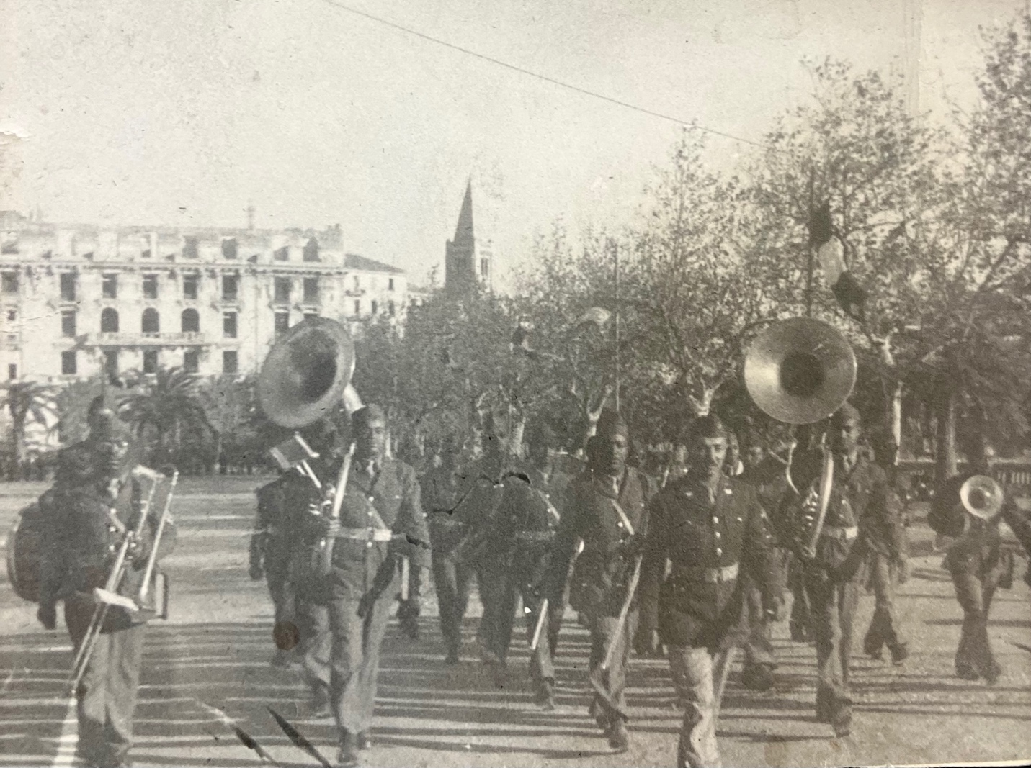
25th Infantry Band
led by Sergeant William M. Jones

