To close out Women’s History Month with The Positive Perspective, we at Unbeatable Spirit show you a personal approach to effect change.

Don’t Hide Your Best Self:
It may be just what the world needs!
(Reading Time: 6 minutes)

If you’re anything like me, you enjoy reading about impactful women, whether that be from a news story or a post on social media. There are some wonderful women in this world doing truly amazing things. With a little help from a favorite search engine, you can find information on female astronomers, civil leaders, humanitarians, musicians, etc. all of whom are truly inspiring.
Each of these women were in the right place at the right time, allowing their impact to radiate to others. By taking hold of their internal drive and using their focus, education, and skills, they were able to change the world. So, the question arises, “Are we doing the same?”
Our Time in History
I recall a conversation with my mother when I was young during which she told me how blessed I was to have been born at that specific moment in time. She spoke of how, if I would have been born even just a few years earlier, my life as someone in a wheelchair would have been quite different. With disability becoming noticeably more socially acceptable, communities improving physical accessibility, and improvements in medical care allowing people to remain in their homes, she made a good point.
What a time in history to be alive! With an entire world at my fingertips, I grew up thinking not of what I couldn’t do, but rather what I could.
- Did I achieve great skill in swimming even though I couldn’t walk? Yes!
- Was I able to encourage our school’s basketball team as a cheerleader from my wheelchair? You bet!
- Did I perform as a percussionist for nine years, interview a famous broadcast journalist in front of thousands, and become a speaker on disability, women’s health care, and other subjects? Yes, yes, and yes.
Because of the positive influence of others in my life, I did these things and more. How could I not? The advantage of my point in time should not be wasted. Along the way, through my example and messages, I hope I have been changing the world for the better.
Strong as Steel
Have you ever considered how the world might be different if you were born in another time? Or how there might be a reason for when you were born? What are you doing to better the world around you? I am of the opinion that we are all born at a certain time because we are the ones who can make the biggest impact on those around us.
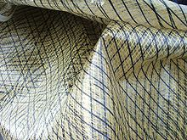

Take Stephanie Kwolek¹ as an example. In 1946, she was trying to save money for medical school when she heard of an opening for a chemist at DuPont, vacant due to men being overseas in the military. While accepting the position as a temporary way to help her save money, she found herself working there for over 40 years eventually leading her to inventing, among many things, a fiber that was ounce-for-ounce as strong as steel.
“This material was dubbed Kevlar, and it's been used to manufacture skis, radial tires and brake pads, suspension bridge cables, helmets, and hiking and camping gear. Most notably, Kevlar is used to make bulletproof vests.²”

Although Kwolek had a different plan for her life, if she had not accepted the job at DuPont, who knows if Kevlar would have been invented? Through her one decision, she changed the world.
Skipping Stones
Wouldn’t it be great to know with certainty that you had a positive impact? Personally, I don’t see myself affecting others on a grand scale like Kwolek. I think it’s happening more as a ripple effect for me, like skipping stones in a river, and that starts with family and friends.
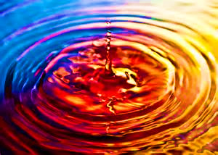
I’ve had a number of people tell me I’ve impacted them through my positive attitude and thriving mindset. The funny thing is I don’t do it intentionally; it’s just who I am. It’s part of my nature, my internal drive. Life is too full of possibilities to let little things like weak muscles, a curved spine, and inability to walk get me down.

Now, don’t get me wrong, I have difficult days and moments where I am fully frustrated by my condition. Being able to do something easily one day and not as well on another day is more than annoying. Whether we are dealing with a physical disability, trauma, or other issue, it is up to us to pull ourselves up by our bootstraps and keep moving forward. As they say, “Attitude is everything.”
Be Open to Your Best Self
I will never discover the latest invention or cure a major disease because I do not have a skillset that supports those things. And that’s OK. Although I have a background in economics and investing, my true self and passions came out when I started working for a non-profit to help others with self-identified disabilities. It was in working as an Independent Living Specialist that I opened to my best self, and my best self is compassionate, caring, and motivating to others on a deep level. It is a true blessing for me to care for others in my own way. Realizing this years ago, I have been able to better focus my intentions and create more ripples of positivity. I believe that truly does effect change.
Who is your best self? Are you highly skilled in a certain trade or vocation? Are you an especially focused parent, neighbor, or friend? Do you have certain aspirations for your life? Do you have a natural skillset that is unique to your situation?
It is my opinion that Stephanie Kwolek found her best self in her work at DuPont. With her love of fabrics, teaching, and chemistry, she was able to grow professionally, accept a change in plans, and focus on the work at hand. It was through her openness to the situation that she found success in a new way to positively affect others.
According to Minimalism Made Simple³, the top three powerful ways to be your best self are:
- Set Goals: Picture your optimal future self and start planning goals that can help you become that person
- Eliminate Distractions: Ask yourself, “What is holding me back?”
- Leave your Comfort Zone: This may require some bravery, but the benefits can be highly rewarding and encouraging.
How can you apply these steps in your life? I apply them by how I live:
- While I find complete joy in each moment, I also always have my eyes on the horizon. What is coming up? What can I do to make certain things achievable and how can I ensure they have a positive affect on others?
- By staying focused on personal priorities (i.e., family, friends, and life goals), I am able to stop myself from being held back from other unnecessary distractions.
- Each day, there is always something that requires me to leave my comfort zone, whether that be by choice or because of disability.
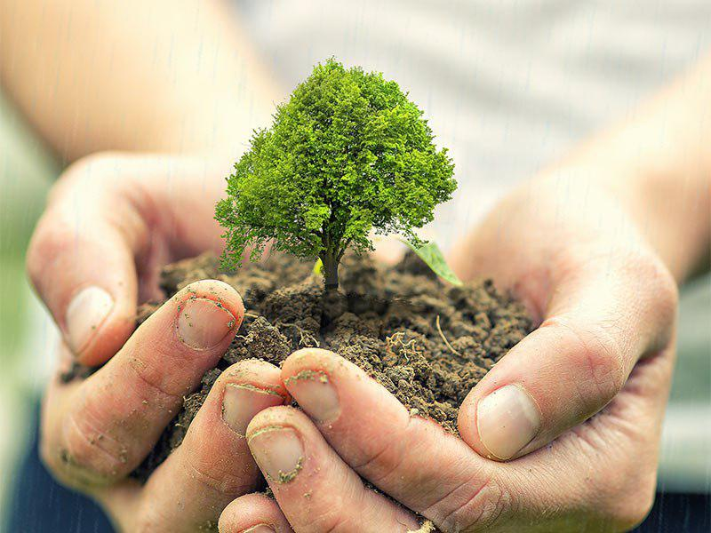

Are there certain goals you’ve always wanted to achieve but never started working toward? Do you find yourself getting caught up in the busyness of life and easily distracted from the task at hand? Are you nervous to venture out and take the leap of faith that you can succeed?

Next Steps
My advice? If you want to become your best self, focus first on how your best self can help others. Personal successes like having a certain job, driving a new car, or losing those last 20 lbs are great but do you want to know how to make them even better? Become a great mentor at work, offer to use your car to run errands for someone who needs help, or use your new knowledge of health and nutrition to help others do the same.
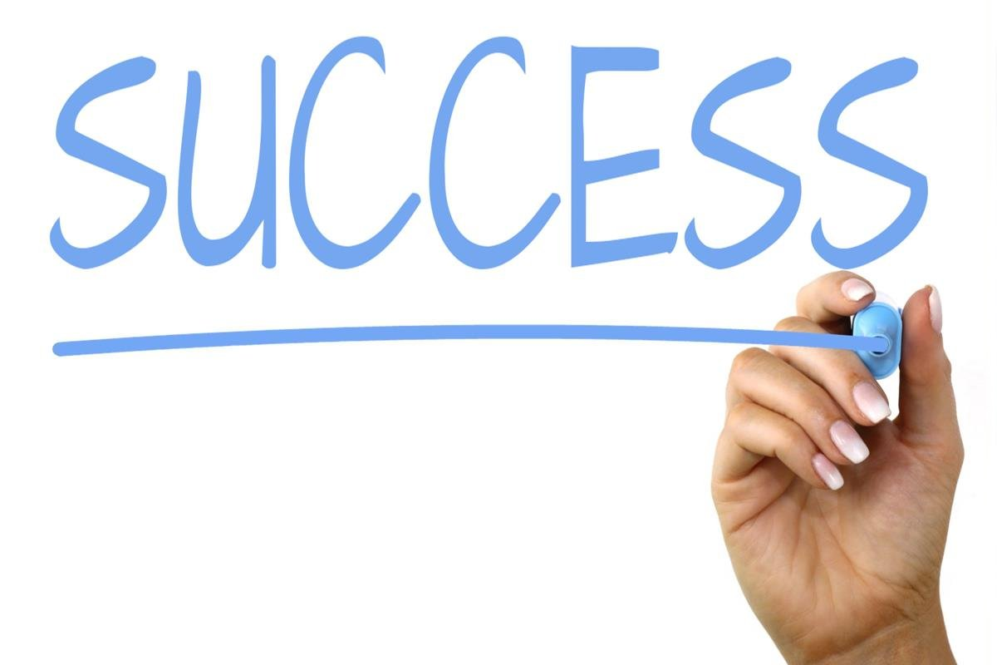

Successes become more valuable when they don’t just belong to you. Kevlar would not mean a thing if it was just kept in the lab. It means infinitely more because of what it does for others. My life as a thriving woman with a disability wouldn’t make any impact if I kept my message to myself. The same can be true of every good thing in life. How will you make your positive impact for history?
This week, I encourage you to take stock of your life. Evaluate your skills and passions. What change can you make to better the world around you? Becoming your best self does not mean you will always feel like your best self, but it will create a pattern that allows your life to blossom. You were born at this time in this place among your people for a very specific reason. Who knows? Like me, you may have a message worth sharing. Or you may be sitting on the next great invention!

¹ WebCite query result (webcitation.org)
² Top 10 Things That Women Invented | HowStuffWorks
³ 11 Powerful Ways to Be Your Best Self - Minimalism Made Simple

