MIDNIGHT SUN COVER CONTEST
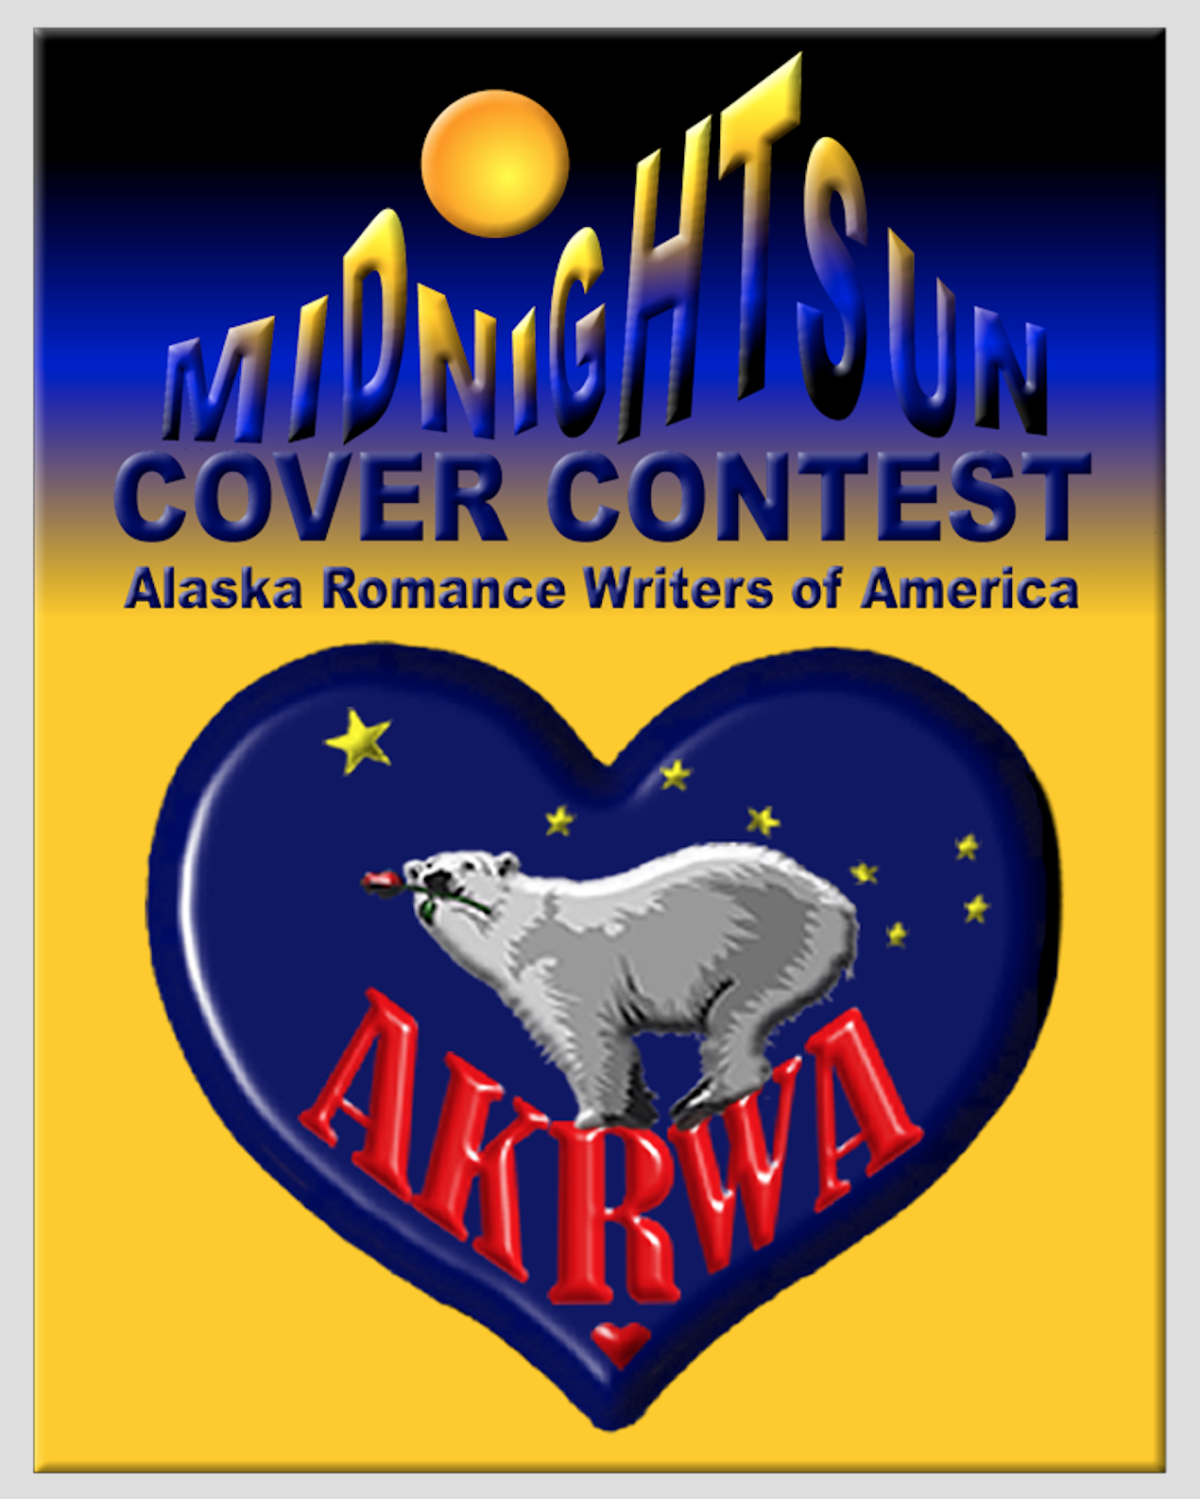
Alaska Romance Writers of America

“Romance authors know exactly what they are doing and what their audience wants. The cover makes a reader pick up a book…”
Tom Luce, New Book Buyer,
Powell’s Books

Do you have a stellar cover that catches the eye and draws the reader in? Alaska Romance Writers of America (AKRWA) is sponsoring a new contest! The Midnight Sun Cover Contest 2018 is a chance for published authors (digital and print) to win some great prizes! Even better, every entry will be on printed, visual display to over 150 voracious readers at the 2018 AWG Writer’s Conference who will vote for the top entries! (And perhaps buy your books!)

WHO CAN ENTER:
Any author can enter their book cover for a romance novel, novella, or short story published prior to August 30, 2018, either electronically or in print, in the United States for the first time.

HOW TO ENTER:
Step 1: Download contest entry form from www.akrwa.com/contest.
Step 2: Pay entrance fee ($15.00 per entry) via PayPal to treasurer@akrwa.com.
Step 3: In an email to contest@akrwa.com (1) copy/paste official entry form and entrant’s agreement into the body of an email, (2) include the entrance fee PayPal transaction ID number, and, (3) attach book’s cover in digital format (JPEG format with 300 dpi or greater).

WHEN IS THE DEADLINE:
The deadline for submissions is midnight (Alaska Standard Time) on September 8, 2018.

JUDGING:
All entries will be placed on prominent display in printed format at the Alaska Writer’s Guild (AWG) 2018 conference, co-sponsored by AKRWA. Conference attendees and presenters (approximately 150) will select first-round entries via ballot box.
FINAL JUDGING:
Trained judges will select the top winner from the top ten entries selected at the conference. Final judging will occur at the annual AKRWA Writing Retreat in early October, with the winner announced in late October. Honorable Mentions: This contest seeks a single, most compelling cover; however, Honorable Mentions will be awarded, including the prestigious librarian’s choice award.

PRIZES:
Finalist and Honorable Mention covers will be published on the AKRWA website with the Finalist cover receiving prime location. The Finalist will also be announced on the AWG website. In addition, the Finalist will receive an electronic badge that can be placed on book covers, websites, or anywhere the winner deems appropriate and a $25 Visa cash card.
FOR MORE INFORMATION:
For more information, please visit http://www.akrwa.com/contest.html‬‬‬‬‬‬‬‬‬‬‬‬. If you still have questions, please email the contest coordinator at contest@akrwa.com.

SUBMISSION GUIDELINES
Include in one electronic submission:
- Title of the published novel.
- One digital copy of the book cover in jpeg format at 300 dpi or more.
- Midnight Sun Cover Contest Form (which can be found at the bottom of this document).
- The book’s ISBN or AISN number as proof of published status with date included.
- Signed statement assuring the AKRWA that you have legal permission to enter the cover for contest judging, including printing and display on websites.

OFFICIAL CONTEST RULES
- Submissions are limited to books published prior to August 30, 2018.
- Submit only:
- The front cover in jpeg format at 300 dpi or greater.
- Contest Form with completed information
- AKRWA Contest Entrant’s Agreement (at the bottom of the Contest Form).
- Payment via PayPal.
- Writers can submit multiple entries, but each entry must be submitted separately with an individual Contest Form, Contest Entrant’s Agreement and payment ($15.00).
- Submissions without payment will not be considered. Fees should be paid via PayPal and will not be refunded. Submit PayPal orders to: treasurer@akrwa.com.
* If you have any questions, please contact the Contest Coordinator at contest@akrwa.com

DISCLAIMER
Alaska Chapter of the RWA maintains no responsibility for the final judging process and considers the grand prize selection to be final and permanent.

This contest is sponsored by the Alaska Chapter of Romance Writers of America.

________________________________________________________________________
INSTRUCTIONS: Copy and paste the Entry Form and Entrant’s Agreement into the body of your email. Complete the required information, including the PayPal Transaction ID found in the upper right corner of your PayPal receipt (please do not submit your entry until you have this information.) Attach a copy of the book cover you entered to the email.

………....BEGIN COPY HERE………...BEGIN COPY HERE…………...BEGIN COPY HERE………..BEGIN COPY HERE………….

AKRWA 2018 Midnight Sun Cover Contest
Entry Form:
Email entry to: contest@akrwa.com

A) TITLE OF ENTRY:
B) ISBN or AISN NUMBER:
C) NAME OF PAYEE:
D) PAYPAL TRANSACTION ID (Found on upper right corner of your PayPal receipt):
E) DID YOU ATTACH COPY OF BOOK COVER? (.jpeg format, 300dpi minimum)

Author Information
AUTHOR (PEN NAME):
NAME (if different from pen name):
CONTACT PHONE (WITH AREA CODE AND TIME ZONE):
ADDRESS:
CITY:
STATE:
ZIP:
E-MAIL (BE SURE TO SPECIFY GIVEN NAME OR PEN NAME EMAIL.):

Questions for Contest Coordinator:
- If the published book is the work of two or more authors, please include a second set of Author Information and Registration within your email from each writer.

- Send Payment to AKRWA PayPal: treasurer@akrwa.com. Once payment is received, acknowledgement of your entry will be emailed.

AKRWA’S 2018 MIDNIGHT SUN COVER CONTEST ENTRANT’S AGREEMENT

I have read the rules of the Alaska Romance Writers of America (AKRWA) 2018 Midnight Sun Cover Contest for published books (digital or paper). I understand and agree to abide by those stated rules. I also understand and agree that any questions regarding the interpretation of the official rules and any matters relating to the 2018 Midnight Sun Cover Contest not covered by the official rules will be decided by the contest officials. I will accept as final the decision of the contest officials in any such matter.

I also accept that judging is subjective by nature. I will accept and abide by the decisions of any judges and/or contest officials regarding winners for this contest. By emailing this agreement, I accept as reasonable the statements made above.

In emailing this Entrant’s Agreement in exchange for the acceptance and processing of my submission in the 2018 Midnight Sun Cover Contest I acknowledge understanding and acceptance of the rules. I accept that the AKRWA, contest officials, and the contest judges are relying on the truth and sincerity of my statements. I also state that the submission is a complete and published work of my own. In the event that I place in this contest, I agree to allow my entry title, cover graphic and/or name to be publicized on the AKRWA Web site. By submitting this entry form, I am agreeing I have full rights to submit this cover to the contest.

Author’s name: (insert name here)
X I accept the above agreement. Date: (insert date here)

Note: to e-sign this document do this: //e-signature//Name in full.
For example: //e-signature//Jane Elizabeth Doe.

