Newsletter- Autumn Term 2017

We are located in the nursery building of-
Thorley Hill Primary School
Park Lane
Bishop’s Stortford
Herts
CM23 3NH

Dear Parents/Carers,
Welcome to Sunflowers Pre-School!
This contains anything you would need to know about your child’s afternoons with us at Sunflowers Pre-School in addition to Thorley Hill nursery’s newsletter. We are so excited to get started and hope to provide a safe, secure, stimulating environment for your child to learn and develop in.
Funding and EYPP
Can we please have your completed parent declaration form, regarding the funding if you haven’t already done so. This needs to be completed whether you are claiming for 30 hours or the universal 15 hours. Please contact the manager if you think your child may be entitled to Early Years Pupil Premium. A copy of our policy on this can be found in our policies and procedures folder at the entrance/exit.
Lunch Time Reminders
Please ensure your child’s lunchbox is nut free and promotes healthy eating. There are lots of good ideas on the NHS’s Change for Life website. We are considering the possibility of hot meals being provided and will send out a separate letter with more information when we have it. Please also ensure that if you send your child in with grapes or anything of a similar shape and size that you cut them to reduce the risk of choking.

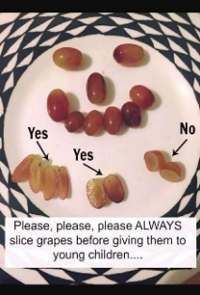

Snack Contribution
We ask for a voluntary donation towards the snack we provide. We aim to have two choices of fruit/vegetable each day. A suggested amount is 25p per session. You can pay by cash on a weekly basis in to the blue tin by the entrance/exit. You are also welcome to pay termly by cash or bank transfer if you would prefer. Please email/call for bank details. Thank you in advance for this support.

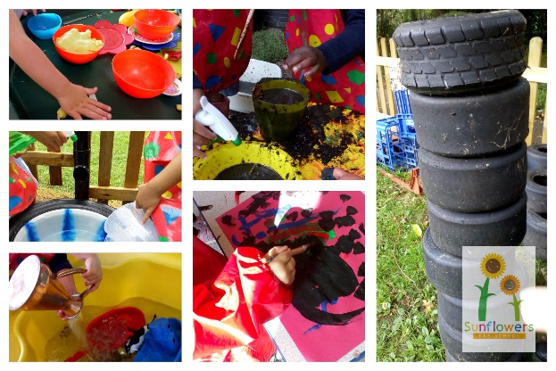
Tapestry
Your child’s online learning journals will soon be up and running. Thorley Hill Nursery and Sunflowers Pre-School will be working in partnership to contribute to these and any assessments that take place. A ring binder will also be kept with evidence and print outs of focus child week sheets. These are available for you to see at any time upon request. Mrs Cowler and Mrs Laws are both Key Workers for all the children and will be contributing towards their observations and assessment together.
A useful guide for parents is-
‘What to expect, when?’ www.foundationyears.org.uk
Contacting
If you would like to get in touch with us during the Pre-School session please remember to use the contact details below and not Thorley Hill Primary School.
A reminder of our session times-
Monday- Friday Term time, following Thorley Hill’s term dates.
11.40-3.00
The Manager will also be available to speak to on the phone or via email up until 5pm each pre-school operating day. If you would like to discuss any matters privately in person please try and arrange this in advance whenever possible.

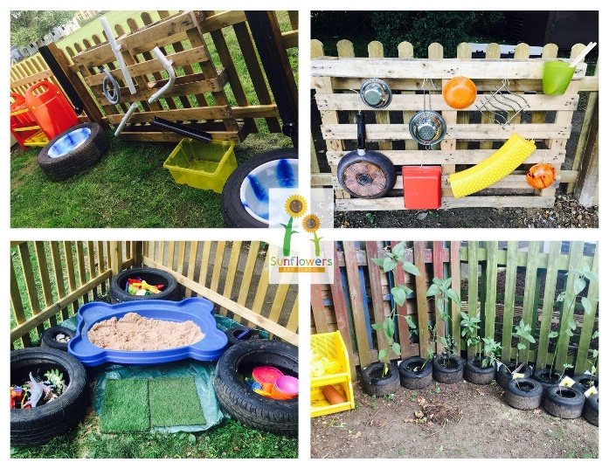
Pick Up Time
Please keep us informed of anyone new picking up at the end of the day. It is our Safeguarding responsibility to not allow your child to be collected by anyone unfamiliar to us unless they have the password that you have provided us with.
Illnesses
Please notify us if your child is unwell prior to attending their session. There are exclusion periods that may need to be put in place to reduce the risk of infections spreading. We can advise you of these as they occur. We can administer certain medicines if they require us to do so in the time-frame. Please see our ‘Medicine Administration’ policy in our folder in entrance/exit.
Contact Us-
Manager- Louisa Cowler (Key Worker)
Deputy Manager- Clare Laws (Key Worker)
Early Years Practitioner- Sarah Pointon
Email- sunflowers.preschool17@gmail.com
Phone- 07752 562206
Website- www.sunflowerspreschool.co.uk
Facebook- @sunflowers17

