Newsletter- Autumn Term 2018

We are located in the Nursery building of-
Thorley Hill Primary School
Park Lane
Bishop’s Stortford
Herts
CM23 3NH

Dear Parents/Carers,
Welcome to Sunflowers Pre-School!
This first newsletter contains anything you would need to know about your child’s afternoons with us at Sunflowers Pre-School in addition to Thorley Hill nursery’s newsletter. We are so excited to get started and hope to provide a safe, secure, stimulating environment for your child to learn and develop in.
Lunch Time Reminders
Please ensure your child’s lunchbox is Nut Free and promotes healthy eating. There are lots of good ideas on the NHS’s Change for Life website. Please also ensure that if you send your child in with grapes or anything of a similar shape and size that you cut them lengthways to reduce the risk of choking. We put packaging and leftover food back into your child’s lunchbox aware of trying to make minimal mess. This is so you can see how much your child has eaten.

Funding and EYPP
Can we please have your completed parent declaration form, regarding the funding if you haven’t already done so. This needs to be completed whether you are claiming for 30 hours or the universal 15 hours. Please contact the manager if you think your child may be entitled to Early Years Pupil Premium. A copy of our policy on this can be found in our policies and procedures folder at the entrance/exit.

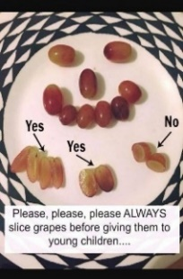

Snack Contribution
We ask for a voluntary donation towards the snack we provide. We aim to have two choices of fruit/vegetable each day. A suggested amount is 25p per session. You can pay by cash on a weekly basis in to the blue tin by the entrance/exit. You are also welcome to pay termly by cash or bank transfer if you would prefer. Please email/call for bank details. Thank you in advance for this support.

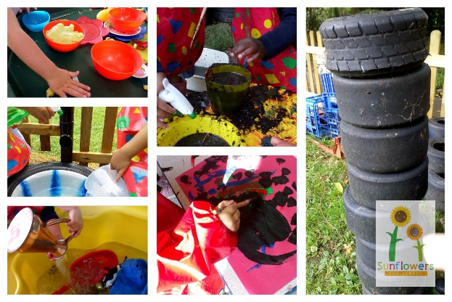
Tapestry
If you have returned your permission slip, you should have received an email with a link to set up Tapestry online learning journal for your child. Please let me know if there are any problems during the set up or if you don’t have access to the internet or a device to access it. Soon we will be starting to add observations that you will be able to see, and we encourage you to respond and/or send in your own experiences to us. A ring binder will also be kept with evidence and print outs of focus child week sheets. These are available for you to see at any time upon request.
A useful guide for parents is-
‘What to expect, when?’ www.foundationyears.org.uk
Contact During Sunflowers Time
If you would like to get in touch with us during the Pre-School session, please remember to use the contact details below and not Thorley Hill Primary School.
A reminder of our session times-
Monday- Friday Term time, following Thorley Hill’s term dates.
11.40-3.00
The Manager will also be available to speak to on the phone or via email up until 5pm each pre-school operating day. If you would like to discuss any matters privately in person please try and arrange this in advance whenever possible.

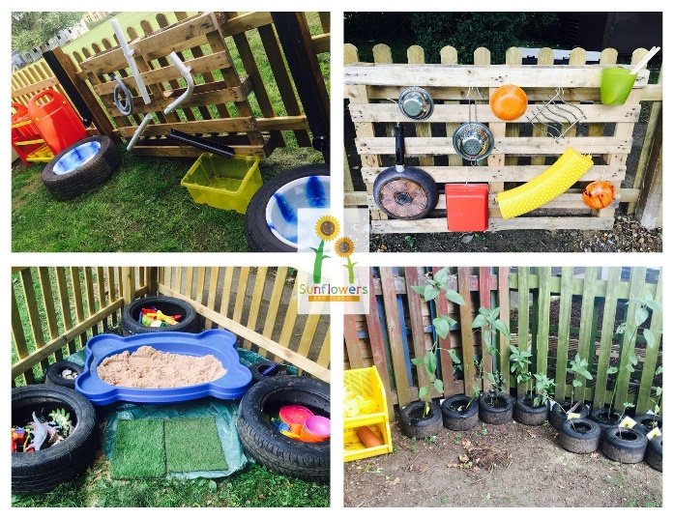
Pick Up Time
Please keep us informed of anyone new picking up at the end of the day. It is our Safeguarding responsibility to not allow your child to be collected by anyone unfamiliar to us unless they have the password that you have provided us with.
Please try and arrive promptly at 3pm for collection. We will endeavour to open the gates for you at around 2.55 to enter. If you ever need to arrive early to collect, please call the Sunflowers number to let us know.
Fees
If you are not using funding for your child’s sessions an invoice will be sent to you towards the end of the first half term. I will be making a note of start dates and will keep a track of how much to charge for this first period. After that once everyone is settled and we are in a routine with regular sessions the invoices will be sent prior to each half term to be paid in advance please. Let me know if you would rather pay monthly so I can adapt your invoice. Childcare vouchers welcome with notice as sometimes it can take a while to set up with a new scheme.
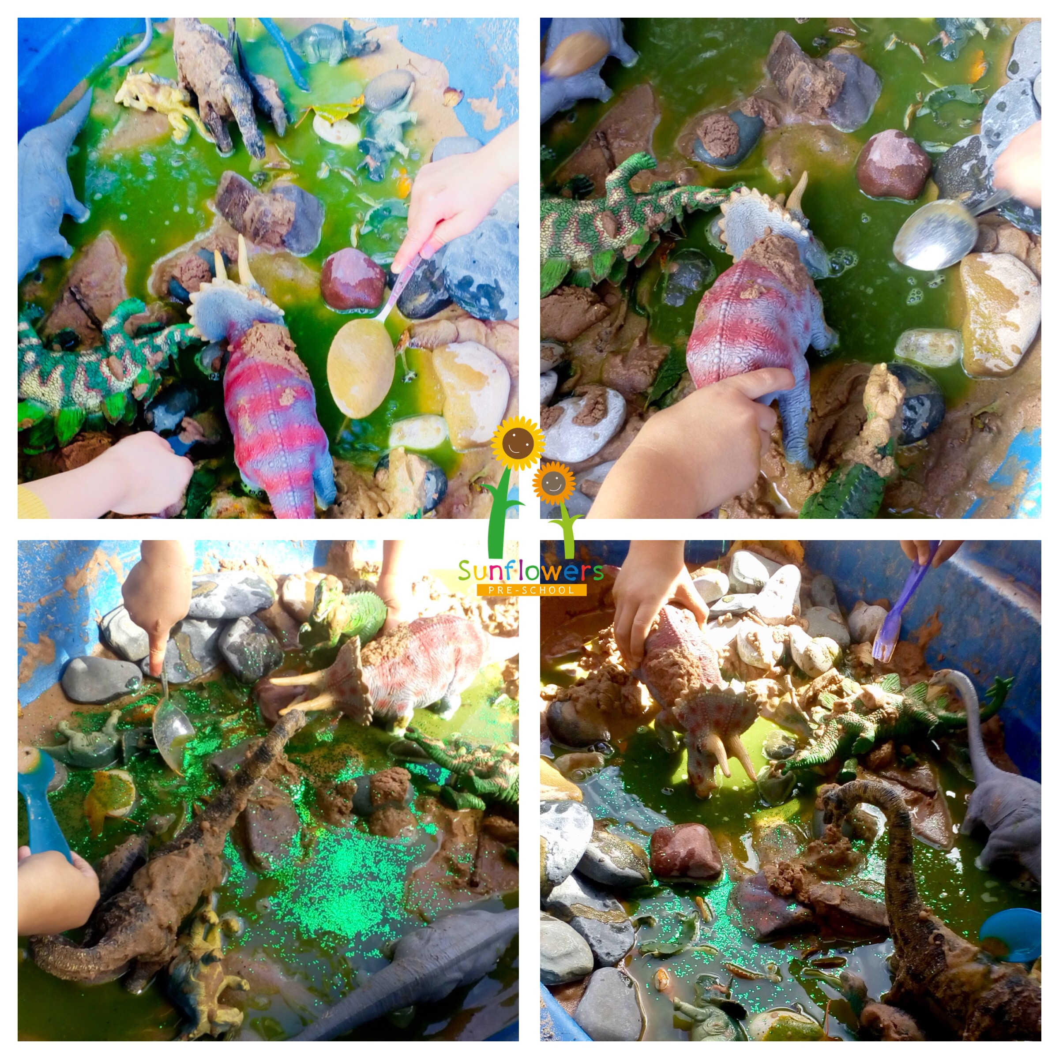

Contact Us
Manager- Louisa Cowler
Deputy Manager- Louise Jaycock
Early Years Practitioner (cover staff)- Sarah Pointon
Early Years Practitioner (cover staff)- Joanne Coulson
Email- sunflowers.preschool17@gmail.com
Phone- 07752 562206
Website- www.sunflowerspreschool.co.uk
Facebook- @sunflowers17
Facebook
We have an informative Facebook page which keeps you as parents/carers and any prospective parents/carers up to date with information and what the children have been learning. Photos never include children’s faces or names/personal information as this is a public page. Please search for it and follow to enjoy and support us. Feel free to ‘share’ with your friends and family.
Key Person
You should have all received a letter regarding who your child’s key person is. As mentioned, this doesn’t mean that the other key person won’t be involved in that child’s learning and care. There is a sign on the Sunflowers notice board with a reminder. (Just inside the Sunflowers collection door.)
Illnesses
Please notify us if your child is unwell prior to attending their session. There are exclusion periods that may need to be put in place to reduce the risk of infections spreading. We can advise you of these as they occur. We can administer certain medicines if they require us to do so in the time-frame. Please see our ‘Medicine Administration’ policy in our folder in entrance/exit.

