We are in the nursery building of-
Thorley Hill Primary School
Park Lane
Bishop’s Stortford
Herts
CM23 3NH
11.50am-3.00pm

Newsletter
Autumn Term 2- 2018

Dear Parents/Carers,
What a fantastic first half term we have had all getting to know each other and settling in to our new exciting surroundings! This newsletter is a little update for you to let you know about any changes this term and some reminders. I’ve also added useful dates for the rest of the term at the side.
Online safety
As you may know, the children do have access to the Interactive white board and some online age appropriate games. We ensure that they are accessing these on a child friendly login that restricts any pop ups/inappropriate websites and we are always there to supervise. It is our duty to begin to teach them even at this early stage to always let an adult know if they are unhappy about anything regarding computers/tablets. This is a good mindset to get them into in preparation for keeping safe online as they get older.
Dates
Monday 26th Nov- INSET day
Friday 21st December-
Last day of term- we will be closing just before the rest of Thorley Hill school at 1.20pm
Friday 21st Dec- Tuesday 8th Jan- Winter Holidays
Monday 7th January-
INSET day
Tuesday 8th January-
Spring Term begins

Snack Contribution
We ask for a voluntary donation towards the snack we provide. We aim to have two choices of fruit/vegetable each day. A suggested amount is 25p per session. You can pay by cash on a weekly basis in to the blue tin by the entrance/exit. You are also welcome to pay termly by cash or bank transfer if you would prefer. Please email/call for bank details. Thank you to everyone that has contributed so far.
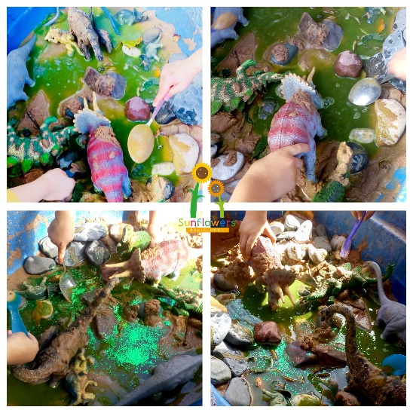
Questionnaires
A big thank you to everybody that filled out one of our questionnaires. The comments and feedback were so positive, and it was valuable to gain your honest opinions at this stage. Please let me know if you are happy for any of your comments to be quoted on any future promotion for Sunflowers Pre-School.
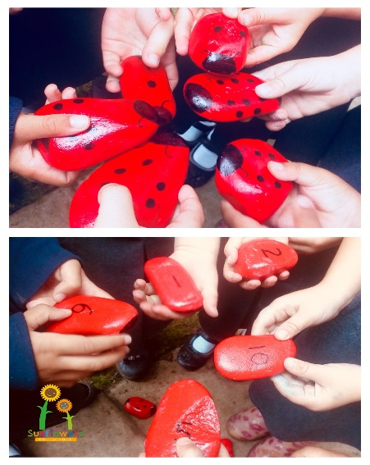
Tapestry/Focus Child Weeks
Now the children have settled in we have begun our ‘Focus Child’ Weeks. We will ask for your feedback on anything your child is currently interested in or any new aspects of their life. Together with our assessments, we spend a week enhancing their learning using our child-led ethos and some thought out opportunities to encourage new experiences. You will get observations on tapestry during this week and we encourage you to send some back to us too please. The following week you will be invited to come and speak to us about your child’s focus week findings and discuss any concerns/next steps. When it is not your child’s focus week you will have a reduced amount of observations than you have had so far. Please let one of us know if you are having problems accessing Tapestry.
A useful guide for parents is- ‘What to expect, when?’ www.foundationyears.org.uk
Pick Up Time
Please keep us informed of anyone new picking up at the end of the day. It is our Safeguarding responsibility to not allow your child to be collected by anyone unfamiliar to us unless they have the password that you have provided us with.
30 Hours Funding
If you are accessing the 30 hours funding I will be asking you to pop in at the end of the session soon to sign the Spring term section of the Parent Declaration form. Please ask if you would like the guidance sent to you again.

Colder Weather
Now that the weather is getting colder, please ensure your child has a named warm coat, hat and gloves with them every day, so that we can continue to make use of our outdoor provision.
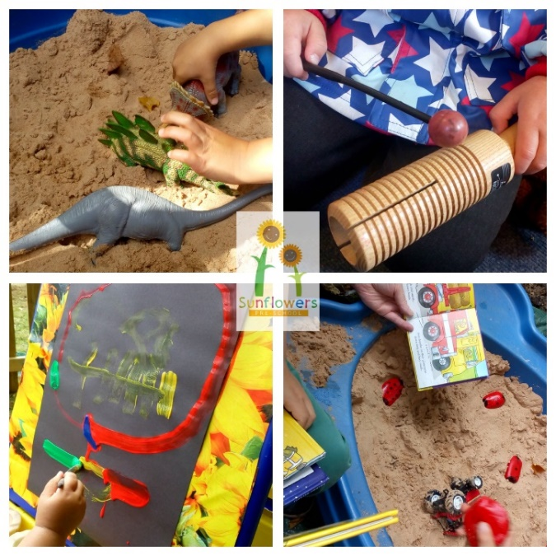
Contact Us-
Manager- Louisa Cowler (Key Worker)
Deputy Manager- Louise Jaycock (Key Worker)
Early Years Practitioner- Sarah Pointon
Early Years Practitioner- Joanne Coulson
Email- sunflowers.preschool17@gmail.com
Phone- 07752 562206
Website- www.sunflowerspreschool.co.uk
Facebook- @sunflowers17

