Key Person Approach
Dear Parents/Carers,
We use the Key Person approach in Sunflowers Pre-School. This means that there is one named member of staff to act as the main point of contact for you and your child.
Your child’s Key Person is: Miss Louise Jaycock- Deputy Manager (photo below)
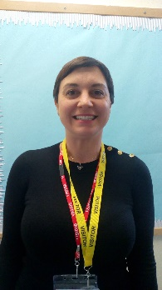
This doesn’t mean that other members of staff will not be getting to know your child and be caring for them during their time with us. Please feel free to speak to any of them regarding any issues if your child’s Key Person is unavailable. Any concerns can always be addressed with the manager, Louisa Cowler.

Your child’s Key Person can help you and your child by:
- Assisting your child closely with the settling in process and ensuring they feel welcome and secure in their new surroundings
- Observing your child’s play with support from other colleagues and as a team working out next steps, suitable resources and any individual needs
- Keeping an up to date record of your child’s learning and sharing these with you via tapestry online learning journal or by adding to your child’s folder
- Encouraging your child to develop their independence, including toileting and putting on coat etc
- Being a liaison on a daily basis in regards to your child’s well-being and learning.

If you have any questions about the Key Person approach, please speak to manager Louisa Cowler.

