We are in the nursery building of-
Thorley Hill Primary School
Park Lane
Bishop’s Stortford
Herts
CM23 3NH
11.50am-3.00pm

Newsletter
Spring Term 2019

Dear Parents/Carers,
Firstly, happy new year to you all! I hope you had a wonderful break with your families celebrating and enjoying a well-deserved rest. Welcome to the first newsletter of 2019- I have kept a lot of the items the same as we have new parents joining us, hopefully they will be welcome reminders!

Occupations and Beliefs
If any parents, grandparents, aunties and uncles have a job or a faith that they would be happy to come in and talk to the children about please have a chat with one of us. Dentists to Postal service, Christians to Hindu, we think the children would be proud to see their special grown up talking about their job or faith and this also helps to spark an interest in occupations and ways of life, supporting our promotion of British Values.

Term Dates
Sunflowers Pre-School follows Thorley Hill’s term dates…
Tuesday 8th January-
Spring Term begins
Friday 15th February-
Finish for half term
Monday 18th – Friday 22nd February-
Half Term
Monday 25th February-
Back to Pre-School
Friday 5th April-
End of Term- Finish at 1.20pm

Snack Contribution
We ask for a voluntary donation towards the snack we provide. We aim to have two choices of fruit/vegetable each day. A suggested amount is 25p per session. You can pay by cash on a weekly basis in to the blue tin by the entrance/exit. You are also welcome to pay termly by cash or bank transfer if you would prefer. Please email/call for bank details. Thank you to everyone that has contributed so far.
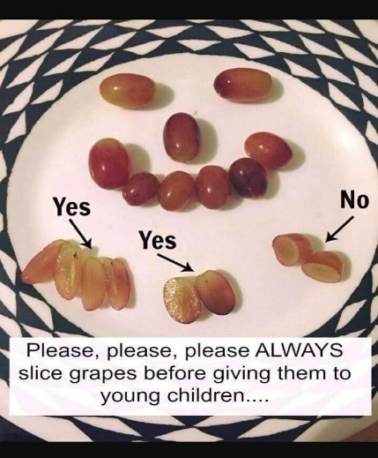
Lunch Time Reminders
Please remember, to reduce the risk of choking hazards at lunch time to cut grapes as shown in the diagram here.
We are a nut free environment.
We encourage healthy eating so please don’t include chocolate or sweets in lunch boxes.

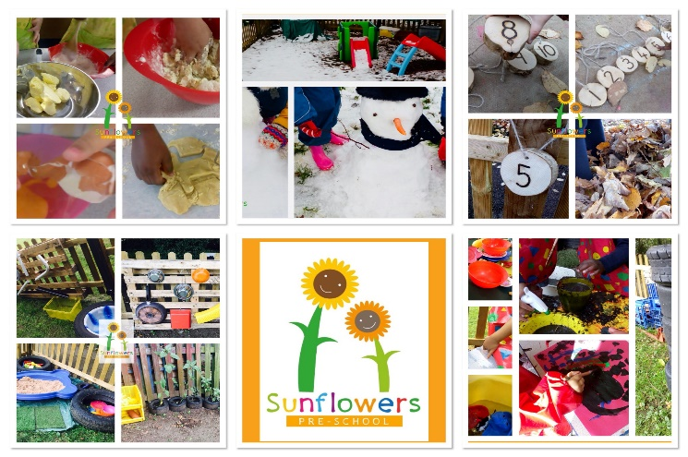
Contact Us-
Manager- Louisa Cowler (Key Worker)
Deputy Manager- Louise Jaycock (Key Worker)
Early Years Practitioners (cover staff)
Sarah Pointon
Joanne Coulson
Email- sunflowers.preschool17@gmail.com
Phone- 07752 562206
Website- www.sunflowerspreschool.co.uk
Facebook- @sunflowers17
Tapestry/Focus Child Weeks
During the spring term we will be starting your child’s second focus week of the school year or first if you’re new to us. A reminder of the process…
We will ask for your feedback on anything your child is currently interested in or any new aspects of their life. Together with our assessments and the last focus week’s ‘Identified areas for future focus’ (next steps), we spend a week enhancing their learning using our child-led ethos and some thought out opportunities to encourage new experiences. You will get observations on tapestry during this week and we encourage you to send some back to us too please. The following week you will be invited to come and speak to us about your child’s focus week findings and discuss any concerns/next steps. When it is not your child’s focus week you will have a reduced amount of observations than you have had so far. Please let one of us know if you are having problems accessing Tapestry.
A useful guide for parents is- ‘What to expect, when?’ www.foundationyears.org.uk
Message Reporting
Please contact us via the Sunflowers contact details if there is anything you need to inform us of once we are in session in the afternoons. Details below…

Pick Up Time
Please keep us informed of anyone new picking up at the end of the day. It is our Safeguarding responsibility to not allow your child to be collected by anyone unfamiliar to us unless they have the password that you have provided us with. Could all parents/carers please endeavour to arrive to collect their child at 3pm promptly. We appreciate your co-operation, many thanks.
Outside Play
Now that the weather is getting colder, please ensure your child has a named warm coat, hat and gloves with them every day, so that we can continue to make use of our outdoor provision. The Sunflowers garden is muddy this time of year, so we will ensure the children now wear their waterproof trousers and welly boots when they access this area. Please have a chat with them at home to support us with this so they are not discouraged from the benefits of continuous provision. Thank you!

