We are in the nursery building of-
Thorley Hill Primary School
Park Lane
Bishop’s Stortford
Herts
CM23 3NH
11.50am-3.00pm

Newsletter
Summer Term 2019

Dear Parents/Carers,
I hope you had a wonderful Spring break with your family and friends. As before this newsletter will have some useful reminders as well as any new updates for you all. A separate email will follow with details of the transition process to reception and a Sunflowers end of year event!

Warmer weather
As we are entering the summer term, please ensure that your child has a named sunhat with them to keep them safe to access the outdoor provision in the sunshine. Water is always accessible but if your child would prefer a named water bottle that’s fine. Please ensure there is only water in these. Please also make sure that children have sun cream applied before drop-off in the morning.
Summer Term Dates
Sunflowers Pre-School follows Thorley Hill’s term dates…
Wednesday 24th April-
Summer Term begins
Monday 6th May-
Bank Holiday
Friday 24th May-
Finish for half term
Monday 27th May – Friday 31st May
Half Term
Monday 3rd June-
INSET day
Tuesday 4th June-
Back to Pre-School
Tuesday 23rd July-
End of Term- Finish at 1.20pm

Snack Contribution
We ask for a voluntary donation towards the snack we provide. We aim to have two choices of fruit/vegetable each day. Recently we have been extending the children’s independence by introducing more of their input in preparing their snack which has had a good response from the children. A suggested amount is 25p per session. You can pay by cash on a weekly basis in to the blue tin by the entrance/exit. You are also welcome to pay termly by cash or bank transfer if you would prefer. Please email/call for bank details. Thank you to everyone that has contributed so far.
Lunch Time Reminders
Please remember to reduce the risk of choking hazards at lunch time to cut grapes in half lengthways. We are a nut free environment. We encourage healthy eating so please don’t include chocolate or sweets in lunch boxes.
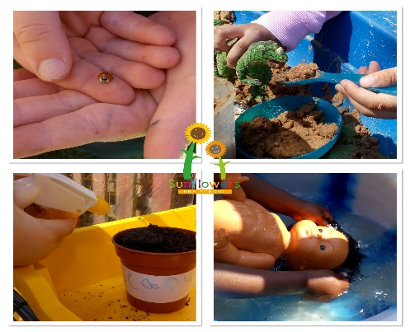
Tapestry/Focus Child Weeks
During the summer term we will be starting your child’s third focus week of the school year. A reminder of the process…
We will ask for your feedback on anything your child is currently interested in or any new aspects of their life. Together with our assessments and the last focus week’s ‘Identified areas for future focus’ (next steps), we spend a week enhancing their learning using our child-led ethos and some thought out opportunities to encourage new experiences. You will get observations on tapestry during this week and we encourage you to send some back to us too please. We don’t have parent meetings in this term unless you are new to us and I will be in touch to arrange a meeting. You will be receiving a transition record instead which outlines your child’s recent progress and their journey with us from the beginning. Please feel free to email or speak to us about any concerns or questions you may have. When it is not your child’s focus week you will have a reduced amount of observations than you have had so far. Please let one of us know if you are having problems accessing Tapestry.
A useful guide for parents is- ‘What to expect, when?’ www.foundationyears.org.uk
Visitors
We welcome any parents/carers/grandparents that would like to come in and help/play, even if it’s just for an hour at the end of the session. The children feel very proud. I haven’t made a rota this term so please just mention you can come in, so we know to expect you. Visitors to Sunflowers are NOT to sign in through the main school. Instead, please come to one of the green side gates and call the Sunflowers number below to let us know you’re there and a member of staff will come and let you through and sign you in inside the nursery/sunflowers building. Thank you.
Sally Sunflower’s Story
Thank you to everyone that has had our flowery friend to stay. The children have responded to it so well and it has created some lovely opportunities for them to share their home life experiences with us and have a sense of responsibility. The children enjoy adding their contribution to her story book which is filling up nicely. You are more than welcome to come in and have a look through it with your child. Thank you again for your efforts!
Pick Up Time
Please keep us informed of anyone new picking up at the end of the day. It is our Safeguarding responsibility to not allow your child to be collected by anyone unfamiliar to us unless they have the password that you have provided us with. Could all parents/carers please endeavour to arrive to collect their child at 3pm promptly. We appreciate your co-operation.

Bradford’s five things to do before you’re five!
This is a lovely resource packed full of ideas, some that you may do all the time but some interesting unique ones too. I have added a link below. Let us know if you give anything new a try at home!
https://bradford.50thingstodo.org/app/os#!50thingstodobefore5/50-things-to-do-before-youre-five

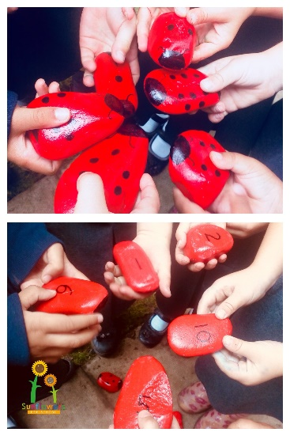
Notice board
There is a display board inside the Sunflowers exit door with information about the setting including a list of key children, in case you are unsure of your child’s key person. There is also a leaflet holder which houses amongst others our safeguarding policy, local information leaflets, speech and language drop in clinic information and more. Feel free to access this area at the beginning of your child’s session or at pick up time. Please allow me to ensure the children have exited to their parent/carer safely before coming inside if it’s collection time.
Thank you.

Contact Us-
Manager- Louisa Cowler (Key Worker)
Deputy Manager- Louise Jaycock (Key Worker)
Early Years Practitioners (cover staff)
- Sarah Pointon
-Joanne Coulson
Email- sunflowers.preschool17@gmail.com
Phone- 07752 562206
Website- www.sunflowerspreschool.co.uk
Facebook- @sunflowers17

