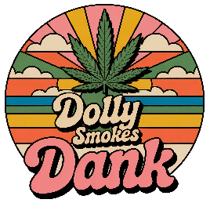
Strain Name: Date:
Strain Parents:
Breeder: Grower:
Type: Flower FECO/RSO (Dose: ) Concentrate Edible
Sativa Sativa Dom Balanced Hybrid Indica Dom Indica
Feels Like | Symptom Relief | Top Terpenes
Alert/Focused | Headache
Foggy | Body ache
Relaxed/Calm | Inflammation
Sleepy | Anxiety
Tingly | Insomnia
Giggly | Rumination
Happy | Tremors
Social  Creative  Couch Lock  Hungry | Stress
Tastes Like:

Smells Like:

How would you describe the high? Did it help you feel better in any way? If so, what way? Did it give you anxiety or paranoia? How did you feel and how would you compare it to other strains you’ve tried?

