November 2018 Volume 19 issue 11
Editor: Rosemary Kautz Website www.rockrivervalleycarvers.com

October 4, 2018 Board Meeting Minutes

- Call to Order: President Mike Hughbanks called the meeting to order at 6:07 p.m. in the Janesville Senior Center conference room. Dave Thill, Mike Hughbanks, Rosie Kautz, Robin Rios, Vern Morris, and Jim Svobada attended the meeting.
- Illness/Sunshine Report (Robin Rios): A card was sent to Ray Henry.
- September 2018 Treasurer Report (Rosie Kautz): The beginning balance was $5,162.52, and the ending balance was $6,235.20. The show proceeds were $1,475.02. The extension office returned the $100.00 show deposit. The major expenditure was $160.00 for the wood bought from County Line Products to give to the members who carved chilies for Chilimania. Members who took Jim Trumpy’s classes at Christian Hummul are turning in their receipts for reimbursement.
- Website Report (Vern Morris): The website received 1,530 hits for September: 10% - Madison, WI., 9% - Fitchburg, WI., 5% - Stevens Point, WI., 3% - Salt Lake City, UT., 3% - Montreal, Canada, 69% - Other. The Facebook site had 127 hits.
- 2018 Show Report (Rosie Kautz and Robin Rios): Vern Morris reported the attendance numbers for the show demonstrations and class. Ray Douglas had 12 observers, Randy Callison taught 10 students in his class, plus another 10 watched his class. Kenny Neubauer had 19 people watch his knife carving demonstration. Vern will give Kenny and Ray a DVD of their demonstrations. Randy already has a DVD from a previous class he taught on icicles. The show profit totaled $681.43. This was without any proceeds from the kitchen this year since Jeff’s Coffee Bar ran that independent of the show. Mike Hughbanks has been trying to contact one winner to get their prize to them. Rosie passed out a show summary to each board member.
- Tuesday Evening Open Carving (Mike Hughbanks): Seven people attended the October 2nd session. The next open carving night is October 16th.
- Roles & Responsibilities of Board Members (Dave Thill): Dave continues to work on this project.

2018 Officers
President: Mike Hughbanks
815-289-8573
Vice President: Tom Kautz
608-868-4522
Secretary: Robin Rios
608-752-3328
Treasurer: Rosemary Kautz
608-868-4522
Librarian: Jim Svoboda
608-554-3268 Editor: Rosemary Kautz
608-868-4522

Advice from a Wood Duck: Let Troubles Roll Off Your Back & Don’t Quack Up!

We meet on the
first Thursday of the month
at the Janesville Senior Center, Second Floor
69 S. Water St.
Janesville, WI
Meeting or Carving
begins at 7:15 p.m.
Board Meeting at 6 p.m.

- Nominations for 2019 RRVC Officers in November: Mike Hughbanks will be stepping down as President to take on the job of Webmaster. Vern Morris will be resigning from this role at the end of the year. Rosie Kautz will stay on as Treasurer and Newsletter Editor. Robin Rios will continue on as Secretary.
- Library Update (Jim Svobada): Vern Morris and Jim are working together to reorganize the library and the contents of the cart that houses the library. There are five DVDs missing from the library. Rosie Kautz will send out an email with the list of the missing DVDs to club members asking them to check at home for them.
- September Hedberg Library Carving Demonstration: Ernie Tucker and Bud Hilgendorf set up for it. Rosie Kautz will send out an email to remind members who signed up for the next date which is November 18, 2018.
- Chilimania Update: Rosie Kautz has already handed out a lot of the wood to members who carved chilies.
- Get to Know a Fellow Carver: Robin Rios is waiting for the selected carvers to return their information to her.
- December Christmas Party: Jerry Cox will be performing a magic show that night. There will be an ornament exchange.
- Additional Items: The Madison carving show will be held on October 21, 2018. Several of the RRVC club members will be exhibitors there.
- Adjournment: President Mike Hughbanks adjourned the meeting at 6:53 p.m. The minutes are respectfully submitted by Robin Rios, Secretary.

Tuesday Evening Open Carving Sessions
November 6th and 20th are our next open carving sessions from 6 pm until 8 pm at Trinity Episcopal Church in Ortmayer Hall, 409 E Court St., Janesville. Enter through the door on the west side of the building. Bring something to carve and inspire some new carvers!

October 4, 2018 Regular Meeting Minutes

- Call to Order: President Mike Hughbanks called the meeting to order at 7:16 p.m. Attendance: 18.
- Welcome/Introduction of Guests or New Members: One guest, Steve Johnson, introduced himself.
- Sunshine Club (Robin Rios): A card was sent to Ray Henry. Rosie Kautz read a letter from Ray thanking the club for the card.
- September 2018 Treasurer Report (Rosie Kautz): Copies of the treasurer report and the show expense report were sent around for members to view. The wood bought from County Line Products to compensate the Chilimania chili carvers cost $160.00. See board meeting minutes for more details. The eight club members who recently took Jim Trumpy’s classes at Christian Hummul need to turn in their receipts to get their reimbursement.
- Chilimania Report (Tim Banwell): Chilimania donated $730.00 to the club for the chilies.
- Nominations of Officers for 2018: See board meeting minutes for details.
- September 2018 Show Update (Rosie Kautz and Robin Rios): See Board Meeting Minutes
- Other Items: Jim Trumpy voiced concern that the club members did not have an opportunity to vote on spending the $732.09 to renew the website contract with GoDaddy for three years. Mike Hughbanks said this decision was within the board’s jurisdiction to make.
- 50/50 Raffle (Randy Callison): Vern Morris won the raffle prize of $11.00, and he donated it back to the club.
- Adjournment: President Mike Hughbanks adjourned the business portion of the meeting at 7:35 p.m. Ron Duffy gave a demonstration of different tools available to hold your work in progress. Minutes respectfully submitted by Robin Rios, Secretary.

Next Meeting – November 1st
Bring your ‘Show & Share’ items and enjoy the camaraderie of your fellow carvers. Open carving during and after the general meeting.

Area Carving Opportunities!
Janesville Senior Center: Mondays & Thursdays from 8:30 – 11:00. Meet and carve with fellow carvers. A wide variety of carvings is always going on. Helpful instruction is available.
Edgerton Senior Center: Tuesday morning carving with Bob Phelps, 9 am until whenever.

Janesville Library Carving
Our next library carving demonstration and promotion of carving will be Sunday, November 18 from 1 to 3 pm.

Have You Seen these Missing DVDs?
The following DVDs are missing from our library. If you have them, please return to Jim Svoboda or Vern Morris so they can be made available for our other club members. Thank you!
- How to soften wood for carving
- Use of an air brush by Ron Duffy
- Decorative gourds by Gary Kvalheim
- How to keep your tools tuned up by Jim Trumpy
- Arbortech-Turboshaft

Brief Show Summary
We had 30 exhibitors and vendors at the show with 42 table sold. Attendance was 311. All comments received were positive, enjoying our show! A couple of suggestions received were to advertise the demonstrations/classes more and to hold the last raffle before 4 pm when everyone is busy packing up.
Net income was $681.43. Without including kitchen revenue, this compares with $509 in 2017 and $432 in 2016. A decrease in printing costs (less quarter-sheet flyers were printed this year) and slight increases in table rental income and cash donations resulted in breaking even in facility and printing net income compared to a loss of $250 last year. Raffle income of $616 and ornament sales of $52 compared to$649 and $110 last year. For more detail, please contact Rosemary Kautz.

December Potluck Meeting
It’s time to get busy carving your Christmas ornament if you want to participate in this year’s ornament exchange at our Dec. 6 meeting! In addition to our potluck meal and ornament exchange, we will have magician Jerry Cox performing after dinner.

We Received this Message from Ray Henry: “Thanks for the beautiful card and the thoughts behind it. You guys are a terrific group. Thank each one for me. BTW County Line Products had the best year at the show ever. Keep up the great work. Ray”

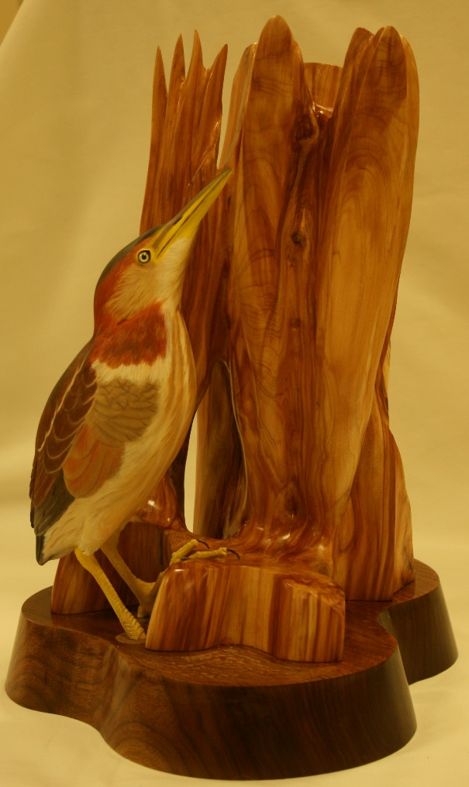
Show & Share
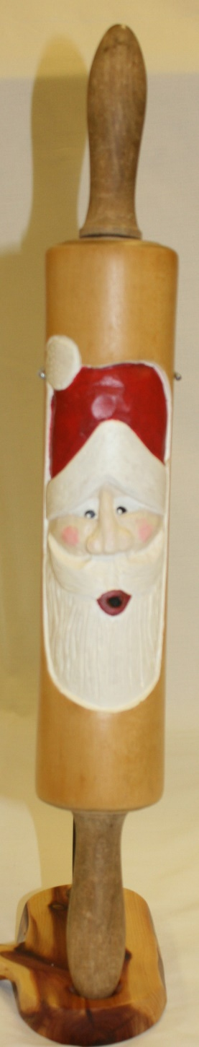

Ron Duffy’s Least Bittern

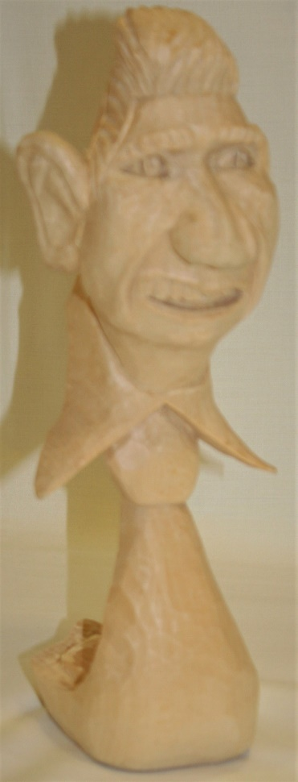

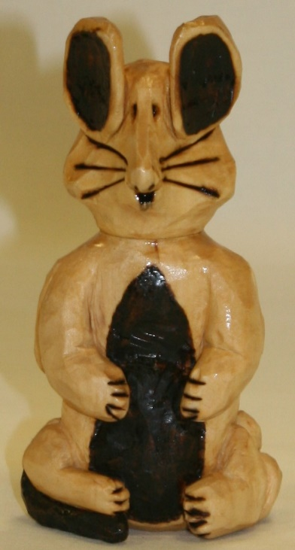
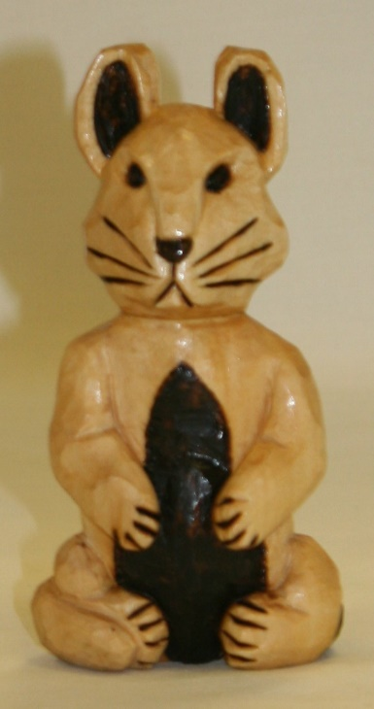
Jim Svoboda’s Santa Rolling Pin &
Mike Hughbanks’ Mans’ Head with Tie

John Eiden’s 2-Sided Cat and Mouse

