December 2018 Volume 19 issue 12
Editor: Rosemary Kautz Website www.rockrivervalleycarvers.com

November 1, 2018 Board Meeting Minutes

- Call to Order: President Mike Hughbanks called the meeting to order at 6:01 p.m. Tom Kautz, Rosie Kautz, Gerry Lesch, Jim Svobada, Vern Morris, Robin Rios, and Mike Hughbanks attended the meeting.
- October 2018 Treasurer Report (Rosie Kautz): The beginning balance was $6,235.20, and the ending balance was $5,776.09. The 50/50 Raffle brought in $100.00. A $60.00 rent check was sent to Trinity Episcopal Church for the months of August, September, and October. Eight reimbursement checks (total of $400.00) for members who took Jim Trumpy’s classes have been given out.
- RRVC Website Update (Vern Morris): The website had 1,512 hits his past month. The percentage of hits breaks down as follows: Fitchburg, WI. - 14%, Guangzhou, China - 14%, Madison, WI. - 6%, Seattle, WA. - 3%, and Stevens Point, WI. - 3%. The Facebook page had 111 hits. During the October monthly meeting Jim Trumpy brought up the concern that the club members should have voted to spend the $732.09 to renew the contract with GoDaddy for the next three years. According to the RRVC By-Laws (last updated December 2014) Article 7, Section 1: All expenditures over $250.00 must be approved by the majority vote of the Board members, except for recurring show expenses. The renewal cost is now down to $439.05 due to a coupon Vern was able to use. The current website was supposed to come down on December 5, 2018. However, for an additional $11.99, the current site can remain useable until January 5, 2019. This will give Vern time to build the new website. The renewal date for the new website will be October 31, 2021. Vern will be putting an article in the December newsletter explaining the benefits to the club in having a website.
- Illness/Sunshine Club (Robin Rios): Cards were sent to Bob Crompton and Reggie James.

Old Business
- Open Carving Evenings at Trinity Episcopal Church: The next two sessions will be held on November 6th and November 20th.

2018 Officers
President: Mike Hughbanks
815-289-8573
Vice President: Tom Kautz
608-868-4522
Secretary: Robin Rios
608-752-3328
Treasurer: Rosemary Kautz
608-868-4522
Librarian: Jim Svoboda
608-554-3268 Editor: Rosemary Kautz
608-868-4522

When You Buy from a Wood Carver, You Get Part of the Artist’s Soul

We meet on the
first Thursday of the month
at the Janesville Senior Center, Second Floor
69 S. Water St.
Janesville, WI
Meeting or Carving
begins at 7:15 p.m.
Board Meeting at 6 p.m.

- Get to Know a Fellow Carver: Another name needs to be drawn tonight at the regular meeting.
- 2018 Show Update (Rosie Kautz): The 2019 show is scheduled for September 14, 2019. The club needs someone to volunteer to be the Show Chair. All raffle winners have received their winnings.
- Chilimania Update: Rosie Kautz has one more piece of wood to give out to Ray Douglas.
- 2019 Officers: Mike Hughbanks is stepping down to become the Web-Master. Vern Morris will be retiring from that position the end of December.
- RRVC Library (Jim Svobada): All the DVDs are now numbered.
- Hedburg Library Carving Demonstration: The next one is scheduled for November 18, 2018. Four members have signed up to help.
- Tuition Reimbursement: Rosie Kautz said it would be good to discuss the possibility of expanding the tuition reimbursement to cover classes outside of Christian Hummul in the future.
- Additional Items: Robin Rios suggested that a copy of the RRVC By-Laws be sent out electronically or by postal mail to members who do not already have a copy. The By-Laws in Article 3, Section 7 states: Each member shall receive a copy of the By-Laws. Rosie Kautz said she would take care of it.
- Next Board Meeting: There will be no board meeting in December. The Christmas party will start at 7:00 p.m. Everyone should bring their own place setting and a dish to pass. There will be an ornament exchange and a magic show put on by Jerry Cox.
- Adjournment: President Mike Hughbanks adjourned the meeting at 6:56 p.m. The minutes are respectfully submitted by Robin Rios, Secretary.

Tuesday Evening Open Carving Sessions
December 4th and 18th are our next open carving sessions from 6 pm until 8 pm at Trinity Episcopal Church in Ortmayer Hall, 409 E Court St., Janesville. Enter through the door on the west side of the building. Bring something to carve and inspire some new carvers!

November 1, 2018 Regular Meeting Minutes

- Call to Order: President Mike Hughbanks called the meeting to order at 7:15 p.m. Attendance: 16
- October 2018 Treasurer Report (Rosie Kautz): See Board Meeting minutes for details.
- 2019 RRVC Officers: Tom Kautz said he will stand for President. Mike Hughbanks is stepping down as President to become the Webmaster. Vern Morris will be retiring from this position at end of December. A Vice President nominee is needed.
- RRVC Annual Christmas Party: Everyone should bring their own place setting and a dish to pass. The club will supply the chicken. If you want to participate in the ornament exchange, please bring a carved ornament. The party will start at 7 p.m. Jerry Cox will be presenting a magic show. There will not be a board meeting prior to the party.
- Raffle (Randy Callison): Ed Hogue won the raffle and donated his winnings back to the club.
- Get to Know A Carver: Bob Hilgendorf will be the next lucky carver to be featured in the newsletter.
- Hedburg Library Carving Demonstration: This will be on November 18, 2018 from 1 p.m. to 3 p.m. in the second floor of the library. Rosie Kautz sent around a sign-up sheet.
- Adjournment: President Mike Hughbanks adjourned the meeting at 7:34 p.m. The minutes are respectfully submitted by Robin Rios, Secretary.

December 6th – Party, Potluck, & Magician
Our annual Christmas Party/Potluck will begin at 7 pm! The club will supply the chicken. Please bring a dish to pass, your place setting (plate, silverware, napkin) and whatever you want to drink. After the meal, we will hold our ornament exchange for members who wish to participate. Then we will all be amazed by magician Jerry Cox!
Come join the fun!

Area Carving Opportunities!
Janesville Senior Center: Mondays & Thursdays from 8:30 – 11:00. Meet and carve with fellow carvers. A wide variety of carvings is always going on. Helpful instruction is available.
Edgerton Senior Center: Tuesday morning carving with Bob Phelps, 9 am until whenever.

Janesville Library Carving
Our next library carving demonstration and promotion of carving will be Sunday, December 16th from 1 to 3 pm. We will also continue the library carving sessions on January 20th and February 17th. A decision will be made whether to continue carving at the library after their construction is completed later next year.

Officer Candidates – To Be Voted in December 6th
- President – Thomas Kautz
- Vice President – Open
- Immediate Past President – Mike Hughbanks
- Secretary – Robin Rios
- Treasurer – Rosemary Kautz

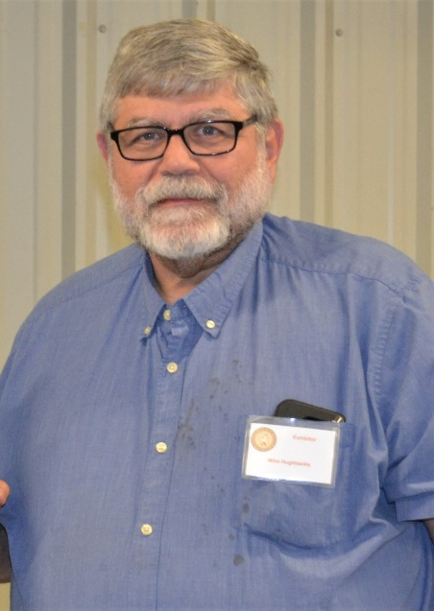
Get to Know a Fellow Carver

Mike Hughbanks has been a member of Rock River Valley Carvers for 13 years. He has lived in Janesville, Wisconsin since September 2005 after moving from Capron, Illinois. He lives with his wife and mother. His mother makes those delicious cookies that many of you have enjoyed eating at RRVC functions.
Mike has been carving for 20 years. He has “tried several kinds of carving from chip carving to carving in the round and also wood burning. I still like to carve whimsies and I’m working on faces.”
Mike’s daughter, Carrie Zulud, has also joined the club and enjoys wood burning. Mike is currently the President of RRVC. He will be stepping down to become the RRVC Webmaster in January 2019. Mike was also a past featured carver.

Update on RRVC Club Website
Every year or so the club is required to renew our subscription with an internet provider by paying them for the privilege to display information about our club and our activities. If we ever decided not to pay these fees, our club wouldn’t be able to communicate to the general public via a website. It is true we have a Face Book site, but it doesn’t allow you to provide the amount of information as a website. For this reason, we as a club have chosen to maintain a website. On average our website has well over a thousand hits each and every month and has for several years. The hits that occur on our website are scattered among Wisconsin cities, often other U.S. states are represented, and occasionally some foreign countries.
So, as a carving club we have spread carving information such as carving tips, talented club members works of art by providing photos monthly, reminded people in the region of upcoming events they may wish to attend, web links to other carving clubs in the tri-state region, monthly you tube videos on a variety of subjects, and list necessary information about our yearly club show and sale. The club website has also allowed the club to accomplish more fully our mission statement of: Informing and educating the general public about wood carving and all the different aspects in which it includes.
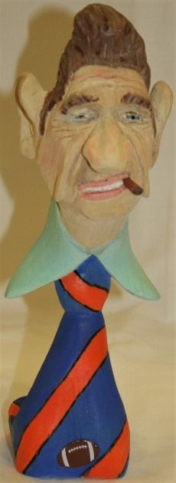
With all of this, there naturally are costs involved. The Rock River Valley Carvers Club did recently make a 3-year commitment to keep spreading the word about wood carving and all of its elements. Our club cost for this 3-year commitment is $439.05 which means per year it will cost $146.35. This yearly dollar figure is $92.68 less then what has been paid in the previous year.
From Vern Morris, Webmaster

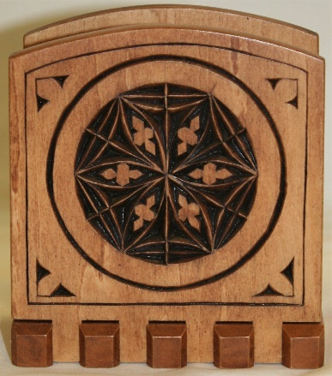
Show & Share

Ray Douglas’ Chip Carved Napkin Holder

Jim Svoboda’s Man with Tie from Jim Trumpy’s class

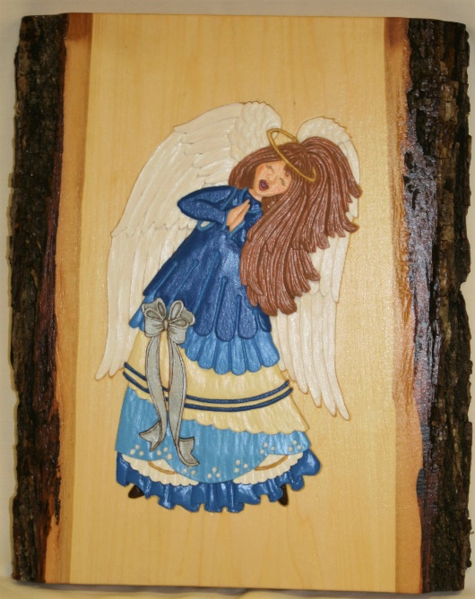
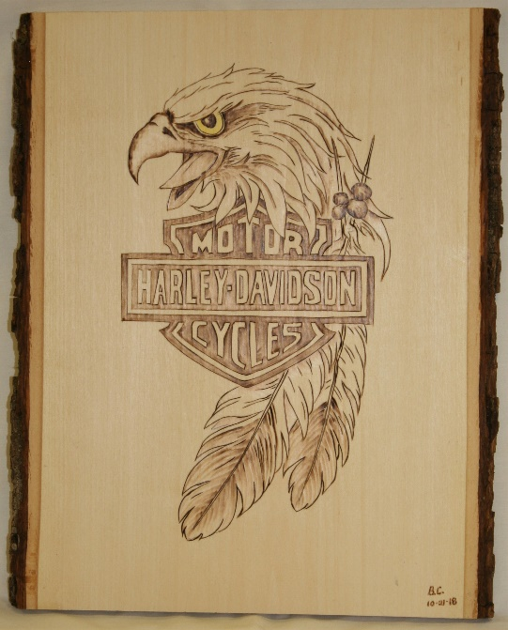
Rosemary Kautz’
Shallow Relief Angel
Bud Cunningham’s Harley Davidson Plaques –
One Wood Burned and One Burned & Colored

