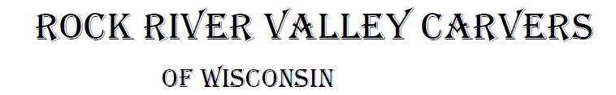
January 2019 Volume 20 issue 1
Editor: Rosemary Kautz Website www.rockrivervalleycarvers.com

December 6, 2018 Meeting

- Call to Order: President Mike Hughbanks called the meeting to order at 7 p.m. 26 club members proceeded to enjoy the Christmas party celebration with baked and fried chicken and numerous delicious sides and desserts brought by our members.
- An amazing magic show was presented by Jerry Cox after our supper. He had everyone scratching their heads trying to figure out how his pet wooden duck chose the 3 playing cards selected by audience members from a full deck and how 3 different length ropes in a closed, clear plastic bag held by Ruth McNally in full sight of everyone turned into 3 ropes of equal lengths. The many magic illusions were enjoyed by all.
- The Christmas ornament exchange was completed to the delight of all. A free raffle of club pins was also held to distribute extra pins found in our club files.
- The election of officers for 2019 followed. The elected officers for next year are:
  - President – Tom Kautz
  - Vice-President – Mark Ludois
  - Secretary – Robin Rios
  - Treasurer – Rosemary Kautz
- Mike Hughbanks will be taking over the web master task as Vern Morris steps down.
- Tom Kautz announced that Reggie James and Brad Crandall had agreed to be co-chairmen for our show in 2019 to a hearty round of applause.

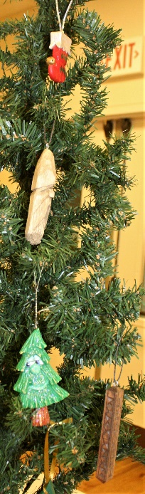
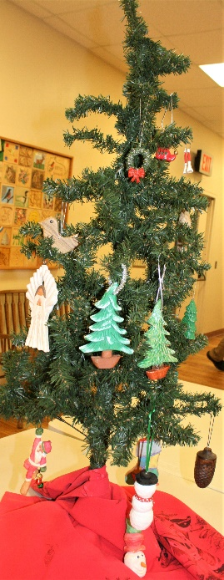

We meet on the
first Thursday of the month
at the Janesville Senior Center, Second Floor
69 S. Water St.
Janesville, WI
Meeting or Carving
begins at 7:15 p.m.
Board Meeting at 6 p.m.
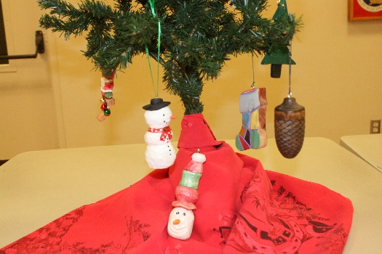

Ornaments carved for our ornament exchange

2019 Officers
President: Thomas Kautz
608-868-4522
Vice President: Mark Ludois
608-371-3838
Secretary: Robin Rios
608-752-3328
Treasurer: Rosemary Kautz
608-868-4522
Librarian: Jim Svoboda
608-554-3268 Editor: Rosemary Kautz
608-868-4522

Tuesday Evening Open Carving Sessions
December 18th and January 15th are our next open carving sessions – no open carving on January 1st! We meet from 6 pm until 8 pm at Trinity Episcopal Church in Ortmayer Hall, 409 E Court St., Janesville. Enter through the door on the west side of the building. Bring something to carve, help new carvers, and enjoy the company of your fellow carvers!

Area Carving Opportunities!
Janesville Senior Center: Mondays & Thursdays from 8:30 – 11:00. Meet and carve with fellow carvers. A wide variety of carvings is always going on. Helpful instruction is available.
Edgerton Senior Center: Tuesday morning carving with Bob Phelps, 9 am until whenever.

Janesville Library Carving
Our next library carving demonstration and promotion of carving will be Sunday, December 16th from 1 to 3 pm. We will also continue the library carving sessions on January 20th and February 17th. If you can assist at the library in January or February, please let Tom or Rosie Kautz know. A decision will be made whether to continue carving at the library after their construction is completed later next year.
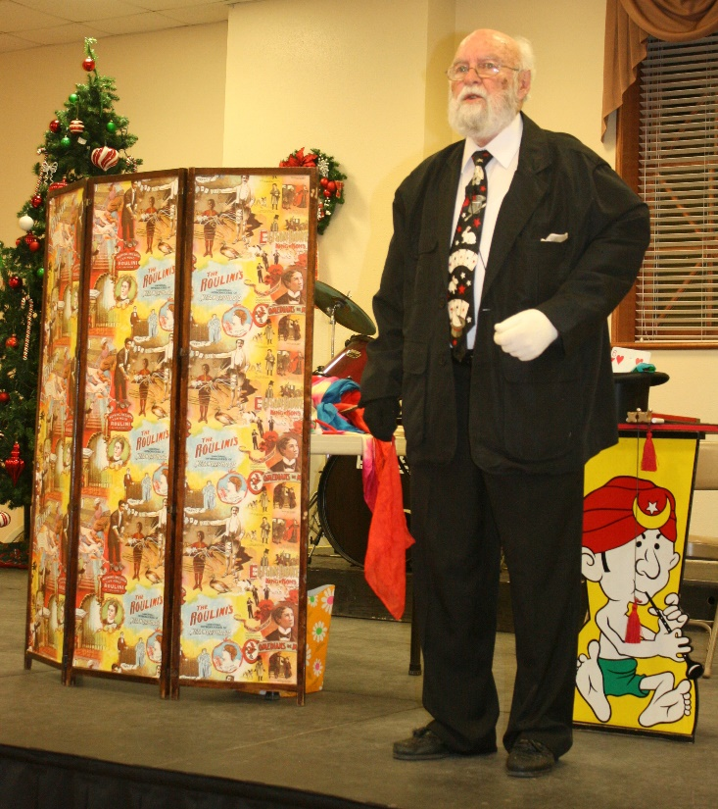
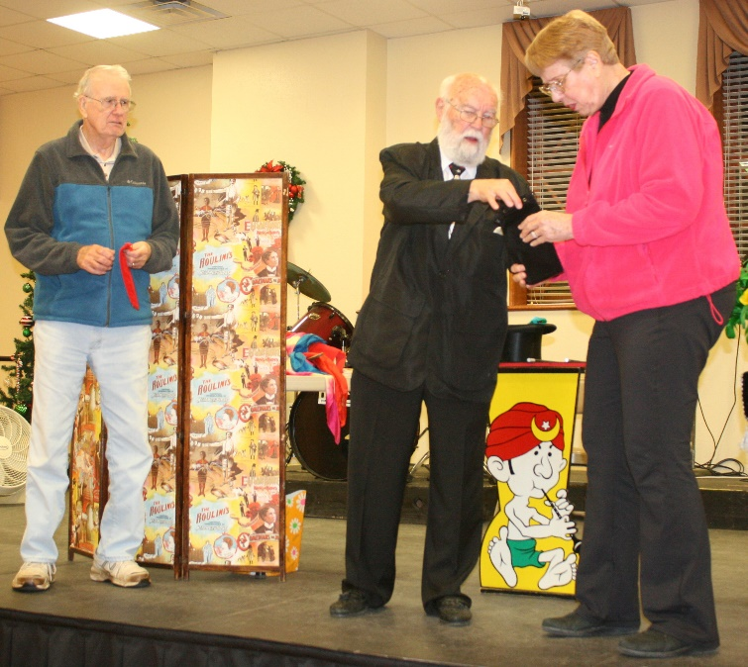

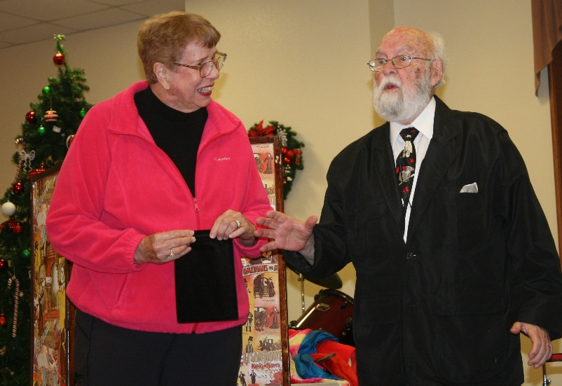
Magician Jerry Cox with
Jim and Rachael Dowd assisting.

Note Received from Jim Dowd: Please extend my heartfelt “thanks” to the RRVC Board of Directors for this years’ ‘Above & Beyond Award.” I was greatly surprised because of the many other members deserving such recognition. I’m happy to have it proudly displayed at home. Sincerely, Jim Dowd

