
ROCK RIVER VALLEY
CARVERS of WISCONSIN, INC.
14th Annual
SHOW AND SALE

Saturday, September 14, 2019
09:00 AM - 4:00 PM

FEATURED CARVER
Rosie Kautz

FREE ADMISSION

Carvers, Vendors, Chain Saw Carver, Demonstrations
People's Choice Awards, Raffle

Rock County Fair Grounds –
Craig Center
1301 Craig Avenue, Janesville, WI. 53545

People’s Choice Competition
All entries for People’s Choice must be at the display tables no later than 9:30 AM
There will be FOUR categories: NOVICE, INTERMEDIATE, OPEN, and PYROGRAPHY.
If you have won a blue ribbon in a category, you must advance to the next category.

All tables must have table covering to the floor, preferably with skirts, plastic or otherwise.
All tables are 6 foot in length.

Show Chairman(s) — Reggie James – (608) 295-0264
Brad Crandall – (608) 931-0188
Reggie – Arjames1972@yahoo.com
Brad – bwkicrandall@gmail.com

www.rockrivervalleycarvers.com
ROCK RIVER VALLEY CARVERS
OF WISCONSIN, INC.
14th ANNUAL SHOW & SALE

SATURDAY, SEPTEMBER 14, 2019
09:00 AM TO 4:00 PM - Please no early dismissals.
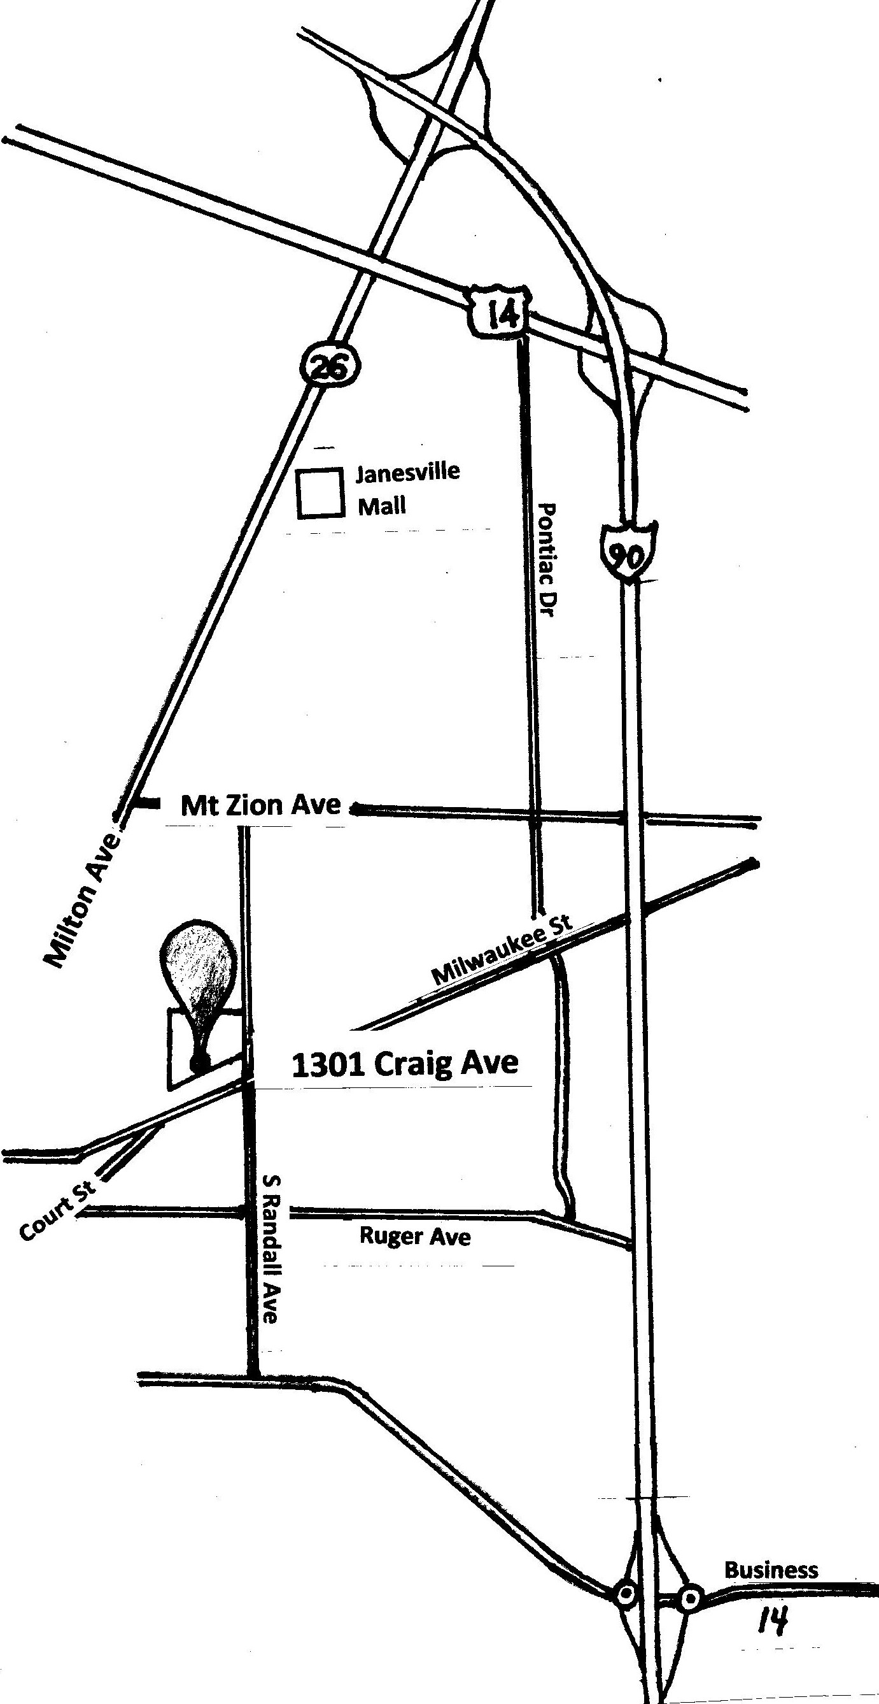
Rock County Fair Grounds — Craig Center
1301 Craig Avenue, Janesville, WI. 53545

DIRECTIONS

COMING FROM NORTH ON I-90,
TURN OFF AT EXIT 171A,
TAKE HWY. 26 (MILTON AVE.) SOUTH,
TURN LEFT ON MT. ZION AVE.,
TURN RIGHT ON S. RANDALL
AND LOOK FOR SIGNS.

COMING FROM SOUTH ON I-90,
TURN OFF AT EXIT 175A
ONTO BUSINESS 14 WEST OR
E. RACINE ST.
TURN RIGHT ON RANDALL AVE.
AND LOOK FOR SIGNS.

COMING FROM EAST ON MILWAUKEE ST., TURN RIGHT ON RANDALL AVE.
AND LOOK FOR SIGNS.

COMING FROM WEST, ON COURT ST.
TO MILWAUKEE ST
TURN LEFT ON RANDALL AVE.
AND LOOK FOR SIGNS.

ROCK RIVER VALLEY CARVERS of WISCONSIN, INC.
14th ANNUAL SHOW and SALE
www.rockrivervalleycarvers.com
Please, no early dismissals.
There will be 7:30 AM entry for set-up time.

Please return this page by mail or email no later than August 1, 2019.

If a confirmation is required by mail, please enclose a self-addressed stamped envelope. Otherwise, the confirmation will be sent to your email address.
Make all checks out to Rock River Valley Carvers or RRVC and return this page to:
Reggie James 2641 Robinson Dr. Beloit Wisconsin 53511

NAME______________________________________________________________

NAME OF GUEST____________________________________________________

ADDRESS__________________________________________________________

CITY___________________________STATE_________ZIP CODE_____________

PHONE NO._____________________EMAIL_____________________________________

TYPE OF CARVINGS_________________________________________________________

Yearly membership in RRVC is $15 per person and $20 per couple.

 | Cost Per Table | Number of Tables | Total Cost
Member Tables | $20.00 or  2 tables for $35
Non-Member Tables | $25.00 or  2 tables for $40
Commercial Tables | $25.00 or  2 tables for $40
Electricity Needed  Yes or No | $0.00
TOTAL

RRVC Photograph, Audio, & Video Release
I hereby grant permission to RRVC the rights of my image, likeness, and sound of my voice as recorded in photographs, audio or video recordings without payment or any other consideration. I understand that this material may be electronically displayed via the Internet or may be used by RRVC in diverse educational settings within an unrestricted geographic area.
This release applies to recordings collected at the RRVC 2019 Show and Sale. There is no time limit on the validity of this release. By signing this form, I acknowledge that I have completely read and fully understand this release and agree to be bound thereby.

Signature: _____________________________________________________

