February 2019 Volume 20 issue 2
Editor: Rosemary Kautz Website www.rockrivervalleycarvers.com

January 4, 2019 Board Meeting Minutes

- Call to Order: President Tom Kautz called the meeting to order at 6:00 p.m. in the Janesville Senior Center conference room. Jim Svobada, Gerry Lesch, Vern Morris, Mike Hughbanks, Tom Kautz, Rosie Kautz, and Robin Rios attended the meeting.
- November & December 2018 Treasurer Report (Rosie Kautz): Each board member received a copy of the report. The beginning balance was $5,776.09, and the ending balance was $5,219.50. The two major expenses were $368.04 for the 3-year RRVC website fee and $150.00 for Jerry Cox, the magician who performed at the Christmas Party. A $185.00 deposit came from membership dues. Vern Morris made a motion to accept the treasurer report as written. Mike Hughbanks seconded the motion. The motion passed.
- Additions/Corrections to December 2018 minutes (Robin Rios): The Christmas party replaced the monthly meeting, so no minutes were taken. The board members have received very positive comments about the program Jerry Cox put on.
- Website Report (Vern Morris): This is Vern’s last report. He will be helping Mike Hughbanks get used to working with the new website over the next three months before he completely steps away from the position. This past month there were 1,216 hits from cities in the United States. The new website program provides only the name of the cities, not the states the cities are in. Vern said he will figure out how to get the state information. The Facebook page received 153 hits. All the show information is up to date on both sites.
- Illness/Sunshine Report (Robin Rios): Cards were sent to Tim Banwell and Gus Helling.

Old Business
- 1st and 3rd Tuesday Evening Open Carving Sessions at Trinity Episcopal Church Ortmayer Hall: Next sessions will be held January 15th, February 5th, and February 19th from 6 pm. to 8 pm.

2019 Officers
President: Thomas Kautz
608-868-4522
Vice President: Mark Ludois
608-371-3838
Secretary: Robin Rios
608-752-3328
Treasurer: Rosemary Kautz
608-868-4522
Librarian: Jim Svoboda
608-554-3268 Editor: Rosemary Kautz
608-868-4522

Make a Friend Today – Carve a Caricature!

We meet on the
first Thursday of the month
at the Janesville Senior Center, Second Floor
69 S. Water St.
Janesville, WI
Meeting or Carving
begins at 7:15 p.m.
Board Meeting at 6 p.m.

- Attendance & New Members: There have been no new members since December 2018.
- Board Member’s Roles and Responsibilities (Dave Thill): Dave is not here tonight to give an update on his progress.
- Get to Know a Carver (Robin Rios): Need to draw a new name tonight at the regular meeting.
- 2019 Show Update: Reggie James and Brad Crandall have volunteered to be co-show chairs. Rosie Kautz has agreed to be the featured carver.

New Business
- Chili Pepper Chairperson: Tom Kautz said we need to find a volunteer to fill this position.
- Carving Demonstrations at Hedburg Library: The last two demonstrations are scheduled for January 20th and February 17th. The library renovation starts soon, and the library will not be hosting demonstrations until after the work is completed. Tom Kautz suggested it would be a good idea to hand out the quarter sheets to advertise the show if they are available. Mike Hughbanks said he could make up some type of flyer on his computer if the sheets are not available.
- Expansion of Reimbursement for Carving Classes: The board discussed expanding the class reimbursement policy to include intarsia, pyrography, and wood turning (that includes pyrography or carving in the turned item) in addition to wood carving classes. Also, the classes could be taken at locations other than Christian Hummul. Club members must submit a receipt from the class they take in order to be reimbursed. Further discussion was tabled until the next board meeting.
- Beginning Carving Class Taught by Ernie Tucker: Ernie will be teaching a three-night introduction to carving class at the Trinity Episcopal Church Ortmayer Hall on Tuesday, February 5th, Tuesday, February 19th, and Tuesday, March 5th from 6 p.m. to 8 p.m. The cost will be $20.00. The fee will include club membership for 2019, a club patch, the monthly club newsletter, wood for the project, and use of the club’s tools. The class will be limited to eight adults, 18 years and older. Rosie Kautz and Robin Rios will get information out to various media sources.
- Additional Items: Rosie Kautz said she needs two volunteers from the club to carry out a financial review of the club's books. Vern Morris suggested that a member of the board, who is not an officer, also take part in the review.
- Adjournment: President Tom Kautz adjourned the meeting at 6:45 p.m. The minutes are respectfully submitted by Robin Rios, Secretary.

January 4, 2019 RRVC Monthly Meeting

- President Tom Kautz called the meeting to order at 7:15 pm. Attendance: 15.
- Treasurer Report (Rosie Kautz): A copy of the report was sent around for members to view. See Board minutes for details.
- Chili Pepper Chairperson: A volunteer is needed to chair this position. Ernie Tucker said he will make the bases, and he will ask Gus Helling to help him. Tom Kautz said Warren Clauss has already volunteered to carve a pepper.
- Get to Know a Carver: Dennis Pryce’s name was drawn.
- Additional Items: Rosie Kautz asked for volunteers to do a financial review of the books. She also sent around a sign-up sheet for the Hedburg Library carving demonstrations scheduled for January 20th and February 17th. Tom Kautz mentioned the Board is discussing making some changes to the carving reimbursement policy and would be voting on it in February. See Board minutes for details.
- 50/50 Raffle (Randy Callison): Ray Douglas was the winner, and he gave his winnings back to the club.
- Adjournment: President Tom Kautz adjourned the business portion of the meeting at 7:37 p.m. The minutes are respectfully submitted by Robin Rios, Secretary.

Tuesday Evening Open Carving Sessions
January 15th, February 5th and January 15th are our next open carving sessions. We meet from 6 pm until 8 pm at Trinity Episcopal Church in Ortmayer Hall, 419 E Court St., Janesville. Enter through the door on the west side of the building. Ernie Tuckers’ class for new carvers will be taking place there on Feb. 5th, Feb. 19th, and March 5th at the same time. The class is advertised on our web site. Local newspapers and radio stations have been contacted to publicize the class also.

Area Carving Opportunities!
Janesville Senior Center: Mondays & Thursdays from 8:30 – 11:00. Meet and carve with fellow carvers. A wide variety of carvings is always going on. Helpful instruction is available.
Edgerton Senior Center: Tuesday morning carving with Bob Phelps, 9 am until whenever.

Janesville Library Carving
Our next library carving demonstrations and promotions of carving will be Sunday, January 20th and February 17th from 1 to 3 pm. If you can assist at the library in January or February, please let Tom or Rosie Kautz know. A decision will be made whether to continue carving at the library after their construction is completed later next year.

Shows & Seminars Coming Up
April 13: Sheboygan, WI Kettle Karvers Annual Woodcarving & Wood Sculpture Show at Lakers Ice Center, 1202 S Wildwood Ave, open 10 to 4, Bob Lawrence, 920-458-4947, www.kettlekarvers.org
May 5: Oshkosh, WI Mid-Wisconsin Chippers Show, Competition & Sale, Oshkosh Convention Center, 2 N Main St, 9am to 4 pm, https://midwisconsinchippers.weebly.com
June 8-16: Maquoketa, IA International Woodcarvers Congress Competition at Jackson County Fairgrounds, 1212 E Quarry St, 10-5 daily, 10-4 Sunday, www.awcltd.org

Help Us Showcase RRVC at the Senior Center
The Janesville Sr. Center is holding an Open House on Wednesday, March 27th. This gives our club has the opportunity to promote our club and talk to prospective new members. We are looking 1-3 people from 9 am to noon and 1-3 people from noon to 3 pm. to promote our group and demonstrate carving. If you can help us out, please contact Tom Kautz, 608-868-4522 or rosietom@centurytel.net.

The 2019 Schedule of Important Carving Dates to Remember is also being sent out with this newsletter for your convenience. Tom Kautz prepared this for our members. He hopes this will be of use.

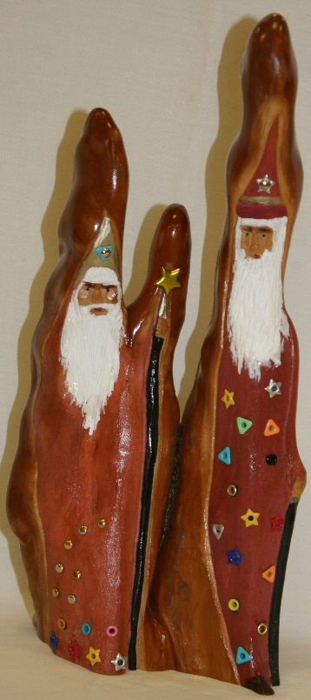
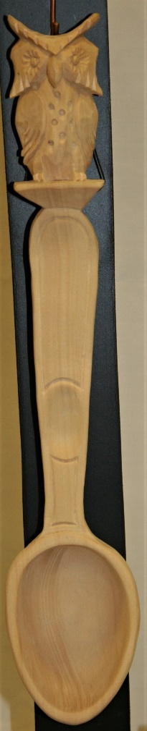
Show & Share
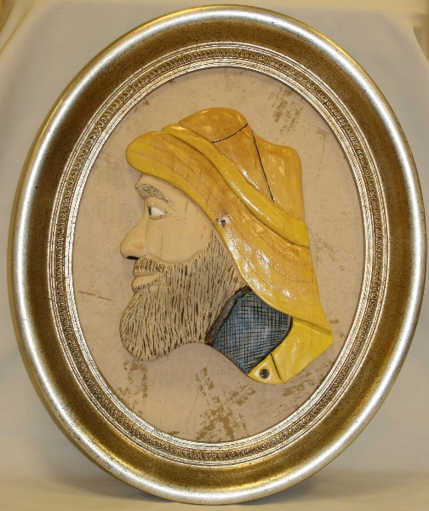
Jim Svoboda’s Sea Captain relief carving

Jim Svoboda’s Cypress Knee Magic Wizards

Tom Kautz’ Owl Scoop
In progress

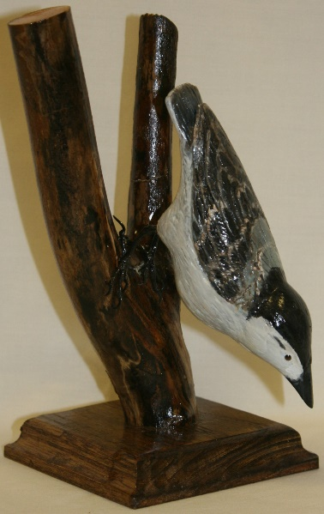
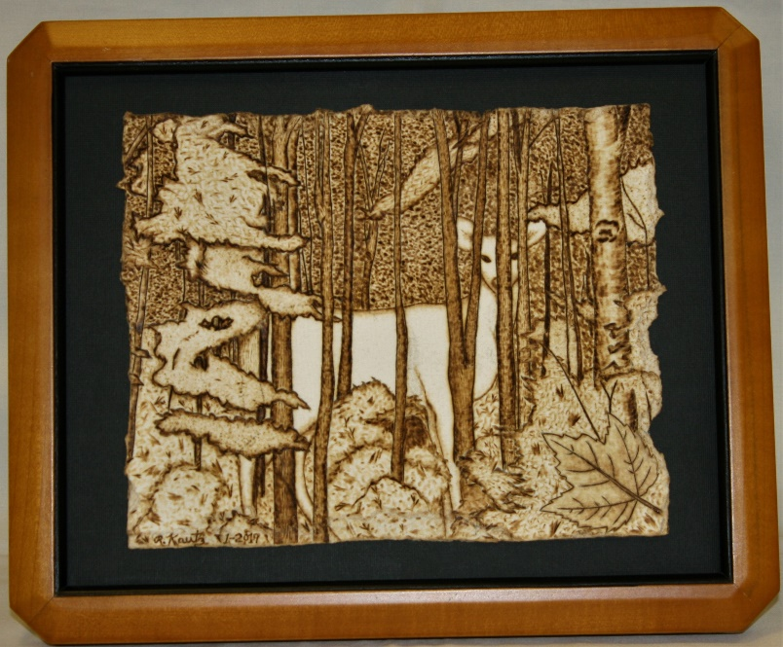

Rosie Kautz’ Ghost Deer, far left, on watercolor paper

Bud Hilgendorf’s
Nuthatch

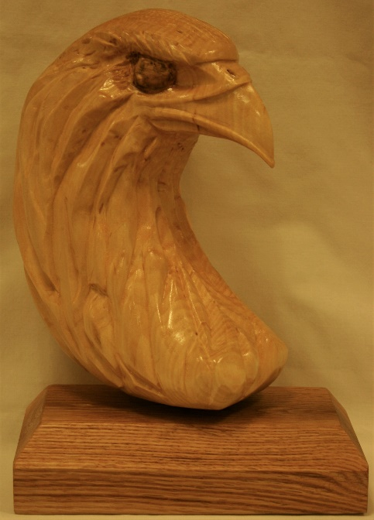
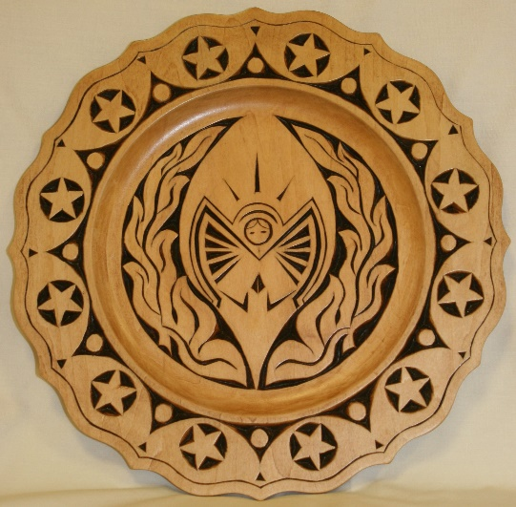
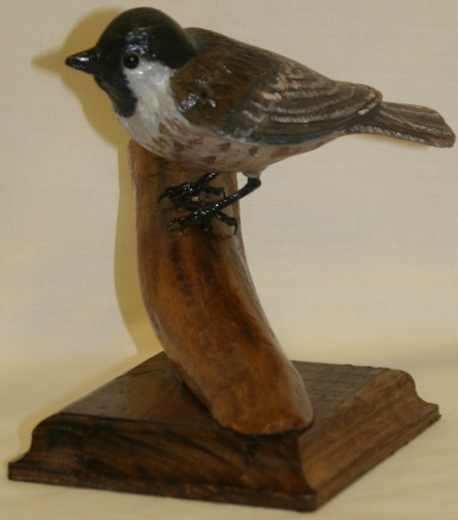
Ray Douglas’ Chip Carved
Angel Plate
Bud Hilgendorf’s
Black-Capped Chickadee
Randy Callison’s Eagle Head

