April 2021 Volume 22 issue 4
Editor: Rosemary Kautz Website www.rockrivervalleycarvers.com

Club Information Updates

- Treasurer’s Report (Rosie Kautz): Beginning balance was $6,376.08 and our ending balance was $6,290.69. Income included $15.00 paid for 2022 dues. Expenses were $45.39 for newsletter ink and $55.00 for newsletter stamps.
- Sunshine Cards (Rosie Kautz): ‘Get Well’ cards were sent to Karen (Brad) Crandall and Carol (Bud) Hilgendorf.
- 2021 Carving Show (Brad Crandall): The Craig Center is currently operating at 50% capacity, which is approximately 400 people. Brad has informed the county that we are interested in reserving the Craig Center for next year, but he is also looking into possible other locations (maybe in Beloit). Sign up for your table(s) soon (prices go up after August 1). Start planning for your entry into the People’s Choice contest now! Remember that we will need carved Christmas ornaments for the club sale and will also be looking for raffle donations.
- Sr. Center Update (Rosie Kautz): The Janesville Senior Center will not be open again until June 1 at the earliest. The HVAC system is being replaced (heating and air conditioning) and will not be completed until then. Access for activities may be limited to a set number of people per time. The roof will also be worked on in June and July. If the center is open, it will be noisy inside during those months.

Show Cancellations:
Sheboygan Show on April 24 has been cancelled
Oshkosh Show on May 8 has been cancelled
Woodcarvers’ Congress in June has been cancelled

2021 Officers
President: Thomas Kautz
608-868-4522
Vice President: Mark Ludois
608-371-3838
Secretary: Mark Ludois
608-371-3838
Treasurer: Rosemary Kautz
608-868-4522
Librarian: Bud Cunningham 608-853-1777
Editor: Rosemary Kautz
608-868-4522

As Soon as You Start Carving,
The Phone Will Ring

We normally meet on the
first Thursday of the month
at the Janesville Senior Center, Second Floor
69 S. Water St.
Janesville, WI
Meeting or Carving
begins at 7:15 p.m.
Board Meeting at 6 p.m.

Notes from the President’s Carving Bench

- Please consider signing up for the members only miniature carving contest of a 2x2x5” block. (See Member Challenge on the next page.) There will be a cash prize awarded and a mystery/artist will be doing the judging. Call or see me if you have any questions and to sign up.
- As weather permits, we could be carving outside at Walt Lindeman’s Sportsman’s Park or we may be able to use the indoor facility at Faith Community Church on Janesville’s northeast side. Adherence to CDC gathering restrictions and requirements will be necessary.
- We will be checking back with St. John Vianney Parish on having evening carving sessions the first and third Mondays, 6:30 to 8:30 pm., in Marian Hall. Details are being developed. The site is air conditioned for comfort and lighting will be good. We will of course, have to clean up after ourselves. Adherence to CDC gathering restrictions and requirements will be necessary.
- Be sure to sign up and participate in our September 11, 2021 Show and Sale! See Brad Crandall for details.
- Look for details in the local press and on our web site for information on the future reopening of the Janesville Senior Activity Center. Sometime after June 1, as restrictions are lifted, we look forward to being able to gather there again for Monday and Thursday carving (9-11 am) and for our monthly meetings. Adherence to CDC gathering restrictions and requirements will be necessary.

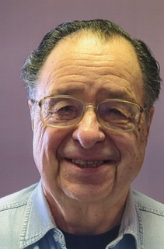
Get to Know a Fellow Carver
Warren Clauss lives in Waukegan, Illinois. He enthusiastically agreed to be interviewed for the RRVC Newsletter. Please enjoy reading his story below in his own words:
I started carving in 1992 after visiting a carving show in Racine, Wisconsin put on by Ducks Unlimited and Dremel. It was the last show they put on, but it attracted many well-known carvers. I said, I can do that! In 1992, Woodcuts opened a woodcarving and woodturning business just north of Racine which gave lessons. I signed up. It was a power carving class, in which we did a kestrel, which I still keep hidden in the attic.
I don’t know exactly when I joined RRVC (about 10-12 years ago). But I have shown at every show except the first one, and we did visit that one.
Most of my work is done by power carving. After my retirement, I started carving with a knife with a group of about 15 people. My favorite items to carve are owls, but if you know me you already knew that.
Over the years I have taught about ten power carving classes. I have had the opportunity to take classes with a few of the great bird carvers.
I have been retired for the last 11 years having spent most of my adult life working as a Jeweler, Goldsmith, and Stone Setter.
Barbara and I have been married for 62 plus years. We have seven children, six girls and one boy. We have 24 grandchildren and 13 great-grandchildren. All but one of the children live within 15 miles of us, so you know we stay busy.
(Article submitted by Robin Rios.)

Member Challenge
All RRVC members have the opportunity to challenge themselves to carve a miniature. Judging will occur at our show and an anonymous donor has provided a $25 cash prize. The club will provide a basswood blank, 1 15/16”x1 15/16”x 4 ¾” tall. Finished carvings must fit inside the official judging box, 2”x2”x5” tall. Any family-friendly subject is ok. It can have a clear finish, painted finish, or pyrography. Contact your club president for your block of wood. If you want to use your own wood (basswood or another species), contact the president to register, but remember that the finished carving must fit inside the official box.

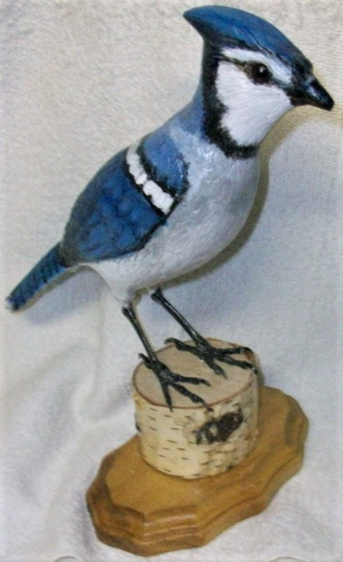
Club Members’ Carvings
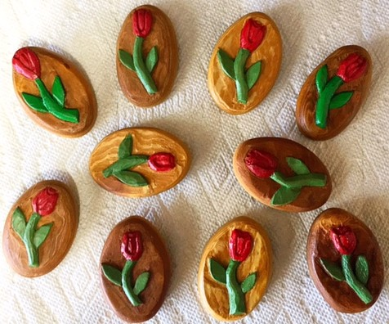
Bud Hilgendorf’s
Blue Jay

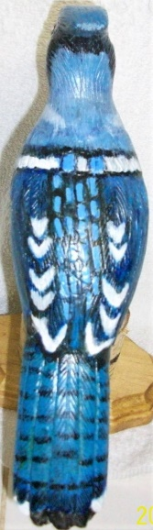
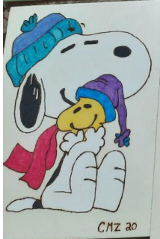
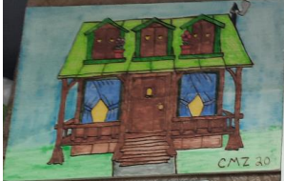
Carrie Zalud’s Woodburned House
Ernie Tucker’s Broches
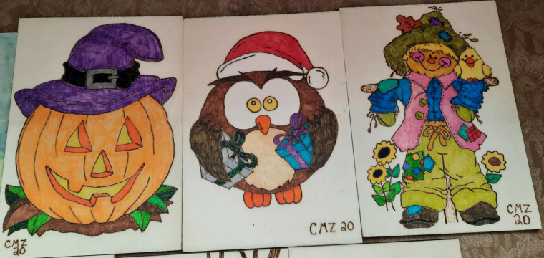

Carrie Zalud’s Snoopy Woodburning

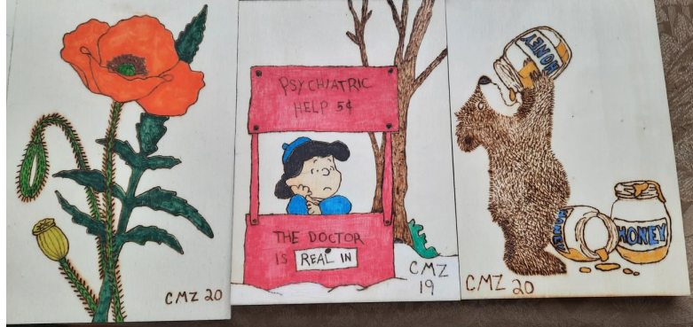
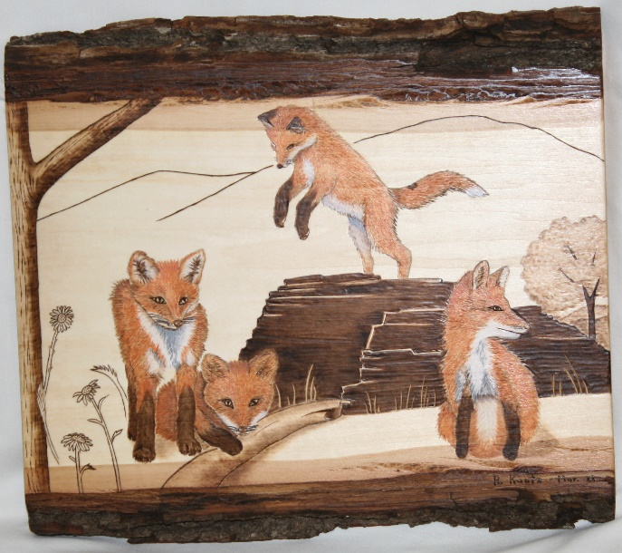
Carrie Zalud’s 6 Woodburned Panels above

Rosemary Kautz’ Fox Kits Woodburning – “Incoming!’

