August 2021 Volume 22 issue 8
Editor: Rosemary Kautz Website www.rockrivervalleycarvers.com

July 6, 2021 RRVC Monthly Meeting
- Called to Order at 6:15 pm
- Introduction of Visitors/New Members: Wendall Lawyer attended and is interested in learning to carve. Welcome Wendall.
- Illness/Sunshine Report (Rosie Kautz): Cards were sent to Mark Ludois (get well), Ed Hogue (sympathy), and Pat Beggs (sympathy).
- Treasurer Report (Rosie Kautz): The only expense in June was $100 to rent the county park for our summer picnic. Beginning balance was $5,975 and ending balance was $5,875. Rosemary reminded everyone that due for 2021 are not owed if you paid for 2020.
- ‘Get to know a Fellow Carver’: No new names were drawn at the meeting.

New Business
- Evening Open Carving Sessions (Tom Kautz): The first and third Tuesdays of the month we will meet at First Lutheran Church from 6-8 pm. Remember to bring a table cover with you if you are carving.
- Senior Center Update (Tom Kautz): Masks are no longer required if you are fully vaccinated. You may bring in beverages in covered containers. Evening rental for meetings is still not possible.
- Show Update (Tom & Rosie Kautz):
  - Friday Setup – Half day rental of the Craig Center begins at 2 pm this year or full-day rent (an additional $300) is required to begin setup at noon. After discussion, Ernie Tucker made a motion, and Bud Cunningham seconded, that we begin setup at 2 pm instead of paying the additional rent. The motion passed.
  - A new Chairman for the show in 2022 is still needed. Please consider stepping up to assume this important role for our club.
  - Cane Segments and Christmas Ornaments are needed. Mike Hughbanks said that Carrie Zalud will make a cane segment.

2021 Officers
President: Thomas Kautz
608-868-4522
Vice President: Mark Ludois
608-371-3838
Secretary: Mark Ludois
608-371-3838
Treasurer: Rosemary Kautz
608-868-4522
Librarian: Bud Cunningham 608-853-1777
Editor: Rosemary Kautz
608-868-4522

Carvers don’t make mistakes – they just carve variations!

Normal meetings on the
first Tuesday of the month
at the First Lutheran Church, Across from Fairgrounds
612 N Randall Ave.
Janesville, WI
Meeting or Carving
begins at 6 p.m.

- Chili Peppers: We have 17 volunteers making chili peppers. Mark will have them mounted and they need to be turned in by August 1st.
- July Picnic July 8th (Rosie Kautz): Carver Roehl Park is rented beginning at 4 pm. Bring your place setting, a dish to pass, and your spouse. Rosie will bring the fried chicken around 5 pm.
- Tallman Art Festival August 1 (Tom Kautz): We are registered for 2 booths as in past years. We did not have to pay anything since they applied our payment from last year to this year.
- Kauffman’s Saturday Markets (Tom Kautz): Brad Crandall has the last 2 Saturdays in July and in August reserved for one EZ Up to promote our show and club. Contact Brad to volunteer to attend and help him out.
- Fermenting Cellars Art Show (Tom Kautz): The Janesville Art League is sponsoring the show on Saturday, July 17 west of Milton. We can promote our show and also sell items. Show runs from noon to 5 pm, setup after 10 am. Eight club members volunteered to participate.
- Next Meeting will be August 3rd at First Lutheran Church, 6 pm, and wood vendor, Dell Lore from Illinois will be there. He will have basswood, butternut, walnut, cherry, catalpa, pine, and cottonwood bark for sale. The Madison, Edgerton, and Rockford carving clubs will be notified.
- Show & Share
Meeting adjourned. Minutes respectively submitted by Rosie Kautz.

Club Meeting Information Update
Evening Carving – Open carving from 6-8 pm on the first and third Tuesdays each month will be at First Lutheran Church (across from the fairgrounds) in Fellowship Hall located at 612 N. Randall Ave. Park in back and enter through the doors under the canopy. Take the first left to the room. Handicapped accessible. Table covers and masks are required at this time. The building is air conditioned and woodburning can be done at certain tables.

Shows & Seminars Coming Up and/or Canceled
September 11: Our Show & Sale in Janesville
September 18-19: Stevens Point, WI 20th Annual Show, Competition, and Sale of the Wisconsin River Woodcarvers, Holiday Inn, 1001 Amber Ave, Stevens Point, WI., Saturday 9-5, Sunday 9-4, admission $5 (under 13 free), Ron O’Kray (715) 570-2534 or Greg Wirtz (715) 323-2035, www.wisconsinriverwodcarvers.org

Tool Glossary (from Jim Svoboda) …
Hose Cutter – A tool used to make hoses too short.
Table Saw – A large stationary power tool commonly used to launch wood projectiles for testing wall integrity.
Drill Press - A tall upright tool useful for suddenly smacking flat metal bar stock out of your hands that smacks you in the chest and flings your canned drink across the room, splattering it against the window you just replaced.

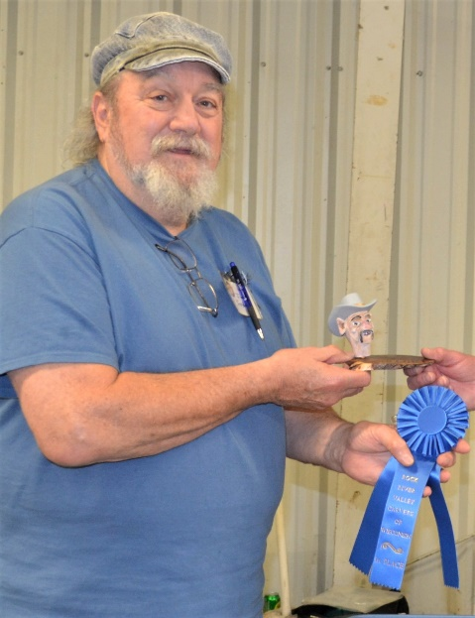
Get to Know a Fellow Carver
Jim Svoboda in his words: I started carving in 2016 at the Janesville Senior Center.
I like carving anything that doesn’t need fine details. I’m more of a freestyle carver. See something and put my own spin on it, which is great for caricatures and flat plane. They are my favorites. I have also carved a trademark tree for the Elder Care Office down the street from the Senior Center.
When we were on vacation in Mesa, AZ in 2020, just before Covid hit, I took first in my division with my wood motorcycle which gave me a 3rd place overall in the Novice Class. I plan to enter in the “Desert Woodcarving Show” in Mesa, AZ again this year.
I did get a carving in the “Chip Chats” magazine for September-October 2020 for a rough out from the Caricature Carvers of America. I have been carving with three different groups from Sandwich, DeKalb, and Sycamore. That should be opening again soon because Illinois is finally opening up. I have been a member of RRVC since 2016.
I was an employee of the US Postal Service for 35 years. I spent half the time in St. Charles, IL and the rest in Gilbert, AZ. I retired in 2005 and moved to Lena, IL and waited for my wife of 35 years to retire. Leona retired from her position as a Junior High School Teachers’ Aide in Special Education in 2012. She is an avid card maker, as you know. We had big plans to attend a lot of the woodcarving shows and vacations for 2020, but that all fell apart with Covid.
In May, we did order a new 2022 Camaro Convertible, but as everybody knows, there’s a big computer chip shortage. We got our vaccinations and are waiting until America opens up to travel. I am currently teaching my son, Chris, how to carve. Leona and I each have two children, each a boy and a girl from our previous marriages. So, four kids later, we now have five grandkids and nine great grandkids.
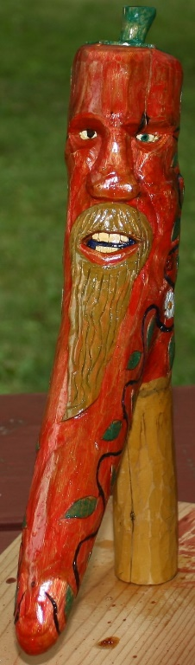
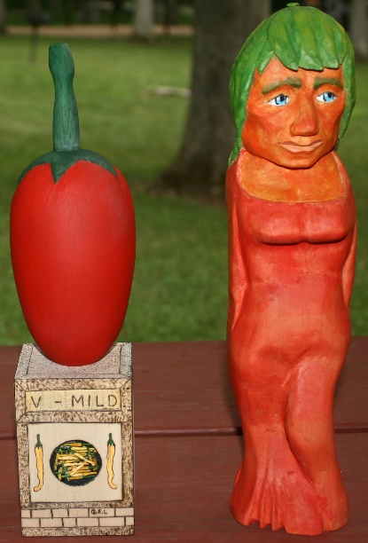
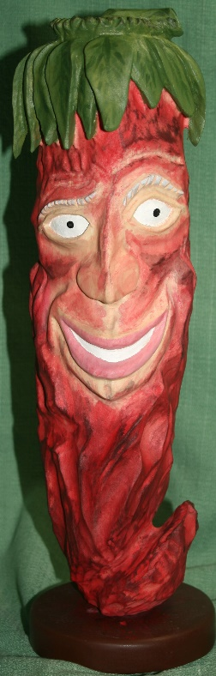
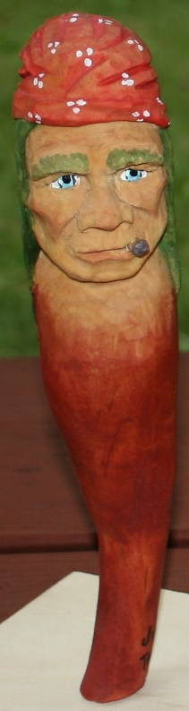
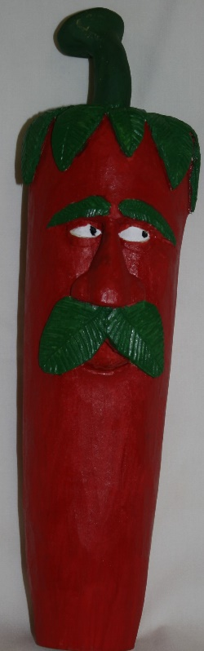
Club Members’ Carvings
Fred Wuthrich’s Bearded Pepper (left)

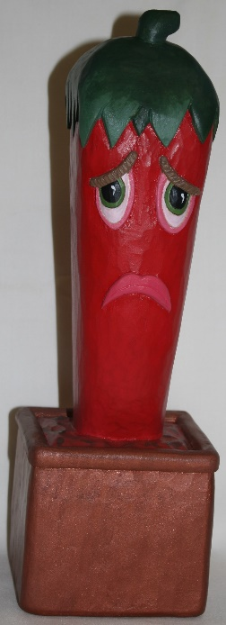

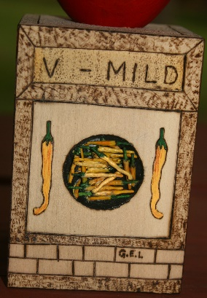
Rosie Kautz’ Sad Pepper
(right)

Chili Peppers by Tom Kautz, Jim Trumpy, and Mike Hughbanks (above). Pepper on cube, with carved mini peppers by Gerry Lesch, and Girl Pepper by Jim Trumpy.

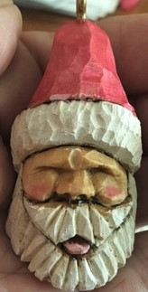
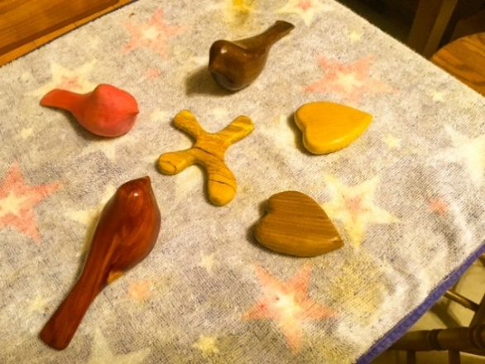
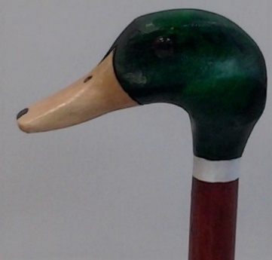
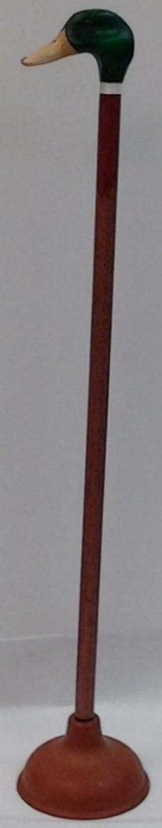
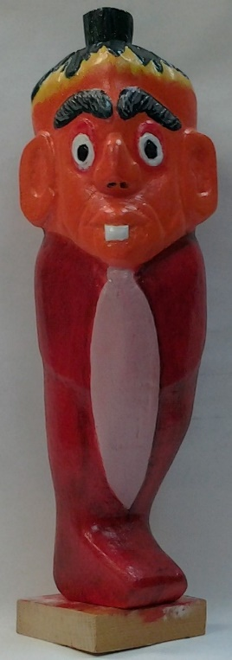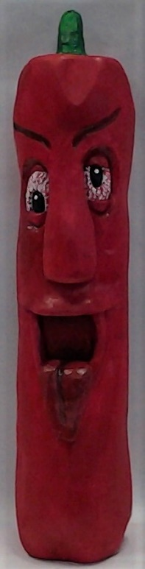
Ernie Tucker’s Comfort Birds, Cross, and Hearts and
His Santa Ornament below
Bud Hilgendorf’s Pepper with a tie and
John Eiden’s Pepper sticking out his tongue
John Eiden’s Duck Head Cane
for those needing extra stability
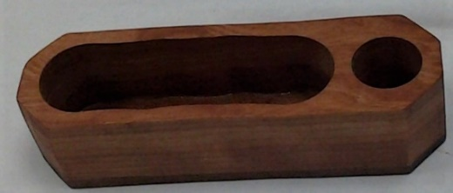
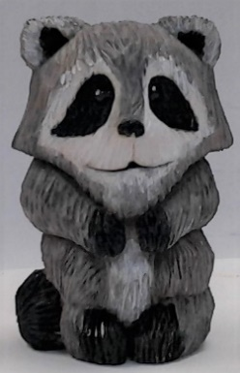
Ernie Tucker’s Olive Server

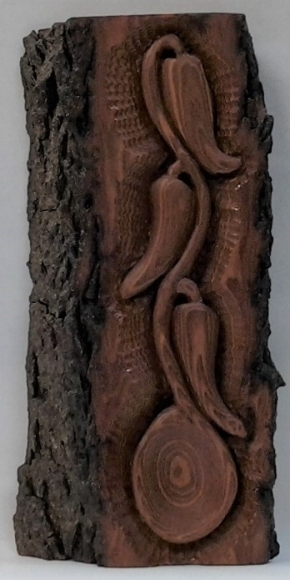
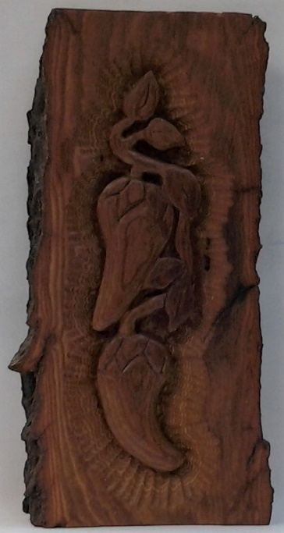
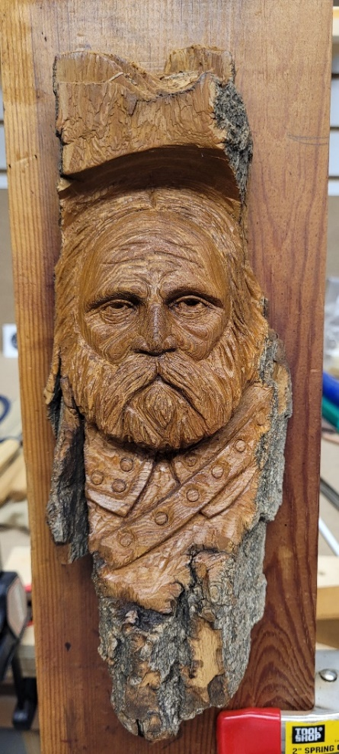
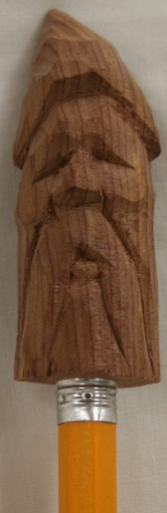
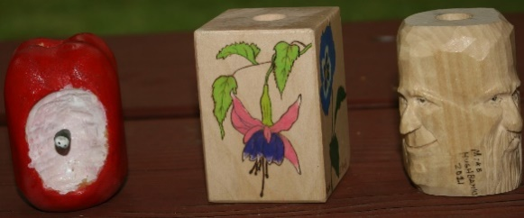
Cane Segments by Randy Callison, Rosie Kautz, and Mike Hughbanks (above, left to right)

Ernie Tucker’s Pencil Man and John Eiden’s Racoon (above)

Denny Pryce’s 2-Sided Bark Peppers
John Raisbeck’s Viking Warrior

