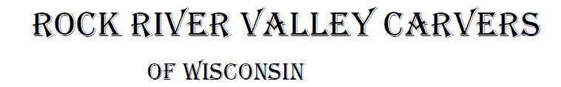
December 2021 Volume 22 issue 12
Editor: Rosemary Kautz Website www.rockrivervalleycarvers.com

November 2, 2021 RRVC Monthly Meeting
- Called to Order at 6:13 pm
- Introduction of Visitors/New Members: None present
- Illness/Sunshine Report (Rosie Kautz): A ‘Thinking of You/Get Well’ card was sent to one of our newest members, Keith Bowman.
- Treasurer Report (Rosie Kautz): Beginning balance was $6,480 and ending balance was $5,775. The main expense was $687 for 3 years web site renewal and security. Plus $38 went to purchase chili pepper replacement wood for next year from Bernie Fields’ estate.

Current Business
- 2022 Show Chairman or Chairmen Needed – Brad Crandall offered to be show chairman again next year and Mike Hughbanks offered to assist Brad.
- Chili Peppers (Tom Kautz): Chili Mania wants chilis carved again next year. A coordinator for assembling and collecting the peppers is needed. Contact Tom Kautz to volunteer.

New Business
- Moving Show in 2022 or 2023 to First Lutheran Church (Vern Morris): The church has a committee looking into pricing for renting space at the church with their rising utility costs in mind. They hope to have the rental policies finalized by Thanksgiving or the end of this year. Vern will check with the church on the availability of rectangular tables and will only be serving as a contact for us with the church. We would have to change the date of our show in 2022 because of a scheduled church function the second weekend of September. Rosie Kautz will contact the church regarding the exact date and discuss use of the kitchen for the show.
- 2022 Slate of Officers (Tom Kautz): Election of new officers will take place at our meeting/Christmas Party December 7.

2021 Officers
President: Thomas Kautz
608-868-4522
Vice President: Mark Ludois
608-371-3838
Secretary: Mark Ludois
608-371-3838
Treasurer: Rosemary Kautz
608-868-4522
Librarian: Bud Cunningham 608-853-1777
Editor: Rosemary Kautz
608-868-4522

Wearing Your Halo Too Tight Gives Others a Headache!

Normal meetings on the
first Tuesday of the month
at the First Lutheran Church, Across from Fairgrounds
612 N Randall Ave.
Janesville, WI
Meeting or Carving
begins at 6 p.m.

- Carving Demo/Class at The Gathering Place (Tom Kautz): Carvers are needed to demonstrate and conduct a carving class at the senior center in Milton on Thursday, February 24 next year. 5 carvers are needed to each teach 2 beginning carvers an easy owl. Set up would be at 1:30 prior to the 2 pm fishing club meeting. The class would be from 2:30-4:30 pm. Jim Trumpy stated that he conducted carving classes at Milton in the past and suggested we look into having regular carving sessions in Milton in the future. Brad Crandall stated that he had a pattern for carving a simple fish and maybe that would be appropriate for the class as it is being sponsored by the Milton Fishing Club.
- May 2022 Library Display (Tom Kautz): We will be able to display members carvings and wood burnings at Hedburg Public Library in May 2022. Tom will contact the library to get more details.
- Next Meeting/Christmas Party (Tom Kautz): Tuesday, December 7 we will have our Christmas party at First Lutheran Church at our regular meeting time, 6 pm. The club will provide fried chicken. Please bring a dish to pass, your place setting, and something to drink (non-alcoholic). If you wish to participate in the ornament exchange, bring a carved ornament. Contact Tom or Rosie Kautz to let them know if you will be attending so the right amount of chicken can be ordered.
- Wild Fowl Magazine (Brad Crandall): Brad announced he had a limited time promotion from Wild Fowl Magazine offering a subscription at half price ($19.94 for 4 issues). He stated that it is a great resource for bird carvers with information on power carving, wood burning, and painting birds.
- Next Meeting: Tuesday, December 7 – Christmas Party!
Meeting Adjourned - Minutes submitted by Rosie Kautz

Club Meeting Information Update
Evening Carving – Open carving from 6-8 pm on the first and third Tuesdays each month will be at First Lutheran Church (across from the fairgrounds) in Fellowship Hall located at 612 N. Randall Ave. Park in back and enter through the doors under the canopy. Take the first left to the room. Handicapped accessible. Table covers are required for carvers. The building is air conditioned and woodburning can be done at certain tables.

Notes From the President’s Carving Bench
Our club needs nominations or volunteers for the board position of Secretary, plus someone to be chili pepper chair. The following individuals will be voted on as officers at our December meeting along with any other person nominated or volunteering: Tom Kautz, president; Mike Hughbanks, vice-president; Rosie Kautz, treasurer; Bud Cunningham, librarian; Rosie Kautz, editor; Gerry Lesch and Dave Thill, members at large. Many thanks to Mark Ludois for serving as vice-president and secretary the past 2 years.

Club Christmas Party on December 7
We have permission to hold our annual Christmas party on December 7 at First Lutheran Church in Fellowship Hall at 6 pm. The club will provide fried chicken. Please bring a dish to share, your own plate, napkin, and silverware, and something to drink. We will do an ornament exchange for everyone who wishes to participate and brings a carved or woodburned Christmas ornament. We will need to clean up and take recyclables and trash to the dumpsters afterwards.
Please contact Rosie or Tom Kautz to let them know if you will attend (608-868-4522).
With lower-than normal meeting attendance, we don’t want to purchase too much chicken.

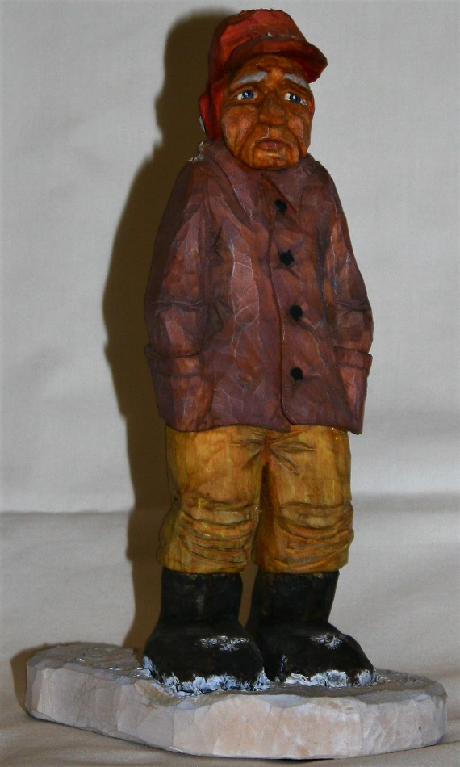
Club Members’ Carvings
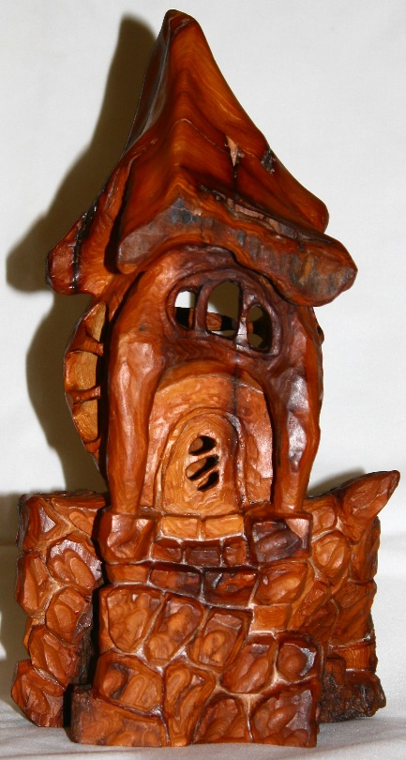
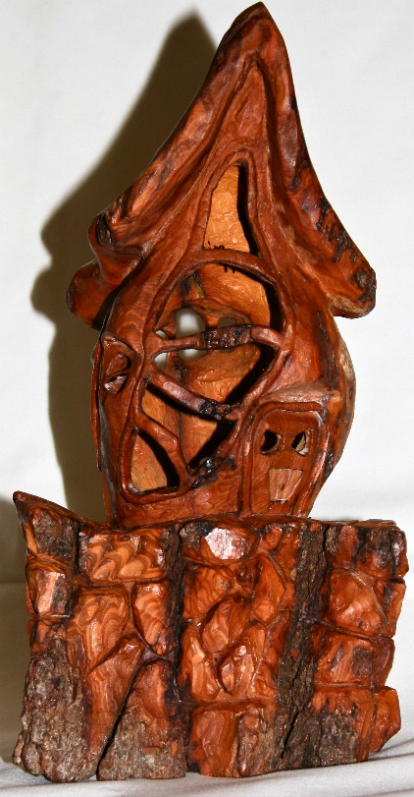
Jim Trumpys’ Snowman. Snow on boots
and hat is Liquitex modeling paste with added titanium white paint.
Jim Trumpys’ Bark House (front and back) finished with Def Min Wax. After application, wax is wiped off and then buffed with a brush.

Have you checked out our clubs’ Facebook page lately?
Check it out to see many beautiful carvings!

