December 2020 Volume 21 issue 12
Editor: Rosemary Kautz Website www.rockrivervalleycarvers.com

IMPORTANT MESSAGE:
There will be No Monday and Thursday morning carving sessions
No Tuesday evening carving sessions
No monthly meetings for now. The Senior Center is closed.

Notes from the Presidents’ Carving Bench
- Please STAY SAFE! News of a safe and effective vaccine look to be coming soon. I hope your Thanksgiving goes well and I wish a wonderful Christmas to all.
- Keep carving and send in your photos of completed projects to Rosie for the next newsletter.
- After the new year begins, our club may be able to lineup an indoor, air-conditioned site for night/evening carving sessions. It looks like Marion Hall at the St. John Vianney parish campus will be useable. More information will come as things firm up.
- The Board will be considering options regarding annual dues in light of the Covid situation.
- A list of items donated by Ruth Banwell, Tim Banwell’s spouse, is included with this newsletter. Some items will be used as raffle prizes at our show and others will be up for sale to members. Stay tuned for more information after we can all be together again.
- FREE WOOD: Sharon Riese in Monroe, WI has some basswood that has been stored indoors for about 20 years. She has one 2 x 7-foot-long log and one 10” x 3-foot-long log. Please contact her directly at 558-1848 if you are interested.
- FREE WOOD: Sharon Powell has some black walnut logs available for the taking. They are approximately 11” in diameter and she has some 12 feet, 8 feet, and 6 feet long. She can be contacted at 262-725-7121 or 262-903-1114 (cell). She lives in Illinois, but the wood is located in Delevan, WI at N2479 Mildred, just off Shore Dr, east of the lake near the old Millie’s Restaurant.

2020 Officers
President: Thomas Kautz
608-868-4522
Vice President: Mark Ludois
608-371-3838
Secretary: Mark Ludois
608-371-3838
Treasurer: Rosemary Kautz
608-868-4522
Librarian: Bud Cunningham 608-853-1777
Editor: Rosemary Kautz
608-868-4522

If Things Get Any Worse, I’ll Have to Ask You to Stop Helping

We normally meet on the
first Thursday of the month
at the Janesville Senior Center, Second Floor
69 S. Water St.
Janesville, WI
Meeting or Carving
begins at 7:15 p.m.
Board Meeting at 6 p.m.

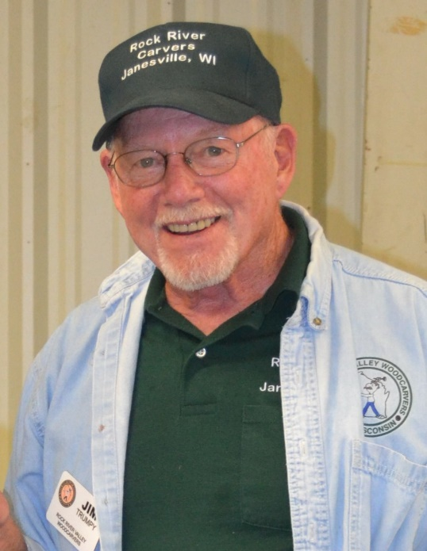
Get to Know a Fellow Carver

Directly from Jim Trumpy: “Sharen & I have been married for 60 years. We had 2 sons along the way, 4 grandchildren and 6 great-grandchildren. In 2000, I retired from General Motors after 32 years. In 1997, while taking a carving class at Blackhawk Tech, I heard about the club and joined. Over the years I have taken classes in all kinds of woodcarving, enjoying every one of them. The people that we've met and the places we went will always be special memories. Woodcarvers are great people and we learn from each other.

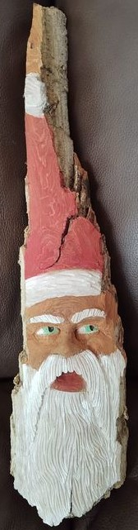

A Few Carving Tips to Keep in Mind
(submitted by Ron O’Kray from the Wisconsin River Woodcarvers Club)
- Remember that there are no dumb questions
- Don’t carve in just one area. Move around on your carving.
- Don’t carve when you’re tired.

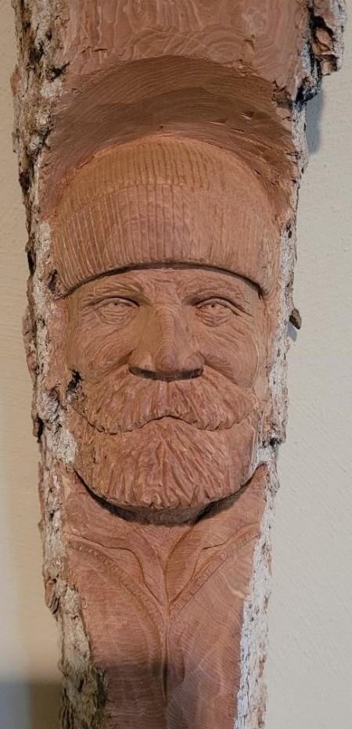
Club Members’ Carvings
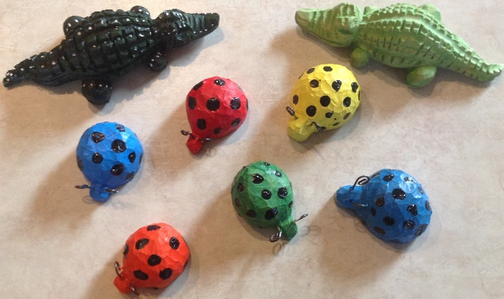
Ed Hogue’s Bugs and Alligators

John Raisbeck’s’ Weathered Sailor
and
Mike Hughbanks’ Bark Santa
(far right)

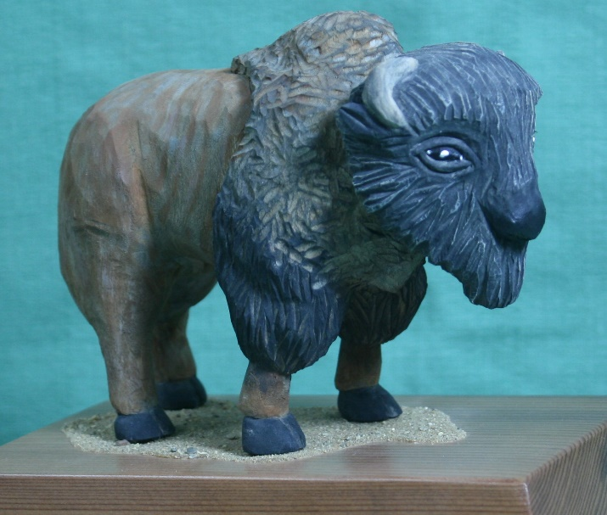
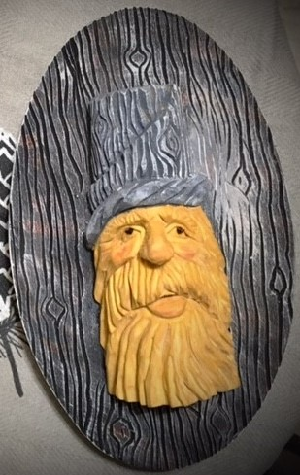
Tom Kautz’ American Bison

Ernie Tuckers’
Wood Spirit

Ed Hogue’s Sewing Display with carved
buttons, pin cushion, and part of the sewing machine

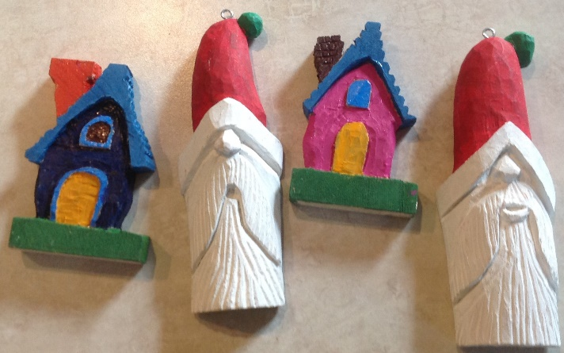
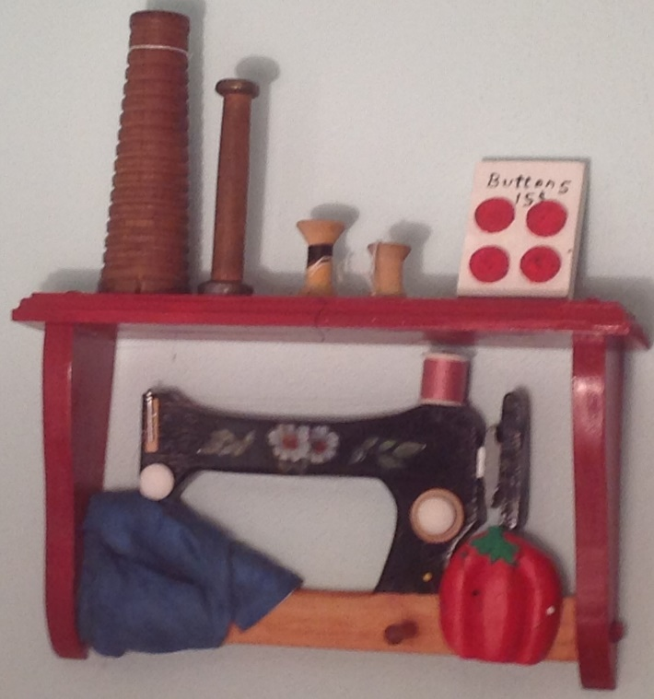
Ed Hogue’s Santa’s and Houses
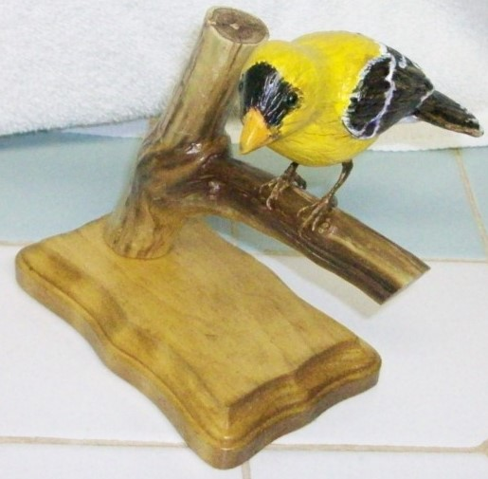

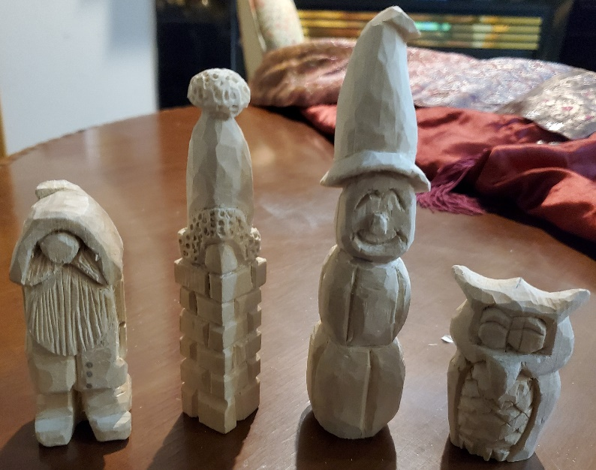

Mark Ludois’ Works in Progress
Bud Hilgendorf’s Goldfinch

