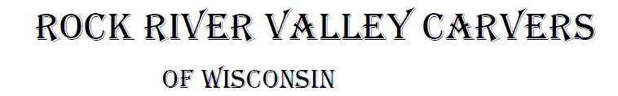
February 2022 Volume 23 issue 2
Editor: Rosemary Kautz Website www.rockrivervalleycarvers.com

December 21, 2022 Board Meeting Minutes

- Call to Order: President Tom Kautz called the meeting to order at 6:11 p.m. Attendees included Mike Hughbanks, Vern Morris, Brad Crandall, Tom Kautz, and Rosie Kautz.
- Possibly Moving Show Location (Brad Crandall and Vern Morris): Due to a rumor of the county possibly not renting out the Craig Center in the future, the option of moving the show to First Lutheran Church was explored.
  - Cost at the church would be $575 (assuming a returned deposit of $100) vs. $900 at the fairgrounds. An additional $200 would be required if meals were prepared in the church kitchen. Vern will check with Jeff to see if he would be able to just bring in the food already prepared.
  - The church has a 20x20’ alcove area outside for the chainsaw carver. The church area includes the entryway, the Fellowship Hall (where we have been meeting evenings), and the hallway between. Exact square footage of the church areas and Craig Center were not known. Brad will check on the area in the Craig Center. Vern will check on the square footage at the church.
  - Due to a date conflict, the show date would have to be changed, probably to the following Saturday since the Stevens Point show has been permanently cancelled.
  - The church has round tables plus 6’ and 8’ rectangular tables we could use. Vern will check on the quantities.
  - We would have access for set up 1-4 pm Friday in addition to all day Saturday.
  - Rosie Kautz stated that she thought the club members should vote on possibly moving the show, not just the board. Brad stated he needed to contact carving magazines soon to have our show included in their publications. Vern stated that the show location and date need to be in all our publicity which needs to be printed soon. It was decided to revisit this issue at the next general meeting on January 4, after further details are obtained.
- Tallman House Christmas Tree Display (Tom Kautz): Tom asked members to think about possibly having a tree from our club on display next year with carved ornaments.

2022 Officers
President: Thomas Kautz
608-868-4522
Vice President: Mike Hughbanks
815-289-8573
Secretary: Vacant
Treasurer: Rosemary Kautz
608-868-4522
Librarian: Bud Cunningham 608-853-1777
Editor: Rosemary Kautz
608-868-4522

Safety Glasses
are a Lot Cheaper than a Seeing Eye Dog

Normal meetings on the
first Tuesday of the month
at the First Lutheran Church, Across from Fairgrounds
612 N Randall Ave.
Janesville, WI
Meeting or Carving
begins at 6 p.m.

- Tom Kautz will do a carving demonstration at the Milton Senior Center, The Gathering Place, on February 25. A carving class will follow. Tom asked for volunteers to teach the class.
- Upcoming Carving/Show Opportunities (Tom Kautz): The Bekkum Carve-In at Westby will be on Saturday, April 23, 10-4. May 1 is the Mid-West Show at Oshkosh, 9-4.
- Hedberg Public Library (Tom Kautz): We have the opportunity to display club carvings in the display cases in the library for 1 month, date to be determined. A possible daytime presentation or evening seminar is also being explored.
- A Chili Pepper Chairman is still needed for this year. Contact Tom Kautz to volunteer for this important position. We are handsomely paid for all our chili peppers and this offsets a substantial amount of our annual expenses.
- Meeting adjourned at 6:55 pm. Minutes submitted by Rosie Kautz.

Next Meeting – Febuary 1st
General meeting and open carving from 6-8 pm on the first Tuesday each month at First Lutheran Church (across from the fairgrounds) in Fellowship Hall located at 612 N. Randall Ave. Park in back and enter through the doors under the canopy. Take the first left to the room. Handicapped accessible. Table covers are required for carvers

January 4, 2022 RRVC Monthly Meeting

- Call to Order: President Tom Kautz called the meeting to order at 6:08 p.m.
- Introduction of New Members/Visitors: None present
- Treasurer Report (Rosie Kautz): November beginning balance was $5,774.83 and ending balance was $5,794.08. December ending balance was $5,569.67. Dues of $30 were collected and major expenses included $91 fried chicken for our December holiday party, $75 for 3 months’ church rent, $34 newsletter ink, $36 miscellaneous show expenses, and $18 sunshine cards and stamps.
- Additions/Corrections to December newsletter: None were voiced
- Web Site Report (Mike Hughbanks): Our site is in the top 75% of similar sites and had over 600 hits in all of 2021.
- Illness/Sunshine Report (Rosie Kautz): Cards were sent to Keith Bowman, Ray Douglas, and Gerry Lesch in November. In December, a sympathy card was sent to Bob Phelps’ family.

Old Business
- Chili Pepper Chairman is still needed for this year. Contact Tom Kautz to volunteer.
- 2022 Show Location and Date Change (Brad Crandall): See Board Minutes for additional information.
  - Vern Morris met with the church custodian and found the total area we are looking at in the church is 5,676 square feet. We have 10,452 square feet at the Craig Center.
  - Tables available at the church include 20 round; 22 6-foot rectangular; 7 8-foot rectangular; and 5 8-foot wooden rectangular. 130 padded chairs are available.
  - It was brought up that our September 10th date for this years’ show was printed on the ‘thank you’ cards distributed at our last show. We would need to change the date to September 17 if we move to the church.
- After discussion, Jim Trumpy made a motion, Gerry Lesch seconded, that we stay at the Craig Center in 2022 and revisit moving if our exhibitor attendance shrinks in the future. The motion passed.

New Business
- Janesville Public Library Opportunities (Tom Kautz):
  - Showcase Display – Steve Field is scheduled for an unknown month and Dave Thill is scheduled for August this year.
  - Demonstration/Presentation at Library Express in the Janesville Mall – Jim Trumpy volunteered to cover this from 10:30-noon either Friday, June 10 or July 8, after he checks his calendar.
  - Evening Demonstration/Presentation – unknown date.
  - Mike Hughbanks volunteered to co-ordinate/schedule these events at the library upon receiving library contact information from Tom Kautz.
- The Gathering Place in Milton (Tom Kautz): Friday, February 25, 1:15 pm setup, class 2-4 pm. The class teacher positions have been filled by club volunteers.
- Donation to Affiliated Woodcarvers/International Congress: June 11-18 at Jackson County Fairgrounds in Maquoketa, IA. Jim Trumpy made a motion to sent a $100 donation as we have in the past, Brad Crandall seconded. Motion Carried.
- Meeting adjourned at 6:40 pm. Minutes submitted by Rosie Kautz.

Area Carving Opportunities!
Janesville Senior Center: Mondays & Thursdays from 9-11 am. Meet and carve with fellow carvers. A mask is required, no food or drink is available in the center. You may bring in covered drinks. Please spray your area and wipe it down with the bleach water provided by the center before leaving.

Shows & Seminars Coming Up
April 23 – Carve-In at the Bekkum in Westby, WI., 206 N Main St. Contact John Sutton, 608-634-4396, lbarnfarms@gmail.com or Bekkum Library 608-634-4419
May 1 – Mid-Wisconsin Chippers Show in Oshkosh, Wi., 2 N Main St, 9-4. Contact Paul Wolters, 920-727-2139 or www.midwisconsinchippers.weebly.com
June 11-18: Maquoketa, IA International Woodcarvers Congress Competition at Jackson County Fairgrounds, 1212 E Quarry St, 10-5 daily, 10-4 Sunday, www.awcltd.org

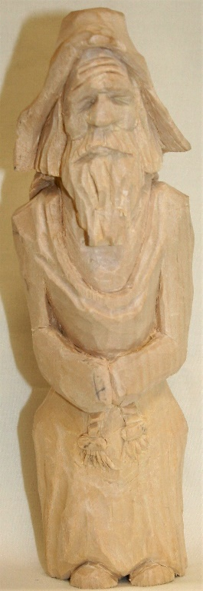
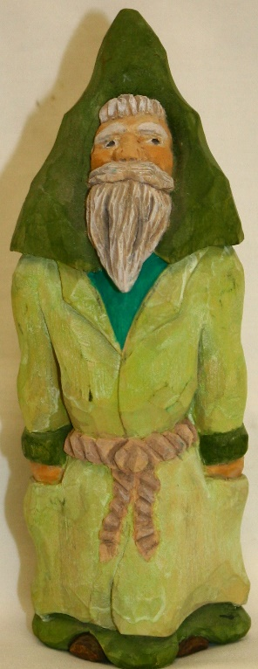

Show & Share
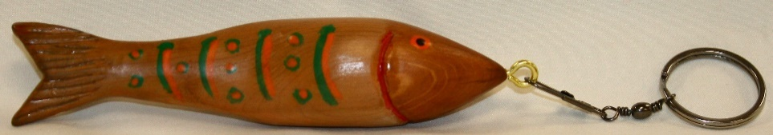
Reggie James’ carved a sample Fish Keychain sample for the carving class February 25th in Milton

Jim Trumpys’ carved the Saint Patty’s Santa
and the Monk – whom club members decided
was praying for Trumpy

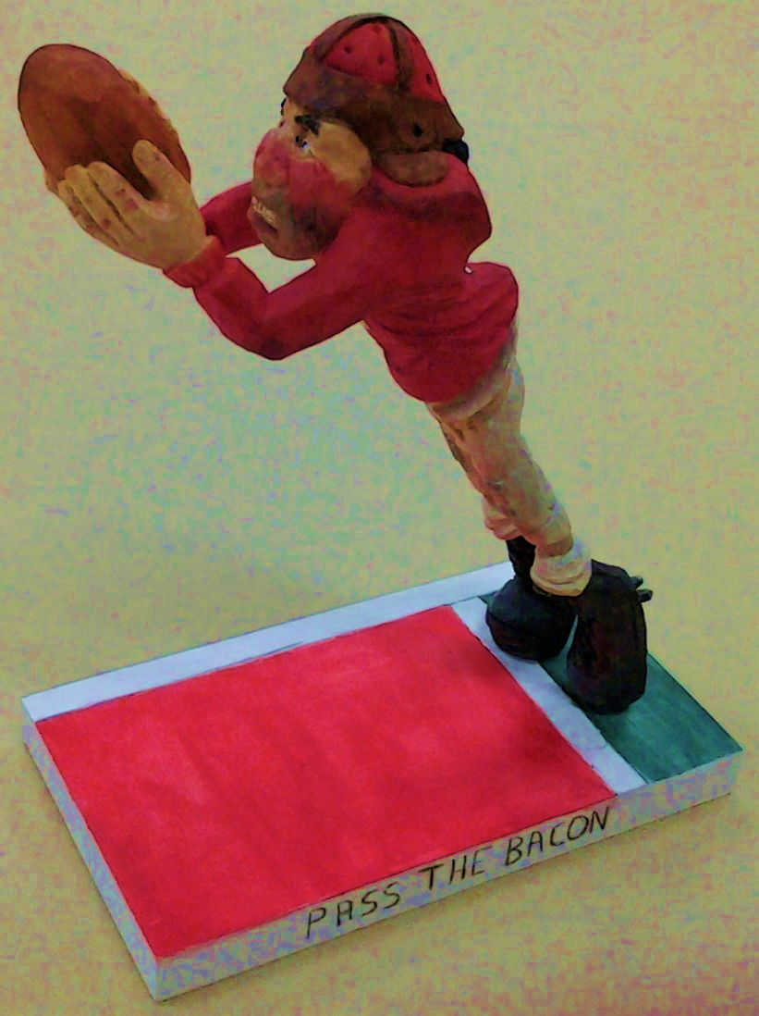
Reggie James’ Santa Spoon

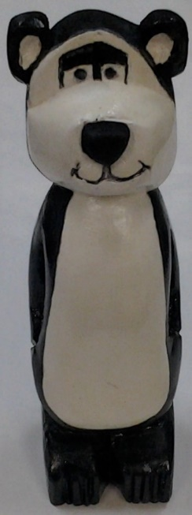
Mark Ludois’
Hamm’s Bear
Beer Tap Handle

Brad Crandall’s’ UW ‘Pass the Bacon’ Football Player

Left to right above: Rosie Kautz’ Birdy Welcome Sign, Mike Hughbanks’ Pepper,
Randy Callison’s Stool Sample (for a doctors’ visit), and Tom Kautz’ Butternut Trout

