February 2024 Volume 25 issue 2
Editor: Rosemary Kautz Website www.rockrivervalleycarvers.com

January 2, 2024 Meeting Minutes

- Call to Order: President Mike Hughbanks called the meeting to order at 6:02 p.m. Attendance: 8.
- Introduction of New Members/Visitors: None were made.
- November 2023 Treasurer’s Report (Rosie Kautz): The beginning balance was $6,474.35, and the ending balance was $6,509.35. The only activity on the account was a $35.00 deposit of dues money.
- December 2023 Treasurer’s Report (Rosie Kautz): The beginning balance was $6,509.35, and the ending balance was $6,579.66. Deposits included a $100.00 donation and $115.00 in dues. Expenses were $80.17 for the Christmas party chicken and $64.52 for newsletter ink.
- Additions/Corrections to December 2023 newsletter/minutes: No additions or corrections were made.
- Website Report (Mike Hughbanks):
12 Months - 2,328 Views
30 Days - 146 Views
7 Days - 37 Views
Score ———— 20
- Illness/Sunshine Report (Rosie Kautz): A get well card was sent to Mark and Kim Ludois.

Old Business
- Program Coordinator (Mike Hughbanks): Club needs someone to set up speakers and or demonstrations for our first and second Tuesday evening meetings at First Lutheran.
- Possible Monetary Club Donation to the Katherine M. Belling Memorial Art Scholarship via the Community Foundations of Southern Wisconsin (Tom Kautz): Steve Johnson suggested the club look into further details about how the scholarship is awarded. It was decided to table discussion until Tom Kautz could get more information to help make a decision.

2024 Officers
President: Mike Hughbanks
815-289-8573
Vice President: Mark Ludois
608-371-3838
Secretary: Robin Rios
608-752-3328
Lori Ruplinger
262-629-9821
Treasurer: Rosemary Kautz
608-868-4522
Librarian: Bud Cunningham 608-853-1777

Remember –
It’s Only a
Piece of Wood
Until It’s Done

Normal meetings on the
first Tuesday of the month
at the First Lutheran Church, Across from Fairgrounds
612 N Randall Ave.
Janesville, WI
Meeting or Carving
begins at 6 p.m.

- Show Lawn Signs (Mike Hughbanks): Everyone should keep their signs at home. The club will buy new date stickers and hand them out for the 2024 show.

New Business
- 2024 Show Update (Brad Crandall): No update available due to Brad Crandall’s absence.
- 2024 Chilimania Update (Randy Callison): No update available from Randy Callison as he was absent. Mike Hughbanks said the chilies must be handed in by the July club picnic. Chiimania already has enough chilies for 2024. The chilies carved this year will be used in 2025.
- Club Logo Shirts: Steve Johnson would like to order a shirt. Mike Hughbanks told him to contact Brad Crandall.
- Show & Share: Rosie Kautz showed off her wood burning of two monarch butterflies to the group.
- Adjournment: President Mike Hughbanks adjoined the business portion of the meeting at 6:30 p.m. Open carving to follow.
The minutes are respectfully submitted by Robin Rios, Secretary.

2024 Dues are Due!
If you haven’t already paid your dues, please do so at your earliest convenience.
Checks should be paid to the Rock River Valley Carvers of Wis.
$15 for an individual or $20 for a family. Thank You!

Club Events in 2024:
Winery Art Walk – Sunday, July 28 at Fermenting Cellars Winery, Noon – 4 pm, setup at 10 am.
Beckman Mill Events:
Ice Cream Social - Sunday, July 21. Display and sales for our club members.
Heritage Sunday – Sunday, September 8. Display and sales for our club members.
Our Show & Sale – Saturday, September 14.

A Founding Member of our Club has Passed Away
Joanne Drinkwine, 85, died Sunday, January 7 in Waunakee. Visitation is from
9:30-11 Jan. 15, service at 11 am at St. John’s Church, 209 South St., Waunakee

Shows & Seminars Coming Up
April 20: Westby, Wis Karve in 8, Westby High School Gym, 206 West Ave., 10-4 pm. Contact John Sutton, lbarnfarms@gmail.com or Steve Michaels, 608-769-8498, steve.michaels@westby-norge.org
April 28: Sheboygan, Wis Kettle Karvers Carving Show, Emil Mazey Hall, 5425 Superior Ave, 10-4 pm. Contact Bob Lawrence, 920-458-4947, bob@kettlekarvers@att.net
June 8-15: Maquoketa, IA AWC Congress Competition, Seminars, and Show, www.woodcarverscongress.org

Area Carving Opportunities!
Janesville Senior Center: Mondays & Thursdays from 9-11 am. Meet and carve with fellow carvers. Please spray your area and wipe it down with the bleach water provided by the center before leaving.
Gathering Place in Milton: Monday afternoon 1-3 pm. 715 Campus St.
Fulton Church: Tuesdays, 9-11 am in the church gymnasium, 9209 N Fulton St.
First Lutheran Church: The 1st and 3rd Tuesdays of every month from 6-8 pm, 612 N. Randall Ave. (Across from the fairgrounds.)

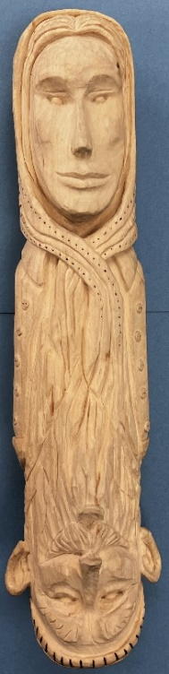
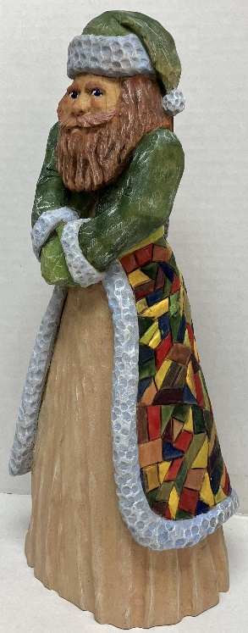
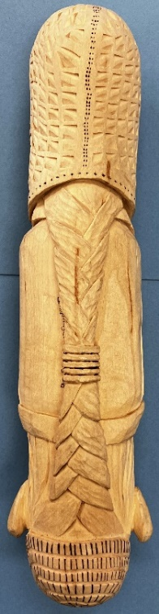
Club Members Recent Carvings

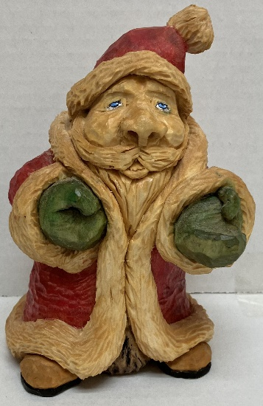
Jim Trumpy Carved the
Santas on the left and right

Gerry Ruplinger Carved the
2-Headed practice stick
on the far right

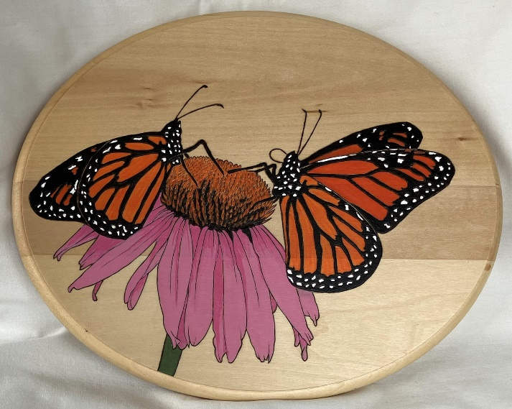
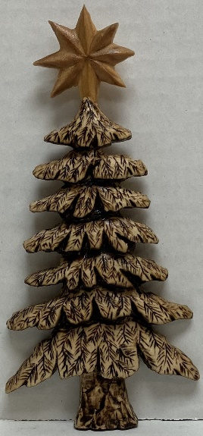
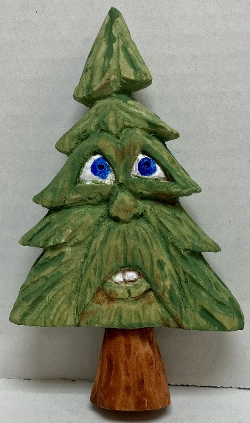
Rosie Kautz’ Butterfly Pyrography,
on left

Denny Pryces’ Tree with Star, on right

Ernie Tuckers’ Tree with Face, far right

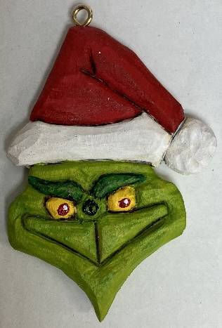
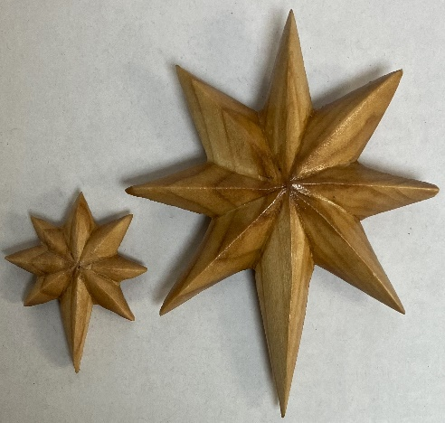
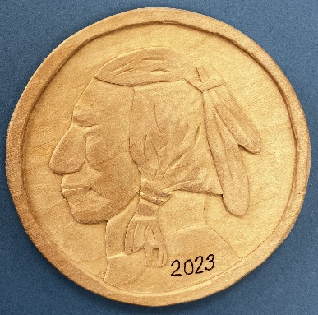
Denny Pryces’ Stars
John Eidens’ Grinch
Ornament

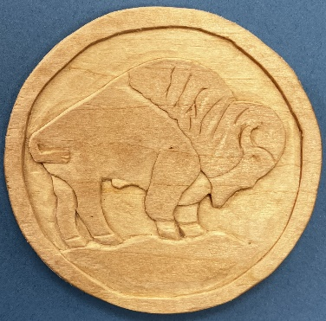
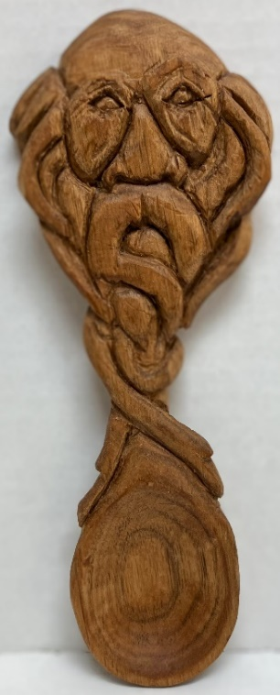
Gerry Ruplingers’ Bison
& Indian Head Carvings
Ernie Tuckers’
Old Man Spoon

