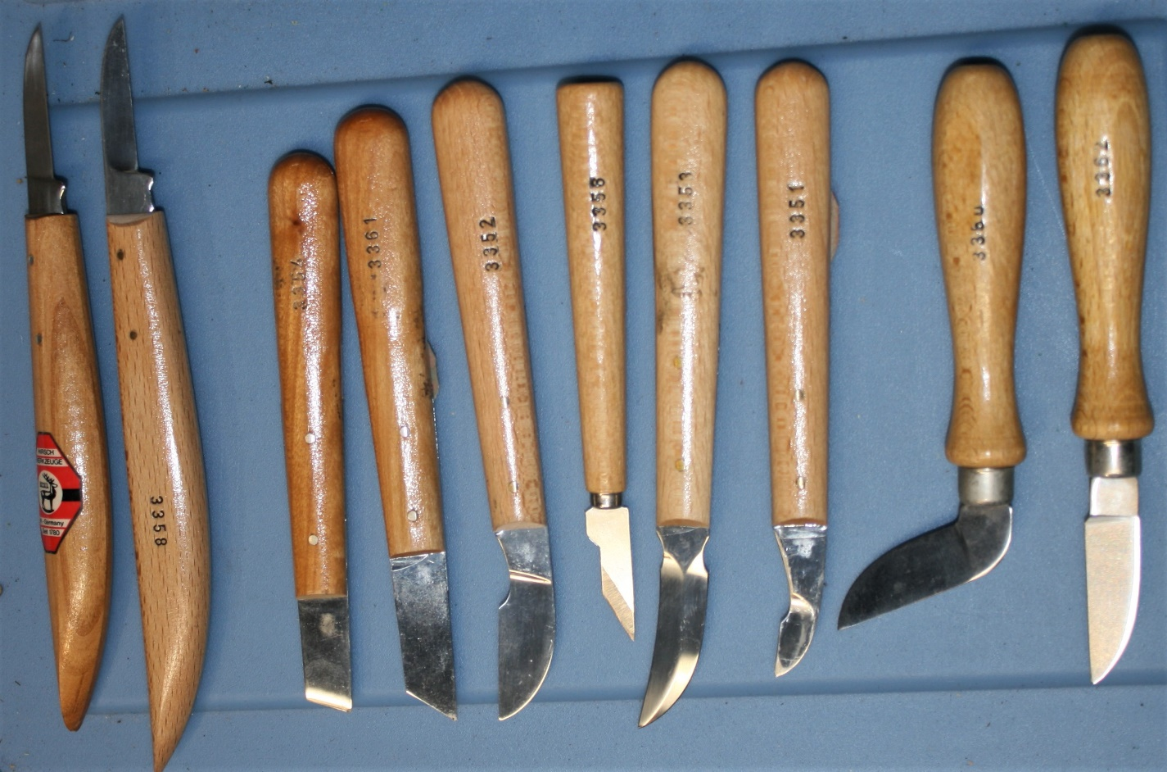
Items Donated by Jerry Heyerdahl
West German (Hirsch Werkzeuge) Tools (left to right): 2 Bench Knives: #3358, 3363: Chip Carving Tools: 3354, 3361, 3352, 3356, 3353, 3351, 3360, 3362
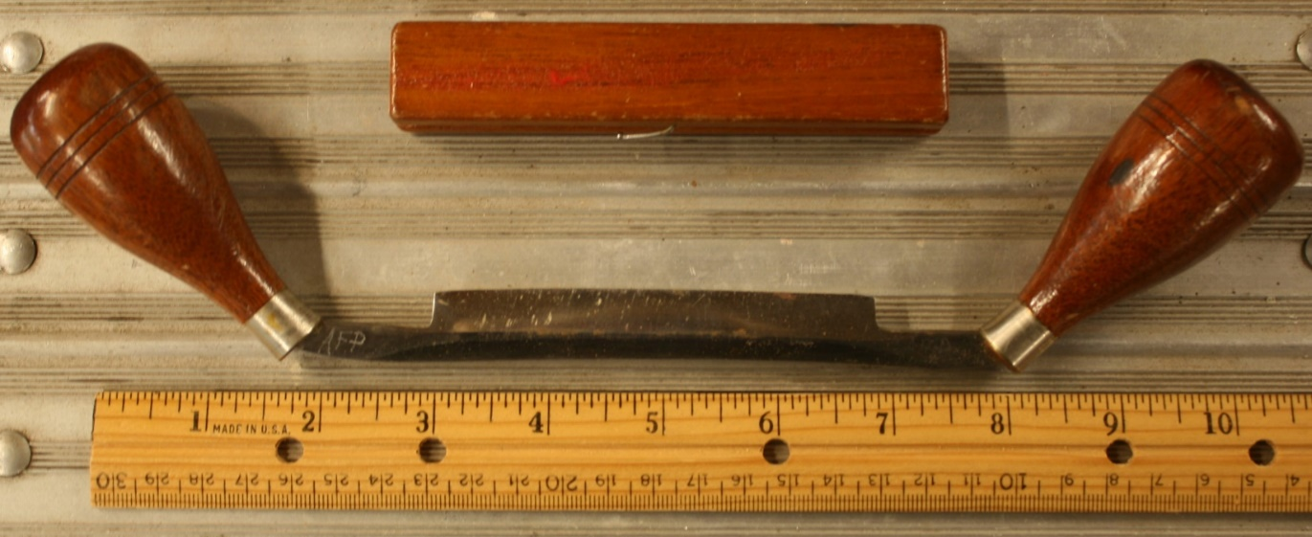
Small Draw Knife

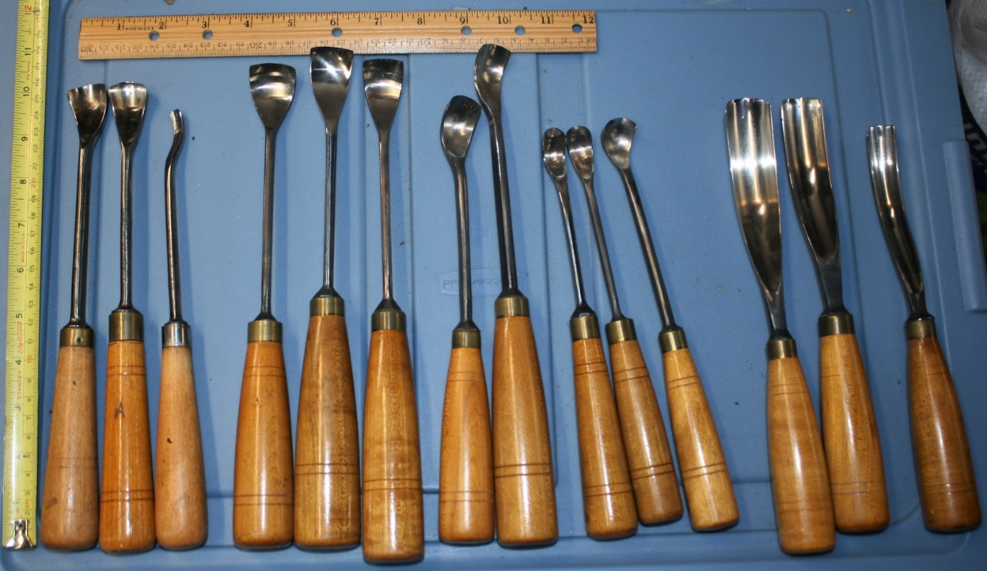
(left to right): JB Addison & Sons Tools: #9 10”x1” Scoop, #10 10”x7/8 Scoop
DR Barton Tool: #28 9 ½”x3/8” Scoop
Unlabeled Carving Scoops 10 ½”x1”, 11”x1”, 11”x7/8”, 9 ½”x3/4” Deep Scoop, 11”x7/8”, 9 ½”x1/2” Deep Scoop, 9”x9/16” Deep Scoop, 9 ¼”x7/8” Deep Scoop
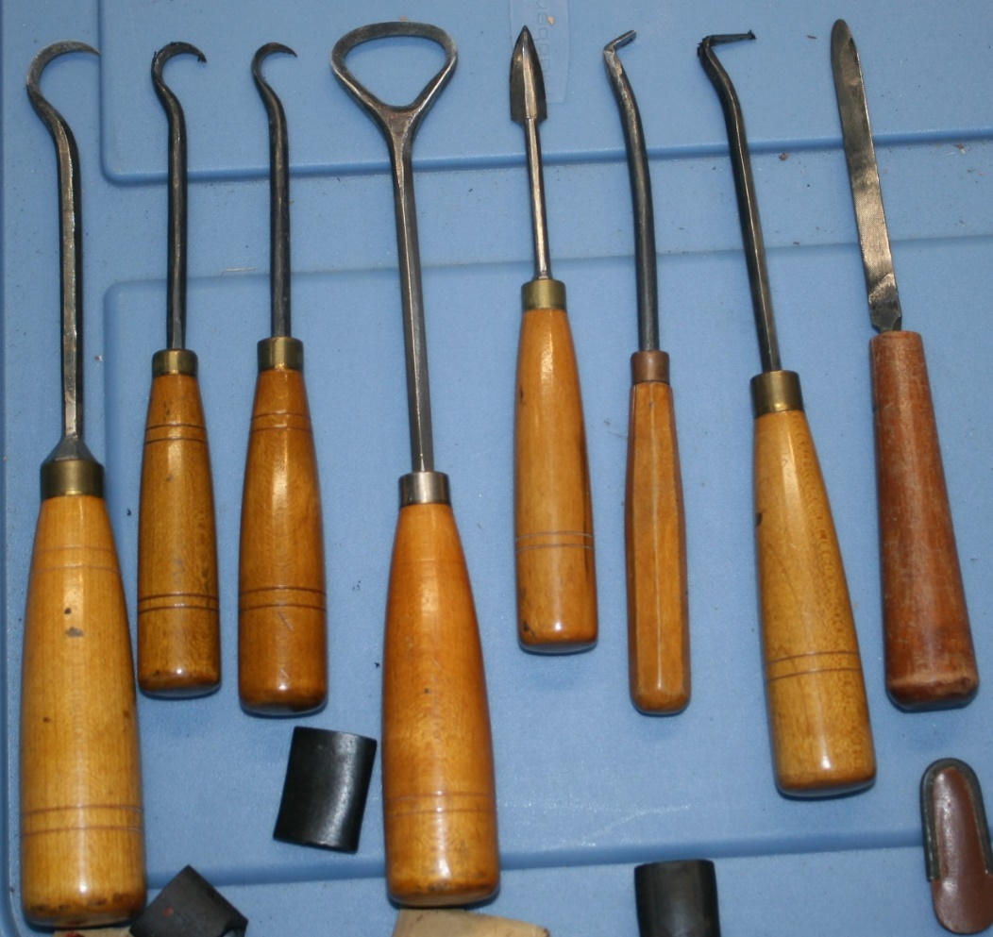
Large Sweep Gauges (left to right): 10”x1”, 9 ¾”x7/8”,9”x5/8”

(left to right):
9” 2-Sided Scoop,
6 ½ & 7” 2-Sided Scoops, 9” 2-Sided Loop Scoop,
6 ½” 2-Sided Hook Knife, 8” Modified right & left side “L”,
7” Side Chisel, Homemade Bullet-Point 7” Chisel

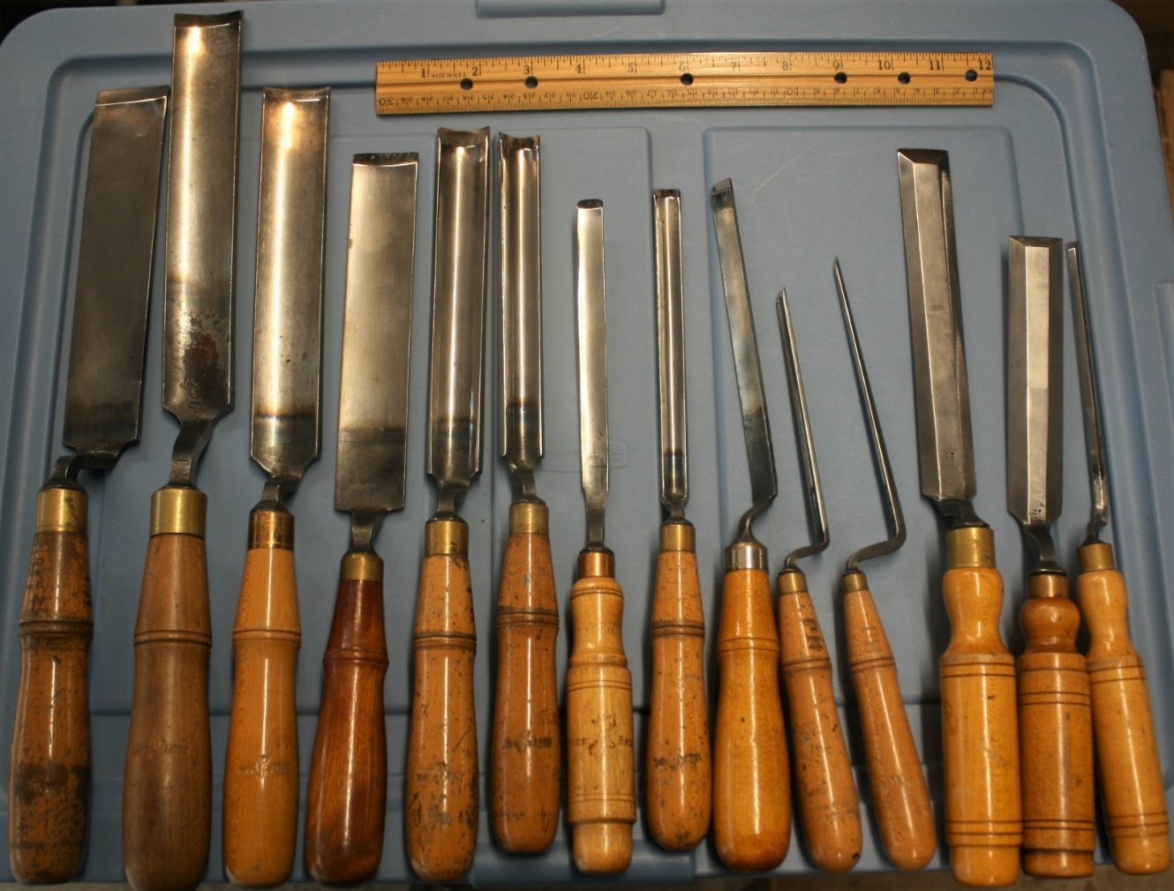

Large Gauges (some JB Addison) (left to right): 15”x1 ½” Flat, 16 ½”x1 3/8”, 15”x1 ¼”,
13 ½”x1 ¼”, 13 ¾”x1”, 13 ¼”x3/4”, 12”x1/2”, 12 ½”x ½”, 12”x ½”, 10 ¼”x1/4”, 11”x3/16”
Buck Brothers Flat Chisels: 13 ½”x1”, 11 ½”x1”, 11 ½”x1/4”
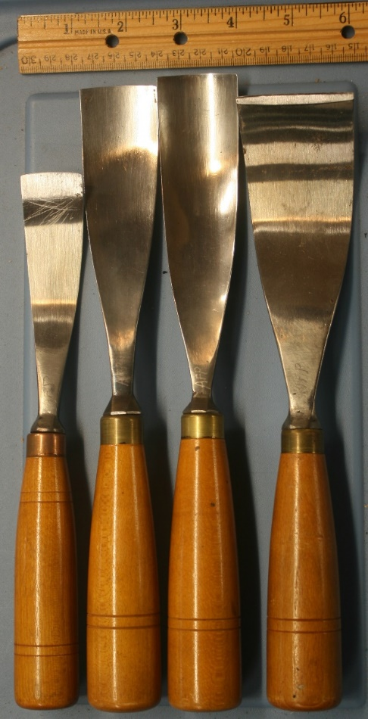

Shallow Sweep Gauges:
9 ¼”x1 1/8” Flat,
11”x1 3/8” Flat,
11”x1 3/8”,

10 ½”x2” Flat Chisel

Other Miscellaneous Items:

Chip Carving with Wayne Burton DVD

Wood Carving Illustrated Issues from 1997 to 2019 (assorted)

Carving Magazine: Issues #5 and 35 through 42

Mallet Magazine from April 1984

Pamphlets:
Learn to Carve Faces & Expressions by Harold L. Enlow, 1980
Carving Heads & Faces by Jack Ekstrom, 1983
Face It by Roy Alsterlind, 1982
Basic Sharpening by Ed Stockey, 1981

Books:
Whittling & Woodcarving by EJ Tangerman, 1936
Woodcarving by Freda Skinner, 1961
How To Do Wood Carving by John L Lacey, 1997
Manual of Traditional Woodcarving edited by Paul N Hasluck, 1977

1 Box, 19x14x10”, of Assorted Oak, Cherry, Mahogany, and Black Walnut Wood Pieces

2 Pieces of Cherry 3/4”x3 1/8” x 35 ½”

Black Walnut Live-Edge Plank 7/8”x9”x8’3”

Pieces of Cherry:
2 at ¾”x3 5/8”x35 ¼” ¾”x3 ½”x10 ½” ¾”x3 ¼”x29 ¾”
¾”x2 ¾”x29 ½” ¾”x3”x25 3/8” 1 3/8”x3”x25 3/8”
¾”x2 7/8”x25” ¾”x3”x25” 3 ¼”x3 1/8”x23 ¼”
¾”x3 ½”x15 ¾” 2 at 7/8”x5 ¼”x17 ¼” 7/8”x5 ½”x17 5/8” joined
1 1/8”x6 ¾”x16 1/8” 2 at ¾”x4”x25”
4 Furniture Legs: 1 ¾” square x 13 3/8” and 4 at 2 3/8” square x 18”
3 Drawer Sides, Dovetailed each ¾”x4 ½”x13 ½”
1 7/8”x5 3/16”x12” 1 7/8”x5 ½”x12” 5/16”x6”x11”
5/16”x6”x6” 5/8”x6 5/8”x7 7/8” 2”x4 ¼”x8 3/8”
1 1/8”x3 7/8”x12” 1”x1 7/8”x10 3/8” 1 7/8”x4 1/8”x8 3/8”
2”x6 ½”x7” 7/8”x5 ½”x6 5/8” 1”x5”x4 1/8”
7/8”x3 ½”x6 3/8” 2”x2 ½”x4 ½”

Pieces of Mahogany:
1 5/8”x2”x20” 1 5/8”x2”x17 ¾” 7/8”x1 ¾”x20 ¾”
1 ¼”x1 3/8”x18 ½” Dovetail Drawer Side ½”x4 1/8”x13 ½”
1”x1”x17” 1”x1”x17 ½” 3/8”x2”x17”
1”x1 ½”x17 3/8” 5/8”x1 ¼”x15” 5/8”x1 ¾”x14 5/8”
5/16”x2 7/8”x15 3/16” 1”x1 7/8”x12 ¼” 1 1/8”x2”x13”
2”x6 ¼”x10” 1 5/8”x1 7/8”x12 1/8” 2 1/8”x2”x9 ½”
2”x2 1/8”x8 3/8” 1 ¾”x3”x6 5/8” 1 7/8”x4 ¼”x7 ¾”
4 at 1 ½”x3”x7” 1 1/8”x2 1/8”x8 ½” ½”x2 ¾”x12”
1 3/8”x1 5/8”x6 ¾” 7/8”x3”x8 ¼” 6 at 1/8”x4 ¼”x6”

3 Pieces with misc. holes: 2”x2”x16” each

