January 2024 Volume 25 issue 1
Editor: Rosemary Kautz Website www.rockrivervalleycarvers.com

December 5, 2023 Meeting Minutes

- Call to Order: President Mike Hughbanks called the meeting to order at 6 p.m. Attendance: 25. Tonight is the annual RRVC Christmas Party.
- Election of 2024 RRVC Officers:
President: Mike Hughbanks
Past President: Tom Kautz
Vice-President: Mark Ludois
Treasurer: Rosie Kautz
Co-Secretaries: Lori Ruplinger/Robin Rios
Member At Large: Gerry Lesch
Member At Large: Jim Trumpy
- President Mike Hughbanks called for a vote on the above names put forth for 2024 RRVC Officers. The above officer nominees were elected unanimously by voice vote from the floor.
- Non-Elected 2024 RRVC Positions:
Newsletter Editor: Rosie Kautz
Librarian: Bud Cunningham
Club Historian: Robin Rios
Co-Show Chairmen: Brad Crandall/John Raisbeck
- 2024 Show Update: Gerry and Lori Ruplinger have volunteered to run the show raffle for 2024.
- Adjournment: President Mike Hughbanks adjourned the business portion of the meeting at 6;15 p.m. Dinner and Christmas ornament exchange to follow.
Minutes respectfully submitted by Robin Rios, Secretary.

2024 Officers
President: Mike Hughbanks
815-289-8573
Vice President: Mark Ludois
608-371-3838
Secretary: Robin Rios
608-752-3328
Lori Ruplinger
262-629-9821
Treasurer: Rosemary Kautz
608-868-4522
Librarian: Bud Cunningham 608-853-1777

We Grow Old
When We
Stop Playing

Normal meetings on the
first Tuesday of the month
at the First Lutheran Church, Across from Fairgrounds
612 N Randall Ave.
Janesville, WI
Meeting or Carving
begins at 6 p.m.

Shows & Seminars Coming Up
April 20: Westby, Wis Karve in 8, Westby High School Gym, 206 West Ave., 10-4 pm. Contact John Sutton, lbarnfarms@gmail.com or Steve Michaels, 608-769-8498, steve.michaels@westby-norge.org
April 27: Sheboygan, Wis Kettle Karvers Carving Show, Emil Mazey Hall, 5425 Superior Ave, 10-4 pm. Contact Bob Lawrence, 920-458-4947, bob@kettlekarvers@att.net
June 8-15: Maquoketa, IA AWC Congress Competition, Seminars, and Show, www.woodcarverscongress.org

Area Carving Opportunities!
Janesville Senior Center: Mondays & Thursdays from 9-11 am. Meet and carve with fellow carvers. Please spray your area and wipe it down with the bleach water provided by the center before leaving.
Gathering Place in Milton: Monday afternoon 1-3 pm. 715 Campus St.
Fulton Church: Tuesdays, 9-11 am in the church gymnasium, 9209 N Fulton St.
First Lutheran Church: The 1st and 3rd Tuesdays of every month from 6-8 pm, 612 N. Randall Ave. (Across from the fairgrounds.) No Meeting Tuesday, July 4th.

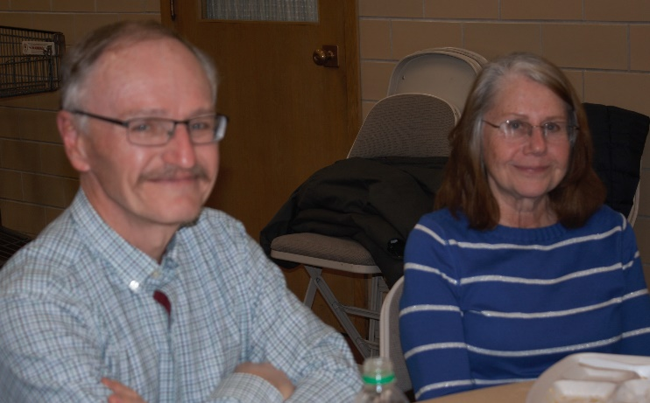
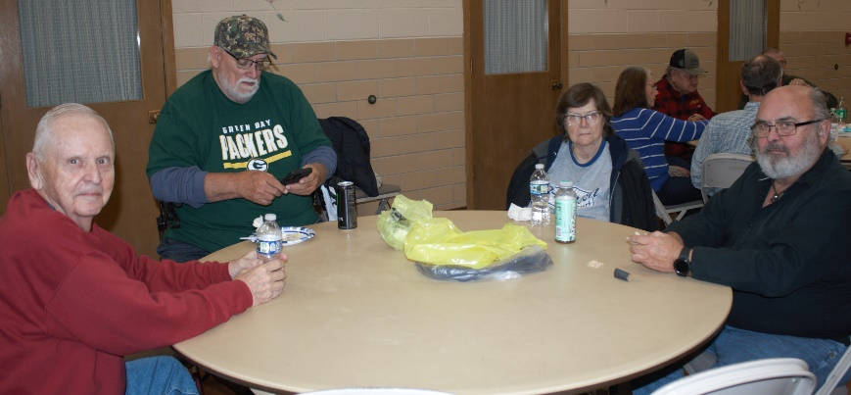
Christmas Party Photos
Roy Whitford, Mark Ludois, and the Sherie & Denny Pryce Gerry & Lori Ruplinger
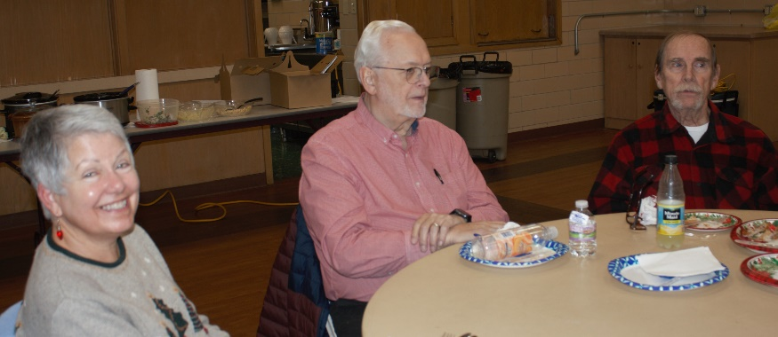

Robin Rios, Vern Morris, and Randy Callison
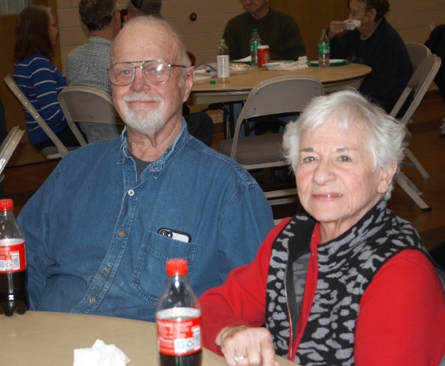

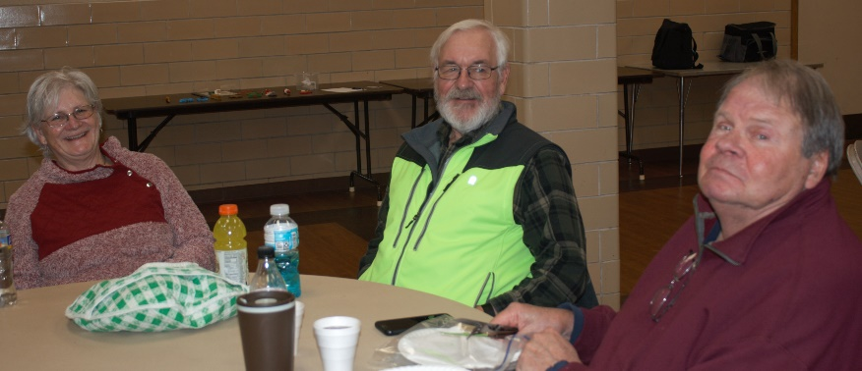

Mr & Mrs Bob Mortensen

Karen & Brad Crandall and Steve Johnson

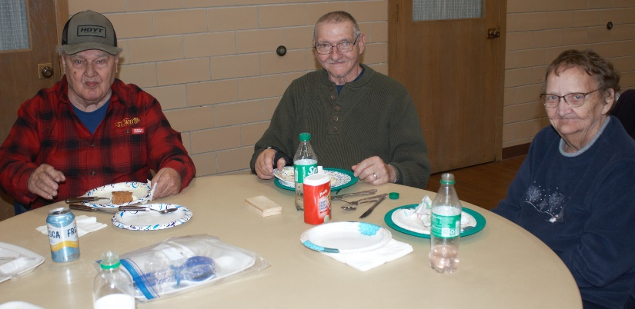
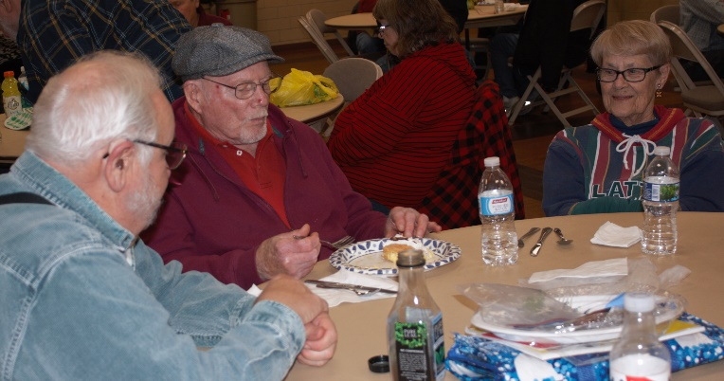
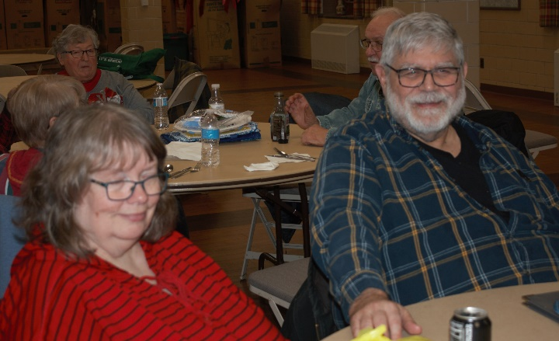
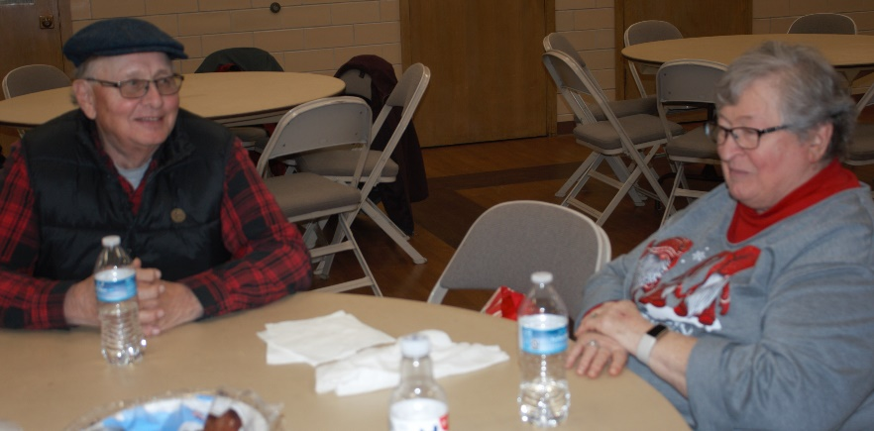
Angela & Mike Hughbanks Gerry & Jan Lesch
Tom Kautz, Jim & Sharen Trumpy Bud Cunningham, Mike & Kathy Schindler
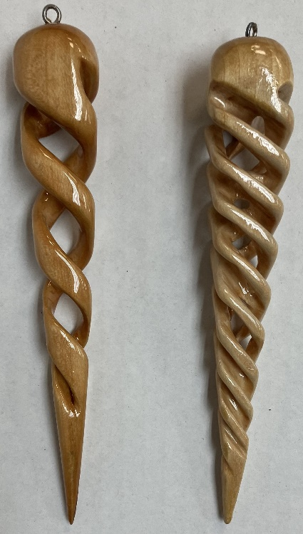
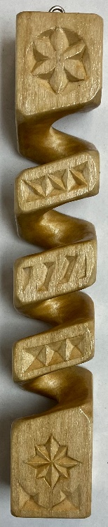
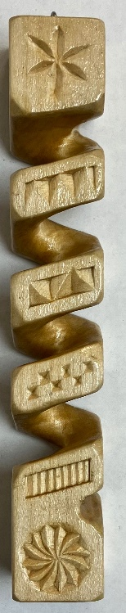

Club Members Recent Carvings

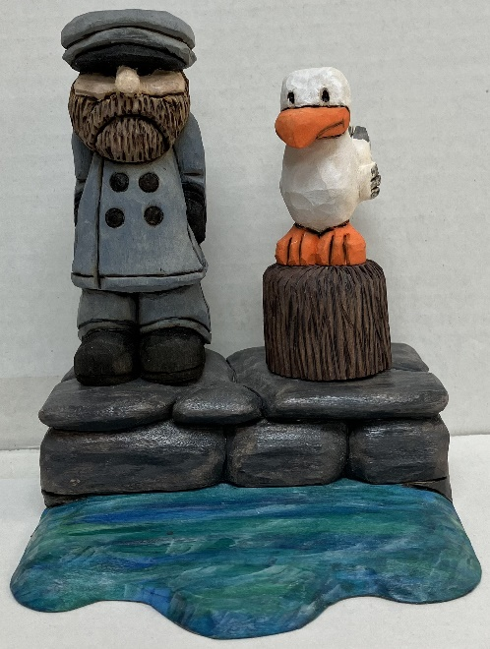

Lori Ruplingers’ 2 and 4 Twist Icicles

Gerry Ruplingers
4-Sided Square
Twist, far left

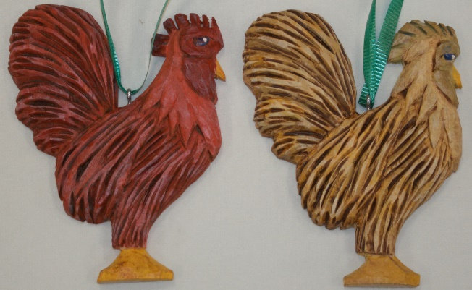

John Eidens’ Sailor & Gull

Jim Trumpys’ 2 Rooster Ornaments

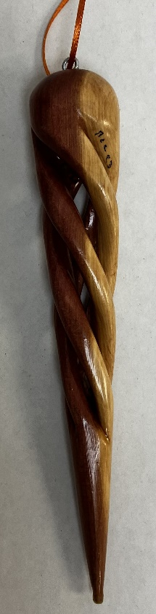
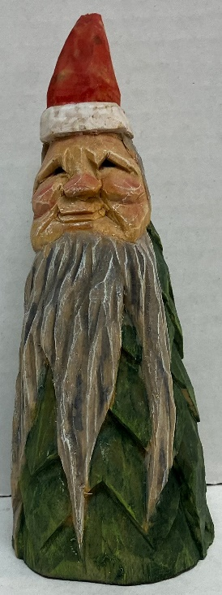
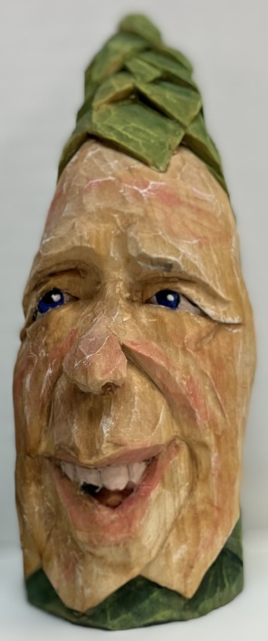
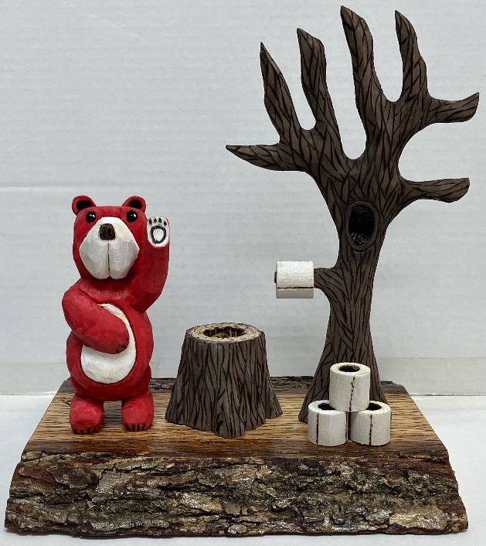

‘If a bear …. In the woods?” by John Eiden
Jim Trumpys’ Tree Men
Randy Callisons’ Cedar Icicle
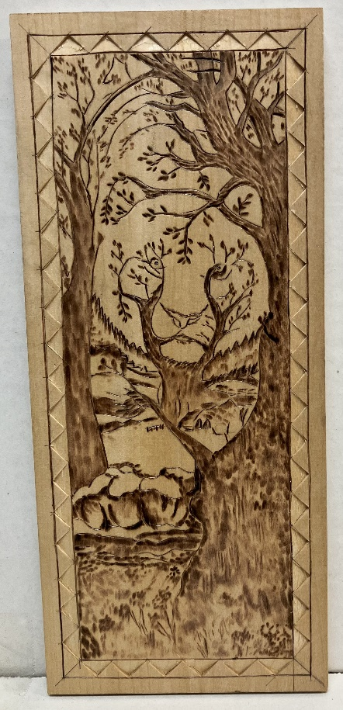
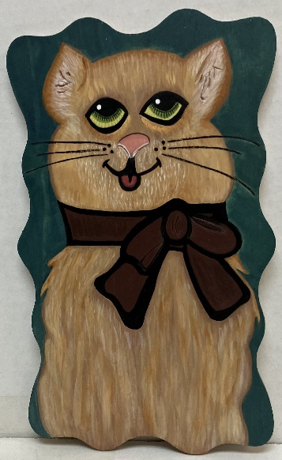
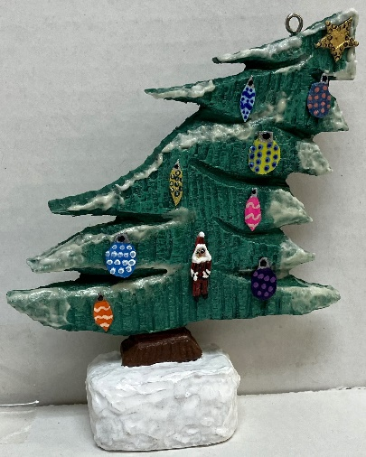
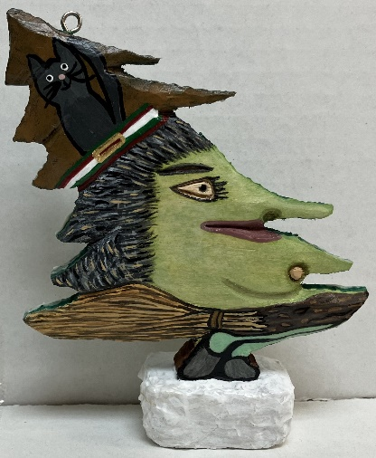
Lori
Lori Ruplingers’ 2-Sided Tree – for Christmas or Halloween?
Lori Ruplingers’
Cat Plaque
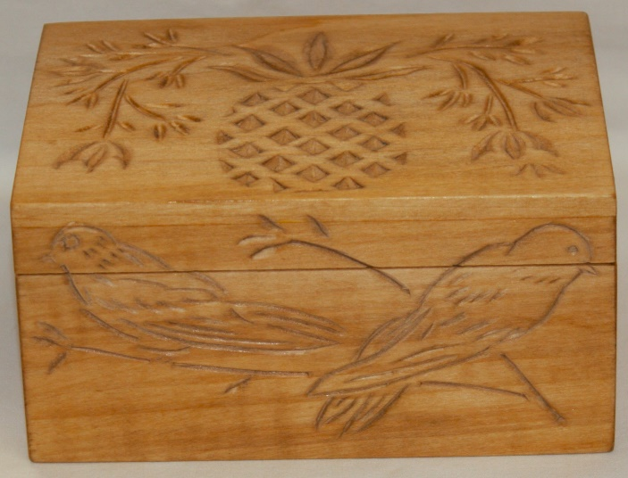

Bud Cunninghams’
Hidden Tiger Plaque

Bud Cunninghams’ Chip Carved
Bird and Pineapple Box

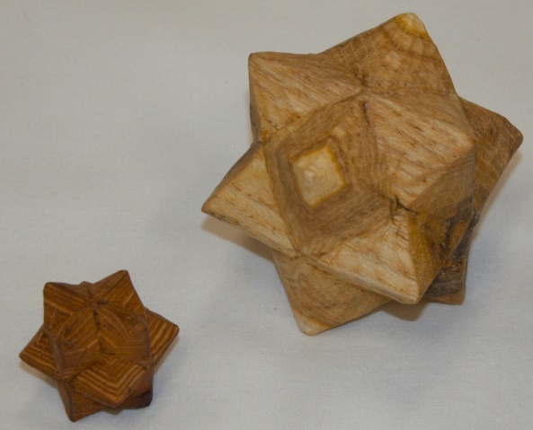
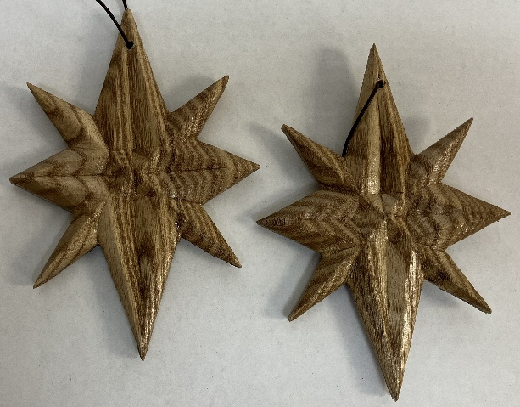
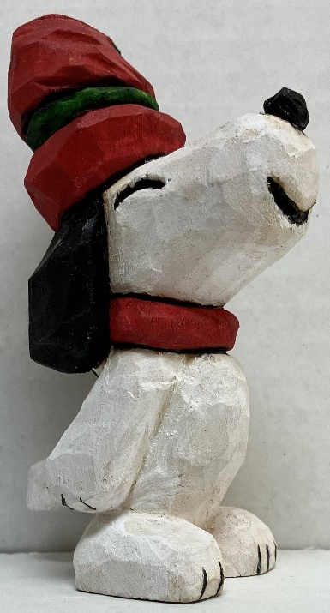
Denny Pryces’ Carved Stars
Denny Pryces’ Cottonwood Bark Stars

John Eidens’ Snoopy Dog

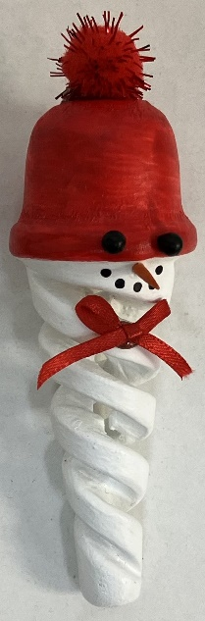
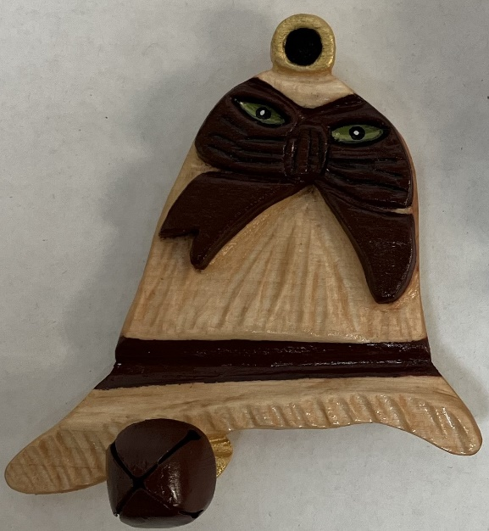
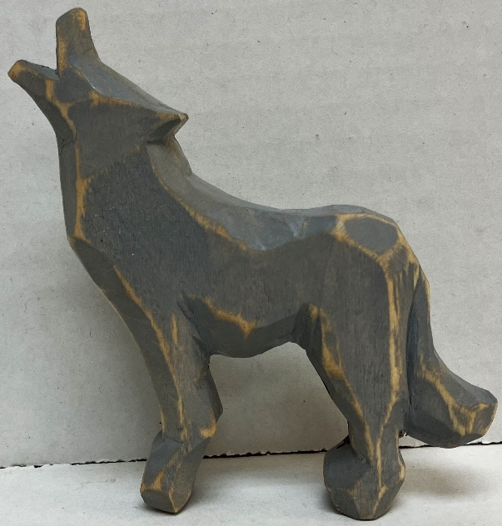

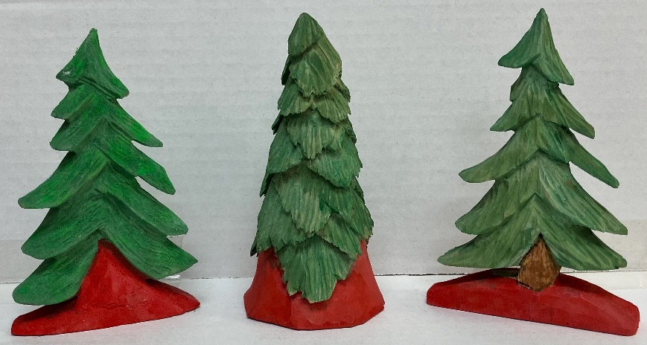
Ernie Tuckers 3 Trees
Jim Trumpys’ Howling Wolf
Lori Ruplingers’ “Looking At You” Bell and Icicle Snowman

