July 2021 Volume 22 issue 7
Editor: Rosemary Kautz Website www.rockrivervalleycarvers.com

July 8th Club Picnic
Our club picnic will be held once again at Carver Roehl County Park from 4:30 until 9 pm! The club will supply chicken. Bring your spouse, a dish to pass, something to drink, and your place settings (plate, silverware, napkin). The park is located at 4907 S Carvers Rock Road, Clinton. Take Hwy. 14 or Avalon Rd East from Janesville, take Hwy. 140 South. Turn East (left) on E Larson Rd and then right (south) on Carvers Rock Rd. to the park. Come for the good food, visit with fellow carvers, and see all the carved chili peppers!

Janesville Senior Center Update
The Senior Center is open with restrictions. Open carving on Monday and Thursday mornings, 9-11 am, has begun with a limit of 12 people. You must call ahead and make a reservation to attend and then check in at the front desk when you arrive. Masks are mandated by the city and social distancing should be followed. No food, coffee, or water will be available (bubblers are turned off). Drinks in sealed containers are permitted. Hand sanitizer will be available and we need to wipe down high-touch surfaces prior to leaving (tables and chairs). Come and join your fellow carvers again!

2021 Officers
President: Thomas Kautz
608-868-4522
Vice President: Mark Ludois
608-371-3838
Secretary: Mark Ludois
608-371-3838
Treasurer: Rosemary Kautz
608-868-4522
Librarian: Bud Cunningham 608-853-1777
Editor: Rosemary Kautz
608-868-4522

Be Patient –
In Time,
Even An Egg
Will Walk

We normally meet on the
first Thursday of the month
at the Janesville Senior Center, Second Floor
69 S. Water St.
Janesville, WI
Meeting or Carving
begins at 7:15 p.m.
Board Meeting at 6 p.m.

June 1, 2021 RRVC Monthly Meeting
- Called to Order at 6:08 pm
- Treasurer Report (Rosie Kautz): May beginning balance was $6,149.02 and ending balance was $5,975.30. Major expenses were donation/thank you to Trinity Episcopal Church and 2 months’ rent paid to First Lutheran Church, as well as newsletter ink purchased.
- ‘Get to know a Fellow Carver’: Roger Anderson’s and Jim Svoboda’s names were drawn.

New Business
- Evening Carving Sessions: Open carving will occur at First Lutheran Church the first and third Tuesdays of the month. The church is located across from the fairgrounds, enter and park in the back of the building. Masks are required by the church at this time.
- Senior Center Update: Remember to call to reserve a space for open carving Monday and/or Thursday mornings, 9-11 am. Masks are required and used tables and chairs should be sanitized before leaving (supplies provided). For more details, see last month’s newsletter.
- Carving at Sportsman’s Park: Carving sessions in the park are no longer being held.
- Show Update (Brad Crandall): Wilcox Wood Works will be our wood vendor, Jessie Borde will be our chainsaw carver, and Jeff’s will be doing lunch again this year.
  - Demos will be conducted by Randy Callison (spirals), Bud Cunningham (pyrography), and Denny Neubauer (little people).
  - Leaders are still needed for the greeters’ table and People’s Choice. Contact Brad to volunteer.
  - Cane Segments Needed – Jim Trumpy needs more carved! Contact Randy Callison for blanks, if needed. Contact Jim to let him know if you’re carving one.
  - Carvings Needed – Christmas ornaments are needed for our ornament sale. Contact Mark Ludois if you will have some to donate by our show date.
  - 2022 Show Chairman Needed – Please consider stepping forward to make our next show a success. Brad will provide past show task information and guidance. Tom Kautz has already agreed to be featured carver in 2022 and the fairgrounds have been reserved for the date.
- Chili Peppers: Mark Ludois was not present. Tom Kautz will verify Chili Mania wants peppers this year.
- July Picnic: Members said they would like to conduct our annual picnic. Rosie Kautz will contact the Rock County Parks office to inquire about a suitable date.
- Tallman Art Festival: We will have 2 booths on August 1. Paperwork has been filed and there will be no charge since we paid last year.
- U-Tube Opportunity (Vern Morris): Vern will create 4-6 videos on carving this year to post on his U-Tube account, each 30-60 minutes long. He has completed the first video that highlights our club website. He will be taping and interviewing club members at our show and the Stevens Point show for a video.
- Saturday Market (Brad Crandall): The following dates are being considered for our club to have a booth at Kauffman’s Market from 8 am to 2 pm to promote our show: July 24 & 31 and Aug. 21 & 28. The club cost would be $8 per Saturday. Contact Brad Crandall if you are able to help out on any of these dates.
- Jim Trumpy is considering teaching a ‘house’ bark carving class. Contact him if interested. More information will be coming.
- Adjournment: Meeting adjourned at 6:40 pm. Minutes respectively submitted by Rosie Kautz.

Club Meeting Information Update
Evening Carving – Open carving from 6-8 pm on the first and third Tuesdays each month will be at First Lutheran Church (across from the fairgrounds) in Fellowship Hall located at 612 N. Randall Ave. Park in back and enter through the doors under the canopy. Take the first left to the room. Handicapped accessible. Table covers and masks are required at this time. The building is air conditioned and woodburning can be done at certain tables.

Shows & Seminars Coming Up and/or Canceled
Woodcarvers’ Congress in June has been cancelled
September 11: Our Show & Sale in Janesville
September 18-19: Stevens Point, WI 20th Annual Show, Competition, and Sale of the Wisconsin River Woodcarvers, Holiday Inn, 1001 Amber Ave, Stevens Point, WI., Saturday 9-5, Sunday 9-4, admission $5 (under 13 free), Ron O’Kray (715) 570-2534 or Greg Wirtz (715) 323-2035, www.wisconsinriverwodcarvers.org

Chili Peppers Wanted
17 chili peppers need to be carved for Chili Mania this year. Contact Mark Ludois
quickly if you can have a pepper carved by sometime in July.

Additional New Information
- Website (Mike Hughbanks): Our club website had 63 page views in the 30 days prior June 10, and 11 page views in the last 10 days.
- Chili Peppers (Mark Ludois): Chili Mania wants carved chili peppers again this year! So far, 9 carvers have committed to carving a pepper and we need 17. Please contact Mark (608-371-3838) to help us out and let him know you will have a carved pepper for him. The peppers we carve cover our “rent money.”
- Saturday Market (Brad Crandall): Brad has reserved July 24 & 31, August 21 & 28 to advertise our show at Kauffman’s’ Country Store Market. Please contact Brad (608-931-0188) if you can help him any of those dates. Set up is 7 am, market opens at 9 am, and current closing time is 2 pm.
- Comfort Crosses (Ernie Tucker): He recently delivered 12 comfort crosses and 12 comfort hearts to Mercy. He has 27 crosses and 13 hearts left. Contact Ernie (608-752-5660) if you have any carved to donate. Randy Callison also is handling the supply to Dean/SSM.

Tool Glossary (from Jim Svoboda) …
Belt Sander – An electric sanding tool commonly used to convert minor touch-ups into major refinishing jobs.
Hammer - Originally employed as a weapon of war, the hammer is used as a kind of divining rod to locate the most expensive part adjacent to the object you’re trying to hit.

Notes From the President’s Carving Bench
Summer is here! Many of us are fully vaccinated! Please encourage anyone you know who is not fully vaccinated to get their shots. The Janesville Senior Center is open for us on Monday and Thursday mornings, 9-11 am, limit of 12. Remember to wear your mask.
As of this writing, the club may be able to participate in an art event on Saturday, July 11 to promote wood carving and our show. As last-minute details are set up, I will be doing contacts via email and phone calls.
The payment for rental of the shelter at Carver Roehl Park on July 8 for our club picnic will be made Monday, June 21. See the information at the beginning of this newsletter. Contact Rosie Kautz if you have any questions.
See the details about evening carving sessions at First Lutheran Church on page 3 of this newsletter. Bring a new carver and join in!

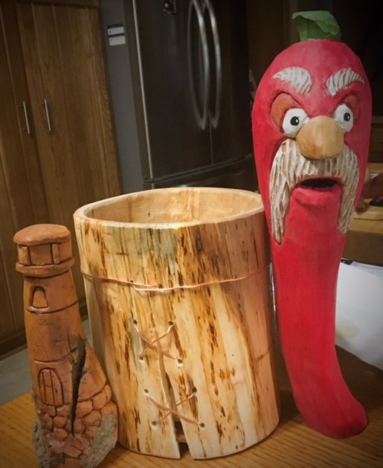
Club Members’ Carvings
Ernie Tucker’s Works, on right:
Cottonwood Bark Lighthouse,
Birch Shrink Box, and
Chili Pepper Trophy

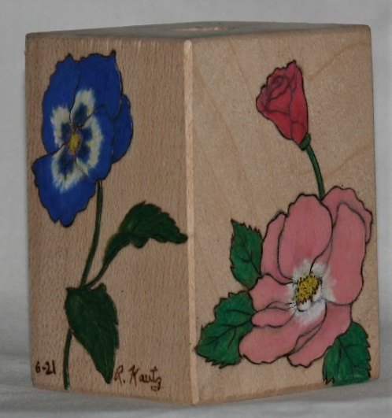

Rosie Kautz’
Cane Segment

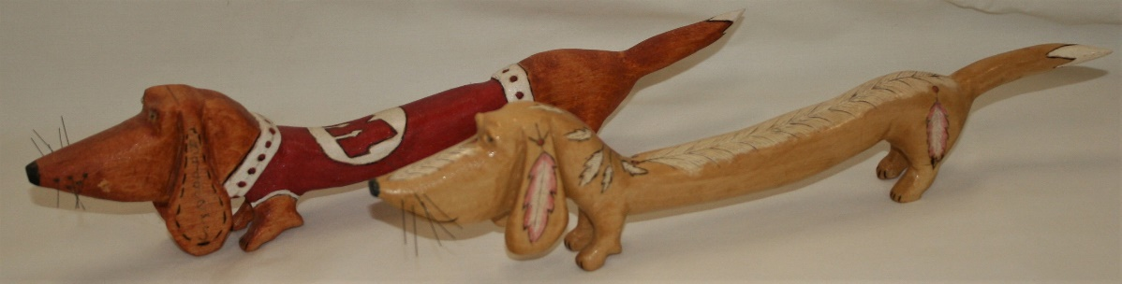
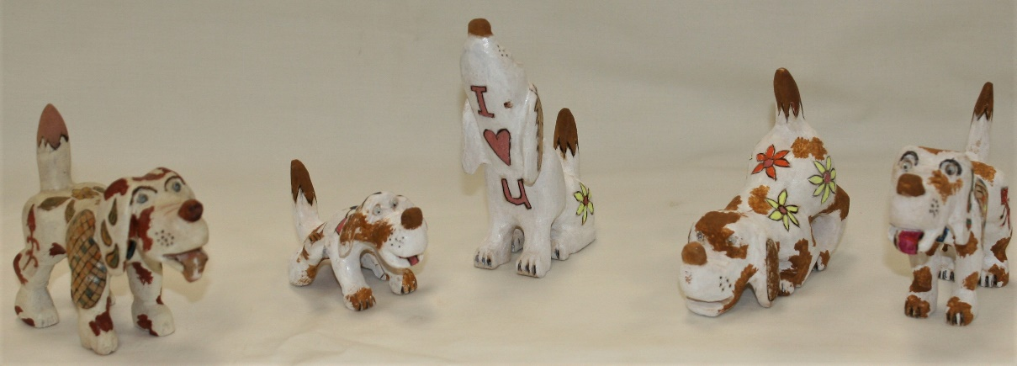
Dave Thill’s
Hound Dogs
Dave Thill’s
Wiener Dogs

