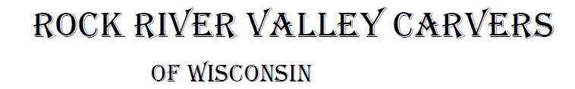
June 2021 Volume 22 issue 6
Editor: Rosemary Kautz Website www.rockrivervalleycarvers.com

Club Meeting Information Update
Evening Carving – Open carving from 6-8 pm on the first and third Tuesdays each month will be at First Lutheran Church (across from the fairgrounds) in Fellowship Hall located at 612 N. Randall Ave. Park in back and enter through the doors under the canopy. Take the first left to the room. Handicapped accessible. Table covers and masks are required at this time. The Building is air conditioned and woodburning can be done at certain tables.
First General Meeting – We will conduct our first club meeting on June 1, 6 pm at First Lutheran Church (see above). Come and join your fellow carvers and bring your recent work along to show everyone!

Janesville Senior Center Update
The Senior Center will be opening up June 1 with restrictions. Open carving on Monday and Thursday mornings, 9-11 am, will begin June 3 with a limit of 12 people. You must call ahead and make a reservation to attend and then check in at the front desk when you arrive. Masks are mandated by the city and social distancing should be followed. No food, coffee, or water will be available (bubblers are turned off). Drinks in sealed containers are permitted. Hand sanitizer will be available and we need to wipe down high-touch surfaces prior to leaving (tables and chairs). Come and join your fellow carvers again! No carving at Sportsman’s Park will be conducted on Monday afternoons after May 24.

2021 Officers
President: Thomas Kautz
608-868-4522
Vice President: Mark Ludois
608-371-3838
Secretary: Mark Ludois
608-371-3838
Treasurer: Rosemary Kautz
608-868-4522
Librarian: Bud Cunningham 608-853-1777
Editor: Rosemary Kautz
608-868-4522

If Things Get Any Worse, I’ll Have to
Ask You to Stop Helping

We normally meet on the
first Thursday of the month
at the Janesville Senior Center, Second Floor
69 S. Water St.
Janesville, WI
Meeting or Carving
begins at 7:15 p.m.
Board Meeting at 6 p.m.

May 18, 2021 Board Meeting Minutes
- Call to Order: President Tom Kautz called the meeting to order at 6:00pm. Mark Ludois, Vern Morris, Mike Hughbanks Bud Cunningham, Gerry Lesch, Brad Crandall, Dave Thill, and Rosie Kautz attended the meeting.
- Treasurer Report (Rosie Kautz): Beginning balance $5,864.02 and ending balance was $6,149.00
- Additions/Corrections to January Board Meeting Minutes: None. Brad Crandall made motion to accept treasure report as is, Bud Cunningham 2nd, motion carried.
- Web Report (Mike Hughbanks): Still at a rating of 63% based on visits, downloads.
- Illness/Sunshine Report: Leo Hanson was sent card.

Current Business:
- Evening Carving Sessions: 1st and 3rd Tues, 6-8 pm at First Lutheran church (Fellowship hall). Donation Amount: of $25.00/month - Bud Cunningham made the motion, Brad Crandall 2nd, motion carried.
- Senior Center update: Center will reopen June 1^{st.}
    - Morning carving sessions will begin on Thursday June 3
    - Limited to 12 people
    - You must call 608-755-3040 to reserve a spot
    - Check in at front desk upon arrival
    - Masks are mandated by the City of Janesville
    - No food, water or coffee will be available
    - You may bring in drinks in sealed containers
- Monday afternoon carving at Sportsman Park1-3 p.m.: Last time will be May 24, then we will return to Sr. Center.
- Show 2021 update:
  - Jesse Borde, JB Woodcraft LLC, will be our chainsaw carver.
  - Denny Neubauer will demonstrate carving little people and will sharpen knives for a fee.
  - Randy Callison will demonstrate carving spirals. (?)
  - Bud Cunningham volunteered to demonstrate woodburning.

New Business:
- Chili Peppers 2011: Mark Ludois will collect them again with date to be determined.
- Trinity Episcopal Church Donation: $50.00 and a thank you card with notice that we will no longer be using their facilities. Motion was made by Mark Ludois, second by Jerry Lesch, motion carried. Dave Thill will return keys to the church.
- Tallman Art Festival Aug. 1: Registration $50.00 for 2 booths before June 1. Mark Ludois made motion to accept price, Jerry Lesch second, motion was carried.
- Vern Morris YouTube Opportunity:
  - Channel is free
  - I-cloud space and batteries would be an expense (around $25) for 12 videos.
  - Motion was made by Bud Cunningham and second was Brad Crandall, motion was carried to try some YouTube How to videos until year end.
- Brad Crandall- Kauffman’s Country Store Farmers Market: Brad is going to put a calendar together with dates he would be able to man a booth close to our show date to promote it. Looking for other members to help in running a booth. Price would be $8.00 per Saturday.
Meeting adjourned at 7:00 p.m. Respectively submitted by Mark Ludois

Shows & Seminars Coming Up and/or Canceled
Woodcarvers’ Congress in June has been cancelled
September 11: Our Show & Sale in Janesville
September 18-19: Stevens Point, WI 20th Annual Show, Competition, and Sale of the Wisconsin River Woodcarvers, Holiday Inn, 1001 Amber Ave, Stevens Point, WI., Saturday 9-5, Sunday 9-4, admission $5 (under 13 free), Ron O’Kray (715) 570-2534 or Greg Wirtz (715) 323-2035, www.wisconsinriverwodcarvers.org

A Successful Show Needs You!
Cane Blocks – We need cane segments carved for our Sept. show. If you have a block you will finish for our show this year or need a blank, please let Jim Trumpy know at our June 1 general meeting or contact him directly.
Christmas Ornaments – Our ornament supply for sale at our show is very low. Please consider carving a few for us! If you need a cutout/blank, please contact Tom Kautz.
Show Chairman – This will be the last show that Brad Crandall will chair. Please consider taking over this important job next year. Brad is willing to help explain/train a new chairperson and will have a show binder with all pertinent information for the new person. The show cannot occur without your help!

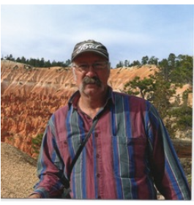
Get to Know a Fellow Carver
Fred Wuthrich is a Navy Veteran. He served as a jet engine mechanic for a squadron of F-14 fighter jets located in Nas Miramar, California. He also made two West Pac cruises on the U.S.S. Constellation.
Fred enrolled at Blackhawk Technical school following his service. He trained under Gerry Lesch, who is a member of Rock River Valley Carvers. He was employed as a welder at Varco-Pruden for 18 years.
Upon leaving Varco, he did odd jobs and travelled to New Orleans after hurricane Katrina. He also explored the state of Arizona before returning to Wisconsin.
He says, “I finally settled down and married Pat Hetzel, a long-time librarian at the Janesville Hedberg Public Library.” Fred and Pat reside in Janesville. Jim joined the RRVC club two years ago. In addition to carving, he enjoys working with stained glass, drawing, painting, wood working, and wood block printing.
Article submitted by Robin Rios.

You Know You Live with a Wood Carver When –
  - There are more knives in the workshop than in the kitchen.
  - You find wood stacked in the basement, garage, shed, gazebo….
  - Nobody in the house drinks wine, but you have a drawer full of wine corks.
  - You find wood chips in the bathroom.

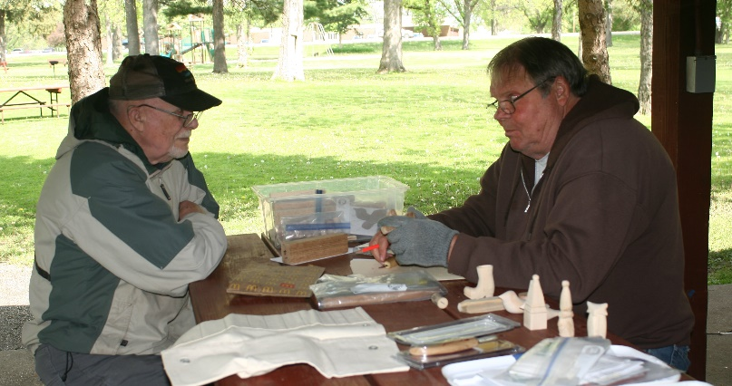
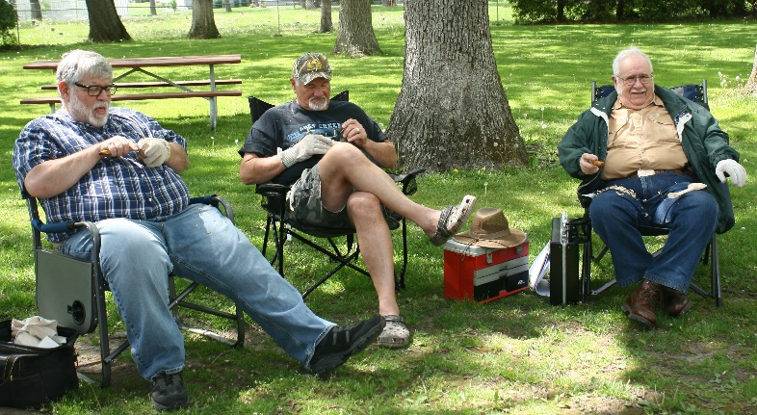
Carving in the Park Ernie Tucker and Steve Johnson on the left, and Mike Hughbanks, Reggie James, and Tom Kautz on the right enjoying a nice day carving at Sportsman’s Park on a Monday afternoon.

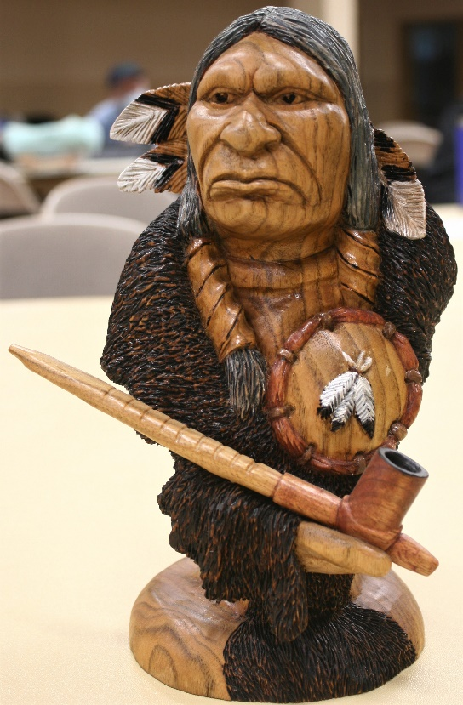
Club Members’ Carvings
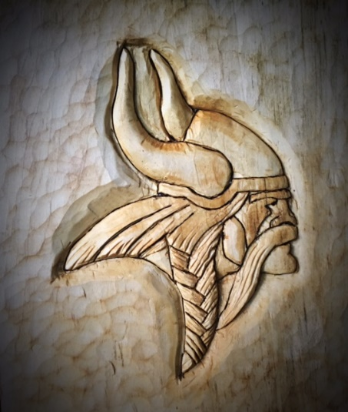
Ernie Tucker’s Parker High Viking

Brad Crandall’s Indian Bust
out of Butternut

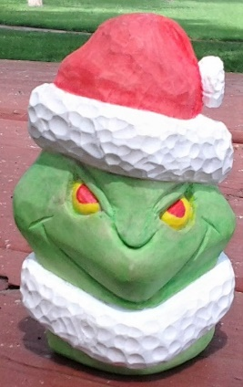
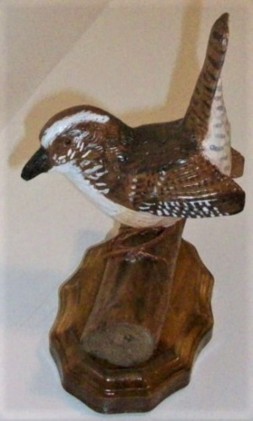
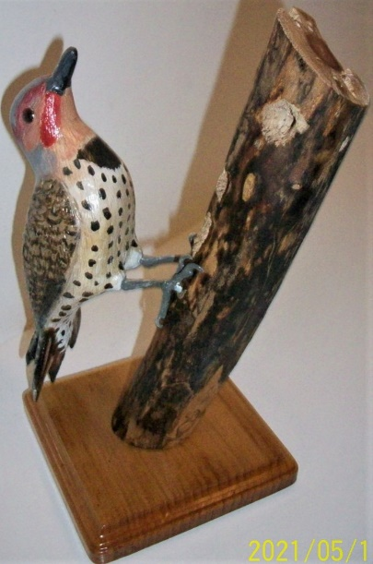
Dale Ehle’s Grinch

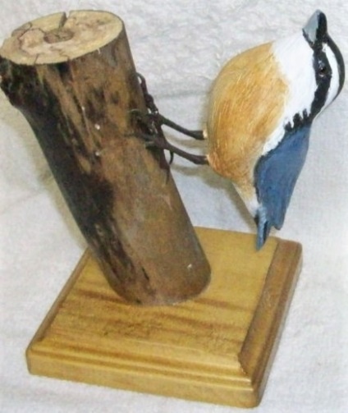
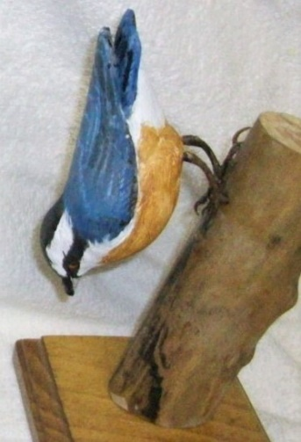
Bud Hilgendorf’s Western Red Shafted Flicker (on left) and Colorado Wren (above)

Two Red Breasted Nuthatches carved by Bud Hilgendorf

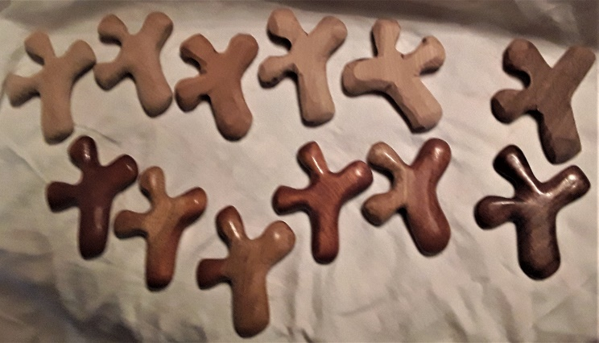
Comfort Crosses carved by Randy Callison

