June 2022 Volume 23 issue 6
Editor: Rosemary Kautz Website www.rockrivervalleycarvers.com

May 3, 2022 Meeting Minutes

- Call to Order: President Tom Kautz called the meeting to order at 6:02 p.m.
- Introduction of New Members/Visitors – None present
- Treasurer Report (Rosie Kautz): Beginning balance was $6,122.56 and ending balance was $5,518.39. The deposits included $70 in dues, $75 from show tables. The main expenses were $400 annual insurance cost, $100 park fee for our summer picnic, and newsletter costs of $239 from January thru April this year. No questions were forthcoming, treasurer’s report accepted.
- Additions/Corrections to last month’s newsletter: None were voiced.
- Web Site Report (Mike Hughbanks): Mike has updated our site with many photos. Over 100 people viewed the site in just the prior week.
- Illness/Sunshine Report (Rosie Kautz): A sympathy card was sent to Andy Navarro for the passing of his wife. Tom Marty emailed that he was having some medical tests done today.

Old Business
- Janesville Public Library Showcase Display in May (Mike Hughbanks): The display is impressive and includes some quarter-sheets for our upcoming show. Rosie Kautz offered to do a write up about our club for the library display information book (completed). The library is interested in us carving in their lobby again. More information will be coming on this. Thanks to everyone who helped create the display on May 2.
- The Gathering Place Follow Up Painting Class (Tom Kautz): A carving/painting class will be held on May 13 from 1:30 – 4 pm. in the garden room upstairs. One new carver has carved 4 additional fish keychains since the first class.
- Christmas Ornaments for Show and Cane Segments: Jim Trumpy thinks only a few more cane segments are needed. Many Ornaments are needed for our show as most were sold in 2021.

2022 Officers
President: Thomas Kautz
608-868-4522
Vice President: Mike Hughbanks
815-289-8573
Secretary: Vacant
Treasurer: Rosemary Kautz
608-868-4522
Librarian: Bud Cunningham 608-853-1777
Editor: Rosemary Kautz
608-868-4522-

If I’m Talking to Myself,
I’m Just Getting Expert Advice!

Normal meetings on the
first Tuesday of the month
at the First Lutheran Church, Across from Fairgrounds
612 N Randall Ave.
Janesville, WI
Meeting or Carving
begins at 6 p.m.

New Business
- Update on Mid-Wisconsin Chippers Show Sunday, May 1 (Tom Kautz): It was a very good show. The club is quite large and they had almost 80 exhibitor tables present. The Appleton Museum has a Leonardo DaVinci exhibit going on that displays constructions of his mechanical sketches of combat machines, a wooden bicycle, the first deep sea diving suit, the first parachute, and many other interesting items. If you’re interested, it’s worth a trip.
- Club Picnic (Rosie Kautz): Sportsman’s Park has been reserved for our annual picnic on July 12 from
4 – 9 pm. The club will provide chicken. The picnic is a potluck as in prior years – bring a dish to pass, your beverage, and your place setting. The restrooms are now open to the public.
Meeting adjourned - Minutes submitted by Rosie Kautz.

Next Meeting – June 7th
General meeting and open carving from 6-8 pm on the first Tuesday each month at First Lutheran Church (across from the fairgrounds) in Fellowship Hall located at 612 N. Randall Ave. Open carving the third Tuesday of each month at the same location. Park in the back and enter through the doors under the canopy. Take the first left to the room. Handicapped accessible. Table covers are required for carvers

Area Carving Opportunities!
Janesville Senior Center: Mondays & Thursdays from 9-11 am. Meet and carve with fellow carvers. Masks are no longer required! The water fountains are now open. You may bring in covered drinks. Please spray your area and wipe it down with the bleach water provided by the center before leaving. Come and join your fellow carvers again!

Shows & Seminars Coming Up
June 11-18: Maquoketa, IA International Woodcarvers Congress Competition at Jackson County Fairgrounds, 1212 E Quarry St, 10-5 daily, 10-4 Sunday, www.awcltd.org
July 24-30: Crete, Nebraska Doane Woodcarving Experience at Doane University. Instruction, accommodations, meals. Rohn Collins, 402-880-6721, www.thedoaneexperience.com
October 1-2: Coon Rapids, MN Metro Chapter of Minnesota Wood Carvers Assoc. 17th annual weekend seminar at VFW Post, 1919 Coon Rapids Blvd. NW. Email Roger Serdahl, dahjrlia@gmail.com or Tom Sheldon at tbshel@comcast.net

July 12 Picnic at Sportsman’s Park
Bring your spouse, a dish to pass, something to drink, and your place settings (plate, silverware, napkin). The park is located at 3411 N Highway 51 (where the deer display is). Come for the good food, visit with fellow carvers, and see all the carved chili peppers!

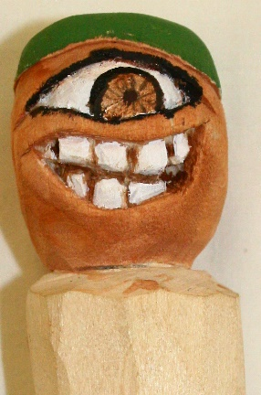
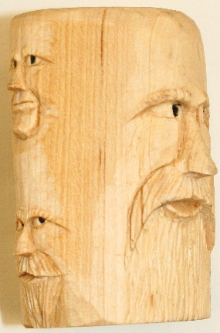
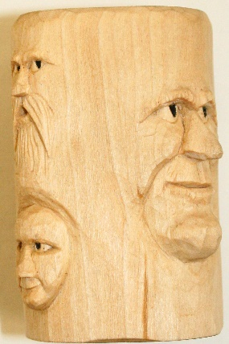
Show & Share

Mike Hughbanks’ Multi-Faced Cane Segment, and
Ernie Tuckers’ Cyclops Top for a Walking Stick

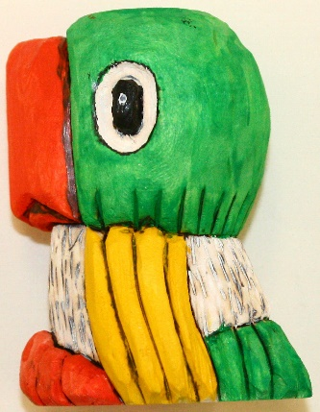
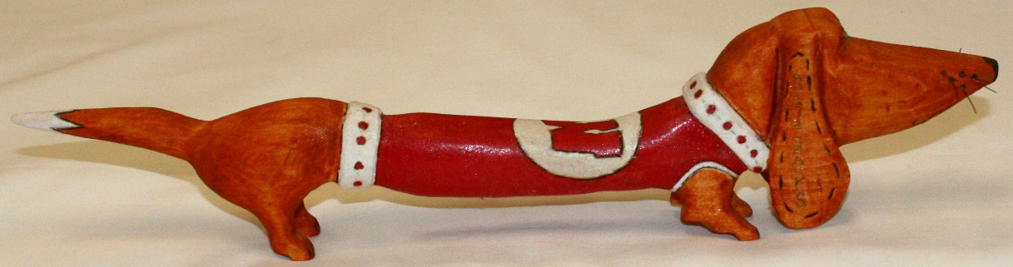
Dave Thills’ Weiner Dog
John Eidens’ Parrot Cane Segment
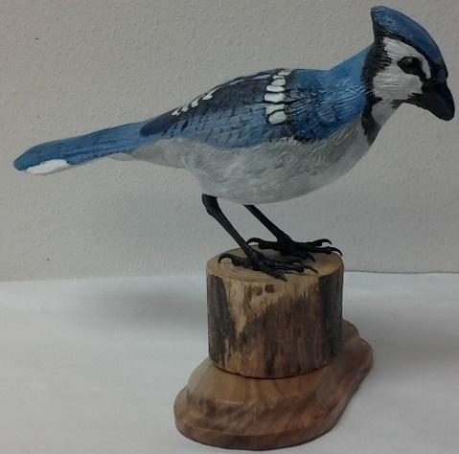
Club Members Other Recent Carvings
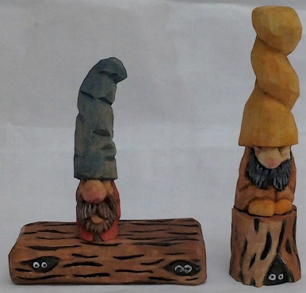
Bud Hilgendorfs’ Blue jay

Ernie Tuckers’ Gnomes are Being Watched

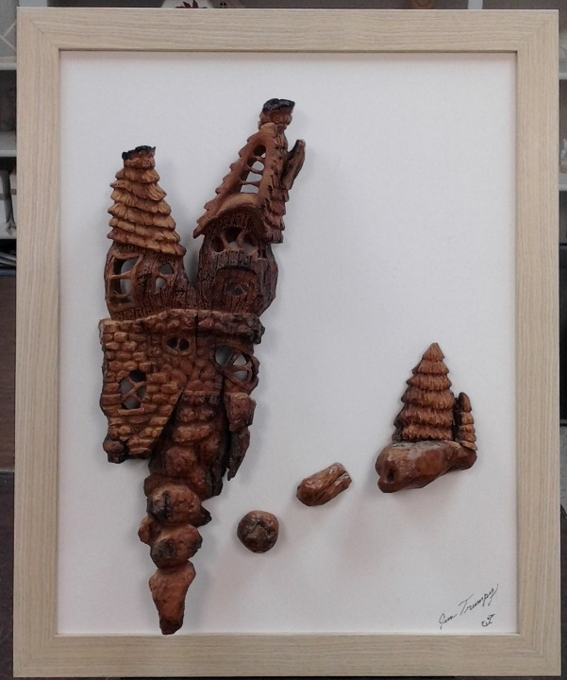
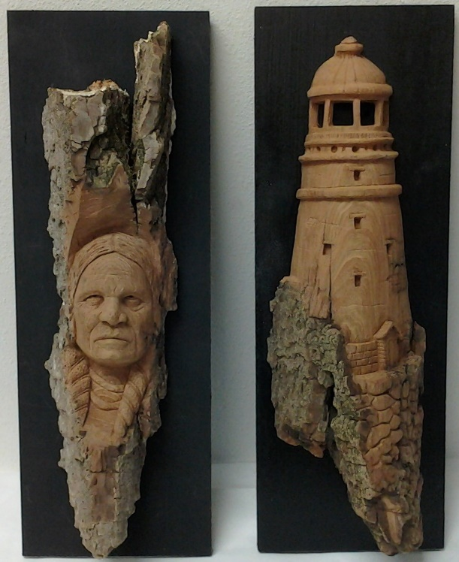

John Raisbecks’ Native American and Lighthouse Bark Carvings, on left

Jim Trumpys’ Framed
Bark Composition,
on right

Left to right above: Rosie Kautz’ Birdy Welcome Sign, Mike Hughbanks’ Pepper,
Randy Callison’s Stool Sample (for a doctors’ visit), and Tom Kautz’ Butternut Trout

