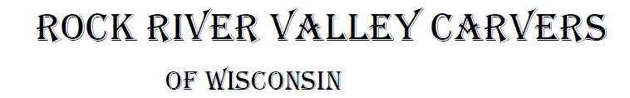
March 2024 Volume 25 issue 3
Editor: Rosemary Kautz Website www.rockrivervalleycarvers.com

February 6, 2024 Meeting Minutes

- Call to Order: President Mike Hughbanks called the meeting to order at 6:00 p.m. Attendance: 10.
- Introduction of New Members/Visitors: No new members or visitors were present.
- January 2024 Treasurer’s Report (Rosie Kautz): The beginning balance was $6,579.66, and the ending balance was $6,839.66. Deposits included $235.00 from club dues and $25.00 for show tables. There were no expenses for the month. Copies of the report were passed out.
- Additions/Corrections to January 2024 Newsletter/Minutes: No changes were made.
- Website Report (Mike Hughbanks):
12 Months 2,321 Visits
30 Days 157 Visits
7 Days 36 Visits
Score 64 (Higher than January)
- Illness/Sunshine Report (Rosie Kautz): No cards were sent out.

Old Business
- Program Director: A person is needed to set-up monthly speakers and or demonstrations. Call Mike Hughbanks if you are interested.
- Katherine M. Belling Memorial Art Scholarship via The Community Foundation of Southern Wisconsin (Tom Kautz): At last month’s meeting Tom Kautz brought up the idea of the club donating to this scholarship. Steve Johnson thought the club needed more information to make a decision. Tom presented the following additional information. Katherine Belling was an art teacher at Craig Senior High. The scholarship was established in her name to give to a graduating senior from Craig High School and Parker High School who intends to pursue an art degree from an accredited college,

2024 Officers
President: Mike Hughbanks
815-289-8573
Vice President: Mark Ludois
608-371-3838
Secretary: Robin Rios
608-752-3328
Lori Ruplinger
262-629-9821
Treasurer: Rosemary Kautz
608-868-4522
Librarian: Bud Cunningham 608-853-1777

You Always Grow From Any Challenge That
You Accept

Normal meetings on the
first Tuesday of the month
at the First Lutheran Church, Across from Fairgrounds
612 N Randall Ave.
Janesville, WI
Meeting or Carving
begins at 6 p.m.

university, or technical college. Each student gets $1,000.00. The scholarship committee from each high school picks the recipient. Tom circulated handouts with additional details about the scholarship. Vern Morris suggested looking into also giving money to a similar scholarship in Beloit. It was decided to continue discussion at March’s monthly meeting.
- Chilies (Randy Callison): Randy will check with Chilimania to find out if they want the club to carve chilies this year. Chilimania already has enough chilies for 2024.

New Business
- 2024 Show Update (Brad Crandall): The Craig Center is reserved for 2025. The show posters and quarter sheets are now available for distribution. Ron O’Kray and Greg Wurtz will be the judges this year. A Santa category will be added for judging.
- Carving Tools/Wood for Sale (Tom Kautz): Jane Valley wants to sell her husband’s carving equipment. Her husband, Art Valley, recently passed away. He was a local carver. Jane’s contact information is: Jane Valley
3532 Briar Crest Drive
Janesville, Wisconsin
608-201-5710
- Tallman House, August 2-3, 2024 (Tom Kautz): The club paid $60.00 for two tables.
- Welty Environmental Center-Maple Sugar Festival on February 24, 2024 (Tom Kautz): Set-up time is 7:30 a.m. The festival should be over by 1:00 p.m.
- RRVC Annual Picnic (Rosie Kautz): Following a short discussion about possible sites for the picnic, it was decided to rent the Sportsman Park again this year.
- Possible 2024 Donation to Congress (Mike Hughbanks): Jim Trumpy questioned how the Congress actually benefits the club. He suggested instead of giving money to Congress, we use the money towards the art scholarship. After further discussion Rosie Kautz made a motion to donate $100.00 to the 2024 Congress. Brad Crandall seconded the motion. The motion passed unanimously.
- Hedberg Public Library (Mike Hughbanks): The club will be displaying carvings at the library for the month of April.
- Show & Share: Tom Kautz passed around three spoons that he carved.
- Adjournment: President Mike Hughbanks adjourned the business portion of the meeting at 6:43 p.m. Open carving to follow. The minutes are respectfully submitted by Robin Rios, Secretary.

Save the Date!
Sportsman’s Park has been reserved for our picnic on Tuesday, July 9 this year.

Club Events in 2024:
Maple Sugar Fest – Morning of February 24 at Welty Environmental Center
Entire Month of April – Members display at Hedberg Public Library.
Winery Art Walk – Sunday, July 28 at Fermenting Cellars Winery, Noon – 4 pm, setup at 10 am.
Tallman House Art Fair – August 2 & 3 we will have 2 tables to display our works.
Beckman Mill Events:
Ice Cream Social - Sunday, July 21. Display and sales for our club members.
Heritage Sunday – Sunday, September 8. Display and sales for our club members.
Our Show & Sale – Saturday, September 14.

Information Coming on Upcoming Classes
Simultaneous classes will be offered at the Milton Gathering Place on carving faces
and a beginning carving class. These will take place April 9 and 15. Information to follow.

Shows & Seminars Coming Up
April 20: Westby, Wis Karve in 8, Westby High School Gym, 206 West Ave., 10-4 pm. Contact John Sutton, lbarnfarms@gmail.com or Steve Michaels, 608-769-8498, steve.michaels@westby-norge.org
April 28: Sheboygan, Wis Kettle Karvers Carving Show, Emil Mazey Hall, 5425 Superior Ave, 10-4 pm. Contact Bob Lawrence, 920-458-4947, bob@kettlekarvers@att.net
May 5: Oshkosh, Wis Mid-Wisconsin Chippers “Artistry in Wood” Show, Convention Center, 2 N Main St, 9-4 pm. Contact Paul Wolters, https://midwisconsinchippers.weebly.com
June 8-15: Maquoketa, IA AWC Congress Competition, Seminars, and Show, www.woodcarverscongress.org

Area Carving Opportunities!
Janesville Senior Center: Mondays & Thursdays from 9-11 am. Meet and carve with fellow carvers. Please spray your area and wipe it down with the bleach water provided by the center before leaving.
Gathering Place in Milton: Monday afternoon 1-3 pm. 715 Campus St.
Fulton Church: Tuesdays, 9-11 am in the church gymnasium, 9209 N Fulton St.
First Lutheran Church: The 1st and 3rd Tuesdays of every month from 6-8 pm, 612 N. Randall Ave. (Across from the fairgrounds.)

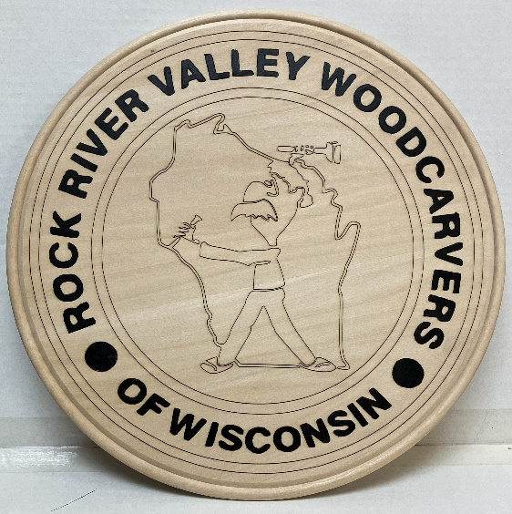
A New Club Plaque
Mike Hughbanks laser cut a new plaque with our club’s logo and
Bud Cunningham used acrylic paint to highlight the lettering.
We will be displaying the plaque on our exhibit/demonstration
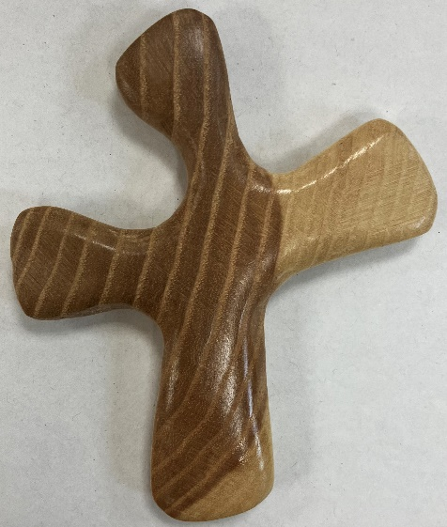
table at the library on the first Saturdays of each month, as well as our other events.
Thank you, Mike and Bud!

Randy Callison is at it again! This is just 1 of 25 comfort crosses he recently delivered to Mercy Hospital to be given to their patients.

Club Members Recent Carvings

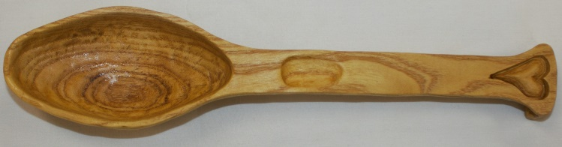

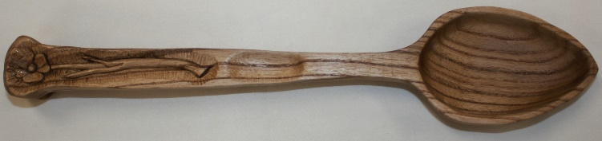
3 Spoons Carved by Tom Kautz. The top one out of “mystery wood” – thought to be Osage Orange, but not. The center flower spoon and oak-leaf spoons are out of butternut.

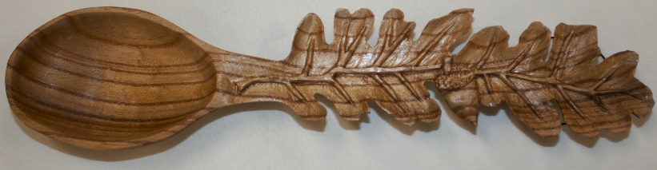

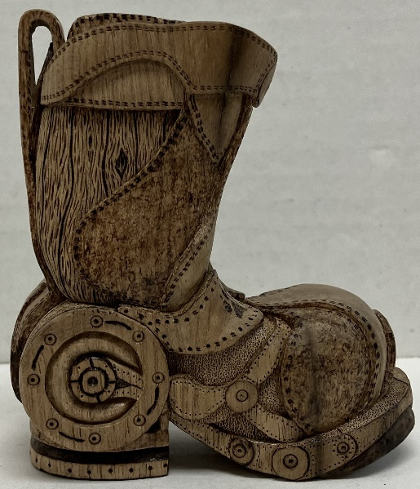
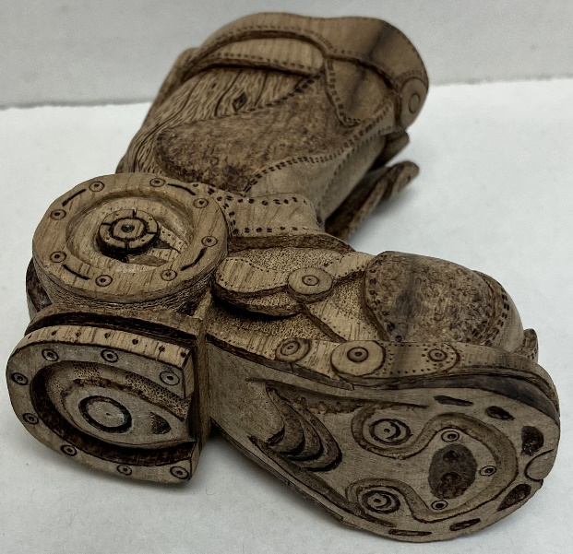
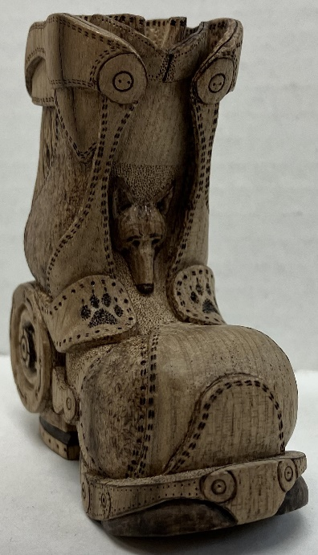
Gerry Lersch’s’ detailed, Small Boot shown in 3 different angles.
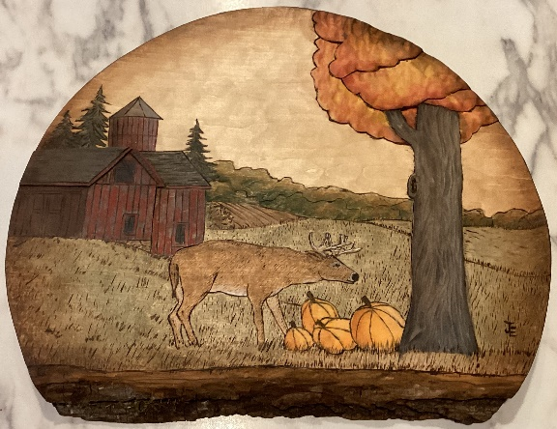
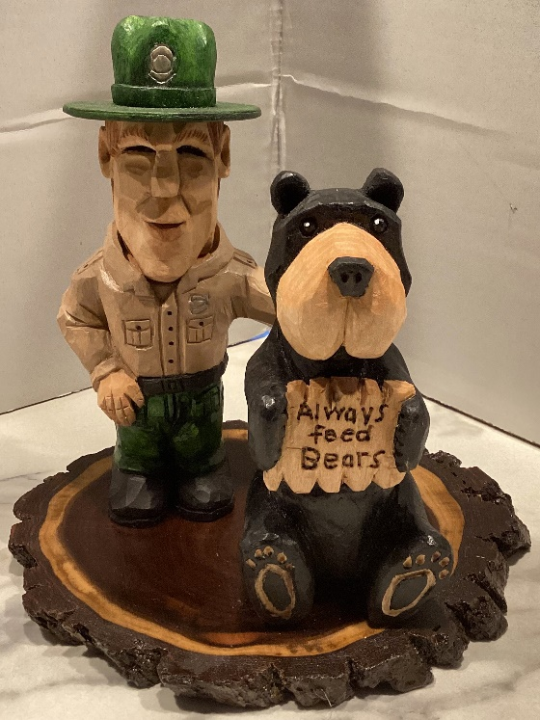

A Park Ranger and Bear
Carved by John Eiden

A Fall Deer Scene and a
Country Barn Scene
by John Eiden.

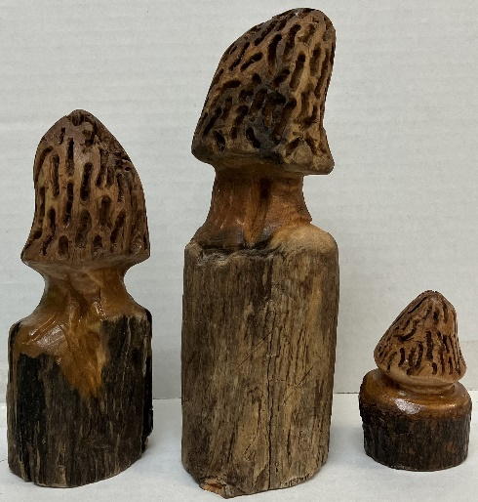
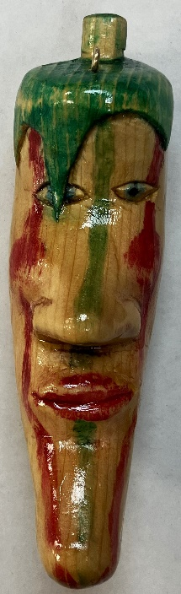
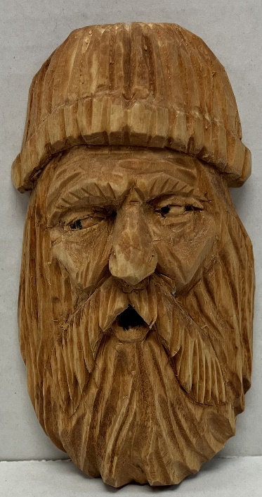
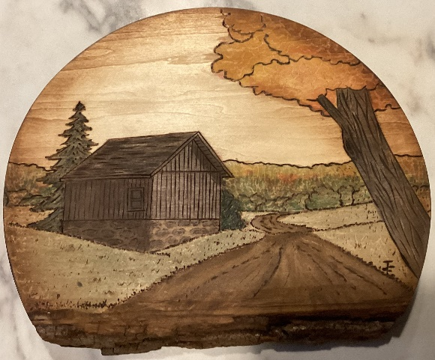
A Chili Pepper Ornament
by Fred Wuthrich Carved
for a chili cookoff in February.

An Old Man Character Carved by Ernie Tucker
In Basswood.
3 Morrel Mushrooms Carved
By Randy Callison

