May 2021 Volume 22 issue 5
Editor: Rosemary Kautz Website www.rockrivervalleycarvers.com

Club Information Updates

- Treasurer’s Report (Rosie Kautz): Beginning balance was $6,290.69 and our ending balance was $5,864.02. Income included $15.00 paid for 2022 dues. Expenses were $41.67 for printing show quarter sheet flyers and posters and $400.00 for our annual club insurance.
- 2021 Carving Show (Brad Crandall): Brad is currently working on finding a wood vendor and chainsaw carvers for our show. Jon Henry (County Line Products) is having health issues and let us know that he may not be able to do our show. Our past chainsaw carver is unavailable and Brad is contacting other possible carvers. Remember that we will need carved Christmas ornaments for the club sale and will also be looking for raffle donations.

Notes from the President’s Carving Bench

- Carve, Carve, Carve! Spring is on its’ way. New carvings, new challenges. Keep in mind “The merit of all things lays in their difficulty.” Challenge: Who said this and in what book?
- Update on open carving sessions: We will have open carving on Monday afternoons, weather permitting, from 1 to 3 pm at Walt Lindeman Sportsmans’ Park (highway 51) on Janesville’s north side. Weather should be over 50 degrees, little wind, and no rain. Masks must be worn and social distancing will be observed. The picnic tables are out in the shelter and restrooms are open. Bring you carvings, tools, and a chair if you wish.
- The Janesville Senior Activity Center is still planning on opening for limited numbers of members after June 1.
- Our club is still looking at sites for evening open carving sessions. We may need to go back to Trinity Episcopal Church if no other site can be found. Marion Hall at St. John Vianney Parish will not be open for use until October. We are aiming for the first and third Mondays, 6-8 pm, as in the past.

2021 Officers
President: Thomas Kautz
608-868-4522
Vice President: Mark Ludois
608-371-3838
Secretary: Mark Ludois
608-371-3838
Treasurer: Rosemary Kautz
608-868-4522
Librarian: Bud Cunningham 608-853-1777
Editor: Rosemary Kautz
608-868-4522

Nobody will watch you carve until you’re making a mistake

We normally meet on the
first Thursday of the month
at the Janesville Senior Center, Second Floor
69 S. Water St.
Janesville, WI
Meeting or Carving
begins at 7:15 p.m.
Board Meeting at 6 p.m.

- Keep in mind that details will be coming up for the Tallman Art Fest on Sunday, August 1, from 10 am to 4 pm. More details will be coming later.
- Details on Beckman Mill Days will be coming up as well. It is scheduled for September 12 from 11 am to 4 pm.
- The Rock River Thresheree is scheduled for September 3-6, from 8 am to 5 pm. More details to follow.
- Brad Crandall, our Show Chairman, is lining things up for our Sept. 11 show and sale. Please get your table registration in soon. (Prices go up after August 1.) Consider entering your work into the Peoples’ Choice contest. Club members can also enter an item in the miniature carving contest for a cash prize. Carvings must fit inside a 2x2x5” plastic cube. Call me to register for the contest. Brad will be contacting people to help, so please consider doing your part when he calls. The Friday afternoon before the show will be set up time. Help will be needed then. Also, remember that help will be needed for show take-down and clean up Saturday afternoon.

Shows & Seminars Coming Up and/or Canceled
Sheboygan Show on April 24 has been cancelled
Oshkosh Show on May 8 has been cancelled
Woodcarvers’ Congress in June has been cancelled
September 11: Our Show & Sale in Janesville
September 18-19: Stevens Point, WI 20th Annual Show, Competition, and Sale of the Wisconsin River Woodcarvers, Holiday Inn, 1001 Amber Ave, Stevens Point, WI., Saturday 9-5, Sunday 9-4, admission $5 (under 13 free), Ron O’Kray (715) 570-2534 or Greg Wirtz (715) 323-2035, www.wisconsinriverwodcarvers.org

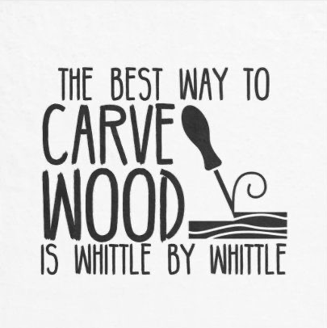

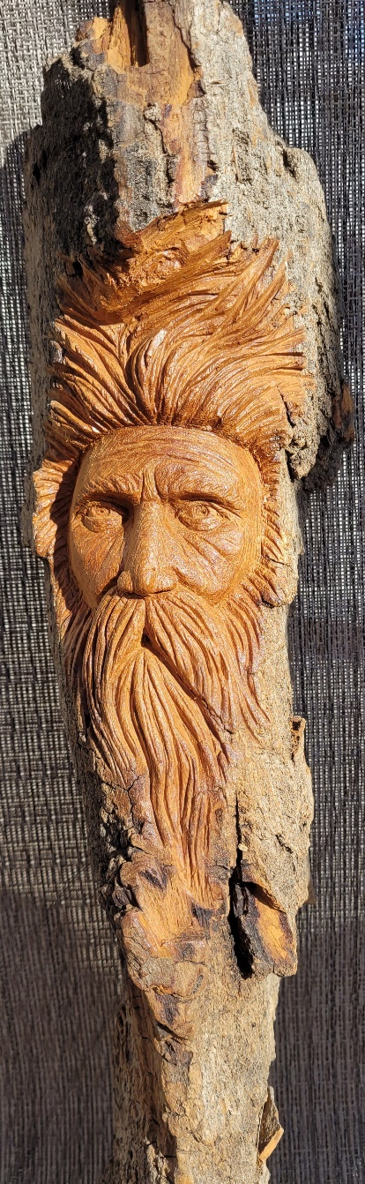
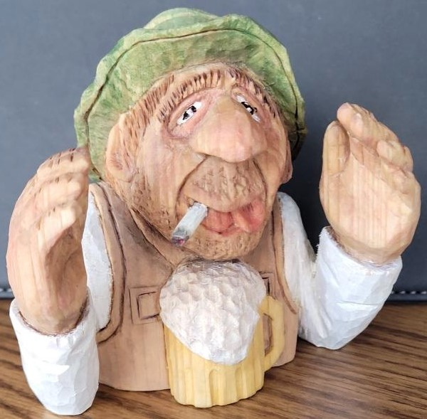
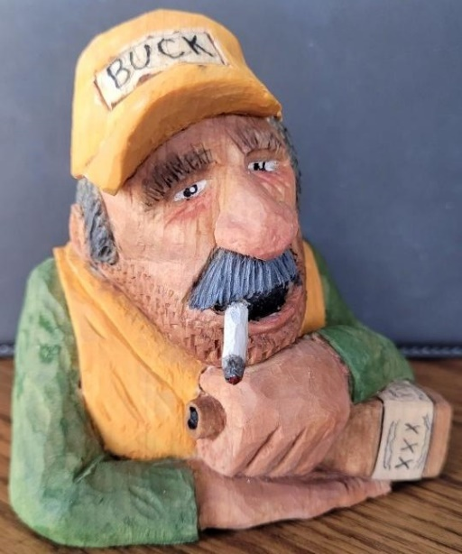
Club Members’ Carvings
John Raisbeck’s The One That Got Away
John Raisbeck’s Buck Hunter
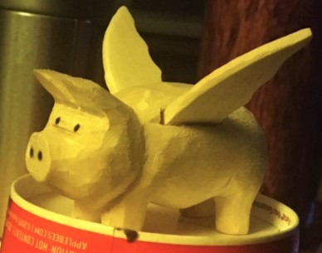
John Raisbeck’s Wood Spirit
Ernie Tucker’s Flying Pig
Rosie Kautz’ Cottonwood Bark Necklaces
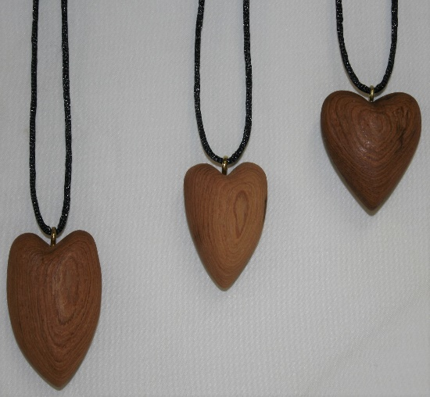
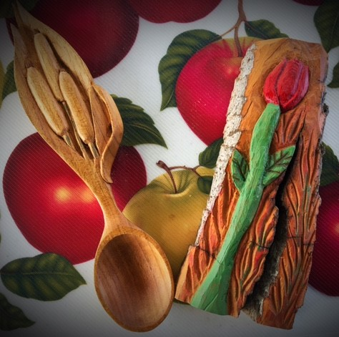
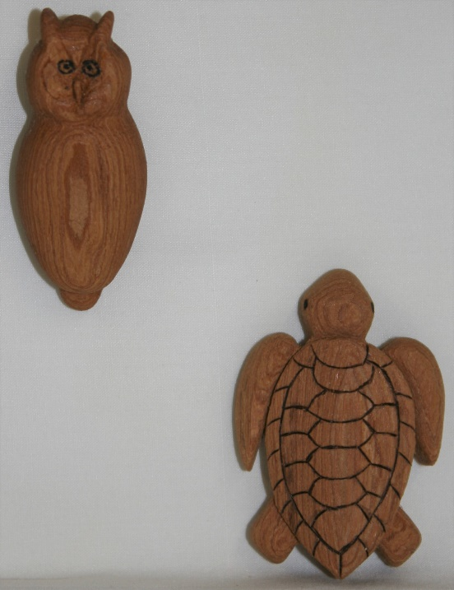

Rosie Kautz’ Cottonwood Bark Owl Pin and Turtle

Ernie Tucker’s
Butternut Spoon and Cottonwood Bark Rose

