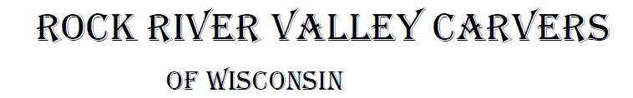

November 2021 Volume 22 issue 11

Editor: Rosemary Kautz Website [www.rockrivervalleycarvers.com](http://www.rockrivervalleycarvers.com)

**October 5, 2021 RRVC Monthly Meeting**

* Called to Order at 6:04 pm
* Introduction of Visitors/New Members: Jim Fischer was present and was welcomed.
* Illness/Sunshine Report (Rosie Kautz): A sympathy card was sent to Walter Deidrick’s’ family and a get-well card was passed around for Mark Ludois and his wife who were in the hospital (but now back home). Bev Fields is still in rehabilitation.
* Web Site (Mike Hughbanks): The club website had 170 visits in September.
* Treasurer Report (Rosie Kautz): Beginning balance was $5,707 and ending balance was $6,480. Major income included $1,249 from show proceeds, and $100 rent deposit returned. The main expenses included replacement chili pepper wood of $180 and show related expenses of $234. Total show profit was $417.65 compared to $449.26 in 2019, but a few small expenses are still unpaid.
* **‘Get to know a Fellow Carver’**: **We need someone to take over writing this article monthly for 2022 or we will no longer continue this next year.**

**Current Business**

* Show Update (Rosie Kautz): We had 217 attendees, 25 exhibitors plus Hummel and Wilcox Wood Works (2 less than in 2019). We ended up printing too many quarter sheet flyers and programs and will need to adjust quantities next year. 20 comments were turned in with 19 indicating they enjoyed the show and 1 with no comment. Overall comments were very favorable to our club members. A few possible areas to improve on were noted, such as adding the name and city of the exhibitor on the tables or programs, providing more information on how to start carving and how to join our club. (Although 2 new members were provided this information at the show and have joined our club.) Most attendees indicated they learned about the show from a friend or club member and few from the newspaper.
  + **A new Chairman or Co-Chairman for the show in 2022 is still needed.**

**Please consider stepping up to assume this important role for our club.**

**2021 Officers**

President: Thomas Kautz

608-868-4522

Vice President: Mark Ludois

608-371-3838

Secretary: Mark Ludois

608-371-3838

Treasurer: Rosemary Kautz

608-868-4522

Librarian: Bud Cunningham 608-853-1777

Editor: Rosemary Kautz

608-868-4522

**Speak well of your Enemies …**

**You Made**

**Them!**

Normal meetings on the

first Tuesday of the month

at the First Lutheran Church, Across from Fairgrounds

612 N Randall Ave.

Janesville, WI

Meeting or Carving

begins at 6 p.m.

* Friends of Beckman Mill Carving Display (Tom Kautz): Tom thanked all the club members who displayed their works Sunday, Sept. 12. Our display was well received by the public.
* Chili Peppers: Chili Mania wants us to carve peppers for them again next year.

**New Business**

* Moving the 2023 Show to First Lutheran (Rosie Kautz): Vern Morris discussed having our 2023 show at First Lutheran Church with church officials. The church is in the process of creating policies for renting to outside groups. This could be cheaper to rent than the fairground building, but we won’t know exact details until probably around Thanksgiving at the earliest. Many details would need to be worked out before a decision could be made.
* Web Site Renewal (Mike Hughbanks): Mike received a renewal notice for our club website for $539.64 for 3 years ($179.88 per year). Board Member voting on payment will be obtained via email. (Subsequent vote by the Board approved the payment.)
* Possible Christmas Party Dec. 7 (Tom Kautz): Tom asked if members were interested in pursuing having a Christmas party at First Lutheran. Interest was expressed and Rosie Kautz will check with the church on this possibility.
* Update From Jim Trumpy: John Raisbeck and Jim took a class on carving a bust from Vic Hood, who has a new book out available at Hummel. Denny Neubauer is current president of the Rockford carving club and they are interested in sharing instructors, classes, and programs with our club. Bernie Fields’ daughter has Bernie’s carving wood for sale and will soon have his carving tools for sale. (Mike Hughbanks subsequently purchased all the wood and has it available for sale. See him for details. Included is a large quantity of thick, western cottonwood bark.)
* Next Meeting: Tuesday, November 2

Meeting Adjourned at 6:40 pm. Minutes submitted by Rosie Kautz

**Club Meeting Information Update**

**Evening Carving –** Open carving from 6-8 pm on the first and third Tuesdays each month will be at First Lutheran Church (across from the fairgrounds) in Fellowship Hall located at 612 N. Randall Ave. Park in back and enter through the doors under the canopy. Take the first left to the room. Handicapped accessible**. Table covers are required at this time.** The building is air conditioned and woodburning can be done at certain tables.

**Notes From the President’s Carving Bench**

The club needs a Show Chairman or 2 Co-Chairmen for 2022. With the election of officers coming up, please consider helping out! For our 2021 Christmas party, please carve an ornament if you want to enter the ornament exchange. If you need a blank or pattern, your president or other club members can provide you with one.

Out club was well represented at the Northeast Wisconsin Woodworkers Show in Green Bay at the Denmark High School. Gerry Lesch, Rosie & Tom Kautz were there for the two-day show. Good times were had and we obtained a new perspective on how a similar event was held.

**Club Christmas Party on December 7**

We have permission to hold our annual Christmas party on December 7 at First Lutheran Church in Fellowship Hall. We will provide table covers and chicken for all. Please bring a dish to share, your own plate, napkin, and silverware, and something to drink. We will do an ornament exchange for everyone who wishes to participate and brings a carved or woodburned ornament. We will need to clean up and take recyclables and trash to the dumpsters afterwards.

**Please contact Rosie or Tom Kautz to let them know if you will attend.**

**With lower-than normal meeting attendance, we don’t want to purchase too much chicken.**

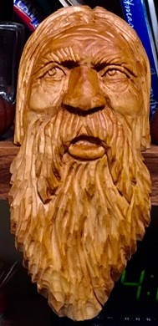**Club Members’ Carvings**

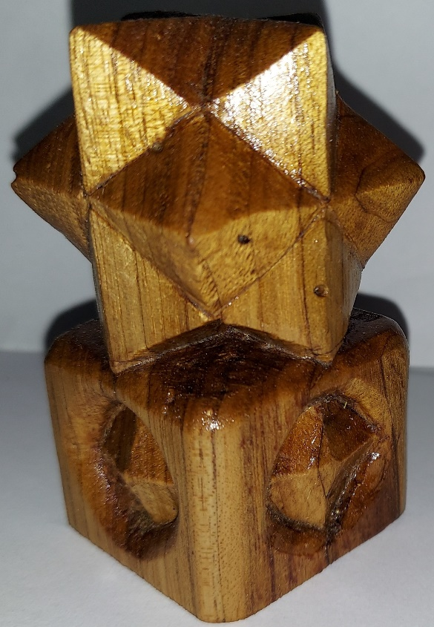

Denny Pryce’s 12-Point Star

Ernie Tucker’s Shelf Sitter

**Have You Checked Out Our Website Lately?**

There are many helpful U-Tube videos on our site – including 3 videos on how to carve a golf ball, or a cane, a simple owl, or a gnome. There’re also videos on different ways to stain and finish your carvings. Check it out!!