November 2020 Volume 21 issue 11
Editor: Rosemary Kautz Website www.rockrivervalleycarvers.com

IMPORTANT MESSAGE:
There will be No Monday and Thursday morning carving sessions
No Tuesday evening carving sessions
No monthly meetings for now. The Senior Center is closed.

Notes from the Presidents’ Carving Bench
Monday, 26 October will be the final time this season to meet at Walt Lindeman Sportsman’s Park. Come promptly at 1:30 if interested in free wood and started projects donated by Tim Banwell’s estate. The toilets will be closed and the chilly dampness has made for poor conditions to carve outside.
The club’s Board of Directors has reviewed the wonderful offer of indoor daytime meeting space by Faith Community Church. The current state of Covid 19 infections and deaths puts that site and any other unsafe for now. A vast improvement would be needed to consider indoor gatherings even in a small group.
The club has been in touch with Saint John Vianney Church in Janesville about the use of Marian Hall for evening open carving sessions. It looks like either the first and third Wednesdays or possibly Mondays from 6:30 to 8:30 pm would be available next year. At this time, we will not receive a commitment from the church until around Easter next year. The hall has air conditioning and will accommodate 10 to 20 people. We would have to set up and take down tables and chairs and clean up our chips. Good light and outlets for pyrography are available as well as restrooms. More information will be coming on this as details are finalized and commitments made. A small donation such as the club was giving for Ortmayer Hall would be appreciated for the use of this meeting site.
When you get a chance to meet our newest and youngest member, welcome Camden Reinstad. He is new to carving and was a regular at our Monday afternoon session at the park.

2020 Officers
President: Thomas Kautz
608-868-4522
Vice President: Mark Ludois
608-371-3838
Secretary: Mark Ludois
608-371-3838
Treasurer: Rosemary Kautz
608-868-4522
Librarian: Bud Cunningham 608-853-1777
Editor: Rosemary Kautz
608-868-4522

I Slice More
Then An
Amateur
Golfer

We normally meet on the
first Thursday of the month
at the Janesville Senior Center, Second Floor
69 S. Water St.
Janesville, WI
Meeting or Carving
begins at 7:15 p.m.
Board Meeting at 6 p.m.

Keep in mind that 2021 should bring vast improvements to life! Our show and other events are “on tap” for 2021, including:
- Our Show on September 11, 2021
- Wisconsin River Woodcarvers Show on September 18 and 19, 2021
- Various other carving clubs shows that have not been finalized
- Other local carving promotions, including Beckman Mill, Thresheree, and Tallman House

On a very sad note, the Musky Area Woodcarvers’ Workshop in Boulder Junction was cancelled for 2020 and the leadership of the event by Mary and Gordy Moscinski have announced that there will not be any classes in 2021 and no more classes in the future.
Stay safe and healthy, keep carving, and submitting photos of your completed projects for the newsletter to Rosie Kautz. Keep in contact with each other via phone, email, Facebook, etc. Remember you can always send items to Mike Hughbanks, our webmaster, for updating our website.

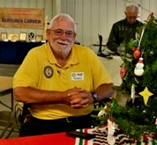
Get to Know a Fellow Carver
Mark Ludois lives in Janesville, Wisconsin. He is currently serving as the RRVC Vice President and Secretary which he is enjoying “tremendously.” Mark started carving three years ago, and he has been a member of the Rock River Valley Carvers of Wisconsin for two and a half years.
Mark says, “I enjoy just about any type of carving. My favorite would be smaller characters like owls, wizards, Xmas tree ornaments, golf balls, pencils, etc.”
Mark and his wife Kimberlee married 44 years ago. They have two “wonderful” children, Nathan and Emily. Mark and Kimberlee are also blessed with three grandchildren: Connor (14 years) and the ten-year old Twinados (Twins) Maddie and Mason.
Article submitted by Robin Rios.

A Tip from Fox Chapel Publishing:

Use a toothpick or stylus to paint perfectly round dots for eye highlights, buttons, and anything else that should be round.
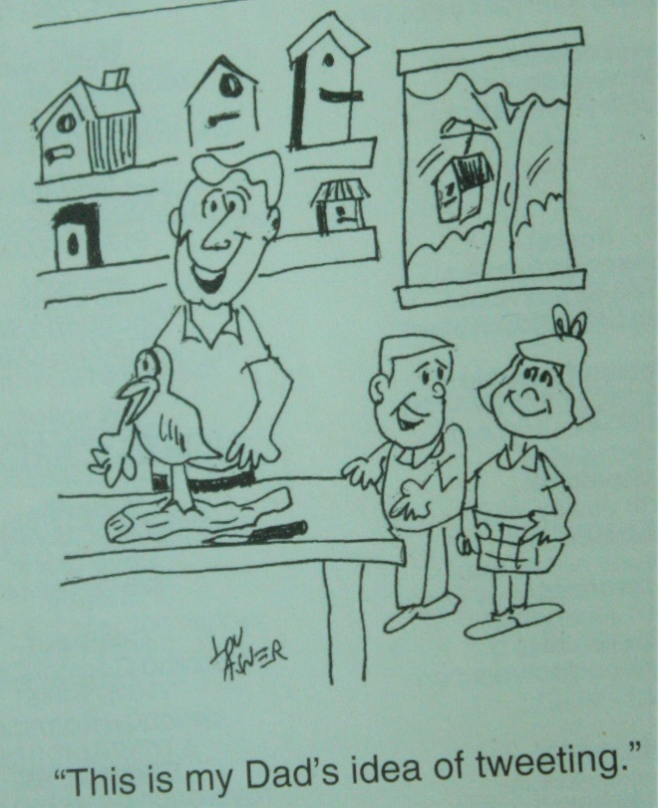

Is it called “relief carving” because that’s how you feel when you’re finished?

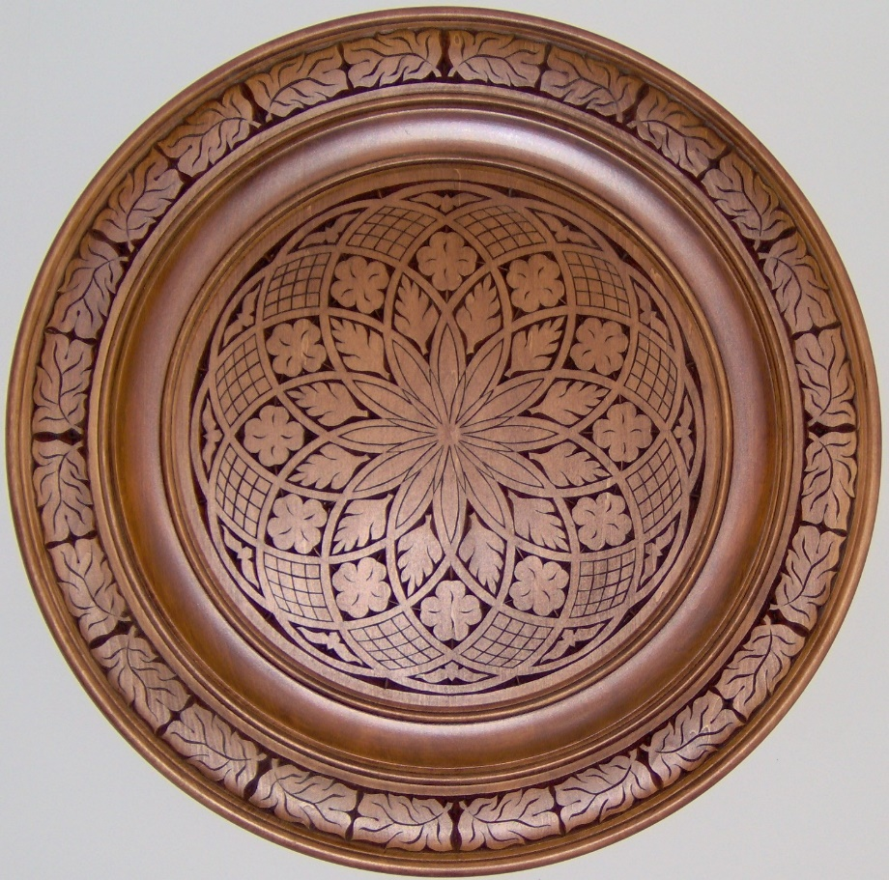
Club Members’ Carvings

Ray Douglas’
30-inch Round
Chip Carved
Basswood Plate

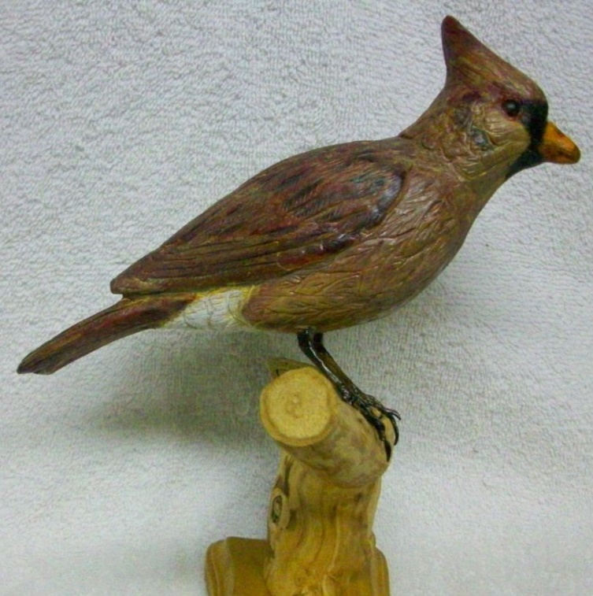
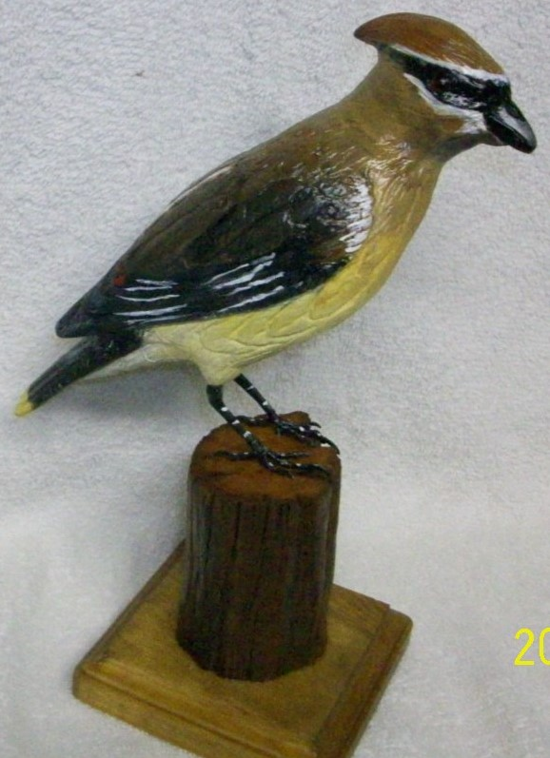

Bud Hilgendorf’s Female Cardinal

Bud Hilgendorf’s
Cedar Waxwing

