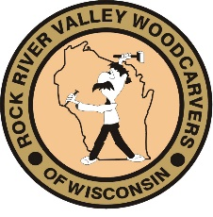
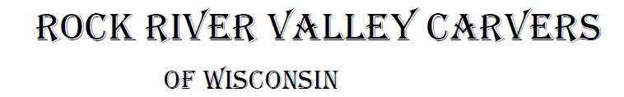
October 2021 Volume 22 issue 10
Editor: Rosemary Kautz Website www.rockrivervalleycarvers.com

September 7, 2021 RRVC Monthly Meeting
- Called to Order at 6:04 pm
- Introduction of Visitors/New Members: None present
- Illness/Sunshine Report (Rosie Kautz): Vern Morris told attendees that Andy Navarro’s wife is home now.
- Treasurer Report (Rosie Kautz): Beginning balance was $4,823 and ending balance was $5.707. Major income included $350 from show table sales and $731 from Chili Mania. The main expenses included purchase of show ribbons, newsletter ink, and donation to First Lutheran for use of their premises for our evening meetings.
- ‘Get to know a Fellow Carver’: We need someone to take over writing this article monthly for 2022 or we will no longer continue this next year.
New Business
- Show Update (Brad Crandall): Set up for the show begins at 2 pm on Friday. We have 25 exhibitors registered for our show. Brad brought the table layout for everyone to review and verified that masks at the fairgrounds are not mandated by the county. Robin volunteered to put up and take down the corner signs the day of the show at First Lutheran and the chiropractor’s office. Vern will pick up the donuts at Festival and Randy will take down the banners at the fairgrounds after the show ends. A few additional members indicated they would volunteer at various club show tables. Vern Morris suggested members with leaf blowers bring them on Saturday to speed up “sweeping” the Craig Center after the show.
  - A new Chairman for the show in 2022 is still needed. Please consider stepping up to assume this important role for our club.
- Chili Peppers (Mark Ludois): Chilimania will be wanting carved chili peppers again in 2022.
- Friends of Beckman Mill Carving Display on Sunday, Sept. 12 (Tom Kautz): The following members volunteered to man the EZ-Ups the day after our show – Tom Kautz, Mark Ludois, Mike Hughbanks, and Bud Hilgendorf.

2021 Officers
President: Thomas Kautz
608-868-4522
Vice President: Mark Ludois
608-371-3838
Secretary: Mark Ludois
608-371-3838
Treasurer: Rosemary Kautz
608-868-4522
Librarian: Bud Cunningham 608-853-1777
Editor: Rosemary Kautz
608-868-4522

When You Know All the Trees in the Forest … You’re
Very Poplar

Normal meetings on the
first Tuesday of the month
at the First Lutheran Church, Across from Fairgrounds
612 N Randall Ave.
Janesville, WI
Meeting or Carving
begins at 6 p.m.

- Chip Chats Article: It was decided to submit an article on our show and photos of the winning entries to Chip Chats. Rosie Kautz will write the article and take the photos. Mark Ludois will put everything on a disk and submit it.
- Next Meeting: Tuesday, October 5
Meeting Adjourned at 6:35 pm. Minutes submitted by Rosie Kautz

Club Meeting Information Update
Evening Carving – Open carving from 6-8 pm on the first and third Tuesdays each month will be at First Lutheran Church (across from the fairgrounds) in Fellowship Hall located at 612 N. Randall Ave. Park in back and enter through the doors under the canopy. Take the first left to the room. Handicapped accessible. Table covers are required at this time. The building is air conditioned and woodburning can be done at certain tables.

Tool Glossary (from Jim Svoboda) …

Pliers – Used to round off bolt heads. Sometimes used in the creation of a blood blister.
Torch – Used almost entirely for lighting various flammable objects in your shop on fire.

Notes From the President’s Carving Bench
A big thank you to Brad Crandall and his spouse, Karen. As show chairman, Brad brought it all together to make our 2021 show a success. We made a modest amount of funds to ensure our club’s solvency and be financially ready for doing a 2022 show. I want to thank all of our club members who helped set up on Friday, helped with the show Saturday, and helped take down and clean up late Saturday afternoon. At this writing, we need to get someone to step forward now to be show chairman for 2022. Without a commitment now, the ability to hold a show will be in great jeopardy. If nobody steps forward by the end of November, the show will have to be cancelled. Our club depends on volunteer efforts. So many, many thanks to all who have helped put on a great show this year!
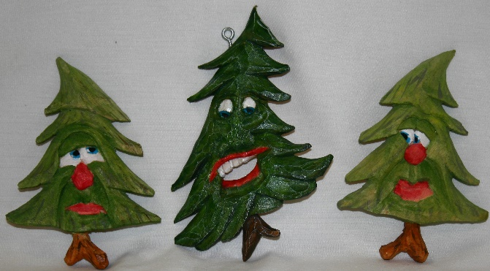
Club Members’ Carvings
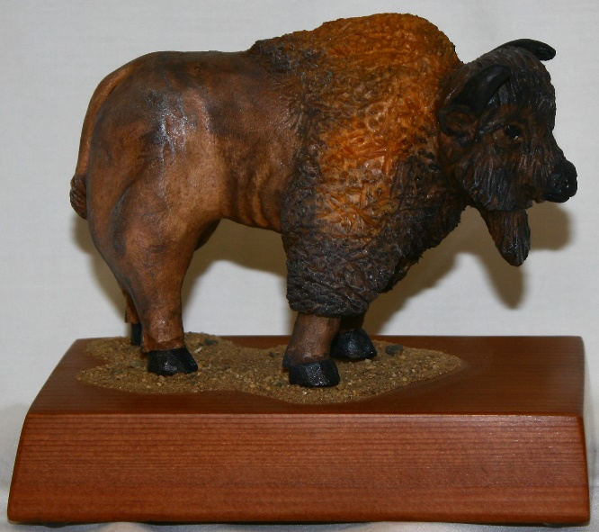

Jim Trumpy’s Trees with Funny Faces

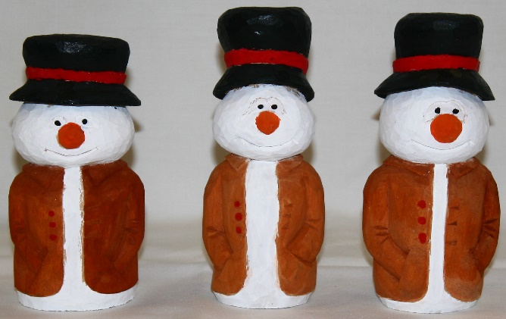

Tom Kautz’ American Bison
Mike Hughbanks’ 3 Snowmen,

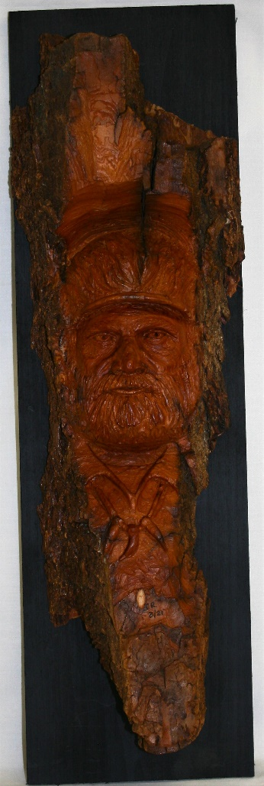
2021 Show Peoples’ Choice Winners
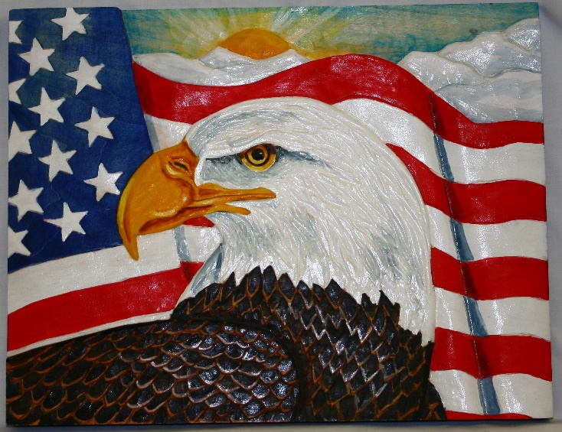
Eagle Flag Entry by John Gehrman Won the People’s Choice Novice Category

John Raisbeck’s
Mountain Man was the Best of Intermediate

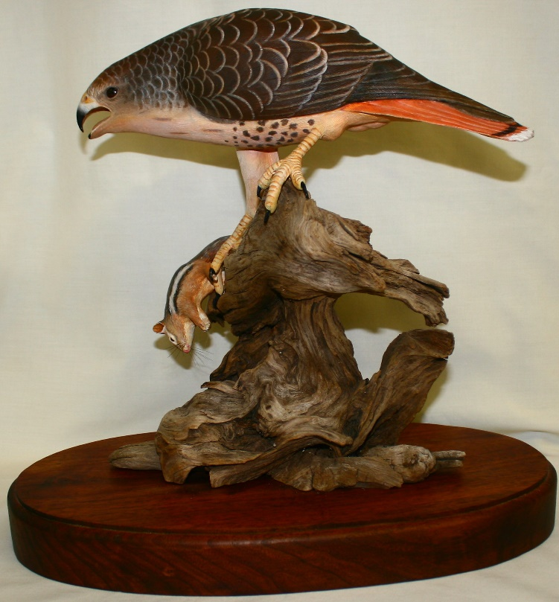
Steve Fields’ Hawk with Chippy Won the Open Category

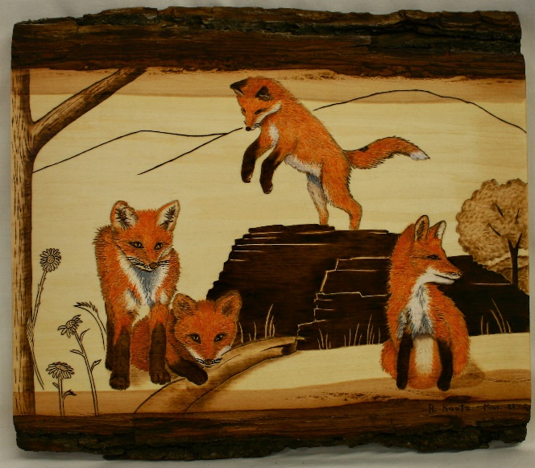

Fox Kits at Play won in Pyrography for Rosemary Kautz

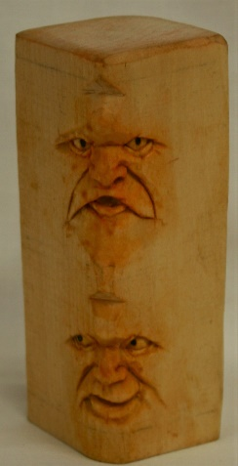
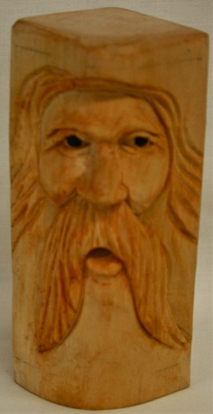
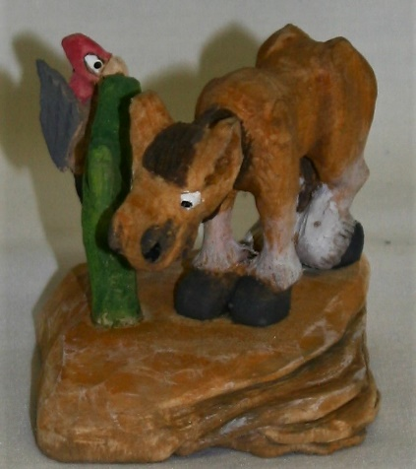
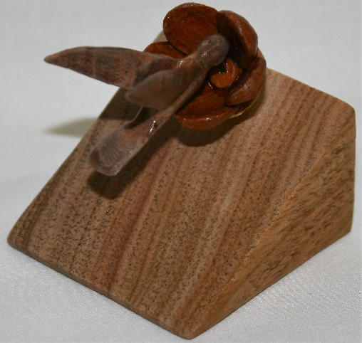
Miniature Contest Entries
(Left to Right) Jim Svoboda’s Hummingbird was the Winner, Two-Sided Faces by Ernie Tucker, and Donkey & Bird by Jim Trumpy.

