October 2020 Volume 21 issue 10
Editor: Rosemary Kautz Website www.rockrivervalleycarvers.com

IMPORTANT MESSAGE:
There will be No Monday and Thursday morning carving sessions
No Tuesday evening carving sessions
No monthly meetings for now. The Senior Center is closed.

Notes from the Presidents’ Carving Bench
Chili Peppers: New wood for those carvers who carved a chili this year was obtained via most generous donations of basswood by the estate/family of Ron Staben, Tim Banwell, and lastly by Bud Cunningham. Your president cut the large pieces up into “chili pepper” size blocks. The leftover good basswood pieces were distributed to club members at our Sportsmen’s Park carving session last Monday to use for other art work with a few pieces still available.
Thanks go out to Mark Ludois (who is getting better from his surgery) for his work on this project and these club members who carved chilis: Brad Crandall, Bud Cunningham, Ray Douglas, Ed Houge, Tom Kautz, Rosie Kautz, John Raisbeck, Jim Trumpy, Mike Hughbanks, Bud Hilgendorf, Ernie Tucker, and the following for carving 2 peppers: Randy Callison, John Eiden, and Fred Wuthrich.
A/C Project at Ortmayer Hall: The square footage/cubic footage of the space the church Vestry Committee selected will not work for a window unit. What will work is a “ductless unit” system with one compressor heat pump outside and 2 wall-mounted cassettes in room #4 (across the hall from the room we have used). One cassette would be at each end of the space. Preliminary proposals from Richter Electric and Lloyds A/C total a proposed project of $11,524. As of this time, our club has not received word as to how the board members of Trinity Church wish to proceed. A careful club budget analysis was put together by our Treasurer. It shows that covering all operating expenses including next years show

2020 Officers
President: Thomas Kautz
608-868-4522
Vice President: Mark Ludois
608-371-3838
Secretary: Mark Ludois
608-371-3838
Treasurer: Rosemary Kautz
608-868-4522
Librarian: Bud Cunningham 608-853-1777
Editor: Rosemary Kautz
608-868-4522

Advice from a Woodpecker:
Use your head and carve out a place for yourself.

We normally meet on the
first Thursday of the month
at the Janesville Senior Center, Second Floor
69 S. Water St.
Janesville, WI
Meeting or Carving
begins at 7:15 p.m.
Board Meeting at 6 p.m.

expenses, the club could safely allocate $1,000 to this project if the church comes up with funds to pay for the remainder. We anticipate that in return for this donation, the club would get 4 years of rent-free use of the room for the 2 evening sessions per month. See the board minutes for additional information plus the attached documents of our financial summary of annual expenses and the proposals for this project.
Also please note – if anyone has suggestions as to an alternate site for the 2 monthly open carving sessions, we would be most welcome to hear of them and consider moving ahead should the church be unable to move ahead. If anyone has questions, please feel free to contact your president or another board member.

September 21, 2020 Board Meeting Minutes

- Call to Order: President Tom Kautz called the meeting to order at 12:05 pm. Board members Mike Hughbanks, Rosie Kautz, Bud Cunningham, Brad Crandall, and Gerry Lesch attended the meeting. Ernie Tucker was also in attendance.
- President Tom Kautz stated that according to the 3-year summary of average annual income and expenses (see enclosed) with a checkbook balance of $5,632 (as of Feb. 20, 2020 when the summary was prepared), he felt that the club had $1,059 available to expend for the A/C project at Trinity Episcopal Church. He proposed allotting $1,000 for the project if board members and general membership approved. This would equal the approximate amount the club was donating to the church for the next 4 years. Rosie Kautz stated that we weren’t positive about receiving funds from Chili Mania next year, approximately $700. Gerry Lesch stated that he had dealt with Richter Electric in the past many times and they were one of the best companies around to deal with. Ernie thought the $1,000 would be ok, but we should look into other sites as well. Rosie Kautz stated that she would contact the Janesville Public Library and St John Vianney Church about the possible use of their facilities. Mark Ludois approved the plan via phone prior to the meeting. The proposal passed with one no vote and will be brought up to a general membership vote as soon as possible.
- Meeting adjourned at 1:12 pm. Respectively submitted by Rosemary Kautz.

A Carving Opportunity
Join your fellow club members on Mondays for open carving from 1:30 to 3:30 pm at Walt Lindeman Sportsman’s Park on Highway 51, across from the County Health Department as long as weather is appropriate. Strict social distancing must be practiced. Wear your mask and keep 6 feet between fellow carvers. Bring hand sanitizer, your own chair and/or table (in case the shelter tables are in use by another group), a carving project, and tools. Electric outlets are not available. The restrooms will be open. Join us for safe social interaction and the exchange of carving ideas.

Shows and Seminars
All known carving shows in Wisconsin & Thresheree have been cancelled for 2020.

Comfort Crosses
Ernie Tucker has delivered the following comfort crosses and hearts to the SSM Chemotherapy, Radiology, and Cancer Centers: 25 in early April, 50 on April 29, 40 in May, and 50 on July 29. Randy Callison delivered 25 to Mercy Hospital. Time and effort producing these were freely given by the following individuals: Ernie Tucker, Ray Douglas, Reggie James, Dave Thill, Dennis Palzkill, Tom Marty, Mike Boutelle, Gerry Lesch, Fred Wuthrich, Brad Crandall, Dennis Pryce, Vern Morris, John Raisbeck, Tom & Rosie Kautz, and Randy Callison. A special ‘Thank You’ to Ernie, Dave, and Dennis Pryce for each carving more than 20!

Get to Know a Fellow Carver
Jackie Widmar is a resident of Beloit, Wisconsin. She works full time for Hummul Carving Company located just outside of Beloit. Shortly after starting work there in 2015 Jackie bought her first wood burner and she started building a collection of tools while experimenting with various carving styles including power and chip carving.
Jackie has three children. Her oldest daughter graduated from high school this year. Her other daughter is currently an 8th grader. Jackie’s son is a 4th grader.
Jackie started carving four years ago. She says, “I’m having so much fun experimenting with the different ways to carve and learning so much from everyone. I have a Facebook page that I share all my work on. It is: KRHPyroDesigns.” She adds, “I look forward to learning so much more.”
Article submitted by Robin Rios.

Carving Eyes (from woodcarving.com)
“IMPORTANT! Eyes are not holes! They are mounds and the eye socket is quite large. Take a look at a human skull to see what I mean. Lots of carvers do not get the area of the eye nearest the nose deep enough. Try carving eyes on a flat piece of board first until you get the technique down. The eye is the same width as the nose. The center of the eye always lines up with the corner of the mouth. Carve a hundred eyes and then carve 100 more and you might be ready to carve an eye in your carving.”

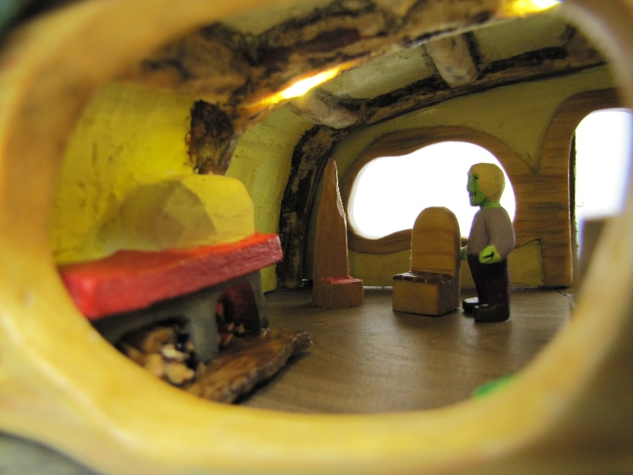
Club Members’ Carvings
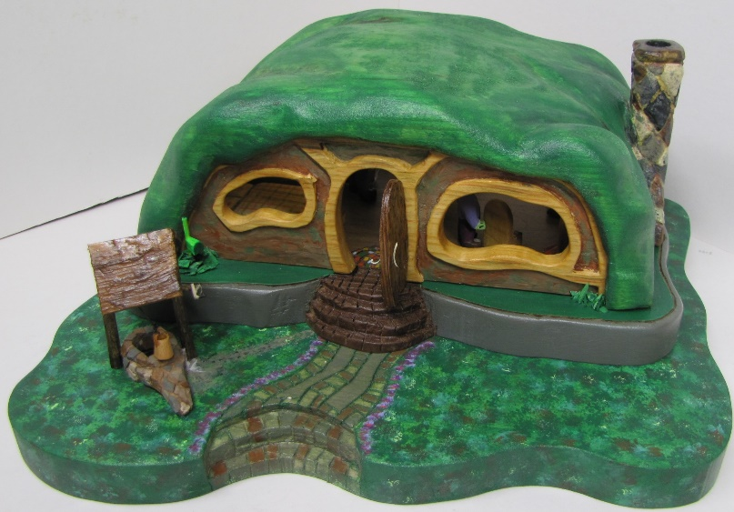
Jim Svoboda’s Forest House on 12” square basswood base, about 6” tall, complete with living room and fireplace, bedroom, and dining area, well and mailbox outside. Pushing down on the mailbox turns on the LED light inside!

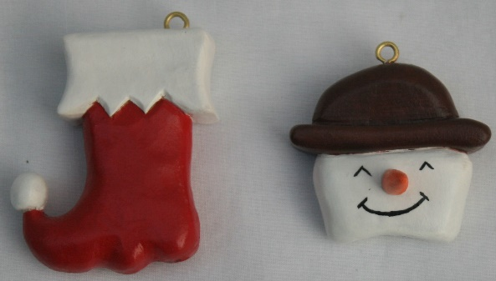
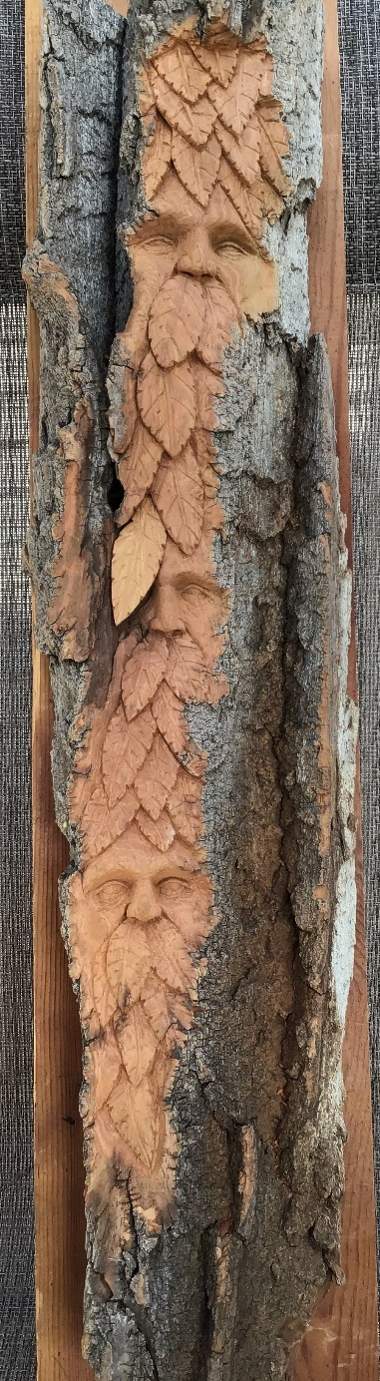
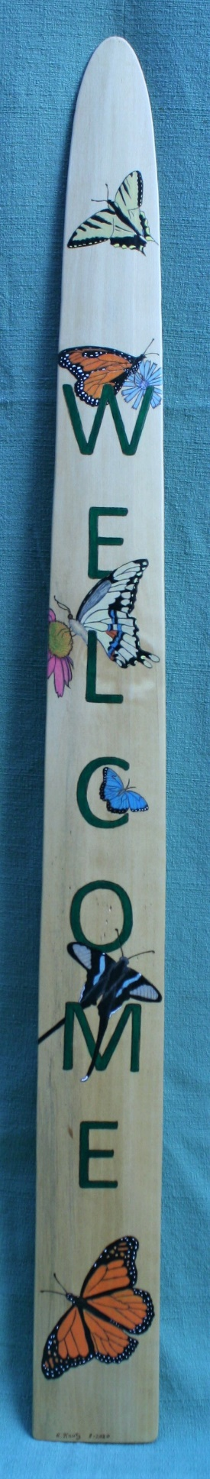
Rosie Kautz’ Christmas Ornaments and Welcome Sign on an old mink-skin stretcher board

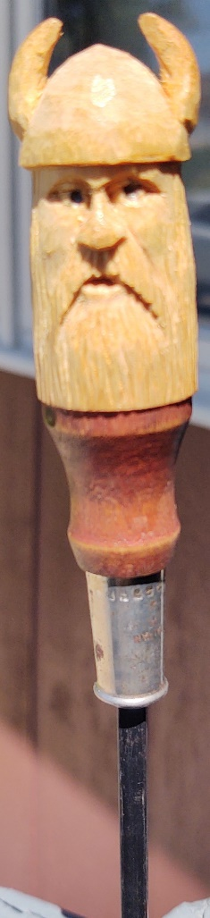

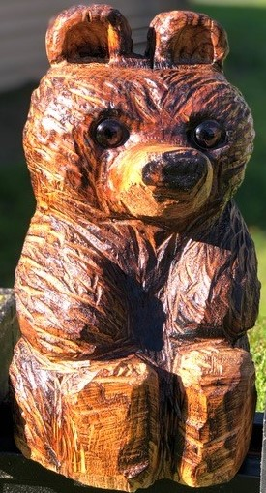
Jackie Widmars’ Chain Saw Bear (her first chain saw carving!)
John Eidens’ Green Man
bark carving
Mike Hughbanks; Viking Screwdriver
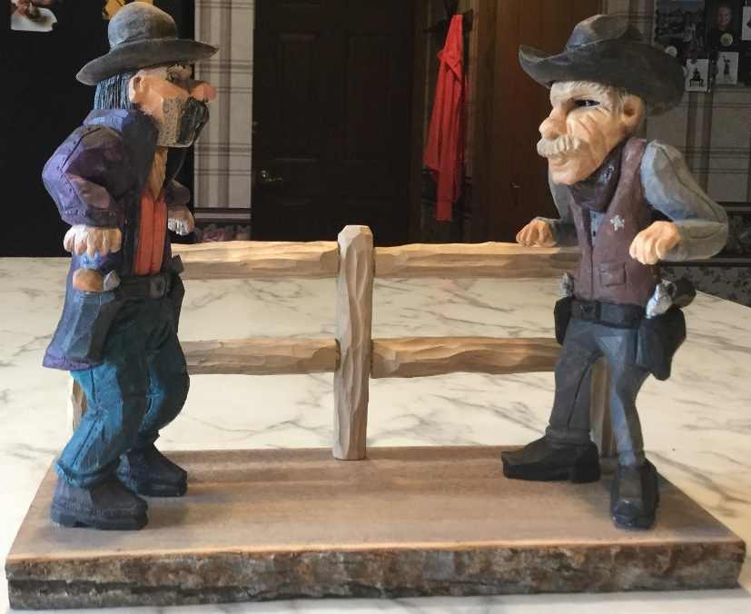
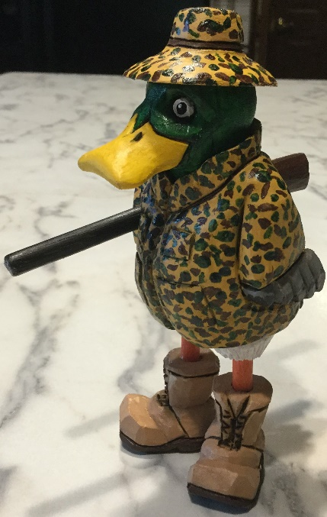
John Eidens’ Gunfight at the OK Corral and his Camouflaged
Duck Hunter

