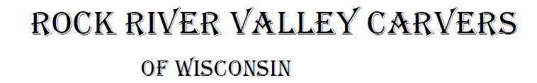
September 2021 Volume 22 issue 9
Editor: Rosemary Kautz Website www.rockrivervalleycarvers.com

August 3, 2021 RRVC Monthly Meeting
- Called to Order at 6:08 pm
- Introduction of Visitors/New Members: Tom Fosdal joined our club. Welcome Tom!
- Illness/Sunshine Report (Rosie Kautz): Vern Morris told attendees that Andy Navarro’s wife was in the hospital and now is in rehab. Andy will be having a heart valve replacement soon. A card will be passed around at Monday morning carving and sent to them.
- Treasurer Report (Rosie Kautz): Beginning balance was $5,875 and ending balance was $4,823. Major income included $125 from show table sales. The main expenses were payment of rent for our show next month and the deposit for our show next year.
- ‘Get to know a Fellow Carver’: Brad Crandall’s and Mike Boutelle’s names were drawn at the meeting. We need someone to take over writing this article monthly for 2022 or we will no longer continue this next year.

New Business
- Evening Open Carving Sessions (Tom Kautz): The first and third Tuesdays of the month we will meet at First Lutheran Church from 6-8 pm. Remember to bring a table cover with you if you are carving.
- Senior Center Update (Tom Kautz): Masks are now required again. You may bring in beverages in covered containers. Evening rental for meetings is still not possible.
- Show Update (Brad Crandall): Friday setup for the show begins at 2 pm. Approximately 25 tables have been sold so far. This will be the last year that Denny Neubauer will be doing tool sharpening at shows. Rosie Kautz confirmed that Jeff will be selling lunches at our show despite being in the middle of changing locations for his business. Help is needed at the show for greeters, ornament sales, raffle, and People’s Choice. Please contact Brad to let him know when you can help out. Ornaments and carved raffle prizes are needed. Randy Callison will be collecting these.
  - A new Chairman for the show in 2022 is still needed. Please consider stepping up to assume this important role for our club.

2021 Officers
President: Thomas Kautz
608-868-4522
Vice President: Mark Ludois
608-371-3838
Secretary: Mark Ludois
608-371-3838
Treasurer: Rosemary Kautz
608-868-4522
Librarian: Bud Cunningham 608-853-1777
Editor: Rosemary Kautz
608-868-4522

A Handful of Patience is Worth More than a Bushel of Brains

Normal meetings on the
first Tuesday of the month
at the First Lutheran Church, Across from Fairgrounds
612 N Randall Ave.
Janesville, WI
Meeting or Carving
begins at 6 p.m.

- Dell Lore from Illinois had basswood, butternut, walnut, cherry, catalpa, pine, and cottonwood bark for sale outside the church. Despite the rain, he appreciated the sales.
- Chili Peppers (Tom Kautz): Mark Ludois is mounting the peppers on bases prepared by Randy Callison and they will be turned in by August 1st. A list of pepper carvers will be used to distribute replacement basswood which has been ordered.
- Rock River Thresheree (Tom Kautz): We will have 3 EZ Ups there and members can sell their art. Sign in and set up is Thursday, Sept. 2. The event runs Friday thru Monday, 8 am to 5 pm. Tom has sprayed weed killer on the poison ivy near our site. Mike Hughbanks, Randy Callison, Ernie Tucker, Jim Trumpy and Bob Crompton will be there. Contact Tom Kautz if you can help out.
- Kauffman’s Saturday Markets (Brad Crandall): August 21 and 28 are reserved for one EZ Up to promote our show and club. We look forward to seeing new people at our show from the contacts made during the 2 Saturday markets in July when Brad was there. Thank you, Mike Hughbanks, Carrie Zalud, and Bud Hilgendorf, for helping out!
- Friends of Beckman Mill (Tom Kautz): We will have members displaying their works and selling on Sunday, September 12, 9 am to 4 pm. Contact Tom Kautz if you plan to attend.
- Next Meeting will be Tuesday, September 6 at First Lutheran Church at 6 pm.
Meeting adjourned at 6:35 pm. Minutes respectively submitted by Rosie Kautz.

Club Meeting Information Update
Evening Carving – Open carving from 6-8 pm on the first and third Tuesdays each month will be at First Lutheran Church (across from the fairgrounds) in Fellowship Hall located at 612 N. Randall Ave. Park in back and enter through the doors under the canopy. Take the first left to the room. Handicapped accessible. Table covers are required at this time. The building is air conditioned and woodburning can be done at certain tables.

Shows & Seminars Coming Up and/or Canceled
September 11: Our Show & Sale in Janesville
September 18-19: Stevens Point, WI 20th Annual Show, Competition, and Sale of the Wisconsin River Woodcarvers, Holiday Inn, 1001 Amber Ave, Stevens Point, WI., Saturday 9-5, Sunday 9-4, admission $5 (under 13 free), Ron O’Kray (715) 570-2534 or Greg Wirtz (715) 323-2035, www.wisconsinriverwodcarvers.org

Tool Glossary (from Jim Svoboda) …

Hacksaw – One of a family of cutting tools built on the Ouija board principle. It transforms human energy into unpredictable motion, and more you attempt to influence its course, the more dismal your future becomes.
Skill Saw – A portable cutting tool used to make studs too short.

Show Assistance Requested
Please contact Brad Crandall at bwkicrandall@gmail.com or 608-931-0188 and let him know when you can volunteer your time at our show on September 11. Help is needed at the greeter’s, ornament, raffle, and People’s Choice tables. Feel free to volunteer for more than one time slot! And thank you to all our volunteers!

Notes From the President’s Carving Bench
Our carved chili peppers will be delivered this week to Chili Mania and we expect payment shortly. As in past years, these funds are used to pay our club’s rent at the Janesville Senior Center. Mark Ludois was this year’s chili pepper chairman. Randy Callison supplied the wood for the bases as well as cutting them out and finishing them in preparation for mounting by Mark. Besides thanking Mark and Randy, club members should thank the pepper carvers: Brad Crandall, Randy Callison, Bud Cunningham, John Eiden, Darrell Higley, Bud Hilgendorf, Ed Hogue, Mike Hughbanks, Tom & Rosie Kautz, Gerry Lesch, Mark Ludois, John Raisbeck, Jim Trumpy (who carved 2), Ernie Tucker, and Fred Wuthrich. These individuals will be given basswood pieces by the club.
A big THANK YOU for all the time and talent that went into this effort!
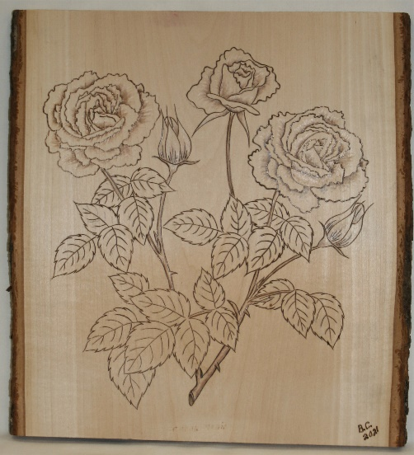
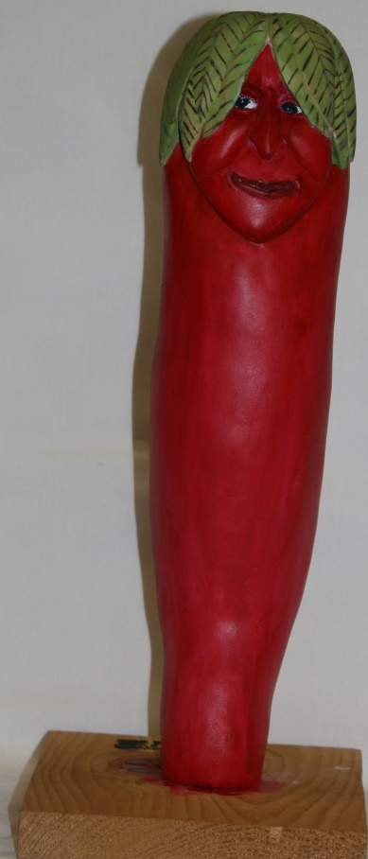
Club Members’ Carvings

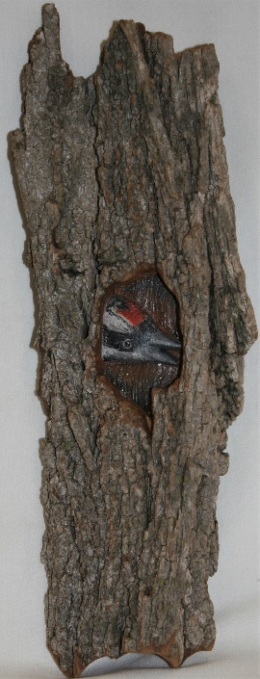
Bud Cunningham’s Pyrography
Roses and Roses with Barn
(left and below)

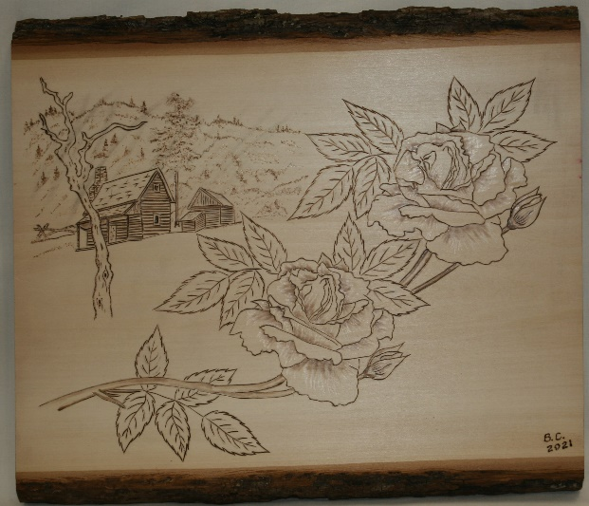
Rosie Kautz’ Bark Woodpecker Home, and
Brad Crandall’s
Chili Pepper (right)

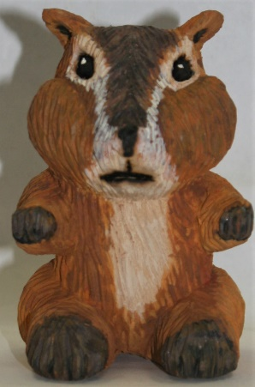
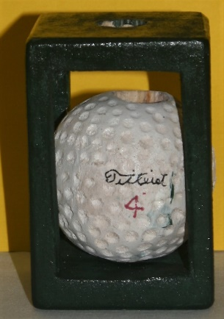
John Raisbeck’s
Chubby Cheeks
Chipmunk and
Randy Callison’s
Golf Ball Cane Segment
(right)

Ernie Tucker’s
Comfort Bird Bottle Stoppers (left)

