September 2020 Volume 21 issue 9
Editor: Rosemary Kautz Website www.rockrivervalleycarvers.com

IMPORTANT MESSAGE:
There will be No Monday and Thursday morning carving sessions
No Tuesday evening carving sessions
No monthly meetings for now. The Senior Center is closed.

Notes from the Presidents’ Carving Bench
It’s with a heavy heart that we must note that long time club member Tim Banwell has passed away. Please see the obituary from the Janesville Gazette on 17 August 2020. The club is sending a condolence card to Tim’s wife, Ruth, and their family. Tim was the person who helped me connect with our club 17 or 18 years ago. Tim’s co-workers at the Rock County Health Department have been in touch about some kind of carved memorial plaque of Tim for installment at the Health Department.
Great news from Mark Ludois and Edgerton Chili Mania. He has received full payment for the 2020 set of 17 chili trophies. This will help with this years’ expenses. Even more significant, Chili Mania specified that they want and will pay for another set of chili trophies for 2021. Feel free to come up with ideas and start carving for next year. We will work on getting replacement wood for everyone who carved a chili this year and last year.
Now that Rosie and I are back from our Boulder Junction camping trip (hiking, biking, and fishing), I will be looking into costs and funding for the air conditioning project at Ortmayer Hall. John Raisbeck has some experience in using a “split system” as has been suggested. John has been very happy with his experience with a system like this.
Keep carving and submit photos of your completed work to Rosie for inclusion in the next newsletter.

2020 Officers
President: Thomas Kautz
608-868-4522
Vice President: Mark Ludois
608-371-3838
Secretary: Mark Ludois
608-371-3838
Treasurer: Rosemary Kautz
608-868-4522
Librarian: Bud Cunningham
608-853-1777 Editor: Rosemary Kautz 608-868-4522

An old wood carver asked “What’s the longest word in English?”
SMILES
Because there’s a mile between the S’s!

We normally meet on the
first Thursday of the month
at the Janesville Senior Center, Second Floor
69 S. Water St.
Janesville, WI
Meeting or Carving
begins at 7:15 p.m.
Board Meeting at 6 p.m.

A Carving Opportunity
Join your fellow club members on Mondays for open carving from 1:30 to 3:30 pm at Walt Lindeman Sportsman’s Park on Highway 51, across from the County Health Department. Strict social distancing must be practiced. Wear your mask and keep 6 feet between fellow carvers. Bring hand sanitizer, your own chair and/or table (in case the shelter tables are in use by another group), a carving project, and tools. Electric outlets should be available at the picnic shelter for pyrography to take place. The restrooms will be open. Join us for safe social interaction and the exchange of carving ideas. Weather dependent, of course.

Shows and Seminars
All known carving shows in Wisconsin & Thresheree have been cancelled for 2020.

Comfort Crosses
We need more comfort crosses carved for our next delivery in a couple of months. Thank you, Ernie Tucker, for heading up, organizing, and delivering our efforts!
Here’s a few tips from Ernie on carving the crosses:
- They need to be comfortable to the touch and look good.
- After shaping comes sanding. Start with course grit to remove all your knife marks. Check your progress in good lighting. If any scratches are left, they will be magnified when you apply finish.
- Apply your finish in thin coats. Sand with your finest grit sandpaper between coats.
- Apply additional coats of finish until you are satisfied with the results.

Get to Know a Fellow Carver
Reggie James lives in Beloit, Wisconsin and he joined the Rock River Valley Carvers four years ago. Since then he has enjoyed learning to carve cottonwood bark with Ernie Tucker, and he has crafted many boots, spoons, owls, and Christmas ornaments.
Reggie and his wife Karen have been married for 46 years. They have two adult sons Chad and Kellen. They too live in Beloit. Reggie retired from the tool and die trade. He says “My first love is the great outdoors. I have two yellow lab hunting dogs, Connor and Murphy*. I enjoy pheasant hunting behind my dogs and deer hunting with the boys.” Fishing is another outdoor sport he participates in as well as camping with Karen in their 24-foot camper.
Reggie states “I enjoy getting together with the group and wood carving. And I enjoyed co-chairing the RRVC carving show and sale with Brad Crandall in 2019. I want to thank the club for everything they taught me and I enjoyed it all. Stay safe and healthy and hope this virus ends soon.”
Article submitted by Robin Rios.
*Unfortunately, Connor recently passed away.

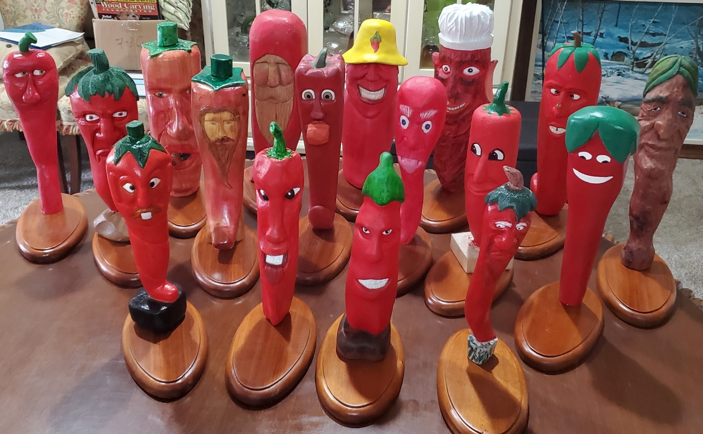
Club Members’
Carvings

All 17 Chili Peppers carved by our club members for Chili Mania and mounted by Mark Ludois on bases created by Randy Callison.

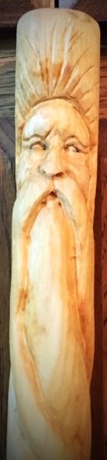

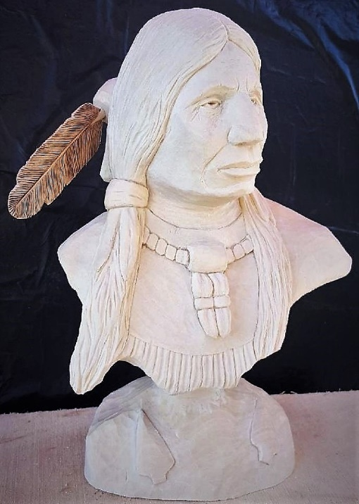
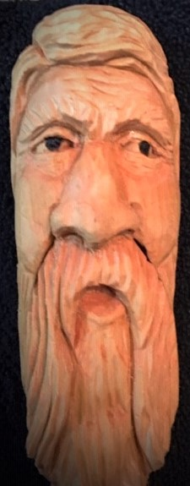
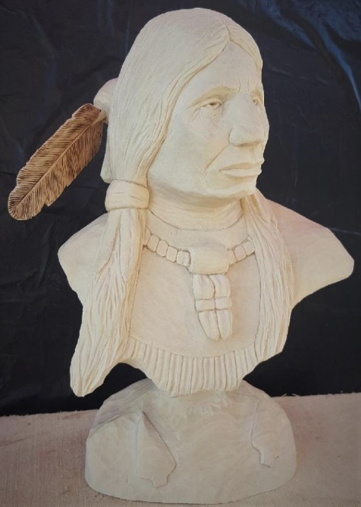
The Wood Spirit and Mustache Man top Hiking Poles (on right) were carved by Ernie Tucker, as well as the Friendly Mushroom (below).

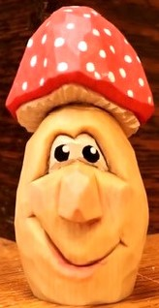

Native American bust carved by John Raisbeck and ready to be painted.

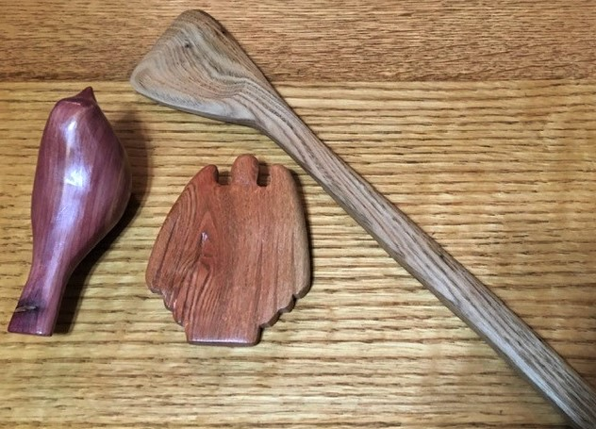
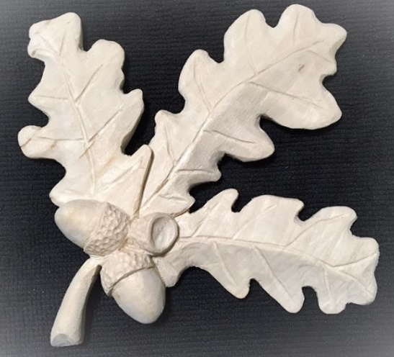
Comfort Bird, Paddle, Angel, and Oak Leaves carved by Ernie Tucker

