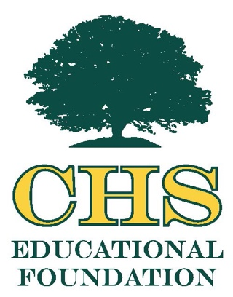

2025 CHSEF Hall of Fame Nomination Form

Please complete this form and submit to CHSEF with a recent photo. Either email your nomination form and additional information to CHSEF at conwayhsef@gmail.com or mail to CHSEF, P.O. Box 3073, Conway, S.C. 29526

Date ________________
Full Name of Nominee (note – Educator or Alumnus) _________________________________
Year graduated from Conway or Whittemore High School _____________________________
Address _____________________________________________________________________
Phone number _______________________ Email ___________________________________
List education past high school ___________________________________________________
_____________________________________________________________________________

Please include the following information in your nomination.

- Work information (past and present)
- Family information
- Honors or awards
- Reasons you believe this nominee is eligible to be recognized as alumnus or educator in the CHSEF Hall of Fame, i.e., impact their work or volunteer contributions have had on the world, the community, students, etc.
- Name and detailed contact information of the individual submitting this nomination for consideration.

Note: Deadline for nominations is March 31, 2025. The CHSEF Hall of Fame Banquet will be held in Fall 2025. If your nominee is selected to be awarded this year, you and the honoree will be contacted by the CHSEF board of directors. If the honoree is being recognized posthumously, please assist us with contacting a family member.

