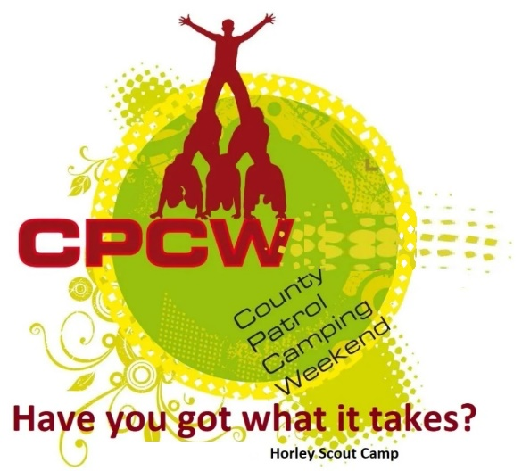
Activity Instruction Sheet
Send A Secret Message
Supervising Adults/Explorers should have read the risk assessment for this activity before running.
Equipment required: Marking sheet.
Description of Activity
The Secret Message Activity is a 20 minute event with patrols given points on how well they are able to complete the task in the time given and work well as a patrol.
Activity Set Up Instructions
Select a good flat grass area that is clear from overhead and other obstructions.
The Patrol should be split roughly into 2 equal groups.
Space each of the groups at least 50 meters apart so that they cannot hear each other talking.
Give the groups the semaphore flags, semaphore instructions and the random chosen words from the set
(see the Instructor WORD sheet – do not show this to the group).
Each group takes it in turn to signal the other group their word. The receiving team tell the instructor what the word is and then they signal back to the 1st group with their word, the 1st group then tell that word to their instructor.
Instructions for Participants
You task is to first split the Patrol roughly into 2 equal groups.
Each group will then then go to 1 of the 2 signalling points.
Once there you will be given Semaphore signalling flags and a semaphore guide.
Once you have these the Instructor will give you a random word to send to the other half of the team.
Each group takes it in turn to signal the other group their word.
The receiving team tell the instructor what the word is and then they signal back to the 1st group with their word, the 1st group then tell that word to their instructor.
For BOTH teams getting the exact word signalled correct within the time given and showing excellent teamwork will be awarded 5 points
For BOTH teams getting the exact word signalled correct within the time given and showing good teamwork will be awarded 4 points
For one team getting the word signalled exactly and the other team getting the word signalled roughly correct within the time given and showing good teamwork will be awarded 3 points
For BOTH teams only getting the word signalled roughly correct within the time given and showing good teamwork will be awarded 2 points
For BOTH teams getting the word signalled totally incorrectly or running out of time or showing poor teamwork will be awarded 1 point

Risk Assessment
What could go wrong? | What is Risk from it? | Who is at risk? | What are you going to do about it?
Slips, trips and falls | Slips, trips and fall related injuries | Young people, adult volunteers and visitors | Keep activity areas of trip hazards.
Weather | Injury from high winds or lightning | Young people, adult volunteers and visitors | Activities that may have to be stopped during strong winds, heavy rain or if thunderstorms are predicted. Event Lead responsible for monitoring.

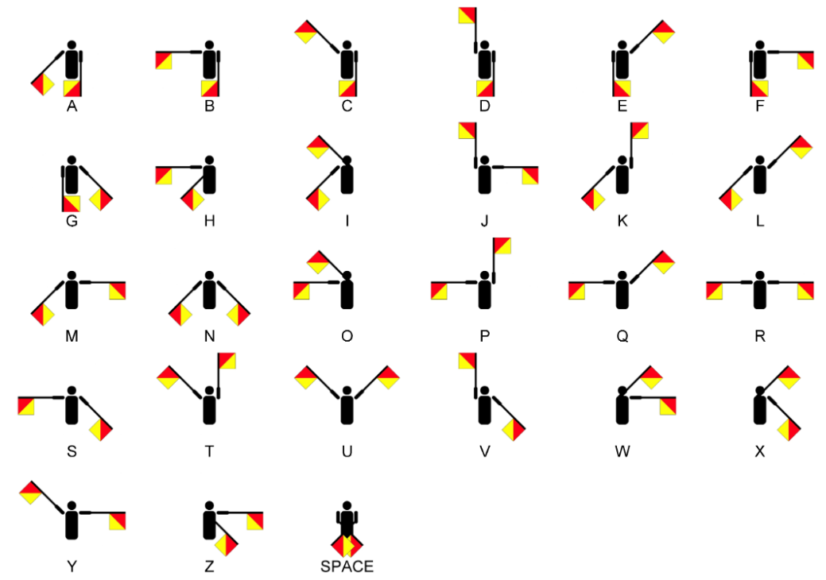

Instructor Random Word Sheet
Set | Word for Team 1 to Signal | Word for Team 2 to Signal
1 | Aardvark | Junction
2 | Location | Cageless
3 | Disabled | Highland
4 | Overhead | Firewall
5 | Captured | Platform
6 | Magnetic | Abducted
7 | Research | Innocent
8 | Bathroom | Notebook
9 | Portrait | Equation
10 | Identify | Salesman
11 | Exchange | Landlord
12 | Shooting | Disposal
13 | Hardware | Ministry
14 | Flagship | Tactical
15 | Umbrella | Governor

Instructor Random Word Sheet
Set | Word for Team 1 to Signal | Word for Team 2 to Signal
1 | Aardvark | Junction
2 | Location | Cageless
3 | Disabled | Highland
4 | Overhead | Firewall
5 | Captured | Platform
6 | Magnetic | Abducted
7 | Research | Innocent
8 | Bathroom | Notebook
9 | Portrait | Equation
10 | Identify | Salesman
11 | Exchange | Landlord
12 | Shooting | Disposal
13 | Hardware | Ministry
14 | Flagship | Tactical
15 | Umbrella | Governor

