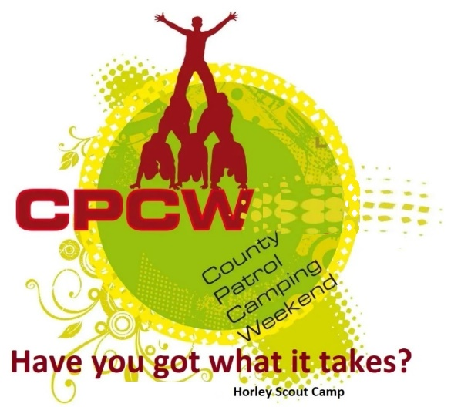
Activity Instruction Sheet
Sheep Herding
Supervising Adults/Explorers should have read the risk assessment for this activity before running.
Equipment required: Cones, Sheep & Sheep Dog Headbands, Blindfolds/eye covers, Whistle, Scoring sheet.
Description of Activity
The Sheep Hearding is a 20 minute activity where the best teamwork will win the most CPCW points. 1 patrol member attempts to guide the other (blindfolded) members of the patrol round an obstacle course and into the end holding pen, by calling out instruction (using the allowed phrases) or by using the whistle.
Activity Set Up Instructions
Select a good flat grass area that is clear from overhead and other obstructions.
Set up a start line for the sheep & sheep dog at least 50 meters from the “Shepherd” and Pen. Then create a course of left & right cones that they will have to go through.
The same course must be used for each team.
Give out the head gear and blindfolds to the sheep & sheep dog and tell them they should stay together at all times.
Instructions for Participants
Your task is choose one member of the team to be a shepherd who will guide (by whistles & calls) the blindfolded sheep & sheep dog round the obstacles and into the sheep pen. The team that complete the task and show the best teamwork will win the most points.
All Patrol members must take part.
The game area has obstacles you must navigate round, so you must WALK, NOT RUN.
The shepherd can only use shepherd instructions i.e.
“Walk-on” = go straight, “Lie-Down” = Stop, “Come Bye” = turn clockwise, “Away” = turn anticlockwise.
Or Whistle commands
1 long whistle = go straight, 1 short whistle = stop, 2 short whistles = turn clockwise, 2 long whistles = turn anticlockwise.
As a team choose 1 method to use before you start
Remember, the sheep & sheepdog cannot talk to the Shepherd once started.
If the leader shouts stop, you must stop immediately.
Risk Assessment
What could go wrong? | What is Risk from it? | Who is at risk? | What are you going to do about it?
Slips, trips and falls | Slips, trips and fall related injuries | Young people, adult volunteers and visitors | Keep activity areas of trip hazards.
Slips, trips and falls (blindfolded participants) | Blindfolded Scouts at risk of tripping, slipping or falling. | Blindfolded young people | Call stop if the sheep are heading towards a hazard. Encourage guides to be sympathetic.
Weather | Injury from high winds or lightning | Young people, adult volunteers and visitors | Activities that may have to be stopped during strong winds, heavy rain or if thunderstorms are predicted. Event Lead responsible for monitoring.

