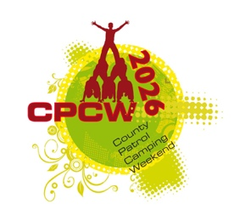 | COUNTY PATROL CAMPING WEEKEND  2nd – 4th October 2026  County Cooking Competition

We are going back to our roots this year and making the County Cooking Competition at the core of our CPCW event. All Patrols will be taking part in this Competition via their Zones for the meals that they are required to COOK on Saturday from Breakfast through to Dinner.

COMPETITION INFO

- Duration – Saturday Breakfast, Lunch & Dinner
- Where – Cooked on Zone
- Judged by – Zone Staff

CRITERIA

- Written Menu (with Patrol Name on) is to be provided by Patrol to Zone Staff on arrival to the Zone on Friday evening
- Meals must be substantial enough and be cooked for the whole Patrol considering all dietary needs and any special cooking requirements needed to meet this.
- All three meals must be hot and cooked on an altar fire (provided by the event)
- All Patrol members must be catered for with the same meal each time.
- No limit on ingredients, food types etc

JUDGING

- By Zone Staff on each Zone
- Judging will consider all three meals on Saturday from Breakfast to Dinner inclusively
- Patrols must cook and eat in the specified time period given by Zone Leaders
- Food preparation and cleaning-up will also be judged
- Food storage will also be judged
- Waste
- Patrols are to provide a small sample of food for Zone Leaders to taste on a separate plate or bowl to allow taste judging.
- Winner of each Zone will go forward to a ‘Ready Steady Cook’ style final that evening on the stage in the marquee where they will be cooking on gas stoves (provided) and a set of ingredients which is the same for each of the seven Patrol Zone Winners.
- They will be asked to produce a meal in 30 minutes from the food provided in front of the CPCW Crowd.
- The winning Patrol will be Judged by OxChefs and announced upon completion of the Ready Steady Cook element of the competition.

CONSIDERATIONS

- Camp / event theme – Sustainability
- Know where your ingredients have come from
- Know your Food journeys
- Consider packaging and waste
- Teamwork
- Limited cooking times and cooking on open fire
- Fire prep before cooking
- Substantial and balanced menu

